P.1 GRAMMAR LESSON NOTES FOR TERM II 2025
Date | Subject | Class | Time | No. of pupils
THEME : Weather
SUBTHEME : Elements of weather
CONTENT : Verbs
Action words
Doing words
sun_________ shine _____________shining
rain__________ rain _____________raining
clouds_______ cover _________covering
wind_______ blow ____________blowing
EXERCISE
Use words in the brackets to complete these sentences correctly.
- It is ____________________________now (rain)
- The wind is ________________________(blow)
- Is it _______________________________now? (rain)
- The clouds are ______________________the sky(cover)
- It is _______________________________outside.(shine)
- Farmers are ________________________their crops (harvest)
- They are _____________________________the garden.(prepare)
- He is ____________________________________crops (plant)

Date | Subject | Class | Time | No. of pupils
THEME : Weather
SUBTHEME : Elements of weather
CONTENT : More about action words (doing words)
grow ______________growing
plant _________________planting
water ________________watering
harvest ________________harvesting
dry ____________________drying
market_________________marketing
weed___________________weeding
prepare_________________preparing
EXERCISE
Use words in brackets to complete the sentences correctly.
- Jane is ______________________________plants(water)
- We are _______________________________our crops(harvest)
- _______________________________is good to growing plants (weed)
- In rainy season, farmers like _______________________their crops (plant)
- Kato is ______________________________________________________maize (dry)
- ____________________________________is good for farmers(market)

Date | Subject | Class | Time | No. of pupils
THEME : Weather
SUBTHEME : Effects and management of weather
CONTENT :
Short forms
Writing words shortly by replacing the missing letters with an apostrophe.
Examples
I am _______________________________________ I’m
He is _______________________________________he’s
She is ______________________________________she’s
Let us _______________________________________let’s
We are _______________________________________we’re
That is _______________________________________that’s
They are _____________________________________they’re
Jan. ___January Can’t – cannot Mon__ Monday
Feb___ February don’t - do not Tues__ Tuesday
Aug._____ August it’s – it is Wed. ___ Wednesday
Sept._____ September Thur.. ___ Thursday
Oct.____ October Fri. ___ Friday
Nov. ___ November Sat. ____Saturday
Dec. ___ December Sun. ___ Sunday

Write in full Write the following in short form.
- that’s ____________ 1. Can not ___________
- you’re____________ 2. Wednesday_________
- let’s______________ 3. It is ______________
- can’t _____________ 4. February.______________
Write the short forms of the underlined words
I am six years old.
He is my father .
I did not go home.

Date | Subject | Class | Time | No. of pupils
THEME : Weather
SUBTHEME : Effects and management of weather
CONTENT :
Writing short form in sentences
Examples
It is raining now.
It’s raining now
Let us go out.
Let’s go out.
EXERCISE :
Write sentences in short.
I cannot play in the rain. ___________________
I am a good girl ___________________________
She is going to eat._________________________
They are school children ______________________
That is my bag _______________________________
Let us eat food now. __________________________

Date | Subject | Class | Time | No. of pupils
THEME : Weather
SUBTHEME : Activities for different seasons
CONTENT :
Plurals where we add “s”
wheelbarrow –
hoe –
spear –
garden fork –
panga –
watering can –
axe –
basket –
spade –
rake –

EXERCISE :
Spelling
Listen and write (10)

Date | Subject | Class | Time | No. of pupils
THEME : Accident and safety
SUBTHEME : Accident and safety at home.
CONTENT :
Nouns on which we add “es” in plural form
Examples
Nouns that end with O, X, sh, ch, s, ss, and add “es” in plural form
One Many
bench benches
box boxes
tomato _________________________
bus _________________________
potato _________________________
dress _________________________
ostrich _________________________
dish _________________________
torch _________________________
mango _________________________
watch _________________________
match _________________________
brush _________________________
glass _________________________
gas _________________________
fox _________________________
bush _________________________

Date | Subject | Class | Time | No. of pupils
THEME : Accident and Safety
SUBTHEME : Accidents and safety at home
CONTENT :
Nouns which add on “ves”
Words which end with ‘f’ . We drop f and we replace3 it with ‘ves’
leaf ____________________
half ____________________
calf ____________________
loaf ____________________
wife ____________________
knife ____________________
thief ____________________
life ____________________
shelf ____________________
self ____________________

Except:
chief – chiefs
handkerchief – handkerchiefs
roof – roofs
Sentences
- Plants have ___________(leaf)
- She gave me two ___________(loaf) of bread.
- Kato has three __________(wife)
- I have two ___ (knife)

Date | Subject | Class | Time | No. of pupils
THEME : Living together
SUBTHEME : The family
CONTENT :
Nouns that change with ‘ies’ change y to ies to form plural – theme words
one many
baby – babies
body – bodies
lady – ladies
lorry – lorries
puppy – puppies
county - counties
dormitory - dormitories
country - countries
Activity:
Complete the sentences correctly.
- Most _________________________drink milk. (baby)
- It is healthy to clean our_____________________________(body)
- All ____________________________are beautiful. (lady)
- Our _________________________________are rich.(family)
- ___________________________________help in transporting things (lorry)
- Most ___________________________love peace. (community)
- _________________________are young ones of dogs (puppy)
Give the plural form of the underlined word

Date | Subject | Class | Time | No. of pupils
THEME : Living together
SUBTHEME : More about nouns
CONTENT :
Nouns which change completely
One Many One Many
man - men policeman policemen
ox - oxen policewoman policewomen
woman - women Nouns which does not change
child - children water - water
tooth - teeth furniture - furniture
foot - feet grass - grass
goose - geese
Complete the sentences correctly
1. Mr. Kato has many _____________________on his farm. (ox)
2. My __________________________are paining (foot)
3. Our ______________________________are so nice. (child)
4. All ___________________________in Uganda are free. (woman)
5. My ___________________________are bringing blood (tooth)

Date | Subject | Class | Time | No. of pupils
THEME : Living together
SUBTHEME : The ways of living together (vocabulary)
CONTENT :
An opposite is something which is completely different from the other
Opposites
good - bad night - day
clean - dirty start - end
old - new thin - fat
short - tall small - big
open - close/shut come - go
far - near sit - stand
empty - full cry - laugh
big - small happy - sad/unhappy
early - late ugly - beautiful/handsome
cheap - expensive smart - shabby

EXERCISE
Match the opposites
Clean full
big end
open small
old shut
good bad
short new
empty dirty
Write opposites of these words
night
fat
neaR
Date | Subject | Class | Time | No. of pupils
THEME : Living together
SUBTHEME : Ways of living together (vocabulary) at home
CONTENT :
Meaning of opposite
More about opposites
sit - stand
come - go
black - white
sell - buy
rich - poor
dry - wet
first - last
in - out
father - mother
hot - cold
up - down
man - woman
long - short

EXERCISE Match the opposites

Date | Subject | Class | Time | No. of pupils
THEME : Food and Nutrition
SUBTHEME : Names of local food
CONTENT :
Using in, on, near, under, front of, to, at, behind
Look at these pictures
The water is in the glass.

The beans are on the plate.

Exercise
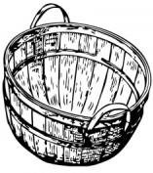
Write in, on, near, under in the gaps

- The mangoes are …………………the basket.

- The millet is …………….the chair.

- The fish is ………………..the water

- The beans are ………….the cassava

- The peas are ………the mat.

Date | Subject | Class | Time | No. of pupils
THEME : Food and Nutrition
SUBTHEME : Names of food
CONTENT : Use of that / those
That is a bird.
Those are birds
EXERCISE :
Fill in the gaps using That / Those.
1. ____________________is a tree.
2. _______________________are trees.
3. _______________________is a bell.
4. _____________________are pencils.
5. ________________________is a table.

Date | Subject | Class | Time | No. of pupils
THEME : Food and Nutrition
SUBTHEME :
CONTENT :
Use of this / these
Examples
This is a table.
These are tables.
EXERCISE :
Make correct sentences using This/These correctly.

Date | Subject | Class | Time | No. of pupils
THEME : Food and Nutrition
SUBTHEME :
CONTENT : occupation
People and their work

Doctor - treats sick people
Teacher - teaches pupils
Lawyer - Solves cases in the court
Nurse - cares for the sick
Policeman - keeps law and order
Cook - cooks food
Tailor - sews clothes
Cobbler - mends shoes.
Tinker - repairs pots
Carpenter -
Dentist - treats teeth
Optician - treats eyes

Exercise
Match people and their occupation.
Doctor treats teeth
Nurse care for the sick
Optician treats our teeth
Dentist cooks food
Cook treats sick people

Date | Subject | Class | Time | No. of pupils
THEME : Food and Nutrition
SUBTHEME :
CONTENT :
Alphabetical
a b c d e f g h i j k l
n o p q r s t u v w x y z
knife, rake, axe, hoe
mat, hat, net, eggs
eggs, hat, mat, net
Activity
- Arrange the following in A B C order.
d c b a
____________________________________________
s r q p
____________________________________________
rat, boy, girl, aunt
____________________________________________
umbrella, tin, vest, stick
____________________________________________
hoe, axe, cut, bed
____________________________________________

Date | Subject | Class | Time | No. of pupils
THEME : Food and Nutrition
SUBTHEME :
CONTENT :
Homophones
These are words of the same sound but different meaning.
Example

to – two – too
cat – cut
heart – hurt
bad – bird – bud
mad – mud
hat – hut
son – sun

fill in with the correct word
- Tom is going ______________ school ( two, to, too)
- The ____________ is flying over the tree. (bad, bird, bud)
- Grace is wearing a _____________. (hat, hut)
- I have __________ my leg. (hurt, heart)
- Sarah has drawn a _____________ . (cat, cut)
- I saw a ____________ man. (mad, mud0
- The ____________ is very hot today. (son, sun)
- The __________ of two and two is four. ( sum, sam)

Date | Subject | Class | Time | No. of pupils
THEME : Food and Nutrition
SUBTHEME :
CONTENT : Conjuctions
Using …………. and …………..
Examples
- She is eating an orange. She is eating an apple.
She is eating an orange and an apple.
- My father has a car. He has a bicycle.
My father has a car and a bicycle
- Peter is a boy. John is also a boy.
Peter and John are boys.
Exercise
Join these sentences using ……… and ………..
- Ivan has a book. He has a pencil.
- The doctor is eating chicken. The doctor is eating chips.
- The dentist has a bag. He has a thermometer.
- The farmer has a spade. He has a panga.
- The teacher has a stick. He has a pen.

Date | Subject | Class | Time | No. of pupils
THEME : Food and Nutrition
SUBTHEME :
CONTENT :
Using …………. but …………..
Examples
- It rained heavily. I did not plant crops.
It rained heavily but I did not plant crops.

- I am sick. I will not go to the hospital.
I am sick but I will not go to the hospital.
Exercise
- I am hungry. I do not want food.
- My father has a car. He doesn’t drive it.
- I feel cold. I don’t have a sweater.
- He rang the bell. I did not hear.
- The farmer grows crops. He doesn’t have food.
Date | Subject | Class | Time | No. of pupils
THEME : Food and Nutrition
SUBTHEME :
CONTENT :
Using …………. because …………..
Examples
- I came late. I was sick
I came late because I was sick.
- They are dirty. They did not bathe.
They are dirty because they did not bathe.

Exercise
Join these sentences using ……….. because…………
- My mother did not cook food. She did not have money.
- The cobbler is crying. He lost his money.
- The nurse is tried. She worked the whole night.
- My father bought a panga. He wanted to cut the tree.
- Our knife is not cutting. It is blunt.
Date | Subject | Class | Time | No. of pupils
THEME : Food and Nutrition
SUBTHEME :
CONTENT :
Using …………. than …………..
Examples
- My aunt is taller. My uncle is tall.
My aunt is taller than mu uncle.
- A monkey is big. A lion is bigger.
A lion is bigger than a monkey.
Exercise
Join using ………. than………..
- A rat is smaller. A rabbit is small.
- A lion is tougher. An elephant is tough.
- My mother is fatter. My father is fat.
- A bus is bigger. A taxi is big.
- Our cousin is browner. Our nephew is brown.
- The tea is hotter. The porridge is hotter.
- The water was colder. The ice was colder.
- My dress is welter. My blanket is wet.
P.1 COMPOSITION LESSON NOTES FOR TERM II 2019
Date | Subject | Class | Time | No. of pupils
THEME : Weather
SUBTHEME : Element of weather
COMPETENCES : Identifying the elements of weather
: Naming and describing them
: Answering the questions given.
CONTENT : Vocabulary
Elements of weather are the things that show change in weather.
sun clouds rain sunshine wind cover
Common words
blow, hot, water, wet, shine, shining, raining, blowing, covering
Exercise
Make correct sentences using these words
- Sun (b) Rain (c) Clouds (d) Wind

Date | Subject | Class | Time | No. of pupils
THEME : Weather
SUBTHEME : Types of weather
COMPETENCES : Reading the given vocabulary
: Spell them correctly
: Use them to construct sentences correctly.
CONTENT : Vocabulary
sunny rainy windy cloudy raining, shinning

Structure
- What is the weather like?
- Is it ___?
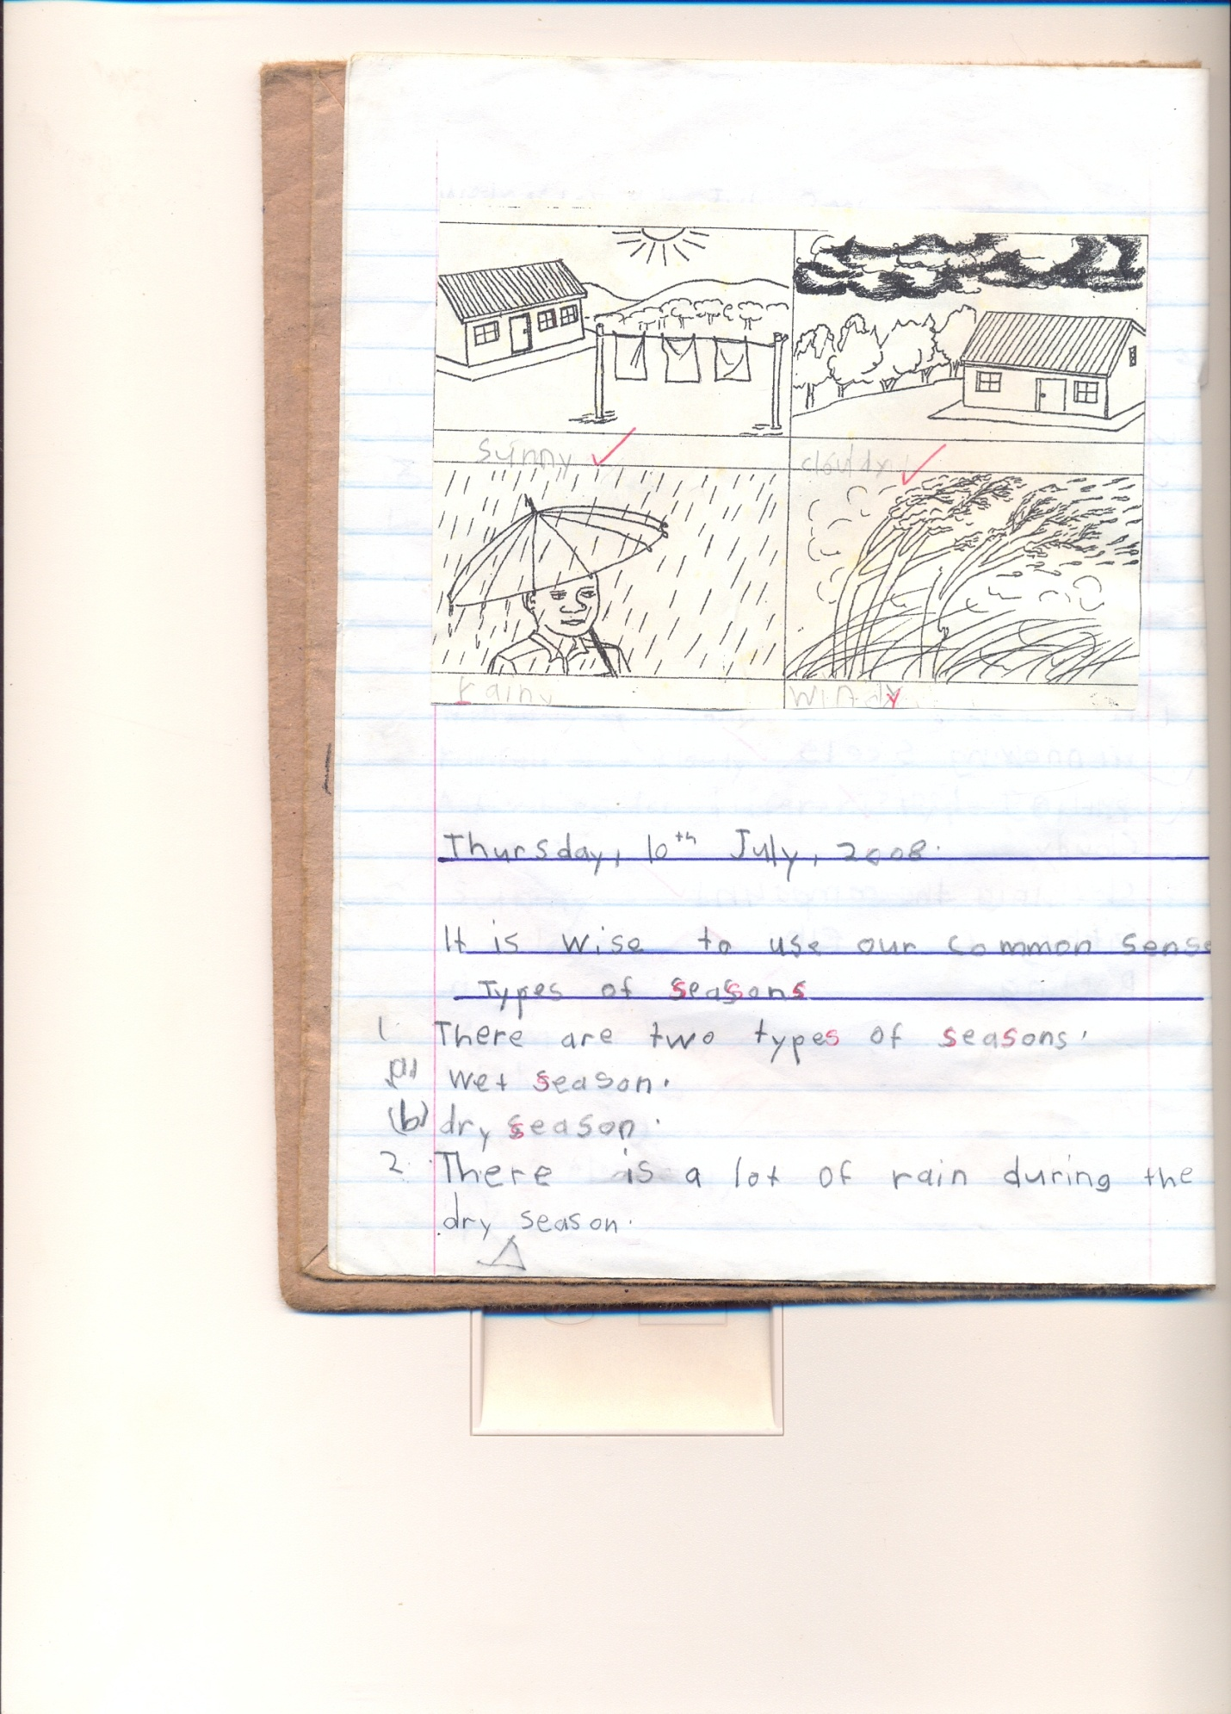
- What is the weather now?
The weather is ________now.
Is it raining?
Yes, it is
No, it is not
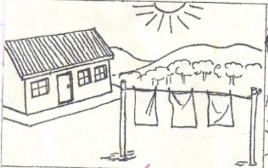
- What is the weather today?
The weather is ____today.

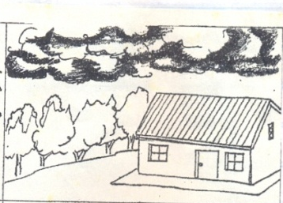
The weather was____ yesterday.

The weather now is ___________

Date | Subject | Class | Time | No. of pupils
THEME : Weather
SUBTHEME : Types of weather
COMPETENCES : Reading the word / sentences correctly.
: Constructing sentences from the table.
Use of is, isn’t
A substitution table
The weather | is  isn’t | windy  cloudy  sunny  rainy | now

Examples
- The weather is windy now.
- The weather isn’t cloudy now.
- The weather is sunny now.
- The weather isn’t rainy now.
Exercise
Write six sentences using words in the table.

Date | Subject | Class | Time | No. of pupils
THEME : Weather
SUBTHEME : Activities for different seasons (Garden tools)
COMPETENCES : Reading vocabulary related to tools
: Spell the letters in the vocabulary
: Answer questions related to the given vocabulary.
CONTENT : Vocabulary (garden tools)
axe, wheelbarrow , hoe , knife, watering can , rake , basket, slasher , spade
exercise
  - Fill in the missing letters
a____e, wh__ __lbarrow, kn__fe, h__e
  - Read and draw
Hoe __________ basket __________ axe ______ slasher _______
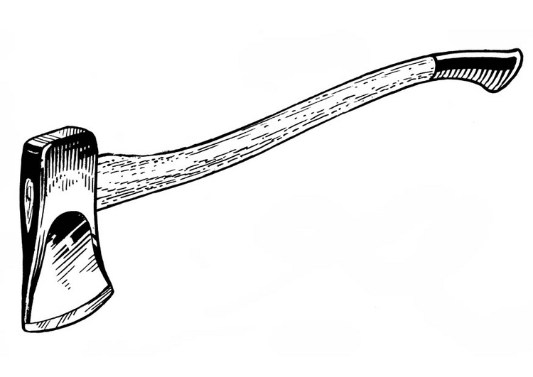
  - Name these pictures.

Date | Subject | Class | Time | No. of pupils
THEME : Weather
SUBTHEME : Activities for different seasons (Garden tools)
COMPETENCES : Reading vocabulary related to tools
: Spell the letters in the vocabulary
: Answer questions related to the given vocabulary.
CONTENT : Vocabulary( uses of garden tools)
Structure
What is this / what do we use __________ for

Activity
Match garden tools to their uses
Uses of different garden tools.
Garden tool use
axe digging
hoe cutting small trees
watering can watering plants

Date | Subject | Class | Time | No. of pupils
THEME : Weather
SUBTHEME : Activities for different seasons
COMPETENCES : Reading the given vocabulary
: Read the given tools in plurals
: Identify the garden tools
: Answering questions correctly
CONTENT : Vocabulary
axe wheelbarrow hoe rake
knife slasher spade basket
Structure
- What do we use ___________________for?
- We use a hoe for _____________

- We use a knife for _____________
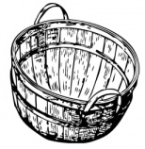

- We use a basket for _____________
(digging, carrying, cutting)
Make correct sentences using these words
        - Carrying
        - Digging
        - Cutting
- Fill in correctly
- We use a _________________ for watering plants
- A _________________ is used for carrying things.
- A_____________________ is used for slashing.
- We use a __________________ for digging.
Date | Subject | Class | Time | No. of pupils
THEME : Weather
SUBTHEME : Activities done in different seasons (clearing, weeding, watering, plunning, harvesting)
COMPETENCES :
CONTENT : Structure
Is he/ she?
No, he / she is not __
Yes he/ she is ____

Picture A
Clearing the garden Is she planting?
__________________

Picture B
Planting Is he weeding ?
__________________

Picture C
Weeding Is she plunning ?
__________________

Picture D
Harvesting crops Is he/ she watering?
__________________

Date | Subject | Class | Time | No. of pupils
THEME : Weather
SUBTHEME : Activities done in different seasons
COMPETENCES :
CONTENT : Types of seasons
Vocabulary
wet, dry, rain, sunshine, clouds, umbrella, gumboots, sweater, jacket, hat. Raincoat, hot, cold, season
Make sentences using these words
  - a) hat –
b) Hut –
  - a) sweater –
b) Sweat –
Choose the correct word from the brackets to complete correctly.
- Farmers grow crops in the ___season. (wet, rain)
- I am putting a __because it is sunny. (hut, hat)
- I put on a sweater when it is __. (hot, cold)
Re-arrange these words correctly
etw_________, ryd________, ainr____________,
Date | Subject | Class | Time | No. of pupils
THEME : Weather
SUBTHEME : Effects and management of weather
COMPETENCES : Read the given vocabulary
: Spell and pronounce them correctly
: Vocabulary
: Jacket, gumboot, cap, hat, vest, umbrella, blanket, sweater,
socks, raincoat, shirt, dress, shorts.
CONTENT : Structure
What is this?
This is a hat .
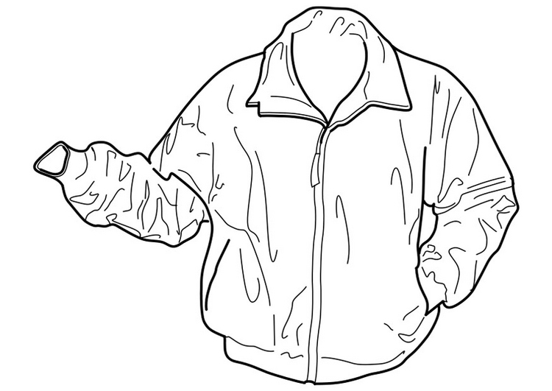

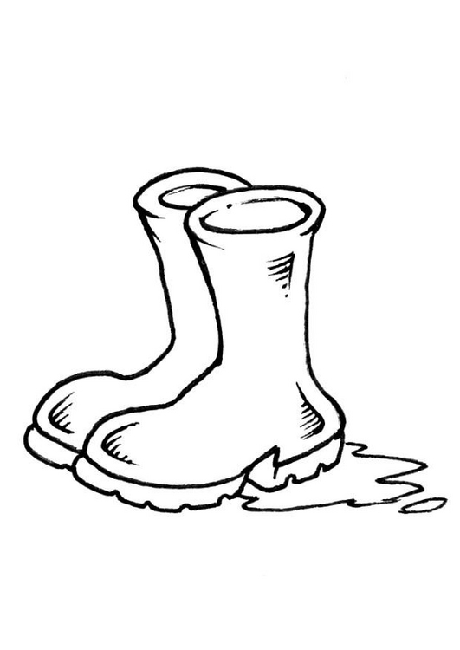

EXERCISE
Make correct sentences using these given words
- Umbrella
- Hat
- Jacket
Get a small word from the big word
- Blanket
- Sweater
- Rain coat
- Hat
- Gumboots
Children will do the exercise on page MK English book 1.

Date | Subject | Class | Time | No. of pupils
THEME : Weather
SUBTHEME : Activities for different seasons
COMPETENCES : Reading the guided composition correctly
: Identifying new vocabulary
: Filling in the correct words
CONTENT : Guided composition about ourfamily
Our Family
We are …………….members in our family. During the …………..weather. We wear gumboots,……………………and ……………….to get wet. In the……………weather, it is always so ……….., we ……………under the………….. to get shade while doing work.
(umbrellas, hot, four, sunny, rainy, sit, rain coats, tree)

Date | Subject | Class | Time | No. of pupils
THEME : Weather
SUBTHEME : Effects and management of weather
COMPETENCES : Read the colour names correctly
: Pronounce and spell them correctly
: Use them with given structures correctly
CONTENT : Colours
black blue white red green
yellow brown
What colour is this?
1. It is a ……………………… sweater.
2. This is a …………………… hat

Read, draw and shade
Yellow socks | Green jacket | Black gumboots

LESSON
Write a short story about “A rainy Day”
Use yes, it is / no, it is not in the given exercise
Date | Subject | Class | Time | No. of pupils
THEME : Accident and safety
SUBTHEME : Things that cause Accidents at home
COMPETENCES : Reading the given vocabulary correctly
: Pronounce the given vocabulary correctly
: Spell the given vocabulary correctly
CONTENT : Vocabulary
pin knife fire razorblade
thorn snake broken bottles
needle safety pin stone
Structure
What is this/that?
This is a _____________

This is a ______________

This is a ______________
Make sentences using these words
- Razorblade
- Knife
- Snake
Jumbled composition
Arrange these sentences to make a good story
  - Like needles, broken bottles, razorblades and pins.
  - Kintu likes playing with sharp things.
  - It cut his finger.
  - One day he picked a razorblade
  - He now fears sharp objects.

Date | Subject | Class | Time | No. of pupils
THEME : Accidents and safety
SUBTHEME : Accidents at home
COMPETENCES : Telling a story about an accident
: Children re-telling the story
: Reading the vocabulary related to accident
: Answering questions correctly
: Vocabulary
burns hurt bites falls cuts near drowning

CONTENT : Structure
- Do not climb trees, you will _____down.
- Do not play with sharp things they will ____you.
- Do not play at the rubbish pit the broken bottles / glasses an ____you.
- Never play with stones, you will _______yourself.
- Do not play in water you will __________
Date | Subject | Class | Time | No. of pupils
THEME : Accidents and safety
SUBTHEME : Accidents and safety at home.
COMPETENCES : Interpret the pictures
: Write sentences related to the theme.
CONTENT : Guided picture composition
What is happening?
1. falls | 2. cuts | 3. near drowning | 4. burns
- The boy is falling off from the tree.
- Mary is cutting herself.
- Kato is drowning.
- The baby is playing with fire.
Use the same pictures to construct sentences
____________________________________________________________________________________________________________________________________________________________________________________________________________________________________________________________

Date | Subject | Class | Time | No. of pupils
THEME : Living together
SUBTHEME : The family
COMPETENCES : Read the given vocabulary
: Spell and pronounce the words correctly
: Answer the given structures
CONTENT : Vocabulary
father , mother, sister, brother, family, extended, nuclear, baby, uncle, aunt, nephew, niece grandfather , grandmother
Who is this / These?

Write the opposites of these words
          - Mother
          - Brother
          - Niece
          - Grandmother
Make sentences using these words
          - Mother
          - Brother
          - Father

Date | Subject | Class | Time | No. of pupils
THEME : Living together
SUBTHEME : Needs of a family
COMPETENCES :
CONTENT : Vocabulary
Shelter, water,, food, medical care, clothes, security, education, money
Make sentences using these words
- Food –
- Foot -

Date | Subject | Class | Time | No. of pupils
THEME : Living together
SUBTHEME : Ways of living together at school
COMPETENCES : Reading the vocabulary about school
: Use them to answer the structure correctly.
CONTENT : Vocabulary
playing sharing caring working
play share care work etc.
Structure

What are they / you doing?
I am playing with a ball.
We are sharing
They are working on the farm
(Pictures to be drawn)

Complete the sentences correctly
- Musa is ___the blackboard (clean)
- Pastor is _____for people (pray)
- We are _______mangoes (share)
- They are _____together (work)
Make sentences using these words
- Playing
- Praying

Date | Subject | Class | Time | No. of pupils
THEME : Living together
SUBTHEME : Working together in a community
COMPETENCES :
CONTENT : Free composition writing
(our family/ my family)

Date | Subject | Class | Time | No. of pupils
THEME : Food and Nutrition
SUBTHEME : Names of common foods
COMPETENCES : Identifying the common foods
: Read the names of foods
: Use and answer the structure correctly
CONTENT : Vocabulary
banana fish eggs cassava yam
beans potatoes Irish potatoes potatoes

Structure
EXERCISE
What food is this / these?
These are
These are

This is a
2. Re-arrange words to make a good sentence.
a) eating cassava and fish . I like
yams in our garden. We have
eats an egg every day. Our baby
Date | Subject | Class | Time | No. of pupils
THEME : Food and Nutrition
SUBTHEME : Names of common foods
COMPETENCES : Identifying the common foods
: Reading food names
: Answering structures correctly
CONTENT : How many ……..are there?
There are ____eggs.
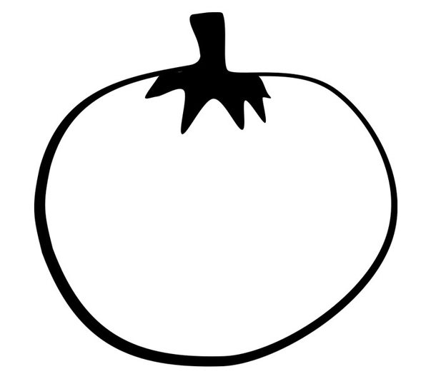
These are _________tomatoes.
There are _____________fish
There are _____________ beans.
Children will do the exercise on __________MK book 1
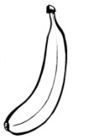
Make correct sentences from the given pictures

Date | Subject | Class | Time | No. of pupils
THEME : Food and Nutrition
SUBTHEME : Names of foods and their sources
COMPETENCES : Reading the words correctly
: Identifying the sources of food.
: Completing the structure correctly
CONTENT : Sources of food
shops market river lakes
gardens farm
Structures
Where do we get ____from?
We get fish from_______.
We get meat from the_____________________.
We buy tomatoes from the ________________
We get milk from the ______________
Arrange these sentences and make a good story
- She carries a hoe and a basket.
- When food is ready
- Mother goes to the garden
- Mother calls us to eat
- She brings cassava and potatoes

Date | Subject | Class | Time | No. of pupils
THEME : Food and nutrition
SUBTHEME : Names of food
COMPETENCES : Reading the words and sentences correctly
CONTENT : Likes and Dislikes.
Structure
Do you like matooke?
Yes, I do. / No, I don’t.
Exercise
Do you like rice?
No,…………………………
Yes,…………………………..
Do you like meat?
Yes,………………………….
No,……………………………
Circle the words from the puzzle and colour
1. yam , rice, meat, eggs, farm, shop,
2. garden, hen
y | b | f | m | e | a | t | K
a | v | z | n | s | t | o | L
m | o | s | y | h | g | m | I
g | v | w | s | o | a | a | S
m | i | l | k | p | r | r | F
x | h | e | n | r | d | k | A
r | i | c | e | n | e | e | R
w | a | r | e | r | n | t | M

Date | Subject | Class | Time | No. of pupils
THEME : Food and Nutrition
SUBTHEME : Uses of food
CONTENT : Guided composition
Food & Nutrition
Guided composition
OUR FARM
My father is a farmer. He does a lot of work on the farm. On the farm I see many animals. The herdsmen cut good grass for the animals.

He gets every day.

My mother looks after ________________________________

Mother grows ____________________

______________and _______________
In her garden. The farm gives us food we eat, we also sell the food from the farm and get money. This money is used for paying our school fees, buying clothes and other family needs.
Lesson: content: free writing
Write a short story about “The Food I like”

P.1COMPREHENSION LESSON NOTES FOR TERM II 2019
Date | Time | Class | Pupils | Subject
 |  |  |  | Comprehension
Theme : Weather
Content :
Elements of weather
- Reading the short passage
- Identify new vocabulary
- Answer questions correctly related to the structures
Mary the Good Girl
Mary is six years old. She goes to Cornerstone Junior School. When it rains, she uses an umbrella and gum boots to go to school. When the weather is windy, she wears a sweater to feel warm. Mary likes playing with a kite when the wind is blowing.
Questions
- What is the story about?
- Which school does Mary go to?
- How old is Mary?
- What does she use when the weather is rainy?
- Draw an umbrella and gum boots

Date | Time | Class | Pupils | Subject
 |  |  |  | Comprehension
Theme : Weather
Content :
Elements of weather
- Read the dialogue correctly
- Pronounce the words correctly
- Act the dialogue and answer the given questions
Dialogue about elements of weather
Wamala : Good morning Duku?
Duku : Good morning Wamala.
Wamala : Why have you come late?
Duku : It has been raining since morning.
Wamala : Why didn’t you use an umbrella
Duku : I did not have any/ one
Wamala : My mother bought for me an umbrella and gum boots last week.
Duku : I will also tell my mother to buy for me too.
Wamala : Bye Bye
Duku : Good bye
Questions
- How many people are talking in the conversation.
- Who are the people in the conversation?
- Who came late?
- Why did Duku come late?
- How many people are in the conversation?
- Mention any three things we use during a rainy day

Date | Time | Class | Pupils | Subject
 |  |  |  | Comprehension
Theme : Weather
Content :
Types of weather
- Read the given poem
- Reads and pronounce the words correctly
- Move according to the rhyme.

Read the poem below and answer the questions that follow
Rainy weather
Rain Rain Rain
Rain gives us water
Water for cooking, bathing, washing and drinking
On a Rainy day,
We put on rain coats,
We also use umbrellas and gumboots
I like rain
By Richard
Questions.
- What is the poem about?
- How many stanzas has the poem?
- What does the rain give us?
- Write the Title of the story?
- Who wrote the poem?
- Give two uses of water.

Date | Time | Class | Pupils | Subject
 |  |  |  | Comprehension
Theme : Accident and Safety
Content : Prevention of accidents at home
Accident and safety at home / school
- Read the poem correctly
- Recite the poem and pronounce the words correctly.
Poem about accident
Accident Accident
We are fed up with you
At home, accidents!
On the way, accidents!
Over speeding, accidents!
Electric wires, accidents!
Oh! Do not take our lives anymore.

By Tom Holland

Questions
- What is the poem about?
- Name any two places where accidents happen?
- What can cause accidents?
- Have you ever had an accident?
- Who wrote the poem?
- How many lines are in the poem?

Date | Time | Class | Pupils | Subject
 |  |  |  | Comprehension
Theme : Living together
Content :
The family members

My Family
My name is Kabega. My father is Mr. Kiwanuka and my mother is Mrs. Kiwanuka. I have two sisters Nakato and Babirye. My sisters are younger than me. They are twins. I have an older brother. My uncle Charles and Aunt Mable are kind.
My sisters sweep the compound and I also go to fetch water from the well.
I love my family so much
Questions
- What is the name of the boy?
- Who are Kabega’s sisters?
- How many sisters does he have?
- What is the name of his uncle?
- What is the name of his auntie?
- Draw Kabega’s family.

Date | Time | Class | Pupils | Subject
 |  |  |  | Comprehension
Theme : Living together
Content :
Ways of living together
- Read the conversation
- Act the conversation

Dialogue about family
Mark : Hullo Mathew
Mathew : Hullo Mark
Mark : How are your family members?
Mathew : They are fine except my little sister Amanda who is sick
Mark : Oh! Sorry, has your mother given her medicine?
Mathew : No, my father has taken her to the hospital
Mark : I wish her quick recovery. Goodbye
Mathew : Good bye too.
Questions
- Who are the people talking in the dialogue?
- Whose sister is sick?
- Was Matthew’s sister given medicine?
- How many people are talking in the dialogue?

Date | Time | Class | Pupils | Subject
 |  |  |  | Comprehension
Theme : Living together
Content : Working together in a community

Date | Time | Class | Pupils | Subject
 |  |  |  | Comprehension
Theme : Food and Nutrition
Content :
Different names of food.
SHOPPING
Items | Quantity | Price
Tamato  Sugar  Cabbage  Mango  Fish | 1  Kg  1  1  1 | 100/=  200/=  300/=  100/=  50/=

Questions
- How much is 1 kg of sugar?
- How much does a tomato cost?
- What is the price of 1 fish?
- How much will Mary pay to buy a mango and 1kg of sugar?
- How much money will Mary pay altogether?
- Which item is expensive?
GRAMMAR REVISION
CONTENT : Use of “is” and “are”
“Is” is used for one object
“Are” is used for many.
Fill in the gaps with is / are correctly.
- This is my teacher.
- The boys are playing football.
- These _______________________girls.
- Those _______________________boys
- David _____________________going to school.
- The teacher ____________________teaching children.
- The cats____________________playing.
- Tom and Sarah ____________________friends.
- Today ______________________Friday.
- It _____________________getting late.

CONTENT : Use of has / have.
Have is used for many.
Has is used for one.
Examples
- He has a bicycle
- They have nice glasses
We He
You have She has
I It
They
EXERCISE
Write has/ have correctly.
- I ____________________________five shillings.
- Birds _________________________two wings.
- You ______________________________my pencil.
- She________________________________ a nice dress.
- He _______________________________ many books.
- We ______________________________ a nice teacher.
- An insect ________________________________ three parts.
- The sky __________dark clouds.
- My mother ____two pineapples.
- Jane __one brother
- My uncle __two cars
- Tom and john __nice flowers
- I __three dresses.
Date | Time | Class | Pupils | Subject
 |  |  |  | Comprehension
Theme : A Dialogue about food
Content :
Ali: Hullo Ryan
Ryan: Hullo Ali
Ali: Did you eat supper?
Ryan: Yes, I did
Ali: What type of food did you eat?
Ryan: I ate rice, fish and potatoes
Ali: What about you?
Ryan: Oh! My dear I ate posho, irish- potatoes, meat and greens
Ali: Ha! Ha! Ha! Won’t you fall sick?
Ryan: No, that is what we call balanced diet
Questions
- How many people are talking in the dialogue?
- What is the dialogue about?
- Give three examples of food mentioned in the dialogue
- Who are the people talking in the dialogue
- Draw these
fish | potatoes | rice | Meat

Date | Time | Class | Pupils | Subject
 |  |  |  | Comprehension
Theme :
Content : a rhyme about occupation

I thought about a teacher
Who teaches pupils at school
I thought about a doctor
Who treats patients in the hospital
I thought about a framer who grows crops and keeps animals
I thought about a carpenter who makes furniture for us
I thought about a driver who drives the school van
Questions
- What is the rhyme about?
- Who teaches pupils at school?
- Where do we go when we are sick?
- Why is a farmer important in the community?
- What is the role of a doctor?
- What do the following people do?
Head teacher: _________________________
Secretary: ____________________________
Librarian: ____________________________
Bursar: _____________________________
Date | Time | Class | Pupils | Subject
 |  |  |  | Comprehension
Theme :
Content : a rhyme about food

Food Food Food
Mummy and daddy are there for us
Daddy buys food and mummy prepares
To look strong, healthy and happy
We need to eat all classes of food
Without food you cannot stand
Questions
- Write the title of the rhyme.
- Who buys food at home?
- _________ cooks food at home.
- What is the story about?
- Give the opposite of the following words
- happy ____________________
- healthy____________________
- stand ____________________
- strong ____________________
- buy ____________________
Date | Time | Class | Pupils | Subject
 |  |  |  | Comprehension
Theme :
Content : a story about the farm

The farm
Mr. Mutale is a farmer. His farm is found at Katalemwa in Wakiso district. On his farm he keeps animals like goats, sheep and cows.
He grows matoke, cassava, sweet potatoes and tomatoes. He serves many markets in Uganda. Mr. Mutale is a rich man.
Questions
- what is the title of the story?
- Who is the owner of the farm?
- In which district do we find Mr. Mutate’s farm?
- Give two examples of food which Mr. Mutale grows on his farm
- Write the opposite of the words below
man __________________
rich ___________________
like ____________________
- Draw Mr. Mukasa digging in the garden

Date | Time | Class | Pupils | Subject
 |  |  |  | Comprehension
Theme :
Content : puzzle

Circle the words given from the puzzle
yam meat market garden farm den
hen shop war knee rice milk
y | b | f | m | E | a | t | K
a | v | z | n | S | t | o | L
m | o | s | y | H | g | m | I
g | v | w | s | O | a | a | S
m | i | l | k | P | r | r | F
x | h | e | n | R | d | k | A
r | i | c | e | N | e | e | R
w | a | r | e | R | n | t | M

COMPOSITION REVISION
Competences : Sentence construction using the given words
- cooking
- praying
- playing
- working
- cleaning
- sweeping
- learning
- singing
- shading

Make sentences using these words
- Cooking 3. Praying
- Playing 4. Learning
Complete these sentences using the word in brackets
- The boys are ………….foot ball.(play)
- Ali is …….the house (clean)
- Mother is…………..food (cook)
- Mary is ……….the compound (sweep)
- The brothers are ……..pictures. (shade)
HOME WORK
CONTENT : Guided picture composition
Every Monday, ___________ Wednesday_______ Friday, I walk to

___________________________________
I go with my __________________________________.

She helps me to cross the ___________________. The road is
busy all the time. There are many _____________________
and many _____________________________.
When I reach school, I sit on the _____________________and I read
my __________________________.

(road , mother , cars , bicycle, chair, books , Thursday, school , Tuesday)
COMPREHENSION HOME WORK
Content: Seasons
There are two types of seasons. The wet season and the dry season.
Farmers grow crops like beans, sweet potatoes and cassava during the wet season.
In the dry season, they harvest the ready crops for eating and selling. They use baskets to carry them from the Gardens to market.
Questions
- How many seasons do we have? ---------------- and -----------------
- In which season do farmers grow crops?
- Write the title of the story.
- What do farmers use to carry ready crops?
- Name two crops mentioned in the story.
PASSAGE
Speeding car
One day while John was going to school on his bicycle, he was knocked down by a speeding car. His leg and hand got broken. He was taken to the hospital for treatment while crying and shading blood.
His bicycle got damaged and had to be taken for repair. The Doctor advised him to always be careful on the road to avoid accidents.
Questions
- Who was going to school?
- What was he riding?
- What knocked him?
- Where was John taken for treatment?
- Why did the Doctor advise John to be careful on the Road?

Dialogue about accidents
Snake bite
Vianney: Good morning Sarah
Sarah : Good morning Vianney
Vianney: Did you hear the news ?
Sarah : Which news?
Vianney: Mary was bitten by a snake.
Sarah : Sorry, that’s why she’s absent!!
Vianney: Yes, but she was taken to the hospital.
Sarah : Where was she when the snake bit her?
Vianney: She was walking on a bushy path.
Sarah : We should avoid dark, bushy places.
Vianney: I do not move at night.
Questions
- Who are the people talking in the dialogue?
- What happened to Mary?
- How many people are taking part in the conversion?
- At what time of the day did the conversation take place?
- What is the title of the story?
Keeping a healthy body
Kato and waswa are brothers. Kato is a small weak boy. Waswa is a healthy boy. He likes doing exercises and goes for games every day.
He eats fruits like oranges, pineapples, lemons and mangoes. Fruits have vitamins which keep him strong and healthy.
Kato is weak because he doesn’t like doing exercises and eating fruits but likes cakes because they are sweet. Kato also needs vitamins to be healthy and strong.
Questions
- What is the title of the story?
- Who are the two brothers?
- Who likes games?
- Who doesn’t like doing exercise?
- Name any two fruits mentioned in the story?

