P.1 READING LESSON NOTES FOR TERM II 2025
Date | Class | Subject | Time | No of pupils

THEME: WEATHER
SUB – THEME: ELEMENTS OF WEATHER
CONTENT: /Oa/ Sound
Boat goal soap loaf oats board moan croak
Roar load loan goat float raincoat oak
Cupboard coat toad road foal coast
Coal roast
Sentences
- My father has many cows and goats.
- He left his coat inside the boat.
- His brother likes roast meat.
- A lion can roar very loudly.
- The goal keeper ate two toasts
- Go to the road and bring the board
- The goat is on the raod.
Exercise
- Listen and write
- Make correct sentences using the words below
- Boat
- Cupboard
- Coat
- Soap
- Goat
- Blend the words below
Coal
Road
Loan
Loaf
- Join and form words

s p 1. ______________________
c oa t 2.______________________
g l 3.______________________
Date | Class | Subject | Time | No of pupils
THEME: WEATHER
SUB – THEME: ELEMENTS OF WEATHER
CONTENT: ACTUAL READING

Date | Class | Subject | Time | No of pupils
THEME : Weather
SUB THEME : Elements and types of weather.
COMPETENCES : Read the vocabulary related to the theme.
: Spell the given vocabulary
: Fill in the missing letters

CONTENT :
sun rainfall wind clouds
sunshine rain blows cover
shine blowing raining covering
shinning sunny rainy windy cloudy

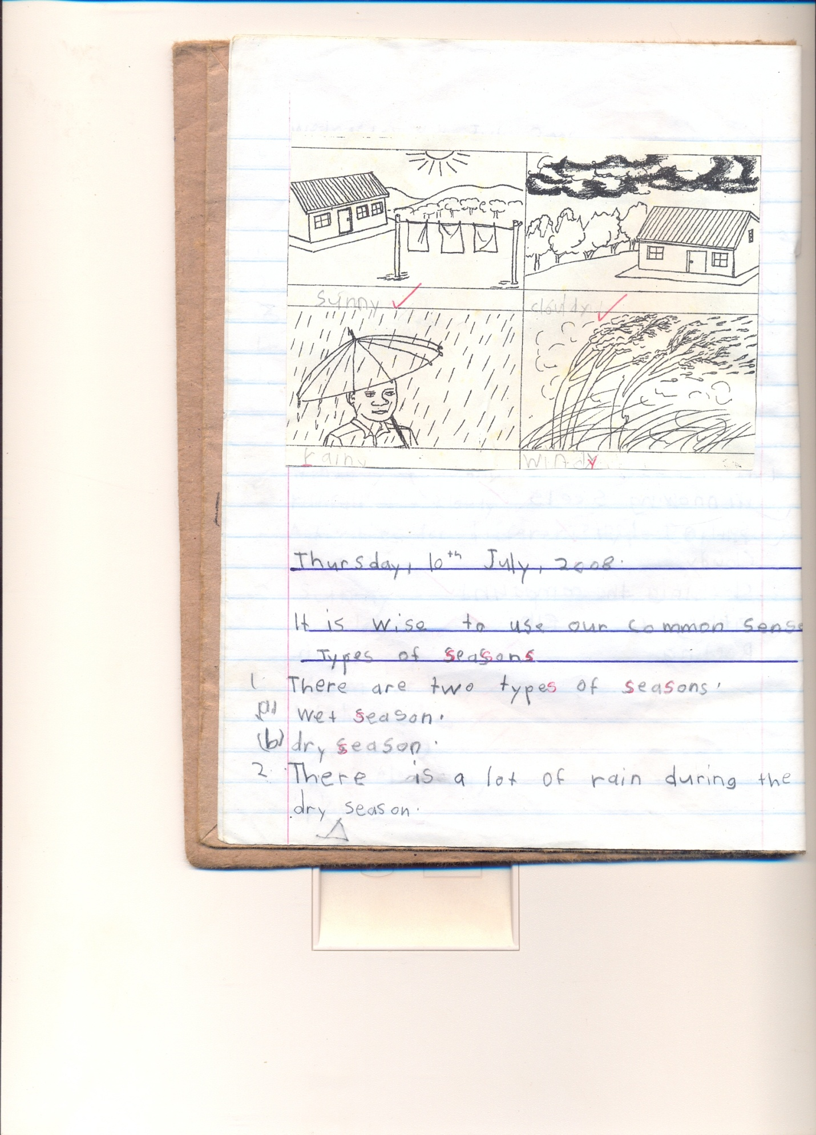
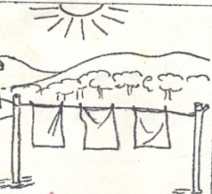
- Name these of weather

_______________
____________ ___________ _______
- Listen and write.

- Fill in the missing letters
su__shine ra__nfall wi__d c__ver

- Read these
The wind is blowing.
sunshine gives us warmth.
Nimbus clouds gives us rainfall.

Date | Class | Subject | Time | No of pupils
THEME : Weather
SUB THEME : Elements and types of weather.
COMPETENCES : Read the vocabulary related to the theme.
: Spell the given vocabulary
: Fill in the missing letters

On Tuesday morning, Joseph was going to school and the clouds were dark in the sky.
The wind started blowing and carried many things up in the sky.
It started raining and Joseph put on his umbrella and went to school.
As Joseph was in class, it started shinning outside.
Questions
- What is the title of the story?
- Write the title of the story
- On which day did Joseph go to school?
- What is the name of the boy in the story
- Where was Joseph going?

Date | Class | Subject | Time | No of pupils
THEME: WEATHER
SUB – THEME: ELEMENTS OF WEATHER
CONTENT: A passage
Elements of weather

Date | Class | Subject | Time | No of pupils
THEME : Weather
SUB THEME : Types of weather
COMPETENCES : Read the given vocabulary correctly
: Spell them correctly.
: Write / Name and draw the elements of weather
CONTENT : Types of weather
sunny cloudy
windy rainy

wind blows / blowing _ windy
clouds cover/ covering _ cloudy
rain raining/ rain _ rainy
sun shines/ shinning _ sunny
Read sentences
- The wind is blowing and brings a windy type of weather.
- Rain gives us water and bring a rainy type of weather
- Clouds are up in the sky and brings us a cloudy weather.
Exercise.
- Fill in the missing letters
s__nny cl__uds ra__ny w__ndy
- Name the types of weather
- Re – write correctly
iwnd_____________ olbw __________ nsu ______

terwa ___________

Date | Class | Subject | Time | No of pupils
THEME: WEATHER
SUB – THEME: ELEMENTS OF WEATHER
CONTENT: ACTUAL READING

Date | Class | Subject | Time | No of pupils
THEME : Weather
SUB THEME : Elements and types of weather
CONTENT : Sound/o – e/
Words
Bone close smoke done home rope hope joke molehill
Spoke tone phone sole broke hole note stone doze
Whole froze nose some stole home made flag pole
Alone broken open cone vote woven
Sentences
- Sam broke his leg.
- I can see some smoke from the chimney.
- Mary has a tone dress.
- The minster has a big nose
- That is my mother’s phone
- The thief stole a broken pole
- We have ropes at home
- The boy stoned his nose
Exercise
- Listen and write
Sentence
- Fill in the missing letters.
b __ne sm __ke n ___se s __me
br __ke d __ne
- Draw pictures for the small
/h/
/tr/
/a/
/st/
- Make correct sentences using these words
water
wind
fire

Date | Class | Subject | Time | No of pupils
THEME: WEATHER
SUB – THEME: ELEMENTS OF WEATHER
CONTENT: A passage
Elements of weather
On Tuesday morning Joseph was going to school and the clouds were dark in the sky.
The wind started blowing and carried many things up in the sky.
It started raining and Joseph put on his umbrella and went to school.
As Joseph was in class, it started shinning out side.

Questions
- What is the title of the passage?
- On which day did Joseph go to school?
- Who is the boy in the story?
- Mention two things we use when it is raining
- Write the title of the passage

Date | Class | Subject | Time | No of pupils
THEME: WEATHER
SUB – THEME: ELEMENTS OF WEATHER
CONTENT: ACTUAL READING

Date | Class | Subject | Time | No of pupils
THEME : Weather
SUB THEME : Elements and types of weather
CONTENT : /oe/ sound
Words with /oe/ sound
hoe toe Joel Joe woe
goes doe foe does
toes poem poetry
mangoes
Sentences
- Tom cut his toe with a hoe.
- Joel goes to school every day
- He likes mangoes
- What is the poem about?
- Joe has mangoes
Exercise
- Listen and write
- Fill in the missing letters
g-es t-es h-e mang-es
- Make sentences using the words below
- Mangoes
- Hoe
- Toes

Date | Class | Subject | Time | No of pupils
THEME: WEATHER
SUB – THEME: ELEMENTS OF WEATHER
CONTENT: ACTUAL READING
Date | Class | Subject | Time | No of pupils
THEME : Weather
SUB THEME : Effects and management of weather
CONTENT : /ow/ sound
Words
blow below crow own cow town drown bowl
elbow arrow fellow follow now flower slow slowest
grow know low show owner pillow sow bow
window snow bow brown fellow glow rain bow lowest
tower vowel reward
Sentences
- The man uses a bow and arrow for hunting.
- Strong wind can blow a roof off.
- Some farmers grow cash crops.
- The small girl followed her sister to school.
- Throw the bowl of rotten eggs away.
- Bring that flower now
- Who owns this pillow?
Exercise
- Fill in/ow/ sound and read
bl __ __n bel __
sh __ wind__
- Join and form words
gr
arr ow
sn
sh
- Listen and write

Date | Class | Subject | Time | No of pupils
THEME: WEATHER
SUB – THEME: ELEMENTS OF WEATHER
CONTENT: ACTUAL READING

Date | Class | Subject | Time | No of pupils
THEME : Weather
SUB THEME : Effects and management of weather
CONTENT : weather
Once upon a time, there lived Mr. Kasasa and his wife. They planned to do some work on the farm. As they were setting to move the clouds covered the sky and it rained heavily for two hours. The wind started blowing and everything was dismantled. They failed to do their work for the whole day.
Questions
- What is the title of the story?
- How many people are in the story?
- Write down the four elements of weather.
- Give two things we use on a rainy day
______________ and _______________
- Draw rain

Date | Class | Subject | Time | No of pupils
THEME : Weather
SUB THEME : Effects and management of weather
CONTENT : /nk/ sound
Words
Inkpot ankle bank blink sank ink kink blank pink
Money donkey sunk tinker thank drink tinkle drank
Wrinkle sink rank monk plunk
Think sunking
Sentences
- There is an inkpot in the bank.
- My grandmother has wrinkles.
- Donkeys and monkeys are animals
- She has a wound on her ankle
- That monkey has wrinkles
- The inkpot is in the bank

Exercise
- Listen and write.
- Read and draw.
- That is my grandmother
- An inkpot is on the table
- The monkey is on the tree
- That is my mother
- Write words with the given syllables
ba
ca
ma
be

Date | Class | Subject | Time | No of pupils
THEME: WEATHER
SUB – THEME: ELEMENTS OF WEATHER
CONTENT: ACTUAL READING

Date | Class | Subject | Time | No of pupils
THEME : Weather
SUB THEME : Effects and management of weather
CONTENT : /mb/ sound
Words
Lamb tomb comb bomber timber number umbrella
Climb dumb limb climber humble assemble member
Climbing thumb plumber climbed bomb symbol assembly
Womb climbing
Sentences
- A lamb is a baby sheep
- My thumb has a bandage
- The man was deaf and dumb.
- We comb our hair every day.
Exercise
- Listen and write
- Fill in the missing letters
T __mb la __b c __mb
Cl __mb b __mb thu __b
- Make sentences using the given words

Thumb
Combing
Climbed
Lamb

Date | Class | Subject | Time | No of pupils
THEME: WEATHER
SUB – THEME: ELEMENTS OF WEATHER

CONTENT: ACTUAL READING

Date | Class | Subject | Time | No of pupils
THEME : Weather
SUB THEME : Effects and management of weather
CONTENT : /mp/ sound
Lamp ramp pump hump example tempt impact impart simple
Jump dump stamp mump complete
Simple compose compare improve
Important import empire empty
Empathy sympathy
Sentences
- Can you jump over that lamp.
- Stamp that letter before you send it
- There are many humps in Mpererwe.
- Compare the two examples
- He dumped a bomb near our house.
Exercise
- Listen and write
- Re – write the words correctly
mpju ____
mpsta ____
mpla____
ainr___
terwa____
nsu ___
Date | Class | Subject | Time | No of pupils
THEME: WEATHER
SUB – THEME: ELEMENTS OF WEATHER
CONTENT: ACTUAL READING

Date | Class | Subject | Time | No of pupils
THEME : Accidents and safety
SUB THEME : Accidents and safety at home
COMPETENCES : Reading the words
: Spell the words correctly
: Constructing sentences
Read these words
Things which can cause accidents
Pin thorns
Knife fire
razorblade
broken glass, needle, sharp, hurt, tall, burn, cat, fall
Sentences
Never play with sharp things
Sarah has stepped on a pin.
The snake has bitten the boy.
Kato has cut himself with a knife.
Exercise
- Fill in the missing letters
snak__ n__edle ti__e kn__fe
r__zorbl__de po__son

- Construct sentences using;-
burn fall cut poison
Date | Class | Subject | Time | No of pupils
THEME : Accidents and safety
SUB THEME : Accidents and safety at home
CONTENT: ACTUAL READING

Date | Class | Subject | Time | No of pupils
THEME : Accidents and safety
SUB THEME : Accidents and safety at home
CONTENT : Reading the passage about accidents
ALI AND HIS FRIENDS
One day, Musa was going to play with his friends and saw a ripe mango on the tree.
He climbed on a branch and it broke.
He fell down and broke his arm.
He was taken to the hospital
Questions
- Write the little of the story
- What happened to Musa?
- Where was he taken after breaking his arm?
- Who treats sick people?
- Draw Musa falling off from the tree

Date | Class | Subject | Time | No of pupils
THEME : Accidents and safety
SUB THEME : Accidents and safety at home
CONTENT: ACTUAL READING

Date | Class | Subject | Time | No of pupils
THEME : Accidents and safety
SUB THEME : Accidents and safety at home
CONTENT : /nt/ sound
Words
enter internal introduction want cent saint went
Interest entire entry tint plant rent elephant
Antelope ant aunt bent pant hunt lent
Anthill Antony mountain blunt burnt
Account amount
Sentences
- That is an antelope.
- My aunt has entered the house
- That book is interesting.
- I can see a mountain
- Give me that amount of money
- The hunter burnt the plant
Exercise
- Listen and write.
- Read and draw
Aunt anthill mountain antelope
- Make sentences
Family
Mountain
Mother
Razorblade

Date | Class | Subject | Time | No of pupils
THEME : Accidents and safety
SUB THEME : Accidents and safety at home
CONTENT: ACTUAL READING
Date | Class | Subject | Time | No of pupils
THEME : Living together
SUB THEME : The family
COMPETENCES : Read the vocabulary related to the theme
FAMILY MEMBERS
Father mother sister brother
grandmother grandfather uncle
aunt nephew baby niece

Construct sentences using the given words
nephew family mother father
- Listen and write
- Fill in the missing letters
f__ther moth__r br__ther s__ster
Date | Class | Subject | Time | No of pupils
THEME : Living together
SUB THEME : The family
COMPETENCES : Read the vocabulary related to the theme
THE FAMILY
My name is Achieng
I have three sisters, Jesca, Jessy and Jacky.
We help our parents to do some domestic work.
My sisters sweep the compound and I go to fetch water from the well.
I love my family.
Questions
- What is the title of the story?
- Who are Achieng’s sisters?
- How many sister does she have?
- Write down the names of Achieng’s sisters
- Draw Achieng carry a bucket of water
Date | Class | Subject | Time | No of pupils
THEME : Living together
SUB THEME : The family
CONTENT : /sl/ sound
Words
Slam sled slit slope slump
Slack slot slush slag slid
Slow slump slang sliver slate
Sleep
Sentences
- Dan has a blue and yellow sled.
- Miracle likes to sleep on the grass.
- Joy has a slit on her skirt.
- Tom is going to slash the compound.
- Let us slope down for community work
Exercise
- Listen and write
- Re – write the words correctly.
Pslee
Slsha
Stil
- Make sentences.
______________________________

_________________________

____________________________

Date | Class | Subject | Time | No of pupils
THEME : Living together
SUB THEME : The family
CONTENT : Actual reading

Date | Class | Subject | Time | No of pupils
THEME : Living together
SUB THEME :
COMPETENCES : Reading the given vocabulary
: Drawing and naming the garden tools
: Reading names of garden tools.
slasher hoe rake
spade basket knife
panga fork wheelbarrow
watering can axe
Exercise
- Listen and write
- Fill in the missing letters
p__nga kn__fe r__ke
ho__ sp__de w__teringc__n
b__sket sl__sher f__rk

Date | Class | Subject | Time | No of pupils
THEME : Living together
SUB THEME : The family
CONTENT : Actual reading

Date | Class | Subject | Time | No of pupils
THEME : Living together
SUB THEME :
CONTENT : /cr/ Sound
1. Identify the letter symbol and tell its name.
2. Introduce the sound with a song/rhyme/ story.
3. Teacher will guide the learners to identify the repeated sound.
4. Teacher will relate the sound to the picture and the picture to the word.
5. Teacher will allow the children to practice the sound and words many times.
Teacher will develop the word family for the sound.

Crack cr cross
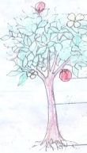
crop
Crested crane
cru | cro | cri | cra | cre
Crush  Cruel  Crucify  Crude  Crusade  crumble | Cross  Crown  Crop  Crow  Crooked  crocodile | Crip  Crime  Crib  Cripple  Cricket  Criminal  crisp | Crack  Craft  Crane  Cram  Crayon  Crash  Crawls  cradle | Cred  Cream  Creep  Create  Screw  Creed  Crested  Crowd  croak
Sentences
1. Jesus was crucified on the cross.
2. A creeping crop is good.
3.God created the crested cane etc.
EXCRISE
- Listen and write
- Read and draw
- Cross
- Crested crane
- Crayon
- Make sentences
Cross
Crack
Craft
cruel
Date | Class | Subject | Time | No of pupils
THEME : Living together
SUB THEME : The family
CONTENT : Actual reading

Date | Class | Subject | Time | No of pupils
THEME : Living together
SUB THEME :
CONTENT : /cl/ sound
Words
Clap class clan cloth clot clan clarify
Clinic close classic client clay cloud clement climate
Clock clever clip clear clump claim climb climax

Sentences
- The boys clapped their hands.
- There is a clock on the table.
- She went to the clinic in the morning
- He is in primary one class.
- The client was clever.
Exercise
- Listen and write
- Fill in the missing letters
Cl __p cl __ss cl __th cl __se
- Make sentences for the pictures
Class
Cloth
Clay
Clinic
Date | Class | Subject | Time | No of pupils
THEME : Living together
SUB THEME : The family
CONTENT : Actual reading

Date | Class | Subject | Time | No of pupils
THEME : Food and Nutrition
SUB THEME : Names and sources of food.
CONTENT : /fr/ sound
Words
Frog front from franc fragile front fridge
France froze frolic fraction fracture fresh fruit
Frisk fritter frantic freedom freeze
Frock frill frit Fredrick
Friends fry free fracture
Sentences
- Franc is from France
- Get those books from franc
- France is a good country
- Fredrick has many friends
- The frog is in front of the cup
Exercise
- Listen and write
- Join to from one word.
Fro – g
Fro – nt
Fro – m
- Blend the words below
Free
Friends
freedom
Date | Class | Subject | Time | No of pupils
THEME : Food and Nutrition
SUB THEME : Names and sources of food.
CONTENT : Actual Reading

Date | Class | Subject | Time | No of pupils
THEME : Food and Nutrition
SUB THEME : Names and sources of food.
CONTENT : /fl/ sound
Words
Flower fly flag flat float flash flamingo flood
Flask flit flock flank flight flour flower florist
Florist flatten flutter flog flow flew
Fled flew fluent flu
Sentences
- They are playing on a flat field
- Our national flag has flowers
- That flask has nice flowers
- The flag is on the flat
Exercise
- Listen and write
- Read and draw
Flower
Flag
Flat
Flask
- Make sentences using the given words.
- Flag
- Flower
- Friend
- Play

Date | Class | Subject | Time | No of pupils
THEME : Food and Nutrition
SUB THEME : Names and sources of food.
CONTENT : actual reading

Date | Class | Subject | Time | No of pupils
THEME : Food and Nutrition
SUB THEME : Names and sources of food.
COMPETENCES : Reading the names of common foods.
: Spell the words given
: Read and draw
Content : Potatoes water banana millet peas
beans groundnuts sim sim

Date | Class | Subject | Time | No of pupils
THEME : Food and Nutrition
SUB THEME : Sources of common foods and places where food is found
Vocabulary to read
garden water/lake market
animal plants shops
Sentences
We buy simsim from the shops.
We grow crops in the garden.
We get fish from the water.
We get meat from animals.

Exercise
Read and draw the sources of food.

Date | Class | Subject | Time | No of pupils
THEME : Food and Nutrition
SUB THEME : Names and sources of food.
CONTENT : actual reading

Date | Class | Subject | Time | No of pupils
THEME : Food and Nutrition
SUB THEME : Uses of food
“Pr” Sound
president prick pray
present price praise
pretty proud primary
practice print prison
present prove pretend print problem
private prepare prison proud press
prey price prefer preach pride profit
Sentences
The president is proud .
Please print properly.
Prossy likes to pray.
I am present sir.
The needle pricked me.
The priest is praying for us.

Exercise
- Listen and write
- Construct sentences using
- Primary
- Pray
- President

- Date | Class | Subject | Time | No of pupils
THEME : Food and Nutrition
SUB THEME : Names and sources of food.
CONTENT : actual reading

Date | Class | Subject | Time | No of pupils

STEPS
i) Identify the letter symbol and tell its name.
ii) Introduce a sound with a song/rhyme/story.
iii) The teacher will guide the learners to identify the repeated sound.
iv) Teacher will relate the sound to the picture and picture to the words.

pl

v) Children will practice the sound and words several times.
Teacher will develop the word family for the sound.
ple | plu | pli | pla | plo
Plead  Plenty  Plain  Place  Play plate  Plane | Plug  Plumber  pludence | Poink | Place  Plant  Plastic  play | Plot  Plural

Sentences
1. The plumber used plastic pipes.
2. Plant those plants in that place.
3. Prudence wants to play with plastic things.
4. Plats are in plenty.
Activity
1. Listen and write.
2. Make sentences using the given words
Play plant place plastic
3. Blend these words.
Plenty plumber plant

Date | Class | Subject | Time | No of pupils
THEME : Food and Nutrition
SUB THEME : Names and sources of food.
CONTENT : Actual reading

Date | Class | Subject | Time | No of pupils
THEME : Food and Nutrition
SUB THEME : Names and sources of food.
CONTENT : A DIALOGUE ABOUT FOOD
Semeo: Hulloa Nadia
Nadia: Hullo Semeo
Semeo: Did you eat supper?
Nadia: Yes, I did
Semeo: What type of food did you eat?
Nadia: Matoke, rice and fish
Semeo: What about you?
Nadia: Oh! My friend very many types of food, bananas, Irish potatoes, peas and meat
Semeo: Ha! Ha! Ha!
Won’t you fall sick?
Nadia: No, that is balanced diet

Questions
- Write the title of the dialogue.
- Who are the two people talking
- Give three types of food mentioned in the dialogue
- How many people are talking in the dialogue?
- What is the opposite of these words below?
Enemy
Many

