P.2 GRAMMAR, COMPOSITION & COMPREHENSION LESSON NOTES FOR TERM II 2025
Date | Time | Class | Pupils
Theme : Our environment
Subtheme : Common animals, birds, insects and plants
Competence :
- Identify animal homes
- Name common animals, birds, insects and plants
- Match animals to their homes
- Read names of homes of animals, insects, birds and plants.
Content : Animal homes
Animals  cow  goat  dog  rabbit  horse/donkey  lion  bird  snail  snake  monkey  chicken  spider  housefly  plant  pig  bee  sheep  parrot | Homes  Kraal/byre  shed  kennel  hutch  stable  den  nest  shell  burrow / hole  trees  run  web  rubbish  garden  sty  bee hive  pen  cage
EXERCISE
- Listen and write
den nest shed
stable kennel web
- Fill in the missing letter
hu __ch h__ve k__aal
mo__key s__ider ho__se
- Match the animals to their homes
snail  bee  horse  plant  pig  rabbit  sheep  hen  lion  spider |  |  | stable  garden  shell  hive  shed  pen  sty  hutch  web  den
Date | Time | Class |  | Pupils
Theme : Our environment
Subtheme : Common animals, birds, insects and plants
Competence :
- Tell the names of the animals, insects, birds and plant young ones.
- Spell the names of the young ones
Content : Young ones
Animals | Young ones
Cow  Pig  Dog  Rabbit  Sheep  Goat  Cat  Horse  Lion / fox / leopard  Elephant  Hare  Frog  Person  fish | Calf  Piglet  Puppy  Bunny  Lamb  Kid  Kitten  Foal  Cub  Calf  Leverate  Tadpole  Baby  fry

Birds | Young ones
Bird  Duck  Hen  Cock  Goose | Nestling  Duckling  Chick / pullet  Cockerel  Gosling

Insects
Cockroach  Housefly  Butterfly  Mosquito | Nymph  Maggot  Caterpillar

EXERCISE
- Listen and write
Lamb Kitten Calf
Kid Puppy Cub
- Fill in the gaps correctly.
- A young goat is a ……………………..
- A young of a dog is ……………………..
- A young one of a cow is …………………..
- A young one of a sheep is …………………
- A young cat is a ……………………………
- A foal is to a ………..as a cub is to a …………….
- A ………….is to a hare as a bunny is to a ……………….
- Fish is to fry as ……..is to duckling.
- ………..is to cub as sheep is to ……………

Date | Time | Class | Pupils
Theme : Our environment
Subtheme : Common animals, birds, insects and plants
Competence :
- Read the names of animal sounds
- Make sentences using the animal sounds
Content : Animal sounds
Animals  cow  cat  sheep / goat  dog  pig  lion  monkey  horse  hyena  mice  frog  snake  hen  duck  goose  turkey  bee  grasshopper  elephant | sounds  lows  mews/purrs  bleats  barks  grunts  roars  chatters  neighs  laughs  squeaks  croaks  hisses  clucks  quacks  cackles  gobbles  hums  chirrs  trumpets
EXERCISE
- Fill in the missing letters
bl__at gru__t r__ar
bar__ m__w c__atter
- Complete correctly.
- A cow moos while a sheep …………………..
- Dogs …………….as pigs grunt
- A lion roars as a monkey …………………..
- Horses ………………..while hyenas laugh

- Match correctly
Duck  Frog  Goat  Snake  Turkey  Bee  Rat | Squeaks  Hums  Gobbles  Hisses  Bleats  Croaks  Quacks

Date | Time | Class | Pupils
Theme : Our environment
Subtheme : Common animals, birds, insects and plants
Competence :
- Mention the animal meat
- Make sentences using the names of the animal meat
Content : Animal meat
cow  hen  sheep  pig  fish  calf  goat | beef  chicken  mutton  pork / bacon  fillet  veal  goat meat
Exercise
- Listen and write
beef mutton pork
bacon fillet chicken
- Complete the sentence
A cow’s meat is …………………..
A pig’s meat is called ………………
A hen’s meat is known as ……………
A fish’s meat is ……………………
A sheep’s meat called …………….
- Beef is to ….as ….is to hen.
- Pork is to pig as fish is to ………..
- Mutton is to sheep as veal is to …………

Date | Time | Class | Pupils
Theme : Our environment Subtheme : Common animals, birds, insects and plants
Competence :
- Explain the term gender
- Give examples of feminine and masculine
- Make sentences used the gender given
Content : Gender
This is a state of being male or female.
Types of gender
- Masculine means male
- Feminine means female

Gender according to animals
Masculine | Feminine
Bull  Dog  Lion  Boar  Buck  Horse  Ram  Drake  Drone  Cock  bullock  gander | Cow  Bitch  Lioness  Sow (pigs)  Doe (rabbits)  Mare  Ewe (sheep)  Duck  queen  hen  heifer  goose
EXERCISE
- Match masculine to feminine
lion  boar  horse  drone  drake  cock  bull  ram | ewe  cow  hen  duck  queen  mare  sow  lioness

- Complete the sentences by giving the masculine of the underlined words.
- The lioness is moving with a ………………….
- The hen spend a lot of time with the…………………
- The ewe was fighting the……………………….
- The bitch barked at the ………………….
- The duck and the …………….flew up the roof.

- Write the opposites of the underlined words
- Mugisha’sduck ate my ground nuts
- I saw a lion in the den.
- My cock is very big
- Kintu slaughtered a ram
- That dog barks loudly every night.
Date | Time | Class | Pupils
Theme : Our environment
Subtheme : Common animals
Competence :
- Give the gender of people
- Make sentences
Content : Gender according to people
Masculine | Feminine
father  uncle  son  man  brother  husband  head master  sir  master  nephew  lord  waiter  widower  mayor  bridegroom  priest  poet  king  Mr.  boy  gentleman  landlord | mother  aunt  daughter  woman  sister  wife  headmistress  madam  mistress  niece  lady  waitress  widow  mayoress  bride  priestess  poetess  queen  Mrs.  girl  lady  land lady
Exercise
Feminine | Masculine
Aunt | ………………………………..
………………………………. | Mother
Woman | ………………………………..
……………………………….. | Nephew
Bride | ………………………………..
2. Re-write the sentences giving the masculine of the underlined word.
- My daughter is sick
- I am going to see the mayoress
- His sister died
- My wife loves me.
- The headmistress is smart
- The waitress served the drink.
Give the opposite of the underlined words
- The bride is smartly dressed
- This gentleman is very shabby
- Mr. Kintu’sson wedded last Saturday
- My nephew visited me yesterday
- The king went to London

Date | Time | Class | Pupils
Theme : Our environment
Subtheme : Occupation
Competence :
People and their work
Teacher teaches pupils
Doctor treats patients
Nurse cares for the sick
Potter makes things out of clay
Pilot flies aeroplanes
Driver drives cars
Carpenter makes furniture
Shop keeper sells things in a shop
Barber cuts peoples hair
Cobbler mends shoes
Farmer grows crops
Black smith makes things out of iron.
Tailor/ seamstress sows clothes
People and their workplaces
Teacher school
Barber salon
Potter swamp
Carpenter work shop
Pilot airport
Farmer garden
Doctor/ nurse hospital
Shopkeeper shop
Lawyer court
Fisherman Lake

Exercise
- Match people to their work
shopkeeper  pilot  teacher  carpenter  potter  nurse | makes things out of clay  makes furniture  cares for sick people  sells things in a shop flies aeroplane  teaches pupils

Date | Time | Class | Pupils
Theme : Our environment
Subtheme : Alphabetical order
Alphabetical letters are twenty six in number.
Arrange these words in Abc order
Letters of alphabet
a b c d e f g h i j k l m n o p q r s t u v w x y z
examples
- e, c, b, d, a
a, b, c, d, e
- elephant, box, ant, cow, dog
ant, box, cow, dog, elephant
- lemon, orange, apple, mango, paw paw
apple, lemon, mango, orange, pawpaw
Exercise
Arrange the words in ABC order.
- piglet, kitten, cub, foal.
- elephant, cow sheep, buffalo
- doll, ball , kite, rope.
- doctor, oculist, cobbler, pilot.
- Ferry, bicycle, ship, aeroplane.
- Kakhi . Cream., grey, maroon.
- rope  - stone  - teacher  - chair | ball  ball  doctor  bag | mat  pencil  nurse  girl | basket  table  potter  boy

Lesson 2
Arrange words following the second letter.
Examples
- book bench ball black
ball bench blade book
- cat cot crame clap
cat clap cot crame
Exercise
Words with the same slanting letters
ball boy bull big
mother mat meat mill
play pray pack pull
town tall tree tin

Date | Time | Class | Pupils
Theme : Our environment
Subtheme :
Competence :
- Explain the meaning of the word homophone
- Give example of homophones

Content : Homophones
These are words with the same pronunciation but different meaning and spelling.
Examples
Sheep  Meat  Sun  Our  New  Week  Here  Buy Piece  Sick  been | - Ship  - Meet  - Son  - Hour  - Knew  - Weak  - Hear  - By - bye  - Peace  - Seek  - bean | There  Too  Four  Steal  Bad  Eat  Know  Dear  One  Seat  dear | - Their -  - Two - to  - For  - Still - steel  - Bird - bud  - It  - No  - Deer  - Won  - Sit etc  - deer

Exercise
Use these words in sentences to show that you understand their meanings.
- a) cut
b) cat
- a) bean
b) been
- a) cat
b) it
Choose a suitable word to fill in the gap.
- His……………….is two now. (son , sun)
- We shall start school next ………….(weak, week)
- A …………..is an animal (bare, bear)
- The ……….is sailing on the lake (sheep, ship)
- Daddy bought a ……………….car (knew , new)
- I shall go …………bus to Nairobi (but, by)
- He is ……….tired to play. (too, to)
- Please, bring me a …………..of chalk (peace, piece)

Date | Time | Class | Pupils
Theme : Things we make
Subtheme : Play materials and things we use at home
Competence :
- Join sentences using conjunction but.
- Read the sentences with who
Content : (“……..who ……….”)
Join sentences using ……..“who”…….
- This is a man. He mad a basket.
This is the man who made a basket
- John is a boy. He broke my pencil
John is a boy who broke my pencil
Exercise
Join using ………. Who ………
- Here is the teacher. He teaches us English.
- That is the woman. She stole the puppy.
- These are the girls. They made wonderful baskets.
- That is the cobbler. He mended my shoes.
- That is the woman. She wove a basket.
- These are the dentists. They removed the teeth.
- Those are the carpenters. They repaired our tables.

Date | Time | Class | Pupils
Theme : Things we make
Subtheme : Play materials and things we use at home
Competence :
- Join sentences using conjunction but.
- Read the sentences with but
Content : (“……..too……….”)
Examples
Join these sentences using”……….too………”
- Grace is very young. She cannot go school.
Grace is too young to go to school.
- James is very short. He cannot clean the chalkboard
James is too short to clean the chalk board.
Exercise
- Julian is very young. She cannot marry.
- The pilot is very sick. He cannot fly the aeroplane.
- The teacher is very tired. She cannot mark our books.
- She is very sick. She cannot come to school.
- The basket weaver is very weak. She cannot carry the basket.
- The butcher is very old. He cannot go to the butcher’s

Date | Time | Class | Pupils
Theme : Things we make
Subtheme : Materials for playing
Competence :
- Define compound words
- Give examples of compound words
- Write compound words
Content : Compound words
These are words which are made of more than one word to make one word.
Examples of compound words
Cup and board  Table and mat  School and girl  Rain and bow  Tea and pot  Flower and pot  Gentle and man  Gate and keeper  Police and man  Home and work  Staff and room  Bath and room  Bath and tub  Tea and spoon  Tooth and paste  shoe and string | - Cupboard  - Tablemat  - Schoolgirl  - Rainbow  - Teapot  - Flowerpot  - Gentleman  - Gatekeeper  - Policeman
Exercise
Join these words to form a compound word.
- Sun and light
- Play and ground
- Bed and room
- Arm and chair
- Hand and ball
- Water and jug
- Tooth and paste
- Soap and dish
- Hand and writing
Make small words from a big word.

- Cupboard
- Blackboard
- Policeman
- Armchair
- Eggplant
- Classroom
- Toothpaste
- Bedroom
- Toothbrush
- Sunlight

Date | Time | Class | Pupils
Theme : Transport in the community
Subtheme : Means of transport
Competence :
- Explain past tenses
- Use verbs in past tenses correctly
Content : verbs and their tenses
A verb is a doing word.

Present continuous tense (Now tense)
This tense talks about activities that are going on.
is , are, am, are used as helping verbs
Examples
- Musa is going to school
- She is praying for the sick
Exercise
Use the correct form of the word given in brackets.

- They are _________ football. (play)
- The teacher is __________ on the black board. (write)
- I am ___________ the house. (mop)
- My grandmother is ___________ in the garden. (dig)
- The policeman is _________ a gun. (hold)
Date | Time | Class | Pupils
Theme : Transport in our community
Subtheme : Means of transport
Competence :
- Define present perfect tense
- Give verbs in present perfect tense
- Use verbs in present perfect in sentences
- Use has and have
Content :
Present perfect tense
This is a tense which t6alks about activities which have already happened.
We use has and have
She
He Use “has”
It

Examples
- Jane has gone to town
- Ali has mopped the house
- The cow has eaten the potato vines
They
We
You Use “have”
I
Examples
- The boys have stolen the mangoes
- I have drunk all the juice
- I have done my work
Table of irregular verbs
Verbs has / have
eat has eaten/ have eaten
write has written/ have written
take
beat
sing
drink
break
do
give
go e.t.c.
Exercise
Fill in with has or have
- Jane has gone to the market
- I ………..eaten enough food today.
- She …………..done her work well.
- They ……………tsaken all the children for swimming.
- Jacob ……………stolen Mummy’s money.
- You ……………….drunk all the milk.
- Anna ……………….broken the bottle.
- Who ……………………has given me this cake?
- ………………….he woken up?
- Past Bugembe ………..sung a nice song.
Complete the sentences with the correct verb tense
- Ben has ___all the books. (take)
- She has ___me a new doll. (give)
- Mummy and daddy have ___to town. (go)
- I have ___my homework already. (do)
- Opio has a ___a dirty shirt. (wear)

Date | Time | Class | Pupils
Theme : Accidents and safety
Subtheme : safety
Competence :
- Explain the meaning of the future tense
- Give another name of the future tense
- Give examples sentences in the future
Content : Future simple tense
he I
she will we shall
it
they
you
Tomorrow tense
We usually use (will) for the pronouns or nouns eg. he, she, they, you, it and other (shall) for I and we.

Exercise
Write will or shall to complete the sentences.
- She ……………….visit us next Sunday.
- We ……………go to the village party.
- Mother ……….care for the baby
- I ……………sit at the front seat.
- They ……………..take him to prison
- Their parent …………….report the case to court.
- I ………………dance for the visitors.
- The priest ………………lead the service.
- We …………help our parents in the holidays
- The Sheikh ……………………chair the meeting.

P.2 COMPOSITION LESSON NOTES FOR TERM II 2024
Date | Class | No. of pupils | Time
THEME : Our Environment
SUBTHEME : Vocabulary composition
Common animals
COMPOSITION: Read the vocabulary
Spell the words
Use the words to make sentences
Read and draw
CONTENT : Vocabulary
cow lion camel
goat snake fox
sheep rhino elephant
pig horse crocodile
rabbit donkey tiger
cat hyena hare
deer buffalo antelope
monkey giraffe tortoise
hippopotamus
Number names
11- 15

11- eleven
12 – twelve
13 – thirteen
14- fourteen
15 – fifteen

Exercise
- Fill in the missing letter.
go__t rab__it le__pard
do__key ele__phant b__ffalo

- Make sentences using these words.
Sheep Lion
Ship Monkey
Pig
- Read and draw.
Crocodile | Rabbit | Monkey
Giraffe | Cow | Goat

Date | Class | No. of pupils | Time
THEME : Our Environment
SUBTHEME : Vocabulary composition
Common animals
COMPOSITION: Read the vocabulary
Spell the words
Use the words to make sentences
Read and draw
CONTENT : structures
Lesson 2
What is this/ that?
Example
This is a crocodile.
That is a goat.

Exercise
What is this / that?
__________________
________________
__________________

Date | Class | No. of pupils | Time
THEME : Our Environment
SUBTHEME : Common birds
COMPOSITION: Read the vocabulary
Spell the vocabulary
Use the vocabulary to make sentences
CONTENT : Vocabulary
hen eagle ostrich
duck hawk weaver bird
turkey owl crested crane
pigeon parrot peacock
kite dove
Exercise
- Listen and write.
- Fill in the missing letters.
h ___n e ___gle d ____ve tu____k ____y
- Write the following words in capital letters
hawk ____________________
ostrich __________________
owl ____________________
- Construct meaningful sentences using the words below
duck: ______________________________
dark: ______________________________
bird: _______________________________
bad: _______________________________
- Arrange the following words in a,b,c order.
  - Eagle, ostrich, hawk, duck
  - Pigeon, peacock, parrot
  - Weaverbird, turkey, hen, owl
- Make small words from the big word
Ostrich: _______________________
Peacock: _______________________
Pigeon: ________________________
What are these/ those?
Example
These are hens

Exercise
- What are these/ those?

________________________________

________________________________

________________________________

________________________________

Date | Class | No. of pupils | Time
THEME : Our Environment
SUBTHEME : Common birds
COMPOSITION: Fill in the gaps given
Complete the composition
Read the composition
CONTENT : Guided composition
Read these words below and use them to fill in the gaps in the composition.
Domestic, wild , eggs , meat , home , bush , turkey , kite , eagle ,biggest , natural,
Dangerous
Exercise
We have ________and ___________ birds in our environment. The domestic birds are the ones which live at ____________ with people while wild birds live in the ________________.
Domestic birds include hens, _______, pigeons, parrots and ducks.
Wild birds are dangerous to us. Some of them are ____________ which eat our chicks. The weaver birds eat millet and maize in gardens. The ___________flies high in the sky. The ostriches the _____bird in the world.
Birds are a ________________beauty to the environment.

Date | Class | No. of pupils | Time
THEME : Our Environment
SUBTHEME : Common insects
COMPOSITION: Read the vocabulary
Spell the vocabulary
Construct sentences using the vocabulary
CONTENT : Vocabulary
grasshopper bee mosquito
cockroach wasp butterfly
bedbug flea termite
tsetse fly tick white ant
housefly spider safari ants
Exercise
- Write the following words correctly.
-qmosuito -tetimer
-ckcoroach -psider
-ttsesefly -psaw

- Make correct short sentences using each of the word.
- Aunt:
- Ant:
- Make small words from the big word.
- bedbug
- grasshopper
- housefly
- Give the plural form of the words.
- fled
- housefly
- cockroach
Date | Class | No. of pupils | Time
THEME : Our Environment
SUBTHEME : Common insects
COMPOSITION: Read the jumbled sentences
Rearrange the sentences.
Write the rearranged sentences.
CONTENT : Jumbled composition
Read the sentences and re-arrange them to make a good story.
- James got twenty thousand shillings.
- He caught many grasshoppers.
- James woke up at night.
- He dried them under the sun.
- James put the grasshoppers in the bucket and took them for sale.
- He fried them and put salt.
Catching grass hoppers
Date | Class | No. of pupils | Time
THEME : Our Environment
SUBTHEME : Common plants
COMPOSITION: Read the words
Spell the words
Use the words in sentences
CONTENT : Vocabulary
maize mango guava
beans grass jackfruit
millet orange ovacado
banana pineapple aloevera
sorghum flower mululuza
pawpaw leaves molinga
exercise
- . fill in the missing letters
ma__ze av___cado sorgh___m j__ckfruit pa__p__w
Read and draw.
bananas
mangoes
pineapple
Exercise
- Construct correct sentences using the words given.
beans orange -grass -
-leaf -flowers -avacado
-bananas aloevera
Date | Class | No. of pupils | Time
THEME : Our environment
SUBTHEME : Common plants
COMPOSITION: Study the picture
: Tell what is happening in the picture.
: Write about the pictures
CONTENT : Vocabulary in picture composition
planting weeding harvesting
cooking peeling eating
Study the picture and write what is happening.
Planting | Weeding | Harvesting
1 | 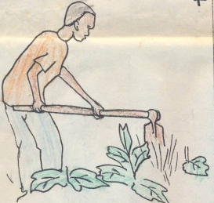  2 | 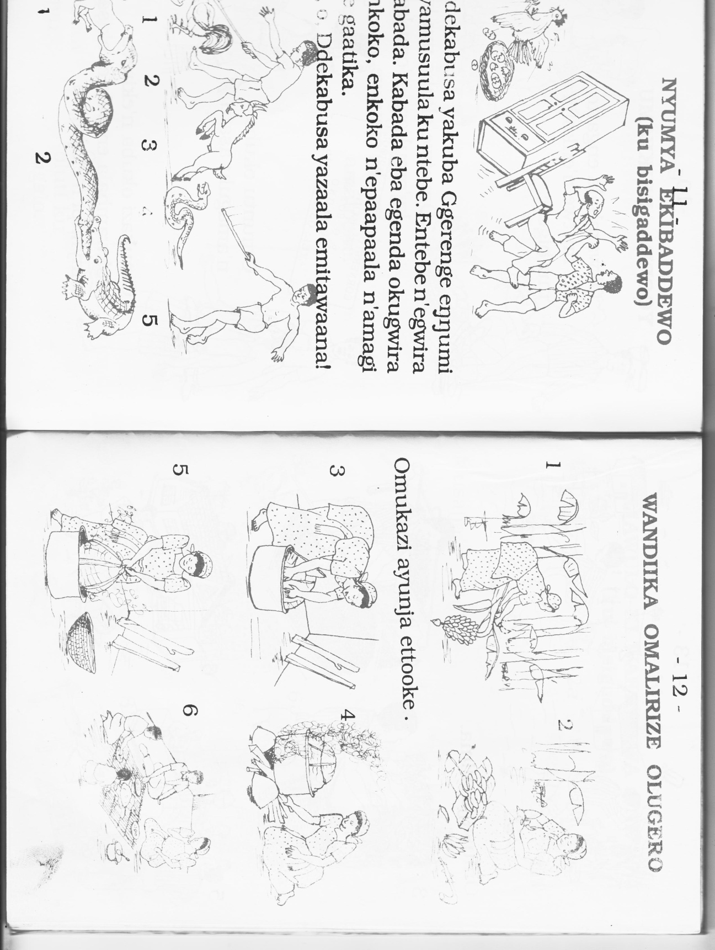  3
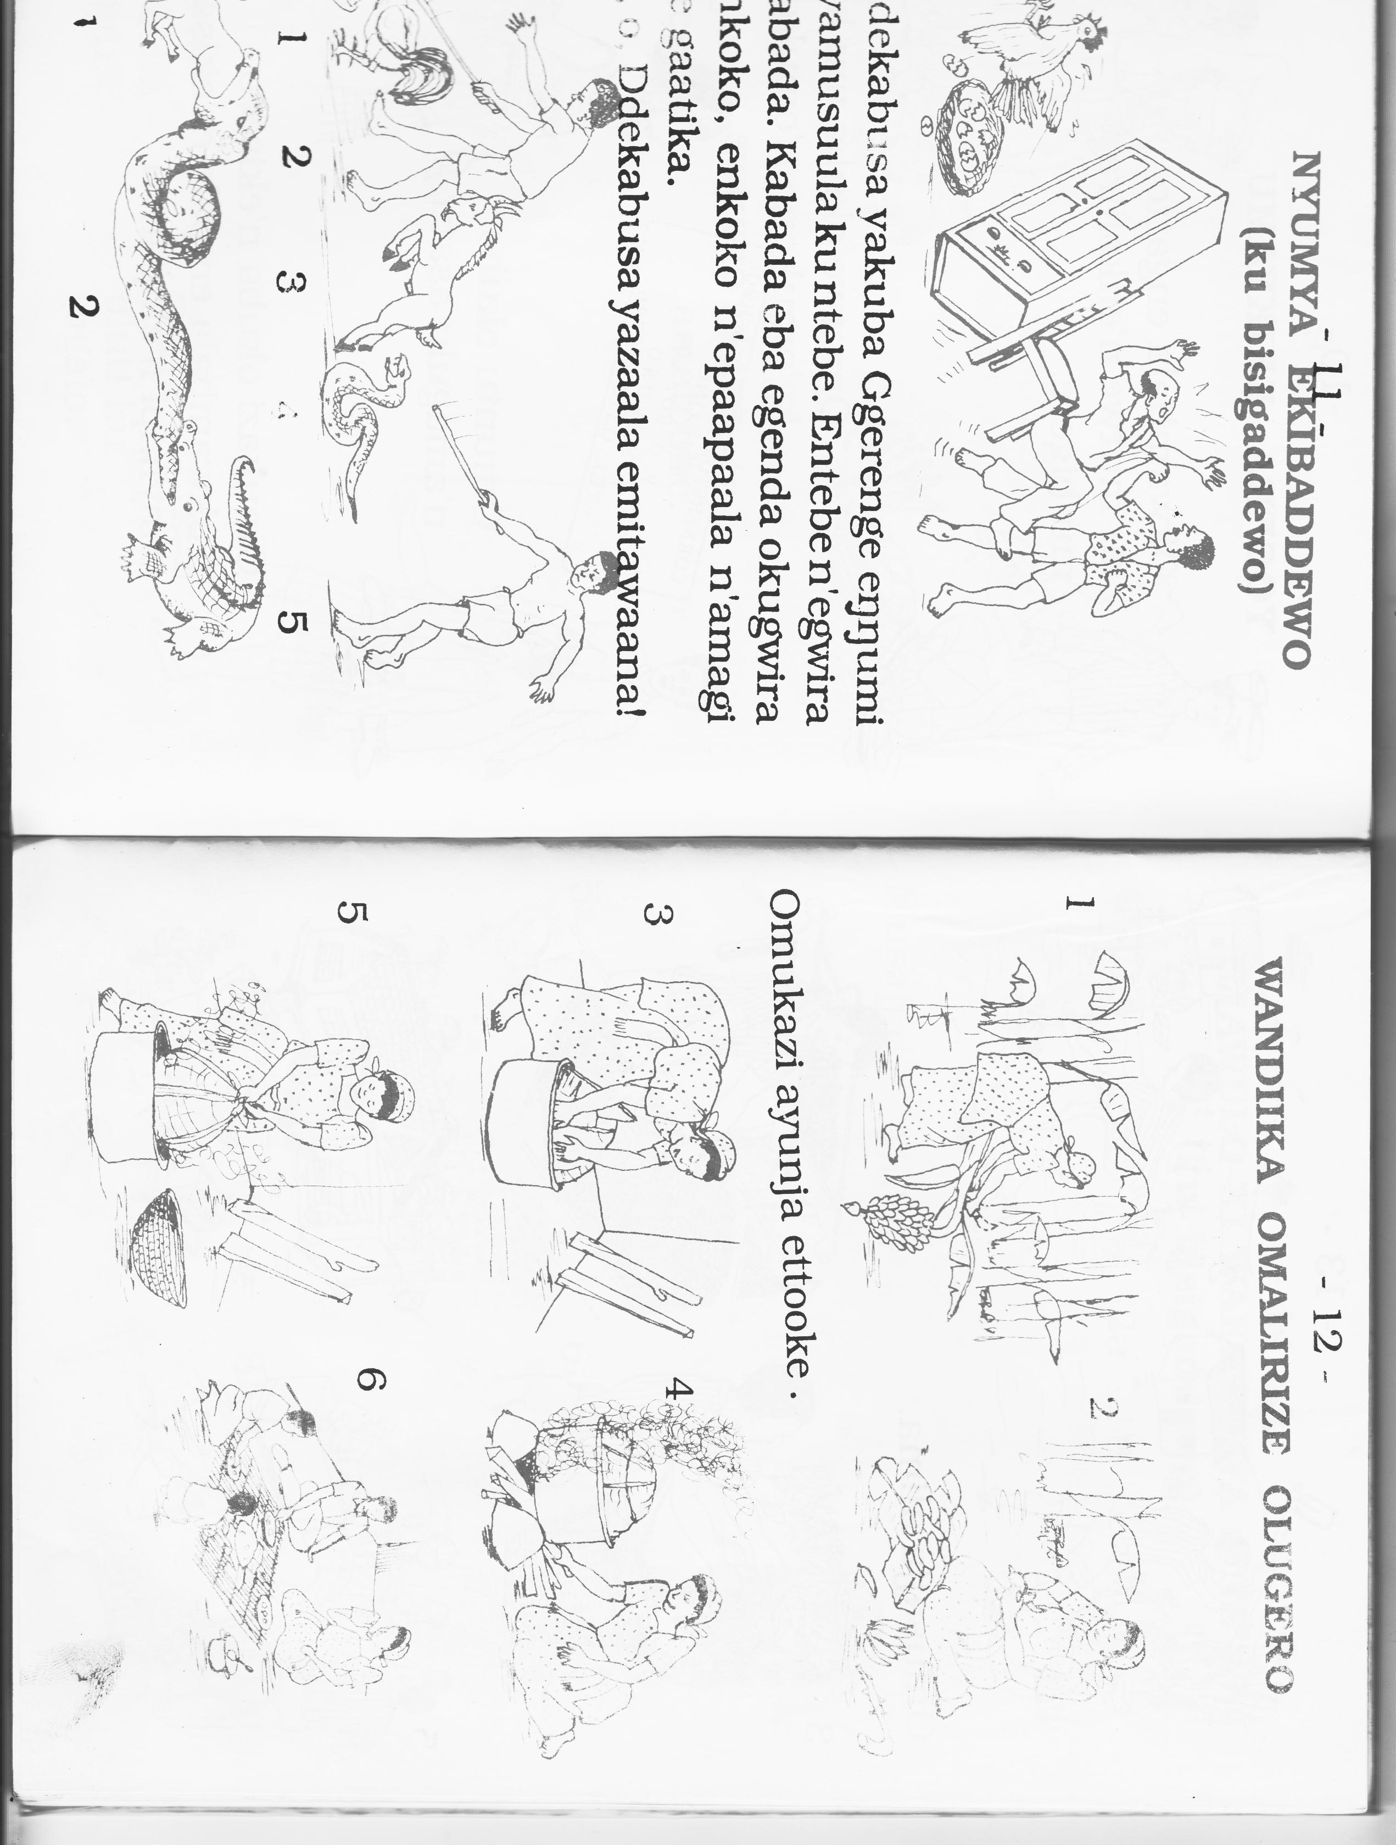  Peeling | Cooking | Eating
4 | 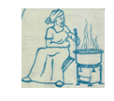  5 | 6

Picture 1 Picture 4
Picture 2 Picture 5
Picture 3 Picture 6
Date | Class | No. of pupils | Time
THEME : Things we make
SUBTHEME : Play materials
COMPOSITION: Read the vocabulary
: Spell the vocabulary
: Use the vocabulary in sentences
: Read and draw
CONTENT : Vocabulary
doll ball rope
mat stove cushion
pot mortar pestle
bed mingling stick ladle
chair stool table
winnower table cloth cup
Exercise
- Listen and write
doll mat table
stool mortar winnower
ladle stove rope

- Where are these __________?
Lesson II
Where is the __________?
How many ropes are there?
There are ______________

Where are the ropes?

How many ladles are there? _____________________________________
There are __________________

Where are the balls?
_____________________________________________
Where is the …………………….?
How many mats are there?
There are _____________

How many charcoal stoves are there? Where is the mingling stick
They are _______________________ __________________________________
where is the stool
_________________________________

_________________________________________
How many pots are there?
There are ____________________

How many stools are there?
There are _____________
Where is the pot?
__________________________________________

Date | Class | No. of pupils | Time
THEME : Things we make
SUBTHEME : Materials used to make things and their sources
COMPOSITION: Read the word
: Spell the word
: Make sentences using the words

CONTENT : Vocabulary
sisal raffia banana fibre
clay grass thread
needle sticks straws
palm leaves swamps papyrus
reeds
Make correct sentences using these words
- Sisal
- Straws
- Grass
Fill in the missing letters
- n__ __dle r__ __ds papa__rus, str__ws
Arrange letters to make correct words.
- Swaspm _________
- Ylac ____________
- Thdrea____________

Structure lesson 2
- What do we use to make_____?
- Where do we get _____?
Exercise
- What do we use for making
- ropes ; we use sisal for making ropes
- mats : we use banana fibres for making mats
- mortar : ________________________________
- pots____________________________________
- brooms __________________________________
- table clothes ______________________________

- Where do we get the following?
- clay ____________________________________________________
- raffia ___________________________________________________
- sisal ____________________________________________________
- palm leaves __________________________________________________

Date | Class | No. of pupils | Time
THEME : Transport in our community
SUBTHEME : Means of transport
COMPOSITION: Read the vocabulary
: Spell the vocabulary
: Use words in sentences
CONTENT : Vocabulary
road bicycle bus
boat taxi wheel barrow
aeroplane cart pick-up
horse lorry donkey
truck train tractor
camel motorcycle ship
ferry canoe
exercise
Give the plural of these words.
Taxi ______ bus _________ road __________ canoe_________
Ferry _______ ship _________
Exercise
Write correct sentences using these words

- sheep
- bicycle
- taxi
- lorry
- ship

Date | Class | No. of pupils | Time
THEME : Transport in our community
SUBTHEME : Means of transport
COMPOSITION: Read the words
: Spell the words
: Use words in sentences
CONTENT : Vocabulary
buss top railway line bus park
taxi park stage airport
lake river parking yard
Washing bay garage shell
railway station
Exercise
Form a small word from a big word.
bus park _____________ railway line ______________
aeroplane ____________ garage _________________
fill in the missing letters.
R___ver lak______ sh__ll ` st___ge
Construct correct sentences using the given words
- frying ______________________ 2). Driving ______________
lesson 2
Examples
Where is the bus?
The bus is at the bus stop.
Where is the taxi?
The taxi is at the stage .
Where is the boat?
The boat is at the river.

Exercise
- Where is the train?
- Where is the aeroplane
- Where is the lorry?
- Where is the bicycle?
- Where is the canoe?
- Where is the truck?
- Where is the ship?

Date | Class | No. of pupils | Time
THEME : Transport in our community
SUBTHEME : People in transport
COMPOSITION: Read the vocabulary
: Spell the vocabulary
: Use the vocabulary in sentences
CONTENT : Vocabulary
driver pilot pedestrian
passenger cyclist traffic police
broker sailor lollipop
captian conductor sailor
mechanic turn-boy
Exercise
- Fill in the missing letters
Con__uctor capta __n m __chan__c p__lo___
Loll__po ___
- Make sentences using those words.
Sailon
Pilot
Cyclist
Captain
- Form small word from one word
- Sailor
- Police
Lesson 2
Structure
Who ____________ a__________/ an______________?
Example s
- Who drives a lorry?
A driver drives a lorry.
- Who flies an aeroplane?
A pilot flies an aeroplane.
- Who repairs vehicles?
A mechanic repairs vehicles
Exercise
- Who collects money in a bus?
- Who directs passengers on the taxis? (tax + out)
- Who ensures safety on the road?
- Who helps children to cross busy roads?
- Who moves on foot on the road?
- Who cycles a motorcycle?
- Who collects money from passengers in a taxi?

Date | Class | No. of pupils | Time
THEME : Transport in our community
SUBTHEME : Action words in transport.
COMPOSITION: Read the action words
: Spell the action words
: Use the action words correctly.
CONTENT : Action words
driving rowing
cycling sailing
operating moving
riding pushing
fuelling hooting
travelling stopping
oar washing
parking flying
Fill in the space using the correct words.
- Musa is _______a lorry.
- The fisherman is ________________on water
- Robert is ____________his sport’s bicycle.
- He is at the shell____the car.
- The man is _______the boat with an oar.
- The pilots are _____helicopters
- We shall be _______to the village tomorrow.
- Juma is _________a wheelbarrow.
- The ship is ______on the river.
- He is ____________his Toyota car at the bay.

Date | Class | No. of pupils | Time
THEME : Transport in our community
SUBTHEME : Means of transport
COMPOSITION: Read the jumbled sentences
: Re-arrange the sentences
CONTENT : Jumbled composition
Read and re-arrange these sentences to make a good story.
- He alarmed and he was taken to the clinic.
- He used a nearby path.
- Mugulu was walking to school.
- As he was moving, something bit him.
- When he checked, he was bleeding.
- He looked around and saw a snake.
Date | Class | No. of pupils | Time
THEME : Accidents and safety
SUBTHEME : Dangerous things on the road
COMPOSITION: Read the vocabulary
: Spell the vocabulary
: Make sentences using the vocabulary
CONTENT : Vocabulary
bandage ambulance
needle safety pin
cold pad razor blade
spirit plaster
tablet wheelchair
basin cotton wool
first aid pain killer
Exercise
- Fill in the missing letters.
b__sin n__ ___dle t__bl__t
- Read and draw.
Safey pin razorblade ambulance
- Get a small word from the big word.
Wheel chair _______ razorblade __________
Bandage __________

Structure
What is this?
This is a _______/an_______________

________________________________
P
500 ________________________________

________________________________

________________________________
Ambulance
________________________________
________________________________

________________________________
1 2 3 4
_________________________________

________________________________

Date | Class | No. of pupils | Time
THEME : Accident and safety
SUBTHEME : Causes of accidents in our community
COMPOSITION: Make sentences from the substitution table
CONTENT : Substitution table
Make correct sentences from the table below.
John  It  They  The children  Mummy  She | has  have | taken poison  cut his fingers  fallen off a tree  blood on the leg  a bottle of medicine  gone to the clinic
- John has gone to the clinic.
- ______________________________
- ______________________________
- _____________________________
- ______________________________
- ______________________________

P.2 COMPREHENSION LESSON NOTES FOR TERM II 2019
Date | Class | No. of pupils | Time
THEME : Our environment
SUBTHEME : Common animals
COMPETENCES : Read the poem
: Answer question about the poem
CONTENT : A story
Read the poem and answer the questions about it in full sentences.
Biira village
Last holiday, Musa went to his home in Birra village. Biira village is found in Mityana District. Musa went to visit his grandmother, Nakate. On his way, Musa saw interesting things like mountains, lakes, rivers and forests. He reached his grandmother’s home at 5:00pm.
The next day, Musa woke up early because he wanted to see different things at his ground mother’s home. He saw tall trees in the compound and in the garden. The wild birds were flying around and some were sitting on the tall trees. Musa’s grandmother had two houses.
The small one was for her hens. She also keeps cows, goats and sheep at her home.
In the afternoon, Musa moved around the village. He saw many people who were hardworking. They had very big gardens with healthy crops. Fruits like papaws, oranges, pineapples and mangoes were very many. Musa enjoyed eating fruits in the two weeks he spent in the village. Questions
- What is the title of the village?
- Who is the boy in the passage?
- In which district is Biira village?
- Why Musa did woke up early the next day?
- At what time did Musa reach his grandmother’s home?
- Where were the birds sitting?
- Give the opposite of the word hard working
- What is the name of Musa’s grandmother?
- How many houses does Musa’s grandmother have?
- A part from cows, which other animal did Musa’s grandmother keep at her home?
- How many weeks did Musa spend in the village?
Date | Class | No. of pupils | Time
THEME : Our environment
SUBTHEME : Common insect
COMPETENCES : Read the passage
: Answer the questions about the passage
CONTENT : A passage

Read the passage and answer the questions in full sentences
Harmful insects
There are many harmful insects in our environment. These include wasps and bees which sting. Houseflies which spread diseases like cholera, diarrhoea and trachoma.
Cockroaches eat clothes, utensils and books.
Termites, red ants and black ants bite us.
The lice, ticks, fleas and bed bugs suck our blood.
Mosquitoes spread the malaria disease. You need to be clean to control these insects.

Questions
- Write down the title of the passage.
- Mention any two insects which sting.
- Which disease does a housefly spread?
- How is a cockroach harmful?
- Which insect spreads the malaria disease?
- What is the passage about

Date | Class | No. of pupils | Time
THEME : Our environment
SUBTHEME : Common insect
COMPETENCES : Read the passage
: Answer the questions about the passage
CONTENT : Our Environment
Our Environment
Plants Plants plants
Plants are useful to us.
Plants are homes for birds and animals.
Plants give us shelter.

Oh! Plants plants plants
We get food from plants.
We get fruits from plants.
We get firewood from plants.
Protect plants, plants are good,.

Activity
- Write the title of the poem.
- How are plants useful to us?
- What is the poem about?
- How many stanzas does the poem have?
- What is talked about in the poem?
- Plants are homes for ____________ and _______________
- What do plants give us?

Date | Class | No. of pupils | Time
THEME : Things we make
SUBTHEME : Things we make in our community
COMPETENCES : Read the conversation
: act the conversation
: take part in the conversation
: Answer questions about the conversation.
CONTENT : A conversation
Mr. Kintu : Good evening children.
Pupils : Good evening teacher.
Mr. Kintu : Everyone should bring banana fibres and straws tomorrow.
Pauline : What! Are they for teacher?
Mr. Kintu : They are for making ropes and balls.
Pupils : Ye e ee s sss___________.
Mr. Kintu : Everyone will make a rope and a ball.
Sharon : Teacher, I will make the biggest ball.
Nakato : I shall make a very long rope.
Waswa : Shall we use them for playing?
Mr. Kintu : Yes, of course, you will play with them.
Pupils : Thank you Mr. Kintu.
Questions
- What is the title of the conversation?
- What does the teacher want the children to bring tomorrow?
- Which things will the children make?
- Who will make the biggest ball?
- How many people are taking part in the conversation?
- What is the teacher’s name in the conversation?
- Who will make a long rope?

Date | Class | No. of pupils | Time
THEME : Things we make
SUBTHEME : Materials used and sources
COMPETENCES :
: Answer the questions about the story.
CONTENT : A PUZZLE
m | o | r | t | a | r | d | s
a | b | z | s | t | o | o | l
t | a | b | l | e | p | l | c
s | l | k | b | f | e | l | u
t | l | c | h | a | i | r | p
o | b | a | s | k | e | t | o
v | e | l | a | d | l | e | t
e | d | p | e | s | t | l | e

Date | Class | No. of pupils | Time
THEME : Things we make
SUBTHEME : Materials used and sources
COMPETENCES : Read the story
: Answer the questions about the story
CONTENT : Passage
Read the passage and answer the questions in full sentences.
Muganga the potter
In Kabowa village, there is a potter called Muganga. Muganga has a wife. Her name is Muton. They have two daughters, Seera and Melisa. Muganga and his children make a lot of things out of clay. He collects clay from the swamp of Kitete village in Mukono District.
Muganga makes pots out of clay. People use those pots to keep their water safe. He also makes charcoal stoves that people use for cooking food.
Muganga gets a lot of money out of the products he makes out of clay.
Questions
- In which village does Muganga live?
- What is the name of Muganga’s wife?
- How many children does Muganga have?
- Where does Muganag collect clay from?
- What do people use for cooking food?
- Write the title of the passage.

Date | Class | No. of pupils | Time
THEME : Transport in our community
SUBTHEME : Means of transport
COMPETENCES : Read the dialogue
: Answer questions about the dialogue
CONTENT : A dialogue
Mutono : Good morning Munene.
Munene : Good morning Mutono.
Mutono : Why didn’t you come to school yesterday?
Munene : I travelled to the village for a party
Mutono : A party! How did you travel?
Munene : I travelled by bus, my parents travelled by taxi, and my brothers by a bicycle.
Mutono : Oh! You must have enjoyed.
Munene : Yes, we also went on foot to visit aunt Norah.

Questions
- How many people are talking in the dialogue?
- Which people are taking part in the dialogue?
- Who travelled by bus?
- How did Munene’s parents travel to village?
- Whom did they go to see on foot?
- How did Munene’s brothers travel to the village?

Date | Class | No. of pupils | Time
THEME : Transport in our community.
SUBTHEME : Means of transport
COMPETENCES: Read the advert
: Answer the questions in full sentences
CONTENT : Advert
Study the advert below and answer the questions.
Motor race Motor race
The Rakataka group will present in the Motor race
Venue: Festino city
Date: 5th August, 2019
Time: 2:00pm – 5:00 pm
Fee: Adults: Shs. 500
Children Shs. 300
Come one come all
Moses
Activity
- What is the advert about?
- Which group will present in the motor race?
- When will the motor race take place?
- Where will the motor race take place?
- At what time will it start?
- At what time will the motor race end?
- Who wrote the advert?
- How much will the adults pay?
- How much will the children pay?
- Write another word to mean venue.
Date | Class | No. of pupils | Time
THEME : Transport in our community.
SUBTHEME : Means of transport
COMPETENCES: Read the passage
: Answer the questions in full sentences
CONTENT : A passage

Read the passage.
KAPATA’S JOURNEY TO KAMPALA
Kapata and his father travelled from Tororo by train. The train was slow. It reached Jinja at 3:00 o’clock. They got out of the train from Jinja railway station. They walked to Jinja Taxi Park. They caught a taxi to Kampala. On their way, they saw many boats, sailing on River Nile at Nalubale dam.
His father told him that the dam is now called Nalubale. It used to be called Owen falls dam. Kapata also saw many buses and taxis. When they reached Kampala, they met Kapata’s uncle. He was waiting for them in a pick-up. They went to Luzira where Kapata’s uncle lives.
Questions
- How did Kapata travel from Tororo?
- What time did they reach Jinja?
- Who was waiting for Kapata in a pick-up?
- What is the name of the dam they saw?
- Where does Kapata’s uncle live?

Date | Class | No. of pupils | Time
THEME : Transport in our community.
SUBTHEME : Means of transport
COMPETENCES: Read the passage
: Answer the questions in full sentences
CONTENT : Means of transport
Cars, lorries, truck, even donkeys
are means of road transport.

Boats, ships and ferries
are means of water transport.

A helicopter and an aeroplane
are means of air transport.

But there is only one mean
of railway transport, it’s a train.
It is very good to have means of transport.
By Moses
Questions
- What is the poem about?
- Which mean of transport is talked about in the last stanza?
- How many stanzas does the poem have?
- What is the title of the poem?
- Write down three means of water transport talked about in the poem.
- Who wrote the poem?
- Which means of transport are talked about in the third stanza
- How many lines are in the third stanza?
- Write these in singular form
ferries ________________ boats _________________

Date | Class | No. of pupils | Time
THEME : Accidents and safety
SUBTHEME : Causes of accidents
COMPETENCES : Recite the rhyme
: Act the rhyme
: Answer questions about the rhyme.
CONTENT : A rhyme
Accident - Accident
You are an enemy.
You don’t know the young or the old.
You don’t know the beautiful or the ugly.
You even don’t know the rich or the poor.

Oh! accident
Potholes, over speeding and drunkardness cause accidents.
Drivers be careful.
Children stop playing on the road.
Dear drivers, brothers and sisters, take care.
Accident skills

Questions
- What is the rhyme about?
- Who should take care?
- Give one cause of accidents
- Name any two people an accident doesn’t know.
- What should children stop doing?
- Who is an enemy according to the poem?

Date | Class | No. of pupils | Time
THEME : Accidents and safety
SUBTHEME : Management of accidents
COMPETENCES: Read the passage
: Answer questions about the passage
CONTENT : A passage
Read the passage carefully.
Joseph is a stubborn boy. His mother told him not to climb trees. One afternoon, he went playing with his friend Charles. They saw a big mango tree. There were green and yellow mangoes on the tree.
Joseph quickly ran and climbed the mango tree. When he was there, he saw a black snake near a ripe mango.
Joseph shouted loudly and jumped down unknowingly.
Charles ran back home and called Joseph’s mother. They met Joseph crying and screaming.
His left leg had got broken. Joseph was taken to Mulago hospital and the broken leg was cut off.
Questions
- Who was told not to climb trees?
- Who was Joseph’s friend?
- What was the colour of the mangoes the boys saw?
- What did Joseph see on a mango tree?
- What did Charles do when Joseph jumped down unknowingly?
- Who do you think took Joseph to hospital?
- How many legs has Joseph now?
- To which hospital was Joseph taken?
- Suggest a suitable title to the passage
Date | Class | No. of pupils | Time
THEME : Accidents and safety
SUBTHEME : Management of accidents
COMPETENCES: Read the passage
: Answer questions about the passage
CONTENT : Conservation
Read the conservation below and answer the questions in full sentences.
Namutosi: Have you heard the news
Nandutu: What news?
Namutosi: Our friend Sanyu was knocked by a car
Nandutu: Sanyu was knocked by car! That’s bad.
Namutosi: Let’s go and see her
Nandutu: Where is she?
Namutosi: She is at Mengo hospital! Do you know where Mengo hospital is?
Nandutu: Yes, I do.
Namutosi: I hope she will get better soon.

Questions
- How many people are taking part in the conservation?
- Who are the people talking in the conservation?
- Who was knocked by a car?
- In which hospital was she taken to?
- What is the conversation about?
- Write the following in full.
Let’s _______________ that’s ________________
- Who talked last according to the conservation?

Date | Class | No. of pupils | Time
THEME : Accidents and safety
SUBTHEME : Management of accidents
COMPETENCES: Read the passage
:
Answer questions about the passage
CONTENT :
Study Mr. Lule’s family tree below and answer the questions about it.
Mr. Lule Mrs. Lule

James Tom Rose

John Ben Cathy

Questions
- How many children do Mr. and Mrs. Lule have?
- Whose family tree is shown above?
- Who does not have a child?
- Who is the mother to Ben and Cathy?
- Who is the grand daughter to Mr. and Mrs. Lule?
- Who is the father to John?
- How many children does Rose have?
- Who is the father of Tom, James and Rose?
- Write the two grandsons of Mr. and Mrs. Lule

