P3 LITERACY 1 TERM 3

HEALTH IN OUR SUB COUNTY

DISEASE VECTORS
- Health is the general well being of a person, mentally, physically and spiritually and not merely absence of disease .
What is a disease?
What is a disease vector?
- A diseases vector is an organism that spreads disease causing germs.
- Germs are tiny organisms that cause diseases.
Examples of disease vectors

- Houseflies - Mosquitoes - Tsetse flies - Cockroaches
- Black fly - Lice -Fresh water snails - rabid dogs
- Rat fleas - Fleas - Ticks
Dangers of vectors
- They spread diseases to people
- They bite people
- Some vectors suck blood from our bodies
Activities
- Give the meaning of a vector
- Differentiate between a vector and a germ
- In which way are vectors dangerous to people?
- State one element of a clean home
- Give two ways of keeping pit latrines clean
- Name one vector which lives in water

Lesson 2
Vocabulary

- Cycle
- Metamorphosis
- Development
- Complete
- Incomplete
- Larva
- Pupa

- Adult
Metamorphosis of insect
- Metamorphosis are stages of development of an insect
Types of metamorphosis ( life cycle)
- Complete metamorphosis
- Incomplete metamorphosis
What is a complete metamorphosis?
- A complete metamorphosis is a type of metamorphosis where an insect undergoes four stages of development
Stages of complete metamorphosis

- Eggs
- Larva
- Pupa
- Adult

Examples of insects which undergo complete metamorphosis

- Housefly
- Wasps
- Mosquitoes
- Butterfly
- Moths
- Beetles
- Lady bird
- Tsetsefly

A complete metamorphosis

Larva
Eggs

pupa

Adult

Activity
- Identify any two common vectors
- Why is a house fly grouped under vectors
- State one difference between a mosquito and a cockroach
- Give any two examples of insects which undergoes complete life cycle
- State one use of bees to people

Lesson 3
INCOMPLETE METAMORPHOSIS (audio visual)
- Incomplete metamorphosis is the type of metamorphosis where an insect undergoes 3 stages of development.
Stages of incomplete metamorphosis
- Eggs - Nymph - Adult
Examples of insects that under go incomplete metamorphosis.

- Cockroach - Grasshopper - White ants - Termites
- Locusts - Crickets -

Incomplete life cycle

eggs nymph

adult

Activity
- Define incomplete metamorphosis
- Name three stages of incomplete metamorphosis.
- Mention at least four insects that pass through incomplete metamorphosis
- How important are grasshoppers to people?
- Why is it important to slass tall grass around homes

Lesson 4
HOUSEFLY
- A housefly is a vector.
- A housefly is able to spread diarrhoeal / feacal diseases because it has a hairy body.
Diagram of lifecycle of a housefly
- A female adult housefly lays eggs in heaps of manure, rotting bodies, and faeces
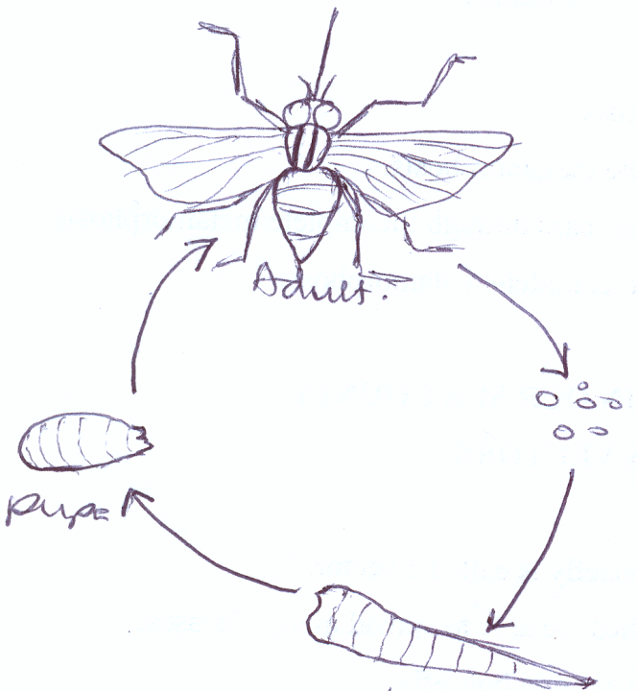
A lifecycle of a housefly

- The dormant stage of a housefly is pupa.
- The scientific name of larva is maggot
- Maggots move by wriggling.
- Maggots eat up faeces in latrines.
- The adult stage of a housefly is dangerous because they spread faecal diseases.
The dangerous stage of a housefly is an adult.
The useful stage of a housefly is larva (Maggot)
Activity
- Why is a housefly called a vector?
- How is a housefly able to spread many diseases?
- What name is given to the larva stage of a housefly?
- Which structures on the body of a housefly helps it to spread diseases
- How do maggots move?
- How are maggots useful to man?
- Identify the dangerous stage of a housefly.
- Why is the above mentioned stage dangerous to man?
Lesson 5
Vocabulary
- Diarrheal
- Faecal
- Cholrela
- Typhoid
- Trachoma
- Chlamydia
Breeding places for houseflies
- Faeces
- Latrines
- Manure heaps
- Rubbish pits
Why do houseflies breed in the above named places?
- To enable maggots get food easily
Ways houseflies spread diseases.
- Using the hairy bodies to carry diseases causing germs.
- By vomiting germs on human food.

The 4F’s germ path
4F’s in full as in the spread of diseases.
Faeces
1
4f’s disease chain
Fingers 4 2 Flies the major agent
3
Food

Diseases spread by a housefly

- Cholera
- Diarrhoea
- Typhoid
- Dysentery
- Trachoma for eyes

Prevention of diseases spread by houseflies
- Covering food
- Covering pit latrines
- Proper disposal of human wastes (faeces and urine)
- Smoking pit latrines.
- Burning rubbish
- Spraying using insecticides
- Proper disposal of rubbish
- Boiling water for drinking - out of class lesson

Activity
- Mention three places where houseflies stay and breed
- State two ways houseflies spread diseases.
- Write 4f’s in full as in disease chain.
- Name the disease of eyes spread by the housefly.
- Give any four ways of preventing diseases spread by a housefly.
- Why should we cover left over the food?

Lesson 6
MOSQUITOES
- They spread malaria, yellow fever and elephantiasis to people
- They lay eggs in stagnant water
Types of mosquitoes
- Culex mosquito
- Anopheles mosquito
- Aedes/ tiger mosquito
Diagrams life cycle of anopheles and culex mosquito

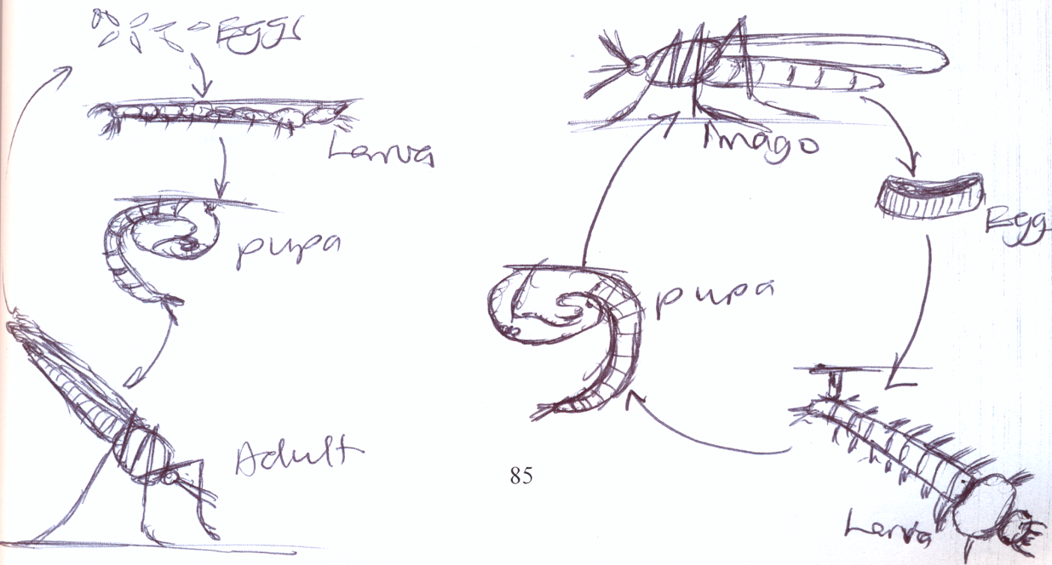

- The larva stage of a mosquito is called a wriggler.
- The larva moves by wriggling
Active stage Dormant stage
- Larva stage (wriggler) - Pupa stage
Adult
Dangerous stage
- Adult stage why? It spreads malaria, yellow fever and elephantiasis to people
Breeding areas of mosquitoes
- Stagnant water

Activity :-
- Name the one type of mosquitoes.
- What name is given to the larva stage of a mosquito?
- Identify the active stage of mosquitoes.
- Which stage of a mosquito is dormant?
- Point out the dangerous stage of a mosquito.
- How dangerous is the above mentioned stage of a mosquito?
- Where do mosquitoes lay their eggs?
- Why is the adult stage of mosquito dangerous?
- How do mosquitoes spread diseases.

HOW MOSQUITOES SPREAD DISEASES.
- Mosquitoes spread diseases through bites
Feeds of mosquitoes
- Blood (female mosquitoes)
- Juice and nectar (male mosquitoes)

Diseases spread by mosquitoes / mosquito to borne diseases
- Malaria
- Elephantiasis
- Yellow fever
a) Malaria
- It is caused by plasmodia germs.
- It is spread by infected female anopheles mosquitoes
How malaria spreads
- Through bites of infected female anopheles mosquitoes
symptoms of malaria
- Headache
- Stomach ache
- Joint pain
- Fever
- Body weakness

Sign of malaria
1. Vomiting
b) Elephantiasis
- It is caused by filarial worm
- It is spread by culex mosquitoes
Sign of elephantiasis
- The legs swell like those of an elephant.
c) Yellow fever / dengue fever
- It is caused by a virus
- It is spread by aedes or tiger mosquito
symptoms of yellow fever
- Headache
- Backache
Prevention/ control of diseases spread by mosquitoes / mosquito borne disease
- Sleeping under treated mosquito nets.
- Draining stagnant water near homes.
- Slashing tall grass near homes.
- Spraying with insecticides to kill mosquitoes.
- Keeping fish in ponds and dams to eat the mosquito larva.

Activity
- How do mosquitoes spread diseases?
- Why do mosquitoes suck blood?
- Which germ causes malaria?
- How is malaria spread to a person?
- Why are male anopheles mosquitoes unable to spread diseases?
- Name the worm which causes elephantiasis
- How do you tell that Joseph has elephantiasis?
- How is elephantiasis spread to man?
- Match the diseases to the mosquito.
A B
Elephantiasis Aedes mosquito
Malaria Culex mosquito
Yellow fever Female anopheles mosquito
- Give at least 4 ways of preventing and controlling the spread of diseases spread by mosquitoes.

LIFECYCLE OF A TSETSE FLY
NB: the eggs of a tsetse fly hatch inside the body of the female. It under goes a complete lifecycle
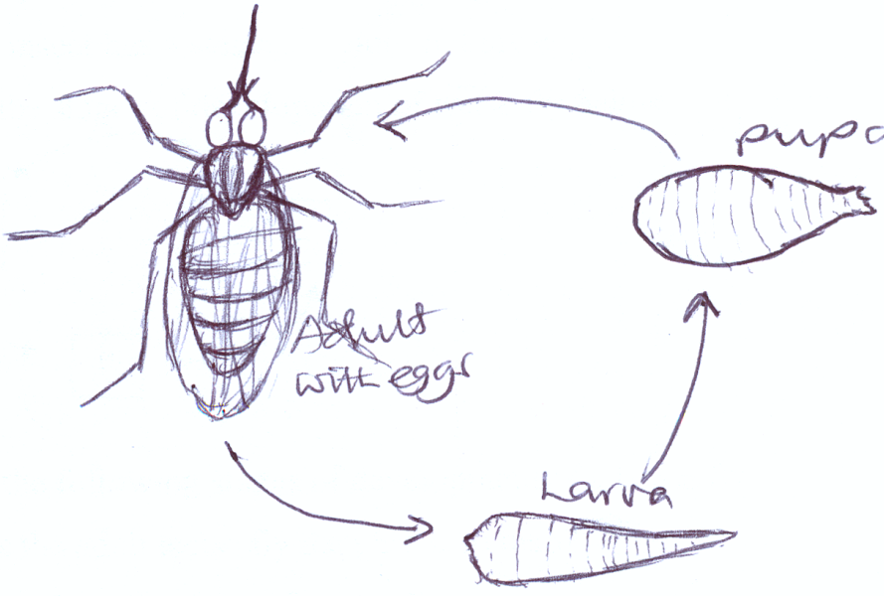

Active stage Dormant stage
Larva and adult pupa
Dangerous stage and why?
- Adult stage because it spreads sleeping sickness
Breeding areas of tsetse flies
- Dry sandy soil.
- Under dry leaves
Food for tsetse flies
- They feed on blood ( female tsetse flies
- Male ones feed on nectar
Germs that causes sleeping sickness (parasite
- Trypanosomes
Diseases spread by tsetseflies
- Sleeping sickness in man
- Nagana in farm animals ( goats, cattle, sheep)

Symptoms of sleeping sickness
- Fever
- Body weakness
- Loss of appetite
Prevention and control of diseases
- Spraying with insecticides.
- By using tsetse flytraps to kill adult tsetseflies.
- By clearing bushes.
- Avoid grazing animals very early and late.
Activity
- Which insect has 4 stages but does not lay eggs?
- Name the stages of development of tsetse fly below.

a c
b
- Name the following stages of development of a tsetse fly
- How is the adult tsetse fly dangerous to man?
- State two breeding area of tsetse flies
- Identify the germ that causes sleeping sickness
- Mention two diseases causes by the germ names above.
- Point out four ways of preventing and controlling tsetse flies.
- Name the insect that do not lay eggs.
Summary table for the lifecycle of insects
Insect | Larva | Adult
Housefly | Maggot | Imago
Mosquito | Wriggler | Imago
Butterfly | Caterpillar | Imago
Bees | Grub | Imago
Wasps | Grub | Imago
Ants | Grub | Imago

Activity Evaluation:-
- Draw and name the stages of a butterfly.
- Name the most active stage of a butterfly
- Identify the dangerous stage of a butterfly.
- How dangerous is the above mentioned staged to plants?
- What name is given to the larvae stage of a butterfly?
- Identify the dormant stage of a butterfly.
- How useful is the adult butterfly?
- Point out one breeding area of butterflies.
- Name the larva stages of the following insects.

- Housefly
- Tsetse fly
- Mosquito
- Ants
- Butterfly
- Bees.

Lesson
COCKROACHES
- They spread polio, dysentery and typhoid
Lifecycle of a cockroach
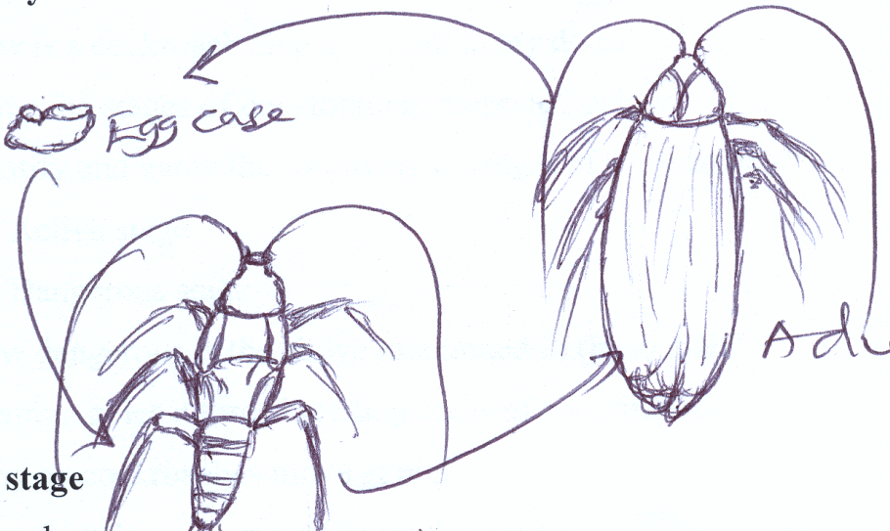

These scientific name of larva stage of a cockroach is nymph
Active stage
- Nymph

Dangerous stage
- Adult stage because it spreads faecal diseases to man.

Breeding areas of a cockroach.
Behind cupboards – they live in dark places like
- Old cookers
- Refrigerators
- In boxes
- In book shelves
- In latrines or toilets.
Why cockroaches move at night.
- To look for food and water.
Diseases spread by cockroaches

- Polio
- Dysentery

Prevention and control of cockroach
- Spraying using insecticides
- Allow much light in a room/ house
- Clean all dirty dark places.
Dangers of cockroaches at home
- They spread faecal diseases
- They destroy paper and books
- They eat furniture
Activity
- How is a cockroach able to spread many diseases?
- Name the stages of development marketed below.
- Identify and name the following in stages of a cockroach.
- Active stage
- Dangerous stage
- How dangerous is the above mentioned in (b) to man?
- Mention at least three breeding areas of cockroaches
- Why do cockroaches move at night?
- Give four diseases spread by cockroaches.
- State three dangerous of cockroaches.
- Point out tow ways of preventing and controlling cockroaches.

DOGS, CATS, TICKS AND ITCH MITES
- Rabid / infected dogs
They spread rabies to man
Rabies is caused by a virus
Sign of rabies
- Rabies makes a person wild, becomes mad and barks like a dog after 6months.

Prevention and control of rabies
- Vaccinate dogs
- Kill mad dogs
- Avoid playing with mad dogs.
- People should get vaccination as soon as a mad dog bites you.

Ticks
- Ticks are commonly found on bodies of wild and domestic animals.
Feed of ticks
- Blood of man and animals
Disease spread by ticks
- Relapsing fever
Black fly
- It is also called the simulium fly.
- It breeds in first flowing water in river bank where it lays its eggs
- It spreads river blindness.
How river blindness spreads
- Through bites of black fly/ Jinja fly.
Why is it called river blindness?
- Stays along river and spreads a worm which causes blindness.
Signs and symptoms of river blindness.
- Itching skin rashes (symptom)
- Lumps appear on the hips and legs (sign)
Control of river blindness
- Spraying using insecticides to kill adult black flies

ITCH MITES
- Itch mites spread a worm which lives and multiplies inside our skins.
Diseases spread by itch mites
- Scabies
Sign of scabies
- Scabies causes a lot of itching and scratching.
- It is also contagious(spread by people teaching each other)

Activity
- What name is given to animals kept at home?
- Identify a disease spread by wildly dogs.
- What helps you knows that one has rabies?
- How can you control wildly dog diseases?
- What will happen to Emmanuel who has been bitten by a rabid dog?
- Where do ticks live?
- Name the food for ticks.
- What diseases do ticks spread?
- Mention the disease spread by itch mites.
- How does scabies affect a person?

Rat fleas
- Fleas living on man bite him causing irritation, pain and scratching but do not spread any disease.
- Fleas living on rats are called Rat fleas.
Life cycle of a rat flea
Fountain bk 4
Baby flea
eggs

adult

Places where rat fleas live
- Animal hair
- Cracks on walls
Disease spread byrat fleas.
- Bubonic plague
Sign of bubonic plague
- Swelling in the neck, arm pits and groins
Prevention of bubonic plague
- Kill the rats
- Spray with insecticides to kill fleas.
- Smearing the floor with cow dung
Types of lice
- Body lice
- Hair lice
- Crab lice (found on pubic hair)
Disease spread by lice
- Typhus fever
Prevention of lice
- Observe personal hygiene
- Cut off infected hair
- Use fine combs to remove the eggs and dead lice.
- Treat people with typhus fever
Ways of controlling vectors
- Proper disposal of rubbish
- Drawing stagnant water
- Slashing tall grass around homes
- Smoking pit latrines
Activity
- What do fleas found on man cause?
- What do we call fleas living on rats?
- Name the disease spread by rat fleas.
- Write down the sign of the above mentioned diseases.
- Point out two ways of preventing the spread of rat flea diseases.
- Give three types of lice.
- Mention the diseases spread by lice.
- How do we prevent lice?
- State two places where bedbugs live.
- What do bedbugs cause to man?
- How can Damalie prevent the bedbugs in her home?

WATER SNAILS
- Water snails are vectors because the worm which causes bilharzias develops in them.
The worm in water snails.
- Bilharzia fluke
Breeding places of bilharzias fluke
- In bladder
- In liver
- In lungs
Ways bilhazia flukes enter our bodies
- Through drinking contaminated water.
- Through the skin when you bathe and swim in contaminated water.
Sign of bilharzia
- Blood in urine
- Blood in stool
- The liver and spleen become big.
Prevention of bilharzia
- Avoid walking, washing, bathing and swimming in water bodies.
- Wear shoes or gumboots while standing in streams and swamps.
- Proper disposal of human wastes
- Boil water for drinking .
- Remove water snails from water sources.

Activity
- Why are water snails called vectors?
- Which diseases do water snails spread?
- Identify the worm that causes the above mentioned disease.
- Mention three places where bilharzia flukes can be found.
- Why is one advised to put on shoes?
- How can one tell that Pulunyi has got bilharzia?
- How will Moses prevent bilharzia?

A summary vectors and their diseases
A table showing vectors and the diseases they spread. (comprehensive bk4 page 125.
Disease vector | Disease spread
Housefly | Diarrhoea, typhoid, cholera, trachoma, dysnetry
Tsetse fly | Sleeping sickness, nagana
A female anopheles mosquito | Malaria
A culex mosquito | Elephantiasis
An aedes mosquito | Yellow fever
Bilharzia fluke | Bilharzia
Itch mites | Scabies

The 4f’s chain
Diseases can spread through the 4f’s as
    - Faeces
    - Flies
    - Food
    - Fingers
Preventing and controlling vectors (general
    - Sweeping the houses, compound.
    - Slashing tall grass around our homes.
    - Spraying using pesticides
    - Digging around the house. etc

HIV AND AIDS
- HIV in full is Human Immunodeficiency virus.
AIDS in full and the meaning of each term
Acquired – get from
Immune – protected against
Deficiency – lack of
syndrome– different signs and symptoms
- AIDS in full is Acquired Immune Deficiency Syndrome
- HIV is a virus that causes AIDS
- AIDS is a serious disease that destroys the white blood cells.
- White blood cells help to fight against diseases causing germs in our bodies.
How AIDS is spread
- HIV is spread through having unprotected sex with an infected person.
- HIV is spread through sharing sharp skin piercing instruments or objects with an infected person .
- HIV is spread through transfusion with infected blood.
Other ways how HIV/ AIDS can spread.
    - Sharing toothbrushes
    - Sharing sharp piercing instruments.
Effects HIV/ AIDs to a victim (individual)
    - Death
    - Pain and suffering
    - Poor job performance
To the family
    - Poverty
    - Loss of beloved ones
To the community
    - Loss of labour
    - Increased number of orphans and street children.
    - Retardation in development.
Organizations that help preventing HIV/AIDS
    - TASO – The AIDS support organization.
    - AIC – AIDS information Centre
    - ACP – AIDS Control programme
Cultural practices that lead to the spread of HIV/ AIDS
    - Wife sharing
    - Wife inheritance
    - Body tattooing
    - Circumcision
Ways in which HIV/ AIDS may not spread
    - Sharing food on one plate.
    - Hand shaking
    - Hugging
    - Playing with infected people.
    - Mosquito bites
    - Sharing the same bed.
People at risk of getting HIV/ AIDS
    - Bar maids
    - Long distance travelers
    - Youth
    - Prostitutes
    - Health workers
Why can’t mosquitoes transmit HIV
    - They have enzymes that kill the HIV in their gut.
Sign and symptoms of AIDS
- Herpes zosta
- Prolonged diarrhea
- Rash all over the body
- Emaciation
- Loss of weight
Symptoms of HIV/ AIDS
- Fever especially in the evening
- General body weakness
- Headache
Activity
- Write the following in full.
- HIV
- AIDS
- SYFA
- Name the virus which causes AIDS.
- Give one danger of AIDS to human body.
- What is the work of white blood cells in one’s body?
- Mention three ways AIDS is spread.
- State two effects of AIDS to an individual

CARE FOR AIDS PATIENT
- Proper feeding
- Encouraging them to take medicine
- Taking them for guidance and counseling
- Washing for them
- Giving them company

Ways of controlling AIDS
- Abstain from sex
- Avoiding sharing skin piercing objects
Controlling AIDS
- Condom use
- Having one trusted partner
- Sterilizing instruments used in tribal circumcision and tattooing

Activity
- Give any ways of caring for Aids patients.
- Give at least two control measures for AIDS.
- Write ABC in full as used in the control of HIV/ AIDS.

PIASCY
- PIASCY in full is Presidential Initiative on AIDS Strategy for Communication to the Youth.

PIASCY messages
- Avoid bad touches
- Avoid bad peer groups
- AIDS has no cure
- Do not share sharp unsterilized objects.
- Avoid lifts from strangers.
- Avoid sex before marriage
- AIDS is a deadly disease
- Care for AIDS victims.
- Respect your body.
- Virginity is health
Importance of PIASCY message
    - To create awareness about HIV/AIDS

ACTIVITY
- Write PIASCY in full
- Identify any two PIASCY messages.
- In which way are PIASCY messages important in a school.
- Write TASO in full.
Give one way through which HIV may not spread.

PERSONAL HYGIENE
- Personal hygiene is keeping of our bodies clean and the things we use .
- The general cleanliness of our bodies.

Things used to keep our bodies clean.

- Soap
- Water
- Towel
- Brush
- Tooth brush
- Tooth paste
- Comb
- Ear pads
- Basin
- Nail clipper
- Shoe polish
- Vaseline

Diagrams
Soap

Water Comb

Importance of good personal hygiene
- Leads to good body smell.
- Leads to easy spread of disease/ skin diseases

How to keep our bodies clean.
- Bathing daily.
- Washing our faces regularly.
- Brushing our teeth after daily meal.
- Washing hands after visiting the latrine.
- Cutting our finger nails short.
- Washing clothes.
Activity
- What is personal hygiene?
- Name at least ten things sued to keep our bodies clean.
- Draw and name five things used to keep our bodies clean.
- How can Abiji keep her body clean?
- Why are P.3 children advised to wash hands after visiting the latrine?
- How useful is cutting off fingernails short?
WHY DO WE BATHE?
- To remove dirt from our bodies
- To control bad body smell
- To remove germs which come during sweating and dirt.
Why do we wash clothes?
- To remove dirt from clothes.
- To prevent lice.
- To control the bad smell.
Why do we iron clothes?
- To kill germs
- To kill lice and their eggs.
- To look smart and clean.
Why do we wash our hands?
- To remove germs.
- To kill germs using soap.
- To prevent spreading germs and dirt which may make us sick
Why do we brush our teeth?
- To control the bad breath
- Prevent tooth decay

Activity
- How useful is brushing teeth to a p.3 child?
- Why do you think p.3 pupils wash their clothes?
- Give two reasons why your mother irons clothes?
- Why does Pulunyi wash his hands after visiting the latrine?
- Two reasons why people brush their teeth.
- How good is washing hands with soap after visiting the toilet/ latrines?
- How do you control bad breathe?

HOW TO KEEP OUR CLOTHES CLEAN?
- Washing clothes when they are dirty.
- Ironing clothes after washing.
- Hanging washed and ironed clothes.
Activity
- Give two ways of keeping clothes clean.
- Why are P.3 pupils advised to iron their clothes?
- How can Ainomuhangi keep her bedroom clean?
- Write down three dangers of improper hygiene

FOOD HYGIENE
- Food hygiene is the keeping of food safe or clean.

Things used in food hygiene

- Water
- Towel for drying utensils.
- Soap
- Sponge

Diagrams of some things used in food hygiene
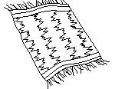

Sponge
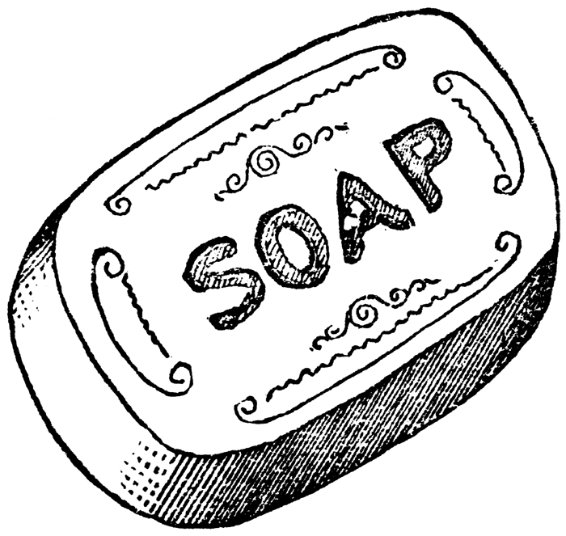
Water towel

Proper ways of handling food.
- Washing hands before preparing food.
- Washing food before cooking.
- Covering the food while cooking.
- Keeping the kitchen clean alway
- Washing the kitchen clean always.
- Washing hands before serving food.
- Serving food in a clean place.
- Washing plates before and after serving food.
- Washing hands before and after eating.
- Washing foods or fruits eaten raw.

Activity
- What is food hygiene?
- Mention any six examples of things sued in food hygiene.
- Write down at least six ways of handling food properly.
- Draw and name any four tings used in food hygiene.
- How do we keep drinking water safe?
- Why does Jjajja boil drinking water?

FOOD CONTAMINATION
Food contamination:The way food gets dirty or spoilt..

Ways food gets contaminated
- When houseflies land on food.
- Handling food with dirty hands
- Putting food in dirty containers
- Cooking food in dirty places
- Serving food on dirty places
Importance of proper handling of food
- To avoid food contamination
Prevention of food contamination
-Putting food in clean container.
- Handling food with clean hands.
- Covering cooked food
Activity
- Give four ways food can be made dirty.
- How important is proper handling of food to P.3 pupils?
- Give four ways of keeping the classroom clean.
- Why are P.3 pupils advised to clean their classroom regularly?
- Of what value is a dust bin in to a P.3 classroom?

FOOD PRESERVATION
- Food preservation is the keeping of food safe

Methods/ ways of preserving food
- Salting
- Smoking
- Sun drying
- Refrigerating

Why should one preserve food?
- Food is also preserved for future use.
- Easy transportation

Activity :-
- Define food preservation.
- Write down four ways of preserving food.
- List down at least two examples of food preserved by each method mentioned above.
- Smoked
- Sun dried
- Refrigerated
- Salted
- Canned/ tinned
- State four reasons of preserving food.

ENERGY
Energy is the ability to do work.

Sources of energy
There are two main source of energy
- Natural sources
- Artificial sources

Natural source
A natural source of energy is a source of energy produced by nature.

Examples of natural sources
- The sun
- Wind
- Running water
Activities that require energy in our daily life
- Dancing
- Running
- Jumping etc.
The sun
The sun provides solar energy as the main energy.
The sun produces two forms of energy
- Heat energy`
- Light energy

Exercise
- What is energy?
- Name two sources of energy.
- Give three examples of natural sources of energy?
- Write three types of energy got from the sun.

Uses of the sun
- Heat from the sun helps us to feel warm
- Heat from the sun helps in the rain formation.
- Plants use sunlight energy to make food.
- Heat from the sun helps to kill some germs on our bodies
- Sun light provides energy that our skins use to make vitamin D.
- Heat from the sun.
Solar energy as a source from the sun
It is trapped using solar panels.
It is stoned in solar batteries as solar electricity.

Uses of solar electricity
- It is used for lighting in homes
- It is used for cooking food
- It is used for ironing clothes
- It is used for charging phones, etc
- It is used to run domestic appliances like radios, televisions etc.

Activity
- Give at least four uses of the sun.
- Where is solar energy stored?
- Mention any four uses of solar electricity.

Dangers of too much sunshine
- The sunshine spoils our eyes when we look at it directly.
- Too much sunshine spoils our crops by drying them.
- Too much sunshine leads drought and famine.
- Too much sunshine reduces the level of water in water bodies.
- The sun has dangerous rays which leads cancer and asthma.

Wind
Wind is the moving air. Air is a mixture of gases.

Uses of wind energy
- It’s used for sailing boats
- It’s used for driving wind mills
- It’s used for winnowing
- It’s used in seed dispersal
- Wind mills are used for pumping water and producing electricity.
Dangers of wind energy
- Strong wind blows off roofs of houses
- Strong wind destroys crops
- Strong wind breaks trees.
- Moving air spreads diseases such as mumps, chicken pox, measles, Tuberculosisetc
How to control dangers of too much wind
- Planting trees and grass in our compounds.

Activity
- What is wind?
- Name energy got from wind
- Give at least four uses of wind
- State any four dangers of wind
- Point out any one ways of controlling too much wind.
- Mention any three diseases spread through air.

Running water

Uses of water as a source of energy
- Water is used to produce hydro electricity
Dangers of too much water
- Too much water leads to floods
- Too much water can spoil plant growth
- Some diseases can be got from water eg cholera, bilharzias etc
- Floods lead to loss of life and property

Safe use of water
- Plant grass and trees to reduce on the speed of running water
- Avoid destroying swamps
- Avoid dumping wastes in water sources
- Avoid urinating or defecating in water sources
- Ensure that water containers and water pipes do not leak.
- Harvest rain water from roofs of buildings for domestic and other uses.

Activity
- Name three sources of energy from water
- Which energy is got from geothermal springs?
- State any four dangers of too much water.
- Write down at least four safe ways of using water.
- Why is water said to be life?

Artificial sources of energy

Examples of artificial sources of energy
- Fuel
- Electricity

Fuel
Fuel is any thing that can burn to produce heat.

Types of fuel
- Liquid fuel
- Solid fuel
- Gaseous fuel
Examples of each type of fuel
- Liquid fuel
  - Kerosene (paraffin)
  - Diesel and
  - Petrol

- Solid fuel
  - Wood fuel is the commonest solid fuel.
Examples of solid fuels
  - Charcoal
  - Firewood
  - Coal
- Gaseous fuel
  - Natural gas
  - Bio gas

Activity
- Define artificial sources of energy
- Give two examples of artificial sources of energy
- What is fuel?
- Mention three types of fuel
- Point out two examples in each type of fuel
  - Liquid fuel
  - Solid fuel
  - Gaseous fuel
- Name any six examples of fuels.

USES OF EACH EXAMPLE OF FUEL
Examples of fuel | Uses
Kerosene | - For lighting kerosene lamps  - For cooking food using stoves  - For dissolving certain paints
Petrol and diesel | - For running vehicle engines  - For running generators  - For running engines of machines like grinding mills
Charcoal | - For preserving/ roasting food like fish  - For ironing clothes  - For cooking food
Firewood | - For cooking food  - For preserving / roasting food  - For boiling water
Coal | - For heating  - For lighting  - For generating thermal electricity
Gas | - For welding  - For cooking food  - For lighting

Activity
- Give at least three uses of each of the following fuels
  - Paraffin
  - Petrol and diesel
  - Fire wood
  - Charcoal
  - Coal
  - Gas

Dangers of different fuel energy
 | Dangers | Safe use
Paraffin  Petrol and diesel | - Cause fire outbreaks  - Can easily catch fire | - Avoid playing with fire while having petrol, diesel or paraffin
Charcoal  Fire wood | - Can burn people and property  - Gives off a dangerous gas in the atmosphere | - Plant more trees  - Use energy saving stoves
Coal | - Cause pollution | - Following in

Ways of saving energy
- Using energy saving stoves and bulbs
- Switching off electric appliances when not in use
- Putting out fire after use
- Planting more trees to replace the cut ones
- Enforcing laws to control deforestation

Importance of saving energy
- To avoid wastage
- To reduce costs ie money paid for electricity or for buying wood fuel
- To conserve the environment.

