P.3 LITERACY_{IB} FOR TERM I 2020
Date | Class | Subject | Time | No. of pupils
THEME : Our sub county
SUBTHEME : Name and location of our sub – county
CONTENT : Location of our sub - county
The word location means a particular place where something is found.
Our sub- county is located in Mukono District.
Another name for a sub – county is a Division
The name of our Division is found in Mukono Municipality.
The table below shows sub regions in our division/sub – county
Area Head
District L.C V Chairperson

Counties / Municipality Mayor /County chief

Sub – county/ Division LC III Chairperson

Parish / word LC II Chairperson

Zone / village LC I Chairperson
Activity
- What is the name of our sub – county/ Division?
- In which Division is our school?
- What title is given to the political head of a Division?
- Mention the smallest division/ unit in our sub – county
- In which District is Mukono Central Division found?

Date | Class | Subject | Time | No. of pupils
THEME : Our sub county
SUBTHEME : Name and location of our sub – county
CONTENT : Our Municipality
Municipality is an urban area headed by a mayor
Examples of municipality in Uganda
- Mukono municipality
- Jinja municipality
- Mbarara municipality
- Gulu municipality
- Lira municipality
NB: In rural areas, municipalities are at the level of counties
Counties in Mukono District
- Mukono North county
- Mukono South county
- Nakifuma county
- Mukono Municipality
Characteristics that enable an area to become a municipality
- It must have very many people living in it.
- It must have improved social services.
- It must have many economic activities
Our Division is found in Mukono Municipality.
The mayor of Mukono Municipality is Mr. Fred Kagimu.
Divisions in our municipality
- Mukono Central Division
- Goma Division
Activities
- Who is the highest political head of a sub county / division?
- What is the name of your municipality?
- Outline one characteristic that enables an area to become a municipality.
- Mention two municipalities neighbouring yours
- Who heads a municipality?

Date | Class | Subject | Time | No. of pupils
THEME : Our sub county
SUBTHEME : Name and location of our sub – county
CONTENT : Sub – Counties in Mukono District
A sub – county is an area headed by LC III chairperson.
In urban area a sub – county is known as a Division
Sub - counties in Mukono District
- Nakisunga sub – county
- Ntejeru sub – county
- Mpata sub – county
- Mpunge sub – county
- Kome sub – county
- Kyampisi sub – county
- Nabbale sub – county
- Kimenyende sub – county
- Kasawo sub – county
- Nagojje sub – county
- Seeta Namugongo sub – county
- Nama sub – county
The name of our – sub county is Mukono Central Division.
Wards that make up Mukono Central Division
- Gulu ward
- Ntawo ward
- Namumira ward
- Nsuube kauga ward
Note: Our school is located in Gulu ward
Zone that make up Gulu ward
- Kitete zone
- Bnasuti zone
- Namubiru zone
- Nabbuti zone
- Takajjunge zone
Note: Our school is located in kitete zone / village

Activity
- In which ward is your school located?
- What title is given to a person who heads a zone?
- Give the name of your village
- Mention any two zones neighbouring yours.
- Fill in correctly
District  __________  ward  ______ | ____________  LC. III chairperson  ____________  LC I chairperson

Date | Class | Subject | Time | No. of pupils
THEME : Our sub county (Division)
SUBTHEME : Name and Location of our sub county
INTRODUCTION : The lesson will be introduced by asking learners
the name of our sub county.
CONTENT :
Maps and pictures
A picture.
A picture is a representation of an object as seen and drawn from aside.
Maps
A map is a representation of an object as seen and drawn from above.

Examples
Diagrams of pictures of different drawn objects
Name | Picture | Map
Tree
House

Table

Pot

Basket

Cup

Differences between a map and a picture
- A map is drawn as seen from above while a picture is drawn as seen from above.
- A picture is more detailed than a map.

Similarities between a map and a picture
- Both are drawings of objects.
- Both represent real objects.

Exercise
- Define a map.
- What is a picture?
- State the difference between a map and a picture.
- Draw the maps of the following objects
Tree, Pot, House
- Draw pictures of the following objects.
Basket, Bottle , Cup

Date | Class | Subject | Time | No. of pupils
THEME : Our sub county (Division)
SUBTHEME : Name and Location of our sub county
INTRODUCTION : The lesson will be introduced by reviewing
the name of our sub county.
CONTENT : Location of our sub county
Map reading
Maps help to show different places
These include schools, villages, market places.
Elements of a good map
A good map should have the following elements:-
- Title - Key
- Compass direction - Scale - boundary
- Frame
Qualities of a good map
- A good map should have a scale
- A good map should have a compass.
- A good map should have a title
- A good map should have a key
- A good map should have a frame
Uses of each map element
- A title is used to tell us all about a map.
- A compass direction helps a map reader to know and find direction.
- A scale is used to calculate the actual distance on the map.
- Boundary / frame – it encloses the map / beautifies the map
- The key is used to explain all map symbols and colours on the map.
Exercise
- Give one importance of a map
- List three elements of a good map.
- Write the uses of each map element
A sub county map should be drawn to indicate all the above elements

- Key c) A compass
- A scale d)A title

- Which element of a map shows direction?
- State four qualities of a good map.

Date | Class | Subject | Time | No. of pupils
THEME : Our sub county
SUBTHEME : Location of our sub county
INTRODUCTION : The lesson will be introduced by reviewing the
previous
CONTENT :
Map symbols
Map symbols are signs which represent real objects and places on the map.
Why are symbols used on a map?
Why are symbols used on a map?
- To avoid over crowding
- To represent real objects
- To make map reading easy
Examples of map symbols.
Symbol Meaning
River
Bridge
Dam
Mountain peak
Lake
Swamp
Railway line
Quarry
Canal
Water fall air port

Rift valley
In land port
Mine

contour
Stone age state

sea port
Exercise
1.Which element of a map interprets symbols?
2. Give the meanings of the following map symbols.

Date | Class | Subject | Time | No. of pupils
THEME : Our sub county
SUBTHEME : Ways of locating places
INTRODUCTION:
CONTENT :
We can find the location of different places using the following ways
- Position of the sun
- Using shadows
- Using Neigbouring places
- Using land marks
- Using a compass
- Using sign posts
Ways of locating places using a compass
- A compass is an instruct used to find direction of places.
- A compass has 4 main points called cardinal points
These are: North
- South
- East
- West
Below is a diagram showing the 4 cardinal points of a compass

North

West East

South

Note: The direction where the sun appears first is East and where it sets is West

Activity
  - Give one way a visitor coming to your school can find where its found.
  - Tell the time of the say where the shadow is
- On the right hand side
- One the left hand side
- Appears shortest
  - Name the points of a compass shown below
a

d b

c
  - Mention the neighbouring zones of Kitete zone in the following directions
North
South
East
West
  - In which direction does the sun
- Rise from ______________
- Sets from ______________

Date | Class | Subject | Time | No. of pupils
THEME : Our sub county
SUBTHEME : Ways of locating places
CONTENT : Semi – cardinal points of a compass
Semi – cardinal points are the secondary points of a compass. They are found between two cardinal points ie North East is found between North and East.

Semi - cardinal points

North
North East
North West

West East

South East
South West
South
People who use a compass
These people use the compass to find direction of places

- Pilots
- Soldiers
- Tourists
- Sailors
- Rally drivers
- Mountain climbers

Importance of a compass
A compass helps to find direction of different places.
Its for study purpose.
Activity
- What name is given to the four main points of a compass?
- Name the instrument used to show direction of places
- Which element of map has the same function like that of a compass?
- Give any one semi – cardinal point of a compass.
- What is the compass direction of A from B
A

B
- Outline two groups of people who use a compass in their daily work.
- Name the direction between South and West.

Date | Class | Subject | Time | No. of pupils
THEME : Our sub county
SUBTHEME : Physical features in our sub county
INTRODUCTION: The lesson will be introduced by reviewing
CONTENT : Physical features in our sub county/ Division

  - What are physical features?
These are natural landforms that give land shape
Physical features are also called landforms.

2. What are landforms?
Landforms are natural features that give land shape / in an area.

3. Examples of physical features include the following:-

- hills
- mountains
- valleys
- plains
- lakes
- streams
- rivers
- islands
- oceans
- seas
- rift valleys

4. Examples of physical features found in our division:
- Hills
- Valleys
- A Lake
- Plateaus

Exercise
1. What do we call the natural landforms in an area?
2. Name any three landforms.
3. What physical feature is surrounded by water?
4. Draw and name any two map symbols you know
5. What is the use of a compass on a map?
6. Which physical feature covers the largest place in our division?

Date | Class | Subject | Time | No. of pupils
THEME : Our sub county
SUBTHEME : Physical features in our sub county
INTRODUCTION: The lesson will be introduced by reviewing
CONTENT : Physical features in our sub county/ Division

LAKES AND RIVERS

- What is a lake?
A lake is a large water body in a basin.
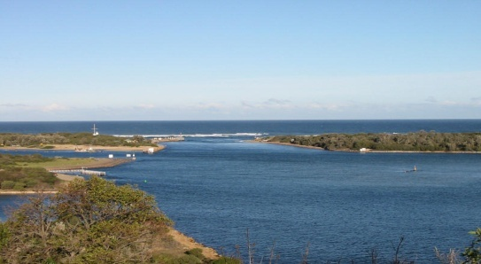
- Examples of lakes in Uganda include the following:-
  - Lake Victoria (Natural-lake)
  - Kabaka’s lake (human-made lake)
  - Lake Albert
  - Lake George

- What is a river?
A river is a narrow and long flowing water body.
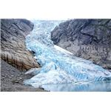
4. Rivers flow from a higher level to a lower level.

NB: There are no rivers in our division.

Importance of lakes and rivers to people
- They are used for water transport.
- People get clay, stones and sand used for building.
- Lakes and rivers provide fish and water to people.
- Rivers help in generating hydro electricity.
- They attract tourists.
- Lakes help in formation of rainfall.

Exercise
1. Name the man-made lake is found in Kampala district.
2. Which water body flows from a high level to a low level?
3. Why do some people like staying near lakes and rivers?
4. In which division is your school found.
5.Whar is the biggest lake in Uganda?

Date | Class | Subject | Time | No. of pupils
THEME : Our sub county
SUBTHEME : Physical features in our sub county
INTRODUCTION: The lesson will be introduced by reviewing
CONTENT : Physical features in our sub county/ Division
PLATEAU

1. What is a plateau?
A plateau is a raised flat topped piece of land.
A plateau is a table land

2. Importance of the plateau to people
- People build houses on the plateau.
- People grow crops on the plateau.
- People graze animals on the plateau.
- Roads, railways and airports are built on plateaus.

HILLS
1. What is hill?
A hill is a slightly raised piece of land.

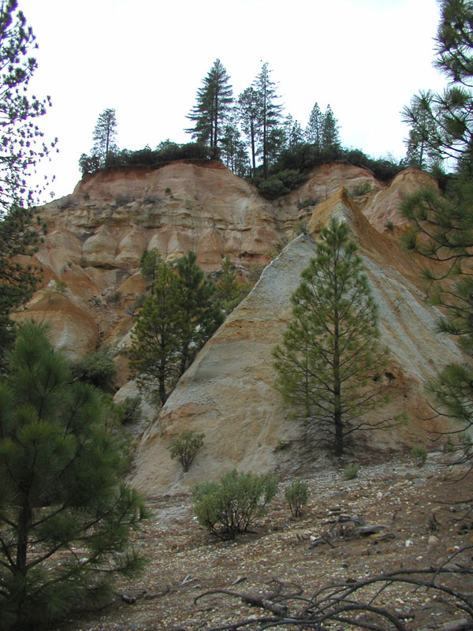

Examples of hills in our Division
- Ham Mukasa hill on which our school is found.
- Namubiru hill on which we find quarrying.
- Besania hill on which we find Ankrah foundation
- Nabuti hill on which we find Festino.

- Importance of hills to people
- People settle on hills.
- They grow crops on hill slopes
- People graze their animals on hills
- Hills help in the formation of rainfall.
- People build masts on hills.

Exercise
- Define a plateau.
- State two uses of hills to people in Mukono Central Division
- Name any two hills in our division.
- Mention the difference between a map and a picture

Date | Class | Subject | Time | No. of pupils
THEME : Our sub county
SUBTHEME : Physical features in our sub county
INTRODUCTION: The lesson will be introduced by reviewing
CONTENT : Physical features in our sub county/ Division

VALLEYS
1. What is a valley?
A valley is lowland between two or more hills or mountains.

2. A picture of a valley
x

Examples of valleys in our sub county
- Kame valley
- Kitete –Namubiru valleys
4. Importance of valleys to people:
- People get water from valleys.
- Valleys are used for growing crops.
- People settle in valleys.
5. Why is it not good for people to settle in valleys?
- They flood during the wet season.
- Valleys are breeding places for vectors like mosquitoes.
- There is poor communication network.
- There are landslides in valleys.

Exercise
- Define a valley.
- Name any two valleys in Division
- Write two problems faced by people staying in valleys.

Date | Class | Subject | Time | No. of pupils
THEME : Our sub county
SUBTHEME : VEGETATION
INTRODUCTION: The lesson will be introduced by reviewing
CONTENT : Vegetation in our Sub County/ Division
What is vegetation?
Vegetation is the general plant cover of an area.
Groups of vegetation
  - Natural vegetation
  - Planted vegetation
Types of vegetation
- Relief vegetation
- Drainage vegetation
Swamps
A swamp is a vegetated water logged area.
Examples of swamps in our sub county
- Nakawolole (papyrus) swamp
Activities in swamps
- Farming
- Fishing
- Tourism
Crops grown in swamps
- Rice
- Yams
- Sugarcane
- Papyrus

Exercise
- List three uses of rivers.
- What is a swamp?
- Write any two activities carried out in swamps.
- Mention any two crops grown in swamps

Date | Class | Subject | Time | No. of pupils
THEME : Our sub county
SUBTHEME : Physical features in our sub county
INTRODUCTION : The lesson will be introduced by story telling
CONTENT : Uses of swamps
- They support faming crops grown include rice, yams, sugarcane
- They are sources of water
- They attract tourists
- They are sources of minerals.
- Swamps are habitats of animals
- People get herbal medicine from the vegetation in swamps
- They are used for study purposes
- They control floods
Define swamp drainage
This is the destruction of swamps for other purposes e.g. settlement, road construction

Fishing
Fishing is the extraction/ catching of fish from water bodies.
Types of fish caught in Uganda

- Tilapia
- Nile perch
- Silver fish
- Lung fish
- Mud fish

The most common type of fish caught in Uganda is Tilapia.
Methods of fishing
- Fishing hooks
- Fishing nets
- Baskets
- Spears
Ways of preserving fish
- By sun drying
- By smoking
- By deep frying
- By tinning
Importance of physical features
- They help in the formation of rainfall e.g. rivers, lakes, mountain
- They attract tourists
- Lakes and rivers support fishing activity
- Some are major sources of water for domestic and industrial use.
- Slopes of hills are used for cultivation
- Valleys are settlement areas
- Swamps are water catchment areas which control flooding
- Swamps are source of crafts materials

Exercise
- Give two uses of swamps
- Write three types of fish caught in Uganda
- Name the commonest type of fish caught in Uganda
- Write the largest fish caught in Uganda
- Give three ways of preserving fish
- list four uses of physical features
Topical Test
  - In which division is your school found?
  - How are lakes and rivers important to people?
  - What name is given to the four main points of a compass?
  - Who is the political head of a country?
  - What is the political language used in schools?
  - What is a valley?
  - How do we call a vegetated water logged area?
  - Which natural forest is found along Kampala Jinja Highway?
  - Mention any one man made lake.
  - How do we call a representation of an object as seen from above?
  - Why do school children put on uniforms?
  - Give the difference between a map and a picture.
  - Who is a child?
  - How is a compass useful to a sailor?
  - Who heads a school?
  - Mention one way of locating places
  - What term is used to mean the plant cover of an area?
  - In which direction does the sun rise?
  - What is the main duty of the police
  - Which map element interprets symbols and signs?
  - Name the parts marked
N
ii East
iii

Date | Class | Subject | Time | No. of pupils
THEME : Our sub county
SUBTHEME : People in our sub county
INTRODUCTION: The teacher will ask learners some examples of tribes in our sub county
CONTENT :
PEOPLE IN OUR SUB-COUNTY
  - What is an ethnic group?
An ethnic group is a group of people with the same origin culture and speaks almost the related
languages.
-An ethnic group is also called a tribal group.
2. What is a tribe?
A tribe is a group of people with the same origin, and speak the same language.
3. What is a language?
A language is the communication by word of mouth.
A system of words used to name things in a particular discipline
4. What is a clan?
A clan is a group of people under one fore -father. (ancestor)
4. Examples of ethnic groups and their origins in our division

- Bantu
- Nilotics
- Nilo-hamites
- Hamites

- Bantu is the largest ethnic group in our division

Exercise
- What is a tribal group?
- What do we call a group of people under one forefather?
- Name the biggest ethnic group in division.
- To which ethnic group do you belong?
Tribes and languages in each ethnic group;

Ethnic group | Tribe | Language
1.Bantu | Baganda  Basoga,  Banyankole  Bakiga,  Banyoro  Batoro,  Bagisu,  Bagwere,  Basamia  Baruuli. | Luganda  Lusoga  Runyankole  Rukiga  Runyoro  Rutoro  Lugisu  Rugwere  Samia  Luruuli
2. Nilo-Hamites | Karimojong  Iteso  Sabiny.  Kumam  Langi | Akarimojong  Ateso  Kupsabiny  Kumam  Langi
3.Nilotics | Acholi  Lugbara  Jaluo  Japadhola | Acholi  Lugbara  Luo  Adhola
4. Hamites | Bahima  Batutsi  Bahororo | Runyankole  Kinyarwanda  Runyankole

Date | Class | Subject | Time | No. of pupils
THEME : Our sub county
SUBTHEME : People in our Division
INTRODUCTION : The lesson will be introduced by reviewing

CONTENT : Leaders in Our sub – county
Who is a leader?
A leader is a person who is given responsibility to guide others
Duties of leaders
- Encourages others to work hard
- Supervises others
- Teaches others their responsibilities
- Settles disputes
- Maintains peace
Types of leaders
- Political leaders
- Religious leaders
- Cultural leaders
- Civic leaders
Administrative set up of leaders in our district
Level leader

- District - LC V chairperson
- Municipality - Mayor
- Division - Lc. III chairperson
- Ward - LC II chairperson
- Zone - LC I chairperson

Activity
- Give any one duty of a leader
- Who is a leader?
- Write down any two types of leaders
- Who is the highest political head of a district?

Date | Class | Subject | Time | No. of pupils
THEME : Our sub county
SUBTHEME : People in our Division
INTRODUCTION : The lesson will be introduced by reviewing

1.Administrative set up of leaders in our division
Leaders
- L C V chairperson
- Mayor
- LC III chairperson
- L C II Chairperson
- LC I Chairperson
Examples of religious leaders include the following.

- Pastors
- Priests
- Sheikhs
- Bishops
- Imams
- Evangelists
- Reverend
- Municipality
- Division
- Zone

2. The roles of religious leaders
- They teach people the word of God.
- The guide and counsel us.
- They help the needy people like; orphans, widows and the blind

Christian sects / denominations
- Catholics - Pentecostals
- Anglicans - S.D.A
- Orthodox
Exercise
- Who is a leader?
- State any one role of each of these leaders.
  - a pastor
  - an Imam
- Mention any two leaders in a church.

Date | Class | Subject | Time | No. of pupils
THEME : Our sub county
SUBTHEME : People in our Division
INTRODUCTION : The lesson will be introduced by reviewing
1. Examples of cultural leaders
- kings
- clan leaders
- chiefs
2. Tribes in Uganda and their kings
Tribe | Title | Name
Baganda | Kabaka | Ronald Muwenda Mutebi
Bakojo | Omusinga | Charles Welsey Omumbere
Banyoro | Omukama | Solomon Gafabusa
Toro | Omukama | Oyo Nyimba Kabamba Igura iv
Basoga | Kyabazinga | William Wilberforce Nadyope
Iteso | Emorimor | Papa Osuban Adugala
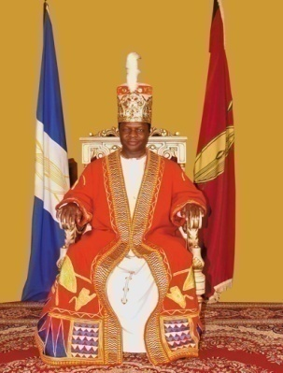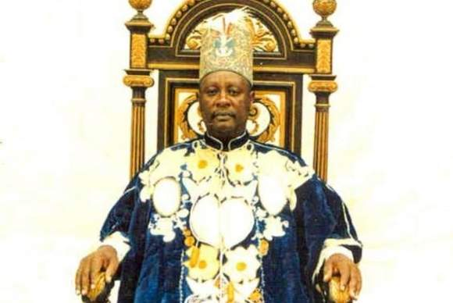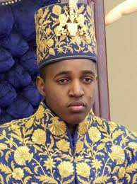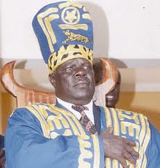
Kabaka Ronald Omukama Solomon Omukama Oy Papa Osuban
Mutebi Gafabusa Kabamba Adugala
Duties of cultural leaders
- They promote culture.
- They unite people.
- They help to develop their areas.
3. Examples of civic leaders
- DEO
- CAO
- DDHS

Exercise
- Who is the current king of Buganda kingdom?
- Which title is given to the king of Toro?
- Which tribe is rule by an Emorimor?
- State one role of a king king.

Date | Class | Subject | Time | No. of pupils
THEME : Our sub county
SUBTHEME : People in our Division
INTRODUCTION : The lesson will be introduced by reviewing
1. Political leaders include the following
- Local council 1
- Local council 2
- Local council 3
- Local council 4/MP
- Local council 5
- Mayor
2. The local council committee is headed by the Chairperson.
3. The local council committee is made up of ten members.
Duties of the local council;
- To keep law and order
- To organize meetings
- To settle disputes

Exercise
- Who is the political head of;
- A village?
- A country?
- How many members make up the LC 1 committee?
- What is the role of the LC in an area?

Date | Class | Subject | Time | No. of pupils
THEME : Our sub county
SUBTHEME : People in our Division
INTRODUCTION : The lesson will be introduced by reviewing
Members of local council and their responsibilities;
1. Chair person;
- Chairs meetings
-Heads the local council
-Signs official documents
2. Vice chair person;
-Assist the chairman
-In charge of children’s affairs.
3. The general secretary;
-records minutes
-keeps records
4) Secretary of finance; -calls the executive meeting
5) Secretary for security
6) Secretary for information, education and mobilization
7) Secretary for youth and education
8) Secretary for women and public affairs
9) Secretary for the disabled.
10) Secretary for production and environmental protection
The mayor of Mukono is Mr. Kagimu Fred.
Hon member of parliament – Nambooze Bakireke
Lc – 5 – Mr. Andrew Ssenyonga Ruzindana
Mayor – Hon. Kagimu Fred
Zone – Mr. Jingo
L.C III – Mr. Kakembo Jamil

Exercise
- Who chairs council meetings?
- Mention two other members of the LC 1 committee.

TOPICAL TEST
- Identify three types of leaders in your area.
- Mention two leaders in a church?
- Who is the current Mayor of Mukono district?
- Write the title given to the kings of the following kingdoms.
- Buganda
- Ankole
- How many members make up the LC 1 executive committee?
6. Why should a village have a Local Council?
7. Who heads the Local Council?
8. Which LC member is in-charge of the following?
- Children’s affairs
- Women’s affairs
- Security
9. Why should we have the LC in our areas?

Date | Class | Subject | Time | No. of pupils
THEME : LIVELIHOOD IN OUR SUB-COUNTY SUBTHEME : Occupations of people in our sub county
INTRODUCTION : The lesson will be introduced by reviewing

CONTENT : Economic activities

OCCUPATIONS OF PEOPLE IN OUR DIVISION

1. What is an economic activity?
An economic activity is any work done by people to get money.

2. People in our areas have different economic activities namely:

- brick making/laying
- fishing
- mining
- pottery
- nursing
- welding
- tailoring
- teaching
- hair cutting
- cattle keeping
- weaving
- carpentry
- car washing
- road construction
- building
- craft making
- farming;

- trade

3. Define these terms;
- Trade: Is the buying and selling of goods.
- Farming :This is the growing of crops and keeping /rearing of animals
- Crafts: Are things made by hands from local materials.eg.
  - balls
  - doormats
  - ropes
  - baskets
  - necklaces

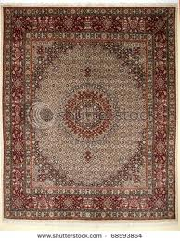 | 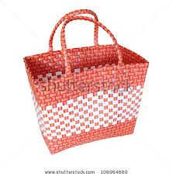 | 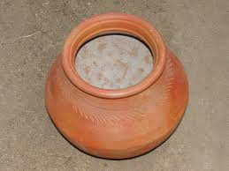
a doormat | a basket | a pot

4. The main economic activity of most people in villages is farming.
5. The main economic activity carried out near lakes and rivers is fishing.

Exercise
- What do we call work done by people to get money?
- Give four examples of such activities.
- What is the main economic activity of most people in villages.

TOPICAL TEST
- What is an economic activity?
- State any four economic activities of people in your division.
- What is the major economic activity around lakes?
- Write the meaning of the words
- Farming
- Trade
- Crafts
- Which other term can be used to mean economic activity?
- Who is a farmer?
- Name any products produced by these people.
- A farmer
- A tailor
- A carpenter

Date | Class | Subject | Time | No. of pupils
THEME : LIVELIHOOD IN OUR SUB-COUNTY SUBTHEMEs : social services in our sub - county
INTRODUCTION : The lesson will be introduced by reviewing

CONTENT : Social Services

SOCIAL SERVICES IN OUR SUB-COUNTY

1. What are social services?
Social services are services provided by the government to make people’s lives better.

2. Examples of social services.
- education
- health
- housing
- banking
- security
- communication services
- transport
- water supply

Date | Class | Subject | Time | No. of pupils
THEME : LIVELIHOOD IN OUR SUB-COUNTY SUBTHEMEs : EDUCATION
INTRODUCTION : The lesson will be introduced by reviewing

CONTENT : Education services

EDUCATION SERVICE
1. Education service is provided by the following people
- teachers
- lecturers
- professors
- tutors

2. Importance of education
- To learn how to read and write.
- To get jobs.
- To learn how to count.
- People learn how to prevent diseases.

Exercise
- What are social services?
- List two social services in your area.
- Why should people go to school?

Important officials in education service
1. The District Director of Education (DDE) heads all schools in a district.

NB. All schools in Uganda are under the Ministry of Education and Sports. (MOES)

2. The Minister for Education and Sports is Hon. Kataaha Janet Museveni .

3. The state Minister for Primary Education is Hon Rose Mary Seninde

- The Minister for Education in charge of Sports is Hon. Charles Bakabulindi.

Exercise
- Who heads all schools in a district?
- Write MOES in full.
- Who is the current minister for education and sports?

Date | Class | Subject | Time | No. of pupils
THEME : LIVELIHOOD IN OUR SUB-COUNTY SUBTHEMEs : water services in our sub - county
INTRODUCTION : The lesson will be introduced by reviewing

CONTENT : Water service
WATER SUPPLY
1. People who provide water services are called plumbers.
2. The body responsible for supplying piped water in our country is NWSC.

3. NWSC in full is National Water and Sewerage Corporation.

SECURITY SERVICE
1. Security means having peace in an area.

2. People who provide security service in our sub-county include;
- The army
- Police
- Local Defence Units(LDUs)
- Local Councils(LC)
- Private security guards

3. How do the above organs keep security?
- The army; Fights all people who attack us with guns.
- It defends the country from external attacks like rebels.
- The police; Keeps law and order.
- The LDUs; Works with the police to arrest wrong doers.
- The prison force; Keeps wrong doers out of good people.
- The LCs; Keep law and order in communities like in villages.

4. Why are wrong doers kept in prisons?
- To reform (change) into good people.
- To stop them from committing more crimes.
- To separate / isolate them from good people/citizens.

5. How do the police keep law and order?
- By arresting wrong doers.
- By keeping wrong doers in cells before they are taken to court.
- By controlling traffic on roads.
- By investigating crimes.

Exercise
- Name any two groups of people who provide security to us.
- How does the police keep law and order?
- Why are wrong doers taken to prisons?

Date | Class | Subject | Time | No. of pupils
THEME : LIVELIHOOD IN OUR SUB-COUNTY SUBTHEMEs : Transport services in our sub - county
INTRODUCTION : The lesson will be introduced by reviewing
CONTENT : Transport service
TRANSPORT SERVICE
1. What is transport?
Transport is the movement of people and goods from one place to another.
2. Types of transport
- Road transport
- Water transport
- Air transport
- Railway transport.

3. Means used in road transport

- cars
- lorries
- bicycles
- tricycles
- motorcycles
- buses
- omnibuses
- wheelbarrows
- animals like donkeys, horses, oxen, camels.
- walking or running

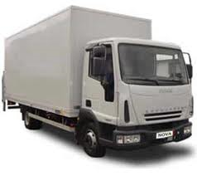 | 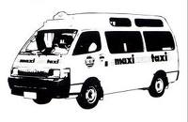 | 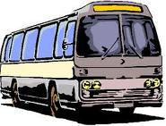
Lorry | Taxis | Buses / vans
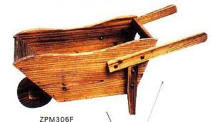 | 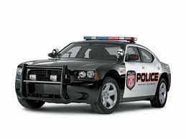 | 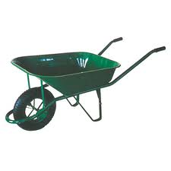
cart | cars | Wheel barrow

Exercise
- Define the term transport
- Mention two types of transport used in your division
- Draw, name and colour any two means of road transport

1. Advantages of road transport
- It is very common.
- It is cheap to construct roads.
- It has many means of transport.

2. Disadvantages of road transport
- Accidents are very common.
- Roads in towns have a lot of traffic jam.
- Marrum roads are slippery in the wet season and dusty in dry seasons.

Exercise
- What is the commonest type of transport used in Makindye.
- Why is road transport used by most people in your division?
- State any one disadvantage of road transport.

Date | Class | Subject | Time | No. of pupils
THEME : LIVELIHOOD IN OUR SUB-COUNTY SUBTHEMEs : water transport in our sub - county
INTRODUCTION : The lesson will be introduced by reviewing

CONTENT : Water transport

WATER TRANSPORT
1. Means used in water transport
- boats
- ships
- ferries
- sub-marines
- canoes
- yachts
- rafts

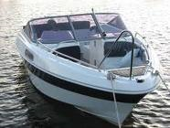 | 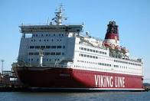 | 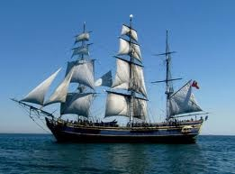
boat | ferry | ship

2. Advantages of water transport
- It is the cheapest type of transport.
- It is the best type of transport for carrying bulky and fragile goods.
- It is not affected by traffic jam.

3. Disadvantages of water transport
- It is very slow and so it cannot be used to carry perishable goods.
- Water accidents are always fatal (deadly).
- It can be affected by bad weather.

Exercise
- Which type of transport is the best for carrying bulky goods?
- Why is water transport not good for carrying perishable goods?
- Draw, name and colour any two means used on water transport

Date | Class | Subject | Time | No. of pupils
THEME : LIVELIHOOD IN OUR SUB-COUNTY SUBTHEMEs : air transport in our sub - county
INTRODUCTION : The lesson will be introduced by reviewing

CONTENT : air transport
AIR TRANSPORT
1. Means used in air transport
  - aero planes
  - air balloons
  - rockets
  - parachutes
  - air-ship
  - helicopters

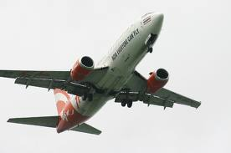
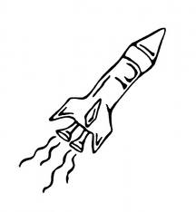
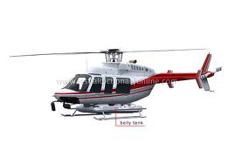
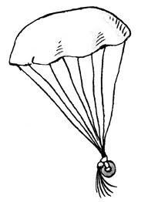

Aero plane | parachute | helicopter | rocket

2. An aeroplane is the fastest means of transport used in Uganda.

3. The fastest type of transport used for long distances is Air transport.

4. Entebbe Airport is the only international airport in Uganda.

- It is found in Wakiso district.

Exercise
- Name the fastest means of transport used for long distances?
- Where do we find the international airport in Uganda?
- Draw, name and colour any two means of air transport

Date | Class | Subject | Time | No. of pupils
THEME : LIVELIHOOD IN OUR SUB-COUNTY SUBTHEMEs : air transport in our sub - county
INTRODUCTION : The lesson will be introduced by reviewing

CONTENT : air transport
1. Advantages of Air transport
- It is the fastest type of transport.
- It is the best for carrying perishable goods.
- It is very comfortable.
- It is not affected by jam.

2. Disadvantages of air transport
  - It is very expensive
  - It is affected by bad weather.
  - It is not common in many places.

Exercise
- Why is air transport the best for carrying perishable goods?
- Give one reason why air transport is used by few people.

Date | Class | Subject | Time | No. of pupils
THEME : LIVELIHOOD IN OUR SUB-COUNTY SUBTHEMEs : railway transport in our sub - county
INTRODUCTION : The lesson will be introduced by reviewing

CONTENT : railway transport
RAILWAY TRANSPORT

1. Means used in railway transport
- Trains

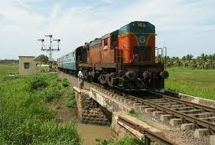
A train

2. Advantages of railway transport
- It can be used for carrying bulky goods.
- It is cheaper than road and air.
- It’s not affected by traffic jam.
3. Disadvantages of railway transport
- It is very expensive to construct railway line.
- It is not common in many places.
- It is very slow.

4. Importance of transport
Transport is good because:-
- It helps people to move from one place to another.
- It makes trade easy.
- It helps to carry goods.

Exercise
- How is railway transport better than road transport?
- Which means of transport is used on railway lines?
- Why is railway transport not good for carrying perishable goods?

Date | Class | Subject | Time | No. of pupils
THEME : LIVELIHOOD IN OUR SUB-COUNTY SUBTHEMEs : Communication services in our sub - county
INTRODUCTION : The lesson will be introduced by reviewing

CONTENT : Communication
COMMUNICATION
1. What is communication?
Communication is the sending and receiving of messages.

2. Means of communication
Communication means can be grouped into traditional (local) and modern means.

- Traditional means of communication include:
  - drums
  - whistles
  - horns
  - bells
  - gestures
  - smoke/fire

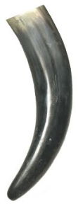  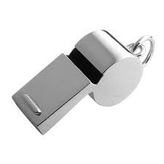 | 
A whistle |  | A horn

3. Draw and name any two local means of communication

Exercise
- What do we call the sending and receiving of messages?
- Mention two places where whistles are used for communication.
- Draw, name and colour any three local means of communication.

Date | Class | Subject | Time | No. of pupils
THEME : LIVELIHOOD IN OUR SUB-COUNTY SUBTHEMEs : Communication services in our sub - county
INTRODUCTION : The lesson will be introduced by reviewing

CONTENT : Communication
1. Modern means of communication include;

- telephones
- newspapers
- televisions
- telexes
- telegrams
- computers
- radios
- letters

  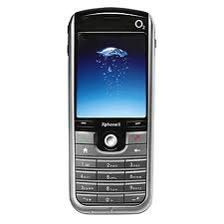 |  | 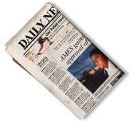  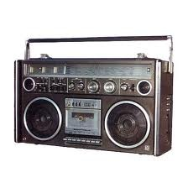
A television | A telephone | A radio | Newspapers

Exercise
- Give two uses of a radio to people.
- How can televisions be a problem to people?
- Why are there few people who use computers?
- Draw, name, and colour any two modern means of communication.

Date | Class | Subject | Time | No. of pupils
THEME : LIVELIHOOD IN OUR SUB-COUNTY SUBTHEMEs : Medical services in our sub - county
INTRODUCTION : The lesson will be introduced by reviewing

CONTENT : Medical service
MEDICAL SERVICE
1. We get medical services from.
  - hospitals
  - clinics
  - dispensaries
  - drug shops
  - pharmacies

2. People who provide medical service include:-
- doctors e.g. surgeons, dentist and opticians.
- nurses
- mid wives
- lab technicians / attendants.
- herbalists

- The district Director of Health Services (DDSS) is in charge of medical services in the district.

4. Where do herbalists get there medicine?

They get them from plants.

5. What is the use of an ambulance?
- An ambulance carries sick people (patients) to hospital.
- It also carries casualties to hospital.

Exercise
- Name two groups of people who provide medical service.
- Where do people get treatment when they are sick?
- Which vehicle carries patients to hospital?

Date | Class | Subject | Time | No. of pupils
THEME : LIVELIHOOD IN OUR SUB-COUNTY SUBTHEMEs : Banking services in our sub - county
INTRODUCTION : The lesson will be introduced by reviewing

CONTENT : Banking service
BANKING SERVICE
1. People who provide banking service
  - Bankers

3. Examples of banks include the following:-

- Bank of Uganda
- Stanbic bank
- Barclays bank
- D FCU bank
- Bank of Baroda
- Housing finance bank
- United Bank of Africa (UBA)
- Standard Chartered bank
- Crane bank
- Cairo bank
- Bank of Africa

4. Importance of banks
- They provide jobs.
- Banks provide loans to people.
- They keep important documents like land titles.
- They give provide foreign exchange services.

Exercise
- Write two examples of banks in your area.
- Apart from keeping money, give other two uses of banks.
- Which is the main bank in Uganda?
- Why do we keep our money in banks?

Date | Class | Subject | Time | No. of pupils
THEME : LIVELIHOOD IN OUR SUB-COUNTY SUBTHEMES : Banking services in our sub - county
INTRODUCTION : The lesson will be introduced by reviewing

CONTENT : Banking service

- Problems faced in providing social services
- Lack of enough funds/money.
- Large population
- Corruption
- War/instability in some areas.
- Lack of skilled people.

- Possible solutions to the problems
- Borrowing money from other countries.
- Teaching people family planning methods.
- Building better roads.
- Building more hospitals and schools.
- Arresting corrupt officials.
Exercise
- State two problems the government faces in providing social services.
- How can these problems be solved?

TOPICAL TEST

- What are social services?
- Mention any two social services in your area.
- Which social service is needed for the following;
- To control death rate and spread of diseases.
(b)To enable the movement of people and goods
- Define these terms.
(a)Communication
(b)Transport
- Write two types of transport used by people.
6. Why are there few people who use air in our division?
7. Draw and name any two modern means of communication
8. How are banks important in your area?
9. Which police department is in charge of maintaining law and order on the road?
10. State any two problems faced by schools under the UPE program.
11. What is the use of an ambulance?
12. In which division is your school found?
13. Who is the minister of Education and Sports?
14. How useful are teachers in a school?

