**CHAPTER**

**WEATHER AND CLIMATE**

**WEATHER.** This is the **condition of the atmosphere** at a particular place over a **short period** of time; it is the state of the atmosphere in terms of weather elements of the temperature. Rainfall, atmospheric pressure, wind speed and direction, humidity and sunshine at a particular time. The weather conditions in the morning may be different from those in the afternoon.

The weather conditions of a place maybe described in a number of ways. It may be said to be **sunny, cloudy, calm, windy, hot, cold, rainy and misty.**

The scientific study of weather is called **METEOROLOGY**. This study involves daily observations and measurements of weather elements the study is done by meteorologists

**CLIMATE.** This refers to the **average weather conditions** of a place over a **long period of time**. The period of time to elapse for climate to be a ascertained is usually 35 years and more. It is achieved by studying weather elements of rainfall, humidity, temperature, cloud cover, pressure and wind over a long period of time.

When the above weather elements are studied over a long period of time, one is able to achieve various climatic types like **Equatorial climate, Savanna climate, montanne climate, Semi desert and desert climate.**

A study of climate is referred to as **CLIMATOLOGY.** This is a study of weather elements over a long period of time as stated above. This study is done by climatologists

**MEASURING WEATHER ELEMENTS**

1. **TEMPERATURE: (i) MAXIMUM THERMOMETER**,

The **maximum thermometer** is used to measure maximum temperature. The instrument has a glass tube with a bulb; inside there is mercury and metal index. When temperature rises the mercury expands and pushes the metal index along the tube recording maximum temperature. When temperature falls the mercury contracts and the index remains behind. The maximum temperature is obtained by reading the scale at the end of the index which was in contact with the mercury. For example, in the figure below the maximum temperature is 300C. The index is then drawn back for the next day’s reading to the mercury by use of the magnet.

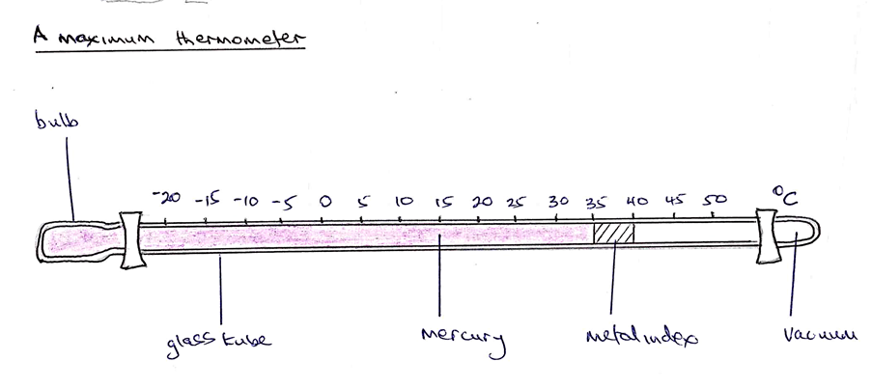

(iii) **MINUMUM THERMOMETER:** It is used to measure minimum temperature. The instrument has a glass tube with a bulb, inside there is alcohol and metal index. When there is a fall in temperature the alcohol contracts and meniscus pulls the index along the tube, when the temperature rises the alcohol expands. The index does not move but remains in the position to which it was pulled. The minimum temperature is obtained by reading the scale at the end of the index which is near the meniscus. In the figure below the minimum temperature is 150C. By raising the bulb of the thermometer, the index is returned to the meniscus.

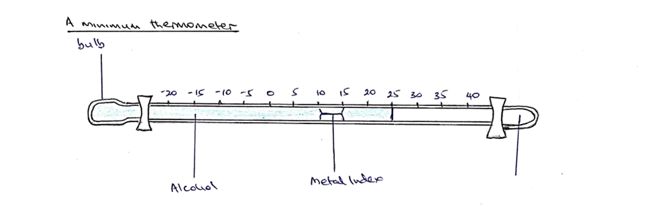

(ii) **SIX’S THERMOMETER**: The **six thermometer** is used to measure both maximum and minimum temperatures at the same time. The six’s thermometer has two limbs as shown in the diagram below. The left hand limb is used to measure minimum temperature and right hand limb is used to measure maximum temperature.

When temperature rises the alcohol in the left hand limb expands and pushes the mercury down in the left hand limb and upwards in right hand limb. The alcohol in the right hand heats up and part of it vaporizes and occupies space in the bulb. As the mercury moves upwards in the right hand limb it pushes upwards the metal index and maximum temperature is recorded.

When there is a fall in temperature, the alcohol in the left hand limb contracts and some of the alcohol vapour in the conical bulb liquifies causing the mercury to move downwards in the right hand limb and upwards in the left hand limb. As the mercury moves upwards in the left hand limb, it pushes the metal index and a minimum temperature is recorded.

A metal index in each of the limb marks the temperature which is recorded. In the diagram below the maximum temperature is 300C and minimum temperature is 250C

Temperature is measured in degrees Celcius or centigrade. On the map lines joining places of the same temperature are called **Isotherms.**

After reading, the sixs thermometer is adjusted for the next day’s reading by the use of a magnet which pulls the metal index downwards. The sixs thermometer is usually placed in the Stevenson screen.

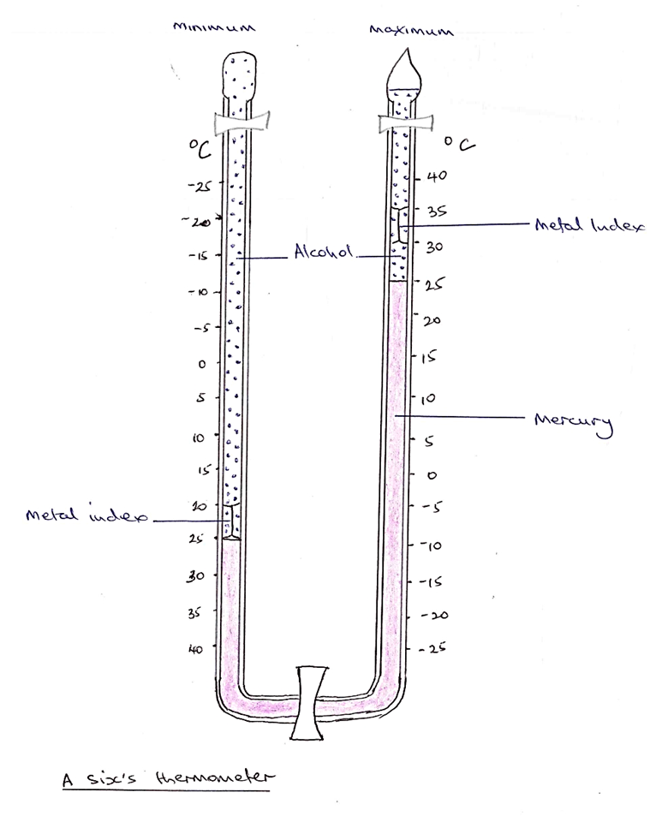

2.**RAINFALL**: Rainfall which is water droplets that fall on surface from atmosphere is measured using **rain gauge.** The rain gauge consists of cylindrical copper container in which there is copper collecting can, containing a glass jar and copper funnel that fits on the top of the container

When it rains the funnel directs rain water into the glass jar. After every 24 hours the water is poured into measuring cylinder that measures rainfall in millimeters.

The rain gauge is sunk into the ground so that the top of funnel is about 30cm above the ground surface. The aim is to prevent runoff water going into rain gauge. Also the outer case is sunk into the ground to prevent sun’s heat from evaporating rain water that collected in the jar. The rain gauge is placed in an open space so that no rain water from trees or buildings or other objects can get into the funnel.

After measuring rain water using measuring cylinder, the rain water is poured away and the rain gauge is put back into the ground for the next day’s reading. Lines drawn on the map joining places of the same rainfall are **isohyets.**

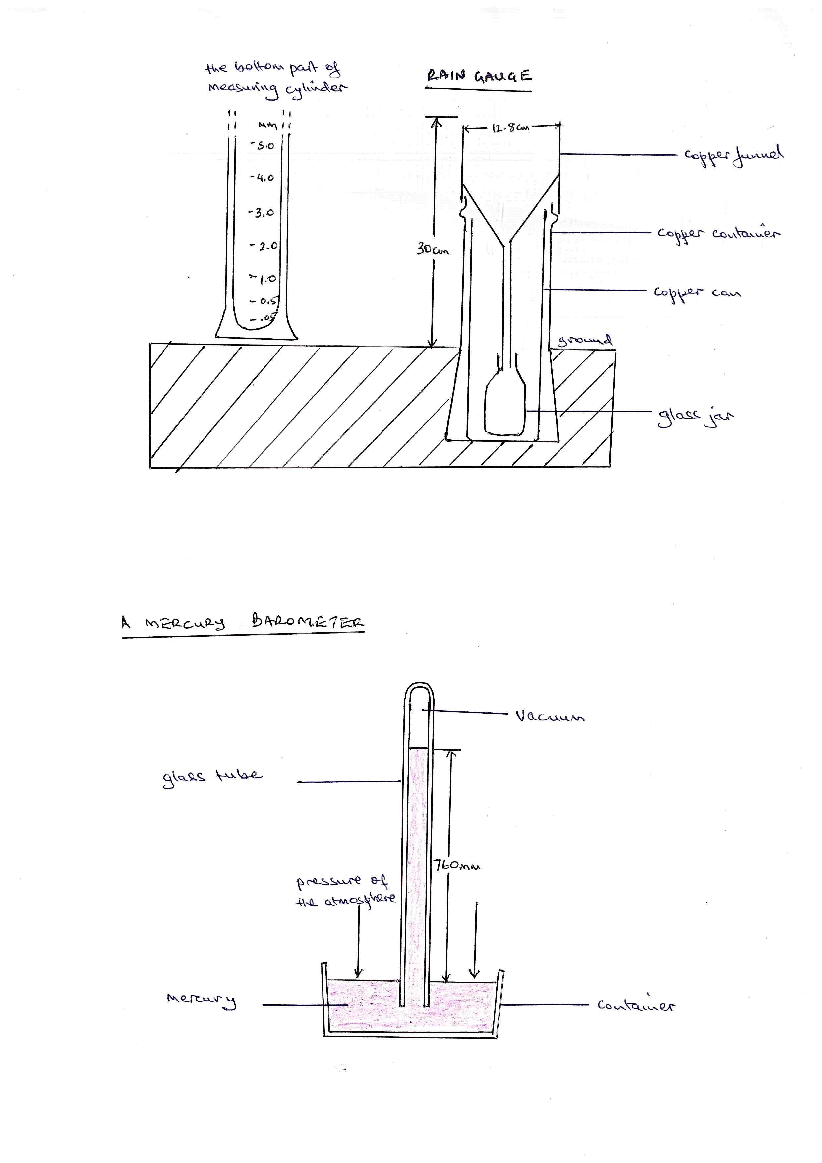

3.**PRESSURE**:

Pressure is the force/ weight of air exerted per unit area over the earth’s surface, this weight of air is the vertical column exerted from upper atmosphere to the earth’s surface which is approximately 1.034kg/cm over the sea surface. Atmospheric pressure is measured using **Mercury barometer** or **Aneroid barometer**

**MERCURY BAROMETER**: This instrument consists of a glass tube which is 1meter long, closed at one end while the other end is open. The glass tube is marked in millimeters. The glass tube is filled with mercury, the open end is closed and the tube immersed in mercury in the container after this, the tube is then opened below the level of the mercury and the tube is held vertically. It is expected to show 760mm above the level of the mercury. This level increases when the pressure is high and decreases when the pressure is low. The atmospheric pressure is measured in millibars. The lines drawn on the map joining places of the same pressure are **isobars.**

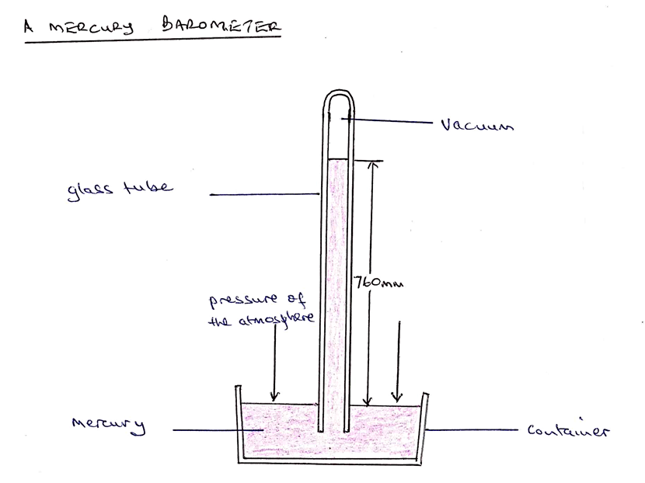

4. **Humidity**. Humidity which is the amount of water vapour in the atmosphere is measured using **hygrometer.** This instrument is composed of two ordinary thermometers.

The bulb of one of the two thermometers is wrapped in a piece of cloth or muslin which dips into water in a can with an aim of keeping muslin wet. This is the wet bulb thermometer while the other is dry bulb thermometer.

When the air is not saturated, the water evaporates from the muslin and this cools the bulb of the wet bulb thermometer causing the mercury to contract. The bulb of the dry bulb thermometer is not affected. Consequently, the two thermometer show different readings i.e the wet bulb shows lower reading. The difference between the readings is used to show humidity by use of a set of tables as shown below.

When air is saturated then there is no evaporation and both thermometers will show the same reading. This means that relative humidity is very high. i e. 100%. If the difference is small humidity is high and if the difference is very large then humidity is low.

Relative humidity is measured in percent while absolute humidity is measured in grammes per cubic meter. This instrument is kept in the Stevenson screen

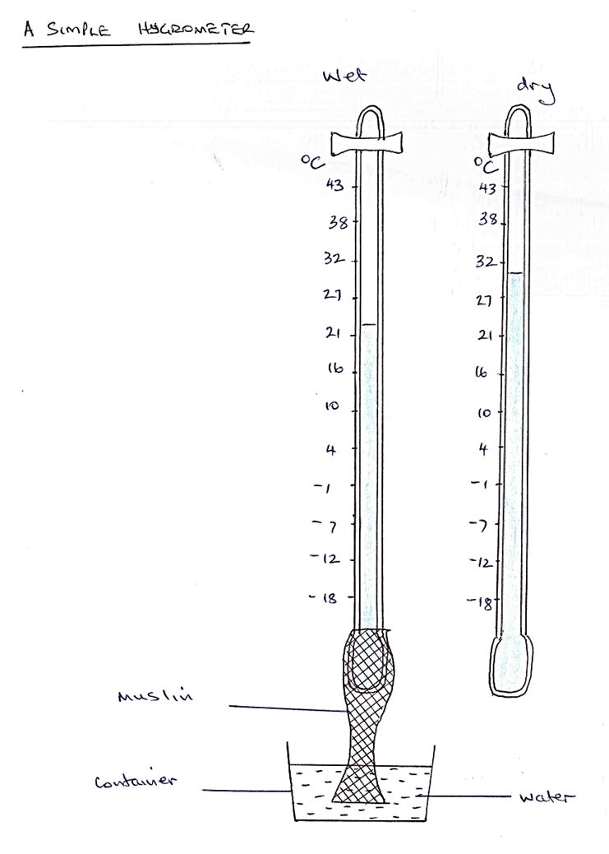

**ASIMPLE HYGROMETER**

**DRY BULB WET BULB**

200C 220C 240C 260C 280C 300C 320C 340C

200C 100% - - - - - - -

250C 65% 80% 95% - - - - -

300C 40% 50% 60% 80% 90% 100% - -

350C 24% 30% 35% 45% 57% 70% 82% 95%

Diagram

5. **WIND SPEED**

Wind speed is measured using **anemometer**. It consists of three or four metal caps, fixed to metal arms that rotate freely on vertical shaft. When there is wind the caps rotate. The stronger the wind the faster the rotation. The number of rotations is recorded on a meter to give the speed of the wind in kilometers per hour.

Diagram

6. **WIND DIRECTION**

In measuring wind direction there is use of **wind vane.** It consists of a horizontal rotating arm pivoted on a vertical shaft. The rotating arm has a tail at one end and a pointer at the other.When the wind blows the arm rotates until the pointer faces the wind. The directions of North, South, East and West are marked on the arms that are fixed to the shaft. In the diagram below the wind is blowing from the North East. The wind vane is placed in an area which is clear with no objects to interfere with movement of the wind.

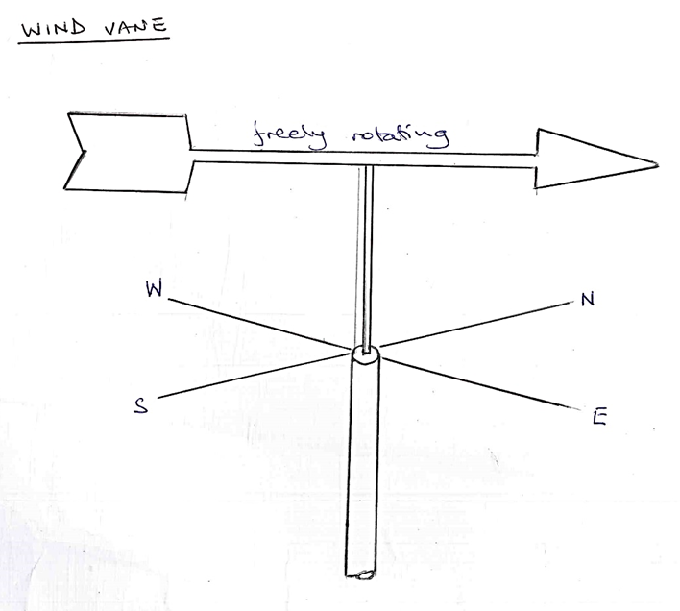

7. **SUNSHINE:**

Sunshine is light and heat that comes from the sun, in measuring sunshine there is use of **sunshine recorder** or **Campbell stokes recorder**. This instrument consists of glass sphere which is practically surrounded by metal frame on the inside of which is sensitized card. This card is graduated in hours and minutes which are units to measure sunshine. When the sun shines, the glass sphere focuses the sun’s rays on the card and as the sun moves across the sky, the rays burn a trace on the card. This only happens when the sun is shining. At the end of the day the card is taken out and the length of the trace is turned into hours and minutes which represents the total amount of sunshine for the day. Lines joining places on the map with the same sunshine are **isohels**

Diagram

**THE CLIMATE OF EAST AFRICA**

East Africa has numerous climatic zones; which include Equatorial climate, Savanna climate, Semi desert and desert climate and Montane climate. These climatic zones are spread throughout East Africa.

**EQUATORIAL CLIMATE.** This type of climate is found astride the Equator around Lake Victoria basin. It is characterized by heavy rainfall of over 1200mm per annum. There is a double maxima of rainfall around April and October. Rainfall is mainly convectional and afternoon phenomena. In this climatic zone there is high humidity of over 80%, dense cloud cover and hot temperatures of 240C-300C. There is small annual temperature range of 10-40c

**SAVANNA (TROPICAL CONTINENTAL) CLIMATE**

This is a type of climate is found in many areas of East Africa. It is found in Northern and Central Uganda, Southern and Western Tanzania and some coastal areas of East Africa. The Savanna is characterized by moderate rainfall of 650mm-1000mm, alternate wet and dry seasons, high humidity during wet season and low humidity during the dry season. And average humidity is around 50%, dense cloud cover during wet season and low cloud cover during dry season, temperatures are hot throughout the year ranging between 230 C and 290C with moderate annual temperature range of 50 C to 90 C and moderate diurnal temperature range.

**SEMI-DESERT AND DESERT CLIMATE.** This type of climate is found in Northern, North Eastern and North Western Kenya, North Eastern Uganda, Ankole Masaka dry corridor and Central Tanzania. It is characterized by low rainfall of less than 750mm, unreliable rainfall, low humidity of less than 30%, low / limited cloud cover, high evaporation rates due to hot temperature of around 300 C, large diurnal temperature range of over 100 C and large annual temperature range.

**MONTANE CLIMATE.** This type of climate is found in highland areas of East Africa like Kilimanjaro, Mt Kenya, Mt Rwenzori, Mt Elgon, Mt Muhavura, Mt Meru, Aberdare and Mau ranges and Southern Tanzania highlands. This climate is characterized by heavy rainfall of 1000mm-2000mm per annum on windward side and low rainfall on leeward side, cool temperature of less than 190 C.

**FACTORS INFLUENCING CLIMATE OF EAST AFRICA**

1. **LATITUDE:** This is the angular distance North or South of the Equator. Areas at or near the Equator experience hot temperatures while those far away the Equator experience cool temperatures. The mid-day sun is always high in the sky within the tropics and the sun’s rays concentrate the heating power onto a relatively small area on the surface leading to hot temperatures. This is in comparison to high latitudes where rays of the sun reach when they are weak and concentrate heating power on to large area leading to cool temperatures.

In the diagram below rays A and B are of equal in width and have the same heating power. Ray A at the Equator concentrates the heating power on a small area compared to Ray B. near the poles. Ray A also travels a short distance through the atmosphere while ray B travel a longer distance over which there is loss of heat through absorption and reflection by clouds and other impurities in atmosphere. This results into hot temperatures in low latitudes and cool temperature in high latitudes.

The hot temperatures in low latitudes like along the equator in East Africa result into high evaporation and evapotranspiration leading to high humidity, dense cloud cover and heavy rainfall.

diagram

2. **ALTITUDE**: Altitude is the height above sea level. Altitude influences temperature, pressure humidity and rainfall. As regards **temperature** the higher you go the cooler it becomes. Temperature decrease with an increase in altitude at an average rate of 10 C per 150 metres vertical rise or approximately 6.50 C per 1000 meters vertical rise. There are hot and warm temperatures in lower atmosphere because in lower atmosphere there is high concentration of water vapor molecules, dust particles, carbon dioxide and carbon monoxide that absorb heat. Also the lower atmosphere is warmer than upper atmosphere because air is heated from below. This explain why in East Africa the upper slopes of mountains experiences cool temperatures compared to lower slopes and lowland areas.

Altitude influences **pressure** of a place. The highland areas like on upper slopes of mountains experience low pressure due to small column of air pressing down on earth surface. In low altitude areas there is high pressure because of a big column of air pressing over the earth surface. As a result, pressure reduces with an increase in altitude.

Altitude influences **humidity** of a place. There is high humidity in lower atmosphere. This is because the lower atmosphere is near sources of water vapour like water bodies and vegetation. Also gravity tends to pull water vapour in atmosphere leading to high concentration in lower humidity layer of the atmosphere. At high altitude there is low humidity due to cool temperatures.

Altitude also influence the amount of **rainfall.** When there is increase in altitude temperature decreases causing condensation of water vapour on windward side of mountains resulting into heavy rainfall of 1000mm -1500mm. It is when altitude is over 4700metres in tropics that cold temperatures lead to formation of ice and snow. On high plateaus of East Africa there is moderate rainfall of between 700mm and 1000mm. The lower plateau areas of East Africa like Nyika plateau are dry receiving rainfall of less than 750mm.

3.**RELIEF**: Relief influences the climate of an area. In areas where there are mountains and highlands, when moist bearing winds meet highlands they are forced to rise, there is cooling and formation of clouds resulting into heavy rainfall on windward side. In East Africa this happens on North Western slopes of Mt. Elgon and South East slopes of Kilimanjaro which receives heavy and reliable rainfall.

The leeward side of mountains are left hot and dry. On the Rwenzori Mountains heavy rainfall is received on western slopes where the moist bearing westerly winds rise and cool leading to heavy rainfall. When the winds climb the Rwenzori mountains they reach Kasese when they are dry resulting into dry conditions

4. **PREVAILING WINDS**. East Africa is visited by mainly three winds which influence the climate of the region. The south East trade winds originate from Indian Ocean where they pick a lot of water vapour leading to high humidity and heavy rainfall on the East Africa coast. When they penetrate the interior they pick water vapour from Lake Victoria leading to high humidity and heavy rainfall on the northern shores of the lake.

The warm moist westerlies pick a lot of water vapour from the Congo forest, when they reach the western slopes of Rwenzori there is heavy rainfall. As they descend to Kasese on leeward side they are already dry leading to hot and dry conditions.

The North East trade winds originate from Arabian Desert thus are hot and dry leading to Seni arid conditions in Northern Kenya and North Eastern Uganda. When they reach the Red sea they pick some little water vapour and when they reach the Ethiopian highlands there is rainfall on windward side and as they rise over they lead to hot and dry conditions on leeward side which is Northern Kenya and North Eastern Uganda.

5.**DISTANCE FROM THE SEA**: East African coastal areas experience heavy rainfall as a result of prevailing winds picking a lot of water vapour from Indian Ocean and transporting it to coastal areas where it cools leading to heavy rainfall. Also the coastal areas experience afternoon and early morning rains due to land and sea breezes.

On the other hand, areas far away from the coast tend to experience relatively hot and dry climate. By the time prevailing winds reach the continental interior they are already dry. This explains why Central Tanzania is relatively dry. The South East trade winds reach the area when they have lost most of the moisture.

The distance from the sea influences temperature. This is because the land and sea have different heating and cooling rates. The sea water warms up slowly and loses heat slowly while land warms up faster and cools down at a high rate. As a result areas close to the sea remain relatively warm even at night because of the warming influence of the sea. The sea breeze moderate temperatures which would be hot during the day. Consequently the coastal areas have uniformly high temperatures while within the interior there are hot temperatures during the day and cool temperatures during the night.

6. **PRESENCE OF WATER BODIES**: Large water bodies like lakes Victoria, Kyoga, Albert, Edward, Tanganyika and Swamps like those around lakes Victoria and Kyoga lead to heavy rainfall and high humidity. This is because from these water bodies there is high evaporation leading to high humidity; water vapour condenses leading to heavy rainfall. Far away from these water bodies there is low humidity and low rainfall.

7.**OCEAN CURRENTS**: The climate of East Africa is influenced by warm Mozambique current. Due to the presence of Warm Ocean current on the East Africa coast the air above is warm and South East trade winds pick warm moist air above warm ocean current raising temperatures of adjacent land masses. Due to warm Mozambique current there is high evaporation from Indian ocean leading to high humidity and heavy rainfall.

8.**VEGETATION COVER**: Dense vegetation cover in form of forests lead to high humidity and heavy rainfall. This is because from the forests there is high evapotranspiration, water vapour go to atmosphere leading to high humidity, dense cloud cover, high rainfall. This happens in areas with forests like Mabira, Budongo and Bugoma in Uganda, Kakamega in Kenya. On the other hand, areas with limited vegetation cover like Northern Kenya experience low rainfall, low humidity and hot temperatures.

9.**PERTUBATION**: This is a climatic phenomenon where there is persistent low pressure over the Indian Ocean. This low pressure tends to attract winds to Indian Ocean. They become off shore winds from the land to the sea denying the East African landmass rainfall leading to low rainfall in northern Kenya.

10.**COASTAL CONFIGURATION**: The East African coast is aligned in North East- South West direction. As a result, when the North East trade winds are blowing they tend to blow parallel to the coast without penetrating the interior of East Africa. This leads to dry conditions in Northern parts of East Africa.

11.**CORIOLIS FORCE EFFECT**: According to ferrels law any loose object like wind, rifle bullets travelling from the Southern hemisphere is deflected to the right of its path when it crosses the equator. As a result, when the south East trade winds cross the equator it is deflected to the right back to Indian Ocean. These winds become offshore winds denying Northwestern, and Northern Kenya moisture leading to arid conditions.

12.**HUMAN ACTIVITIES**: Deforestation, overstocking and overgrazing, swamp reclamation, sinking of boreholes and urbanization has led to the destruction of vegetation cover leading to reduced evapotranspiration, low water vapour in atmosphere and reduced rainfall. The destruction of vegetation also increases temperatures because of limited absorption of gases. Industrialization also release hot gases to atmosphere leading to hot temperature

**TYPES OF CLIMATE IN EAST AFRICA**

1. **EQUATORIAL CLIMATE**

In East Africa this type of climate is found in Lake Victoria basin. Outside East Africa it is found in Congo basin, Southern part of West Africa in Africa, Amazon Basin in South America and some parts of South East Asia like Indonesia and Malaysia.

**CHARACTERISTICS OF EQUATORIAL CLIMATE**

1. Heavy rainfall with rainfall totals ranging between 1000mm and 2000mm on average. However, in some areas the rainfall is over 2000mm like on Kalangala islands.

2. Rainfall is reliable, well distributed throughout the year with no clear marked dry season.

3. Rainfall is in form of two maximas with peaks in March-April and October- November.

4. Rainfall is mainly convectional and an afternoon phenomena accompanied by lightning and thunderstorms.

5. The temperatures are hot throughout the year ranging between 230-290 C. There is great uniformity of temperature throughout the year ranging between 250C-280C on average.

6. The maximum temperature is 380C while minimum temperature is 150C depending on location.

7. The annual temperature range is small 10-40C on average. Also the diurnal temperature range is small.

8. Humidity is high around 80% due to high rates of evaporation and evapotranspiration.

9. There is dense cloud cover due to high evaporation and condensation.

10. It is dominated by air masses that converge to Inter tropical convergence zone (ITCZ) due to persistent low pressure or doldrums.

**FACTOR RESPONSIBLE FOR EQUATORIAL CLIMATE**

**1.** **LATITUDE**: East Africa is astride the equator which explains why some parts experience equatorial climate. Areas which lie between 50N and 50S of equator with an altitude of below 1000metres above sea level experience equatorial climate of hot temperatures and heavy rainfall. This is due to maximum isolation received from the sun leading to hot temperatures that lead to high evaporation and evapotranspiration that lead to high humidity and heavy rainfall.

**2**. **ALTITUDE:** This is the height above sea level Areas below 1000 meters above sea level tend to experience Equatorial type of climate of hot temperatures ranging between 230C- 290C. A number of areas of East Africa are below 1000 meters above sea level especially the lake Victoria basin or the plateau area and therefore experiences hot temperatures.

**3.** **WATER BODIES**: East Africa has numerous water bodies including lake Victoria, Kyoga , Edward, Albert and Tanganyika, Swamps like those around lake Victoria and Kyoga and rivers like Nile, Rufiji, Pangani and Ruvuma. From these water bodies there is evaporation leading to high humidity, dense cloud cover, and heavy rainfall typical of Equatorial climate like in lake Victoria basin. These water bodies lead to micro-climatic effects through land and sea breezes increasing humidity, rainfall and moderating temperatures to those typical of Equatorial climate.

**4**. **VEGETATION COVER**: East Africa has areas with tropical rain forest like Mabira, Budongo, Itwara, Kalinzu and Imaramagambo. These tropical rain forests influence the climate of surrounding areas.From these forests there is high evapotranspiration,water vapour goes to the atmosphere leading to high humidity of around 80%,dense cloud cover and heavy rainfall of over 1500mm typical of equatorial climate.

**5**. **AIR MASSES**; East Africa is visited by the South East trade winds which are on shore and have contributed to Equatorial climate on the East African coast. The South East winds pick water vapour from the Indian ocean and transport it to the land leading to high humidity, dense cloud cover and heavy rain fall of over 1000mm typical of equatorial climate. When the South East wind trade winds travel across Tanzania, they lose water vapour and reach Lake Victoria when dry but are recharged by Lake Victoria leading to high humidity, dense cloud cover and heavy rainfall on Northern and North Eastern shores of Lake Victoria typical of Equatorial climate. The westerly winds from the Congo basin bring high humidity, dense cloud cover and heavy rainfall in some parts of the Western East Africa typical of equatorial climate.

**6. CLOUD COVER**: The presence of thick cloud cover has contributed to equatorial climate in East Africa. The thick cloud cover prevents heat loss to space, more heat is retained in the lower atmosphere leading to hot temperature and small range in temperature typical of Equatorial climate

**7. ITCZ AND APPARENT OF THE OVERHEAD SUN**

The Inter Tropical Convergence Zone and the apparent movement of the overhead sun

influences the isolation and rainfall pattern. East Africa lying astride the Equator

experiences hot temperature particularly around September and March leading to high evaporation and evapotranspiration that lead to high humidity and heavy rainfall typical of equatorial climate. Because of the apparent movement of the overhead sun places around lake Victoria have rainfall throughout the year and double rainfall maxima around March- April and September –October typical of equatorial climate.

**EFFECTS OF EQUATORIAL CLIMATE**

1. The heavy rainfall high humidity and hot temperature associated with Equatorial climate lead to growth of forests like Mabira, Budongo, Bugoma, Itwara that promote forestry and lumbering.
2. The heavy rainfall experienced under equatorial climate lead to presence of many water bodies like rivers swamps and lakes that provide water for domestic and industrial use.
3. The heavy rainfall experienced under equatorial climate lead to presence of water bodies like lakes, rivers, and swamps which promote fishing and are a source of fish to surrounding people.
4. The papyrus swamps have promoted handcraft industry.
5. Heavy rainfall in Equatorial climate is lead to formation of swamps and associated peat soils.
6. The heavy rainfall experienced under equatorial climate lead to presence of forests and swamps which are habitat of wild animals like lions, leopards, elephants, and crocodiles that attack man and destroy his property.
7. The heavy rainfall and hot temperature experienced under equatorial climate lead to high water balance in the soil leading to growth of plantation crops like sugarcane tea coffee and bananas.
8. Equatorial climate is characterized by heavy rainfall accompanied by thunder and lightning. This rainfall is constantly accompanied by hailstorms and floods which cause destruction of crops which consequently lead to food shortage and famine.
9. The heavy rainfall experienced under equatorial climate lead to presence of forests and swamps which encouraged pests and diseases like tsetse flies and mosquitoes and wild animals like lions, leopards and elephants that are a threat to man, attacking man leading to loss of life.
10. Heavy rainfall and hot temperature under equatorial climate encourage leaching and formation of lateritic soils not suitable for cultivation of some crops.
11. The heavy rainfall encourages soil erosion in some areas where there are hills which leave soil infertile not suitable for agriculture.

**2. SAVANNA (TROPICAL CONTINENTAL) CLIMATE**

This type of climate covers the largest part of East Africa. In East Africa it covers most of Northern Uganda, some parts of Central and Western Uganda, most of Western Tanzania and the rift valley areas of Kenya.

**CHARACTERISTICS OF SAVANNA/ TROPICAL CONTINENTAL CLIMATE**

1. Moderate rainfall ranging between 750mm to 1000mm extending to 1270mm near the Equator and to 500mm towards semi desert areas.

2. Rainfall is seasonal with one rainy season and one dry season. This rainfall depends on the movement of Inter Tropical Convergence Zone (ITCZ).

3. Rainfall is convectional and an afternoon phenomenon.

4. Rainfall is mainly received October to March in Southern parts of East Africa and April to September in Northern parts of East Africa.

5. There is high humidity during the wet season and low humidity during the dry season.

6. There is dense cloud cover during the wet season and clear skies on low cloud cover during the dry season.

7. In savanna climate regions there are hot temperatures ranging between 200C and 270C.

8. Day temperature reach 350C and night temperature reach 200C.

9. The annual temperature range is moderate between 60C and 90C.

**FACTORS THAT HAVE FAVOURED OCCURRENCE OF SAVANNA CLIMATE IN EAST AFRICA**

**1. LATITUDE**: East Africa is located within the tropics between 4½0 North of the Equator and 120 South of the Equator. As a result of this location astride the Equator most of East Africa experiences hot temperature between 230C and 290C which is typical of tropical continental (savanna) climate. Northern Uganda and Southern Tanzania also experience one rainy season and one dry season typical of savanna climate.

**2. ALTITUDE**: Many areas of East Africa lie at an Altitude of below 1500 meters above sea level. As a result of this altitudinal location areas like Northern Uganda, Central Uganda, Rift Valley areas in Western Uganda, Western Tanzania and Western Kenya experience hot temperatures, and moderate rainfall which is typical of savanna climate.

**3. RELIEF:** Relief has influenced the occurrence of savanna climate in East Africa. Many areas of East Africa are low lying areas like Northern Uganda, Rift valley areas and Western Tanzania. As a result of being low-lying without mountains to act as cooling agents, these areas experience hot temperatures typical of Savanna Climate. Also the absence of high mountains in these areas has resulted into moderate rainfall of between 500mm to 1000mm being experienced.

**4. AIR MASSES (WIND SYSTEM**: East Africa is visited by South East trade winds, westerly winds and North east trade winds which have contributed to occurrence of savanna climate. The South East Trade winds originate from Indian Ocean where they pick water vapor which they transport to mainland which they deposit on East African Coast as rainfall. As they penetrate the interior of Tanzania they have lost most of the moisture resulting into moderate rainfall of 500mm to 1000mm in Western and Central Tanzania typical of savanna climatic conditions

The Westerlies which are winds that originate from the Congo basin deposit moisture on the windward side of Kigezi highlands and Rwenzori Mountains leaving the lee ward sides relatively dry with savanna climate. This explains why the western rift valley and Ankole- Masaka corridor experience savanna climate characterized by moderate rainfall and hot temperatures.

**5. CONTINENTALITY**: Continuality or distance from the sea is responsible for Savanna climate in East Africa. Areas like Central, Western and Northern Uganda and central Tanzania are very far in the interior. The winds from the ocean/sea reach these areas when they have deposited most of the moisture leading to tropical continental climate.

**6. LIMITED WATER BODIES**: Areas of East Africa like Western and Central Tanzania, Ankole-Masaka corridor and Northern Uganda have limited water bodies in form of lakes, rivers and swamps to recharge the winds that traverse these areas. As a result these winds pick limited water vapour leading to moderate rainfall and hot temperatures typical of savanna climate.

**7. VEGETATION**: The vegetation cover in Western and Southern Tanzania is mainly savanna woodland, Northern Uganda and rift valley area of Western Uganda is dominated by savanna grassland, Nakasongola areas are dominated by savanna grassland while Ankole Masaka corridor is dominated by dry savanna. These vegetation types have released moderate humidity through evapotranspiration resulting into moderate rainfall typical of savanna climate.

**8. HUMAN ACTIVITIES**: Human activities have contributed to the occurrence of savanna climate in East Africa. These human activities include deforestation, overstocking and overgrazing, sinking boreholes, swamp reclamation and burning. These human activities have contributed to deterioration of vegetation and some water bodies leading to reduced evapotranspiration leading to reduced rainfall to moderate levels and hot temperatures typical of savanna climate.

**OUTLINE OF EFFECTS OF SAVANNA CLIMATE**

1. It has led to growth of savanna vegetation characterized by savanna woodlands and savanna grassland the latter which has encouraged livestock rearing and pastoralism because of the available pastures.

2. The growth of savanna vegetation in form of savanna woodland and grassland due to savanna climate has encouraged creation of National Parks, Game Reserves that have promoted tourism.

3. Savanna climate of moderate and seasonal rainfall has encouraged growth of annual crops like cotton, maize, beans and millet.

4. In areas where there is savanna woodland due to savanna climate, it has encouraged pests and diseases like tsetse flies and associated sleeping sickness to man and nagana to cattle.

5. Savanna climate in low land areas has encouraged severe destructive floods during the wet season which displace people.

6. Savanna climate is associated with long drought during the dry season which leads to failure of crops, low agricultural production and food shortage and famine. In some areas it has led to expensive irrigation farming like Mobuku irrigation scheme in Western Uganda

7. Savanna climate characterized by long drought and hot temperatures has resulted into wildfires during the dry season.

**SEMI DESERT CLIMATE**

Semi desert climate is found in the interior of continents and on western sides of continent along the horse latitudes 300 North and South of the Equator. In East Africa Semi desert Climate is found in North East Uganda (Karamoja), Ankole- Masaka Corridor, Lake Albert Flats, North Western Kenya (Turkana), North Eastern Kenya, Nyika Plateau in Kenya and some parts of Central Tanzania.

**CHARACTERISTICS OF SEMI- DESERT CLIMATE.**

1. Low rainfall of less than 750mm annually. This rainfall is not evenly distributed but concentrated in one season.

2. Rainfall received is unreliable and seasonal with no definite wet season.

3. Has a long dry season of around 9 months and a short wet season of around 3 months.

4. There is low humidity of less than 30% as a result of low evapotranspiration due to limited vegetation cover.

5. There is low or no cloud cover especially during the dry season.

6. The air is dry due to constant desiccating effect of dry winds like North East trade winds.

7. There are strong winds particularly during the dry season.

8. There are hot temperatures of 300 C and over due to absence of cloud cover.

9. There is high/ large diurnal temperature range of 100C and above.

10. Day temperatures are very hot over 350C because of clear skies and night temperatures decrease to below 200C because of clear skies.

11. Diurnal temperature range is high/ large over 150C

**FACTORS RESPONSIBLE FOR THE OCCURANCE OF SEMI DESERT CLIMATE**

**1. TRADE WINDS**: The trade winds that visit East Africa are responsible for semi-desert climate in northern, Northern Western Kenya and North Eastern Uganda. The North East trade winds originate from the Arabian Desert thus are hot and dry pick little moisture from the Red sea. On reaching the Ethiopian highlands deposit moisture on the windward side. The leeward side being Northern and Northwestern Kenya, Northern Eastern Uganda receives little rainfall, have low humidity and hot temperatures typical of semi-desert climate.

The Southern East trade winds originate from the India Ocean where they pick water vapour which is deposited along the East African coast. As they continue to the interior they lead to dry conditions in Central Tanzania. When the South East trade winds reach Lake Victoria, they are recharged depositing moisture in the on the North-Eastern shores of the lake thus leaving Ankole-Masaka corridor dry.

The Westerly winds originate from Atlantic Ocean, pass over Congo forest where they collect water vapour are moisture laden and deposit this moisture in form of rain in on the wind ward side of Mt. Rwenzori. On reaching the leeward side of the mountain they are already dry, lead to hot temperatures and dry conditions in some parts of Kasese and Lake Albert flats.

**2. DISTANCE FROM THE SEA / CONTINENTALITY**: Places near water bodies like East African coastal areas receive heavy rainfall and have high humidity. When South-East trade winds reach the East African Coast after collecting a lot of water from Indian ocean, they deposit moisture in form of rain. When they penetrate inland they continue depositing moisture and by the time they reach Central Tanzania, they are already dry leading to hot and dry conditions typical of semi-desert climate.

**3. ABSENCE OF HIGH MOUNTAINS**: The absence of high mountains in some parts of East Africa has led to Semi desert climate. Although the South East trade winds are dry, they are not completely dry. Northern Kenya, Turkana land and Karamoja lack high mountains to trap the little water vapour brought by North East trade winds . The winds blow across the region without rising and cooling thus there is limited rainfall formation leading to semi-desert climate.

**4. LIMITED WATER BODIES**: Parts of East Africa like Northern Kenya, Northern Western Kenya, North Eastern Uganda, Ankole-Masaka corridor and Central Tanzania lack water bodies. The dry winds blowing over these areas, pass without being re-charged and thus continue to bring semi-desert climatic conditions.

**5. LIMITED VEGETATION COVER**: Areas like North Eastern Uganda (Karamoja), Ankole-Masaka corridor; Northern Western Kenya and Central Tanzania have limited vegetation cover resulting into low evapotranspiration, low humidity and low rainfall typically of semi-desrt climate. The limited vegetation leads to limited absorption of gases like carbon dioxide and carbon monoxide thus leading to hot temperatures.

**6. CORIOLIS FORCE EFFECT**: According to Ferrell’s law any loose objects flowing in the Northern hemisphere is deflected to the right of its path. This deflection is due to the rotation of the Earth. As a result the South East trade winds blowing across Kenya are deflected towards the Indian and therefore become offshore winds which do not bring rainfall to the land mass hence semi-desert climate in Northern and North Eastern Kenya.

**7. PERTUBATION:** This is a condition whereby there is persistentlow pressureover the Indian Ocean as a result of high temperatures. As a result of this warm moist air over the land is diverted to Indian Ocean where they become offshore leaving the land mass dry.

**8. COASTAL CONFIGURATION**: The East African coast is aligned in the North East-South West direction. As a result, the North East trade winds blow parallel to the coast with its moisture without penetrating the interior of the Northern part of East Africa. This leaves Northern and North Eastern Kenya dry with low rainfall and hot temperature typical of semi-desert climate.

**9. INDUSTRAILISATION AND GLOBAL WARMING**: At present there is general increase in temperature worldwide as a result of global warming leading to hot and dry conditions in numerous areas of East Africa. Increased industrialization worldwide has resulted into atmospheric pollution increasing greenhouse gases in the atmosphere. This has resulted to general increase in temperatures resulting into semi desert climate.

**10. HUMAN ACTIVITIES:**

(i) **DEFORESTATION**: The continuous cutting of trees for timber, fuel wood (charcoal, firewood) building materials and poles has contributed to semi desert climate. It has resulted into reduced evapotranspiration and limited absorption of gases leading to low humidity, low rainfall and hot temperatures hence semi-desert climate.

(ii) **OVERSTOCKING AND OVER GRAZING**: Overstocking is keeping of many animals more than the carrying capacity of an area while overgrazing may be due to lack of controlled grazing. When there is overstocking and overgrazing there is destruction of vegetation resulting into reduced evapotranspiration leading to low humidity, low rainfall and hot temperatures

(iii) **BURNING**; Burning is used by nomadic pastoralists as a method of clearing the land to get rid of unpalatable pasture to allow growth of fresh pasture and shifting cultivators as a method of clearing the land. Wild fires also lead the destruction of the different vegetation types. When there is the burning there is reduced evapotranspiration, leading to low humidity, low rainfall and hot temperature

(iv) **SWAMP RECLAMATION;** In many areas in East Africa swamps have been reclaimed for crop cultivation, grazing and settlement. This has been the case as regards swamps in broad valleys of Kigezi and lowlands with swamps in Lake Kyoga and Lake Victoria basins. As a result of swamp reclamation there is reduced evaporation and evapotranspiration resulting into low humidity, low rainfall and hot temperatures typical of semi desert climate.

(v) **SINKING BOREHOLES;** In semi-arid areas there has been sinking boreholes to get water for domestic and other uses. When there is sinking of boreholes, there is lowering of water table resulting into drying of trees. When trees dry there is reduced evapotranspiration resulting into low humidity, low rainfall and hot temperatures.

(vi). **OTHER HUMAN ACTIVITIES;** These includes mining and quarrying, over cultivation. All these activities lead to reduced evapotranspiration leading to low humidity ‘low clouds cover and low rainfall hence semi desert climate.

**EFFECTS OF SEMI DESERT CLIMATE**

Semi desert climate is characterized by low and unreliable rainfall leading to prolonged drought. This leads to low agricultural production, food shortage and famine.

It leads to low soil water balance. This hinders agricultural activities particularly cultivation of crops.

It is characterized by low and unreliable rainfall, with a short wet season. This leads to growth of seasonal crops like millet, sorghum and groundnuts. Fast maturing crops are grown.

It results into degeneration of the vegetation cover. There is growth of semi desert vegetation which leads to shortage of pasture that limit livestock rearing.

It leads to degeneration of vegetation leading to poor pasture and this in turn force people to practice nomadic pastoralism. People move from place to place in search of pasture and water.

It has led to lowering of water table. This is as a result of low and unreliable rainfall. The lowering of water table leads to shortage of water for domestic and other uses.

It is associated with hot temperatures which lead to high evaporation. This leads to saline conditions on the earth surface. The soils have high concentration of salts

It leads to limited vegetation cover which results into soil erosion. Wind erosion is common in semi desert climatic areas of East Africa like Northern and North western Kenya.

It leads to air pollution. As a result of limited vegetation cover strong winds lead to air pollution and dust storms which lead to respiratory diseases, and poor visibility that lead to traffic accidents.

The hot and very hot temperatures that characterize semi desert climate result into wildfires. This is as a result of extreme hot temperatures during the dry season. This result into burning of vegetation due to due to wildfires.

**DESERTIFICATION**

Desertification is the process whereby formerly semi-arid areas experience desert conditions.

It is the process where areas formerly experiencing low rainfall, hot temperatures, and low humidity experience desert conditions. It is where the desert conditions extend into formerly semi- arid areas. The desert conditions that extend into semi-arid areas include:

* Very low rainfall of less than 250mm. This rainfall is very unreliable and when it comes it appears in one short season.
* Very low humidity of less than 20%.
* Very clear skies with limited or no cloud cover.
* Very hot temperatures throughout the year.
* Very large diurnal and annual temperature range which in some cases may be over 250C.
* Very strong winds and dust storms.
* Absence or limited vegetation cover.
* Absence of surface water apart from some few salt marshes.

**CAUSES OF DESERTIFICATION**

**Deforestation** has contributed to desertification in East Africa. Trees have been cut for timber, for fuel for cultivation and settlement particularly in densely populated areas like Kigezi Highlands and slopes of Mount Elgon. When trees are cut there is reduced evapotranspiration leading to reduced humidity in atmosphere, low rainfall and hot temperatures leading to desertification.

**Burning** has contributed to desertification in East Africa. Burning is commonly used by the shifting cultivators as an easy method of clearing the land. Also burning is used by nomadic pastoralists like the Masai, Turkana, Karamojong who burn grass during the dry season to allow growth of fresh pasture. Wild fires also contribute to burning. When there is burning there is deterioration of the vegetation leading to reduced evapotranspiration, leading to low humidity, low rainfall and hot temperature resulting into desertification.

**The rapid population increase** has contributed to desertification. The population of East Africa countries (Kenya, Tanzania and Uganda) has grown to around 157 million in 2020. The rapid population increase has resulted into the use of marginal lands like semi-arid areas and steep slopes that has accelerated soil erosion and deterioration of vegetation leading to reduced evapotranspiration, resulting into very low humidity, very low rainfall and very hot temperatures typical desertification.

**Overstocking** and **overgrazing** in areas like Karamoja, Turkanaland and Masailand has resulted into desertification. This is because it has resulted into destruction of vegetation cover resulting into reduced evapotranspiration resulting into very low rainfall and very hot temperatures associated with desertification.

**Poor agricultural methods** have resulted into desertification. These agricultural methods include up and down ploughing, monoculture, over cropping and over cultivation. These result into loss of soil fertility, deterioration of vegetation cover, reduced evapotranspiration resulting into very low humidity, very low rainfall and very hot temperatures typical of desertification.

**Sinking boreholes** in many parts of East Africa in search of water has contributed to desertification. It has resulted into lowering of water table which in turn leads to drying of trees that reduces humidity in atmosphere leading to very low rainfall and very hot temperatures.

**Swamp reclamation** in many parts of East Africa has contributed to desertification. Swamps have been reclaimed in Kigezi and Bushenyi for cultivaton and in areas around lake Kyoga for cultivation of rice and around urban centers like Kampala for settlement. The reclamation of swamps has reduced evaporation and evapotranspiration resulting into reduced rainfall and hot temperatures.

**Mining and quarrying** especially by open cast methods has resulted into destruction of vegetation cover which contributed to desertification. The destruction of the vegetation as a result of mining leads to reduced evapotranspiration resulting into low rainfall and hot temperatures.

**Urbanization** and **expansion of settlements** in rural areas in East Africa has contributed to desertification. This is as a result of rapid increase in population. This has resulted into destruction of vegetation in order to get land for settlement which in turn has led to reduced rainfall and increase in temperatures typical of desertification.

**Industrialization** has contributed to desertification. Increase in greenhouse gases due to air pollution when hot gases are released into atmosphere as a result of industrialization has led to desertification. These greenhouse gases have high affinity for heat resulting into very hot temperatures.

**Reduction in surface water bodies** like lakes and swamps has led to desertification. The reduction in surface water bodies is as a result of siltation and evaporation. This results into reduced evaporation, low humidity and very low rainfall typical of desertification.

**AN OUTLINE OF WAYS OF COMBATING DESERTIFICATION**

1. There is establishment of environmental Management bodies like National Environmental Management Authority in Uganda (NEMA), National forestry authority (NFA) to fight environmental degradation.
2. There has been undertaking regional cooperation to fight drought and desertification through Intergovernmental Authority on Development (IGAD) with members states including Djibouti, Ethiopia, Somalia, Eritrea, Sudan, South Sudan, Kenya and Uganda.
3. International organization have cooperated with local East African countries to control desertification. These international organizations include world wild fund for Nature (WWF) United Nations Environmental Program (UNEP) and International Union for Conservation of Nature. (IUCN)
4. Encouraging the operations of local Non-Conservational Organizations (NGO) involved in conservation.
5. Evicting encroachers from National parks/ game reserves, forest reserves and wetlands.
6. Use of proper agricultural practices like contour ploughing, terracing, mulching, agro-forestry and controlled grazing that conserve the environment.
7. Construction of water reservoirs like valley dams.
8. Use of alternative sources of energy like hydro-electric power and solar energy to reduce the cutting of trees for fuel.
9. Afforestation which is planting trees where they never existed and reafforestation which is replanting trees where they were cut.
10. Mass Education and public awareness programmes through radio and television programmes, Seminars, newspapers and magazines

. **TEMPERATURE**

Temperature is how hot or cold a place is. It may be hot, warm, cold or very cold.

**MEAN DAILY TEMPERATURE**

This refers to the sum of maximum and minimum temperature divided by two i.e.

Mean Daily Temperature = Maximum Temperature + Minimum Temperature

2

**MEAN MONTHLY TEMPERATURE**: This refers to the sum daily mean temperature for one month divided by the number of days in that month.

**MEAN ANNUAL TEMPERATURE**: This refers to the sum of mean monthly temperatures for a year divided by 12 months.

**DAILY TEMPERATURE RANGE:** This is difference between maximum temperature and minimum temperature for a day e.g.

Maximum temperature = 320C

Minimum temperature =240C

Daily (diurnal) temperature range = maximum – minimum

= 320C – 240C

= 80C

**ANNUAL TEMPERATURE RANGE**: This is the difference between the highest and the lowest mean monthly temperature in a year e.g.

- Highest mean monthly temperature = 280C

- Lowest mean monthly temperature = 240C

- Annual temperature range =highest – lowest

= 280C – 240C

= 40C

**CONDITIONS RESPONSIBLE FOR TEMPERATURE VARIATIONS**

**1. LATITUDE**: This is the angular distance North or South of the Equator. Areas in tropical latitudes tend to experience hot temperatures where as areas far away from the Equator tend to experience cold temperatures sometimes going below O0C. In the tropics the mid-day sun is always high in the sky and concentrates the heating power on to relatively small area while the sun rays that affect temperate areas and Polar regions concentrate the heating power on to a wide area. As a result at the Equator there are hot temperatures while high latitude areas experience cold temperatures.

In the diagram below two rays A and B are equal in width and thus have the same heating power. Ray A concentrates the heating power on to relatively small area and travels over a short distance over which heat is absorbed reflected and scattered by clouds, dust and water vapour. This results into temperatures being hot at the Equator and cold in Polar regions.

**MORE INSOLATION REACHES EARTH SURFACE AT 900 THAN WHEN IT IS LESS THAN 900**

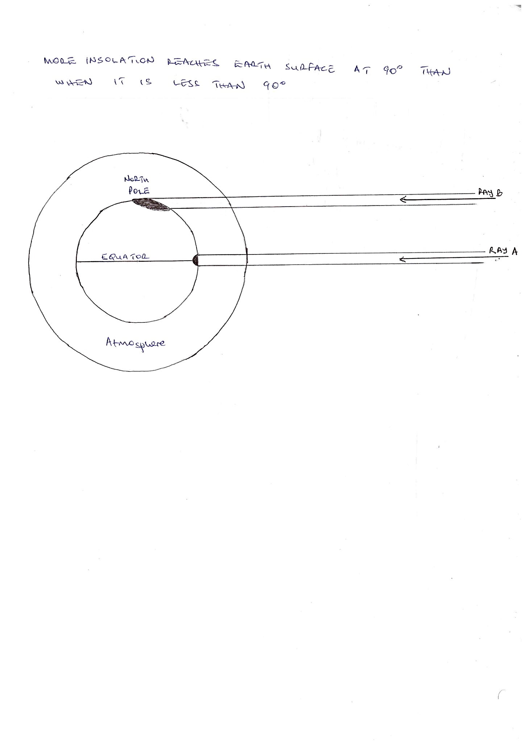

2. APPARENT MOVEMENT OF OVERHEAD SUN: The apparent movement of the overhead sun North or South of the Equator influences temperature of a place. When the sun is in the Northern hemisphere around June / July there are hot temperatures over the Tropic of Cancer and cold temperatures over Tropic of Capricorn.

On the other hand, when the sun is overhead the Southern hemisphere around December / January there are hot temperatures over the Tropic of Capricorn and cold temperatures over the Tropic of Cancer.

3. ALTITUDE: Altitude is the height above sea level. Temperatures decrease with an increase in altitude. The temperature of air falls by 6.50F per 1000 metres vertical rise. High temperatures are recorded in lower atmosphere because in lower atmosphere there is high concentration of water vapour molecules, dust particles, carbondioxide and other gases which absorb heat and retain it in lower atmosphere. This explains why highland areas like Rwenzori, Kilimanjaro and Kenya experience cold temperatures. Secondly the atmosphere is heated from below. Outgoing terrestrial radiation from the earth surface warm the atmosphere from below. As a result, areas in the lower atmosphere experience high temperatures while those in the upper atmosphere experience cool temperature

4. WIND SYSTEM: Winds have the ability to transport temperature conditions of their origins to final destinations. For example on the African continent, the North East trade winds transport hot conditions to Northern and North Eastern Kenya. This is because it originates from the hot Arabian desert, passes over the hot Somalia and transports the hot temperatures to Northern Kenya. When the North East Trade winds pass over the Ethiopian highlands, they descend, warming up bringing hot conditions to Northern parts of East Africa. Outside East Africa the warm Harmattan winds transport hot conditions to some parts of West Africa during the dry season.

5. DISTANCE FROM THE SEA: The Land and water surfaces normally absorb and lose heat at different rates. The land heats and cools very quickly than the sea due to a number of reasons.

-The land has low specific heat capacity than the sea water. -The land surface tends to be dull absorbing heat while the water surface tends to be shinny reflecting more sunlight.

- The land surface is opaque and therefore a small layer is heated while the water tends to be transparent allowing incoming radiation to penetrate to considerable depth.

- The waves and currents in the water tend to transport heat to lower layers

As a result of the above during the day the land heats up faster than the sea. Low pressure develops over the land and high pressure develops over the sea which is cool. **A** **sea breeze** develops from the sea moving to the land transporting cool temperatures.

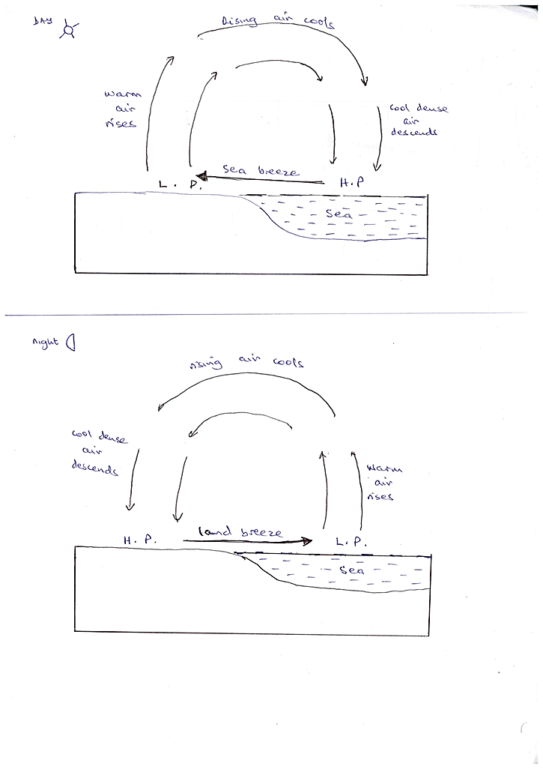During the night the reverse occurs. The land cools faster than the sea resulting into the land becoming cold while the sea remains relatively warm. High pressure develops over the land and low pressure develops over the sea. This results into the **land breeze** that moves from land to the sea.



6. OCEAN CURRENTS. Ocean currents influence temperature conditions of surrounding areas. This is when winds blow over them. When a place has Warm Ocean current like Brazilian warm current, Mozambique warm current and North Atlantic Drift, the air above is warm. When a wind blows over such warm current it is warmed up and transports warm temperatures to surrounding areas.

When a place has a cool ocean current like Benguela, Peruvian / Humboldt and canary cool ocean currents, the air above is cool and when the wind passes over it transports the cool temperatures to the land margins. This explains why Namib coast affected by cool ocean current experiences temperatures of 160C – 190C while Mozambique coast affected by warm ocean current experiences hot temperatures of 220C – 280C.

7. COLOUR OF THE SURFACE: The nature of the surface influences mean annual temperatures as it influences the ability of such surfaces to reflect and absorb heat. The ice surfaces like on upper slopes of mountains like Ruwenzori, Kenya and Kilimanjaro reflect heat resulting into low mean annual temperatures, whereas dark land surfaces particularly in volcanic areas absorb heat leading to high mean annual temperature.

8. VEGETATION COVER

Thick vegetation cover tends to reflect, absorb and scatter heat leading to low temperatures. The thick vegetation cover also absorbs gases in the atmosphere like carbon dioxide and carbon monoxide which have high affinity for heat. As a result areas with thick vegetation cover like Mabira, Imaramagambo, Kibaale, Budongo and Bugoma in Uganda and Kakamega in Kenya tend to experience cool temperatures while areas with limited vegetation cover like Central Tanzania North Eastern Uganda and Northern Kenya experience hot temperatures

9. CLOUD COVER: Clouds tend to reflect and scatter heat. When there is thick cloud cover it reduces the amount of solar radiation reaching the surface thus reducing temperature. This explains why in Equatorial regions the temperatures are lowered by cloud cover. In arid and semi-arid areas during the day the absence of cloud cover result into high solar radiation resulting into hot temperatures.

During the night areas with thick cloud cover tend to experience hot or warm temperatures. This is because the thick cloud cover tend to trap outgoing radiation from the earth surface which it absorbs and reflect back to the surface. In areas where there is absence of cloud cover during the night there is rapid loss of heat to atmosphere leading to cool temperatures.

10. HUMIDITY: When there is high humidity in the atmosphere, temperature tends to increase. This is because water vapourtend to absorb heat and retain it in lower atmosphere thus increasing temperatures. On the other hand in areas with low humidity, less heat is absorbed leading to low temperatures.

11. LENGTH OF DAY AND NIGHT: The temperature of a place depends on length of day and night. When the sun is in the Southern hemisphere around December / January, there are few hours of day light in Northern hemisphere and when the sun is in Northern hemisphere in June / July there are few hours of day light in southern hemisphere. When an area has 8 hours of day light and 16hours of night, it experiences limited insolation leading to cool temperatures.

12. ASPECT. This is the direction of the slope in respect to sunshine. Aspect is of minor significance in tropical areas but is important in temperate areas. In Europe like in Alps, the south facing slopes are warmer than the North facing slopes due to rays striking the south facing slopes at a steeper angle. As a result the North facing slopes of the Alps are sheltered from direct sun and are therefore cooler than the south facing slopes.

1/3 page

13.HUMAN ACTIVITIES: Activities of man like deforestation, swamp reclamation, industrialization and burning grass have tended to increase temperatures. When there is deforestation there is less absorption of gases in the atmosphere leading to hot temperatures. The swamp reclamation, sinking boreholes, and burning grass reduce vegetation cover, reducing the rate of absorption of gases in the atmosphere leading to hot temperatures. Industrialization releases carbon dioxide and other gases in the atmosphere that increase temperatures.