**BOOK FOUR**

**LOWER SECONDARY CURRICULUM.**

**TERM ONE.**

**THEME; REPRODUCTION IN ORGANISMS.**

**CHAPTER ONE; ASEXUAL REPRODUCTION IN PLANTS (VEGETATIVE REPRODUCTION).**

**Competency;** The learner appreciates that some parts of a plant can develop into new develop into new independent plants.

***Learning outcomes;***

* ***Know the meaning of asexual reproduction***
* ***Understand how plants reproduce asexually.***
* ***Understand the asexual reproduction in plants has important commercial applications.***

***INTRODUCTION.***

Continuity of living organisms is assured by the life process of **Reproduction**.

Reproduction is the means by which organisms propagate themselves. New individual organisms are reproduced from their offsprings. This can either be by **asexual reproduction** and **sexual reproduction** Plants reproduce asexually by **vegetative propagation**.

Vegetative propagation is a type of asexual reproduction where parts of a plant other than the seed becomes detached and develop into a new self-sustaining plant.

Types of vegetative propagation are ***Natural vegetative propagation*** and ***artificial vegetative propagation.***

***1.1: Meaning of asexual reproduction.***

|  |
| --- |
| ***Asexual reproduction is a type of reproduction which does not involve fusion of gametes and therefore only one individual is involved.*** |

***1.2: Identifying plant parts that reproduce asexually.***

|  |
| --- |
| Plant parts that are used to get **new plants** are;   * Leaf. * Stem. |

How each of the plant part is used to form new plants?

|  |
| --- |
| ***Leaf.***  A leaf of **Bryophyllum** forms tiny plants at **notches** which develop into new plants when conditions are favourable. |

|  |
| --- |
| ***Stem.***  There are mainly **two types** of stems namely.  ***Aerial stems***   * These stems that are above the ground e.g. erect stems (woody stems, herbaceous stems) and weak stems (twinning stems, creeping stems, climbing stems).   ***Runners.***   * This grows on the surface, develops adventitious roots at nodes, internodes and lateral buds. The runner continues to grow new stems and keeps running. When you cut of and plant runner stems with buds on them, they will grow to become mature plants. Examples of plants that can be grown from runners include. Commelina, straw berries, spider grass.     ***Stolons.***   * This is a stem that grows creeping along the ground surface or underground surface or underground, developing adventitious roots at the nodes along its length to form new plants. Examples of plants that can be grown from stolon include couch grass, spear grass.     ***Underground stem.***   * These are modified stems which remain permanently underground. They are important in ***vegetative propagation*** and often swollen serving as food storage organs for plants e.g. stem tubers, Rhizomes, Bulbs, Corms. |
| ***Stem tuber***.  This is a swollen end of **underground stems**. It is swollen due to storage of food. It has scale leaves and axillary buds for examples Yams, Irish potatoes. |
| ***Bulbs***.  This is a short, conical, underground stem which grows underground and surrounded by fleshy leaves and scale leaves. It bears terminal buds, axillary buds and very short internodes e.g. Garlic, Onion. |
| ***Corms.***  A corm is a short swollen vertical underground stem. It is swollen due to storage of food and has axillary buds, nodes and internodes, adventitious roots. E.g. yams. |
| **A rhizome** is a horizontal underground stem swollen with stored food substances.  Rhizomes have nodes, internodes, adventitious roots and axillary roots.  Examples of Rhizomes include; couch grass, spear grass, ginger, cannalily. |
| ***Suckers***.  Suckers are short horizontal branches given off by a stem at the ground level. For example banana, sisal and pine apple. |
| ***1.3 Methods of Artificial vegetative propagation and their uses in commercial farming.***   * Plants naturally reproduce asexually by vegetative propagation. Scientists have discovered that they can make plants reproduce faster using the same methods artificially. * The methods of artificial vegetative propagation (artificial reproduction) were developed to make plants reproduce in great numbers to boost commercial farming and produce much more food. |

|  |
| --- |
| ***Methods of artificial vegetative propagation.***  ***Artificial budding.***   * In artificial budding, a part of bark with a bud is cut out of the stem of one plant and transferred onto a slit made on the bark of the stem of another plant. The bud is the ***scion*** and the stem where it is inserted is the ***root stock*** * Crops that are grown on large scale using artificial propagation include Lemons, Mangoes, etc.     ***Marcotting.***   * This is also known as air layering. The branch of a carefully selected mother tree grows an independent root system while still attached to the tree * Crops that are grown on large scale using artificial propagation include Lemons, Mangoes     ***Layering propagation method.***   * This is when the stem of a parent plant is bent to touch the ground and allow them develop roots while still attached to the parent plant. The rooted part is then cut from the parent plant to grow as separate self-supporting new plant. * It’s so much used in horticulture.     ***Grafting.***   * This is a process of joining two plants together to grow as one. It involves placing of a bud into or on the stem, roots and leaves of another plant. * The part that provides the root is called the ***stock*** and the part that is attached is called o ***scion but of the same species.*** * Crops that are grown on large scale using artificial propagation in Uganda are lemons, mangoes etc.     ***Stem cutting.***  Many types of plants, both woody and herbaceous, are propagated by cuttings. A cutting is a stem or root part got from a parent plant, buried in the soil. It should have at least one leaf node. The cutting is able to produce new roots and shoo, usually at the node thereby forming a whole new plant.  ***Plant tissue culture.***  It’s a collection of techniques used to maintain or grow plant cells, tissues or organs under sterile conditions on nutrient culture medium of known composition. Its widely used to produce clones of a plant in a method known as micro propagation. |

|  |
| --- |
| ***1.4 Importance of artificial propagation with regard to crop production.***   * It retains good qualities of a given plant because the plants produced resembles parent plant. * The vegetative materials develop faster because they have enough stored food reserves for new plants * It does not require agents of pollination. * In fruit production, they enhance production of different types of fruits on the same stem. |

|  |
| --- |
| ***Advantages of vegetative propagation.***   * New plants resemble the parent plant and any good quality in the parent is retained. * The growth of new plant is rapid. * Large area plantations can be covered by use of plant parts in a relatively short time. * It doesn’t involve processes like pollination, fertilization or dispersal agents are not required. * Some vegetative parts store plenty of food which the new plant uses. |

|  |
| --- |
| ***Disadvantages of asexual propagation.***   * If the parent plant has a poor characteristics, they can be maintained by the offsprings. * Shortage of water and mineral salts is likely to occur due to competition. * Diseases of the parent plant can be transmitted to the young plants. * There is usually crowding of the same plant in the area especially due to natural vegetative propagation. |

|  |
| --- |
| ***End of chapter summary.***   * New plants can grow from plant parts and this is one way how plants reproduce. * Plant parts that give rise to new plants include leaves and stems some of which grow underground. * Examples of modified stems that can be used for reproduction are tubers, bulbs, corms, rhizomes and suckers. * Knowledge of asexual reproduction in plants has enabled farmers to grow crops vegetative examples sugarcane, cassava, potatoes, onions, garlic and ginger. * By applying knowledge of asexual reproduction in plants, humans are able to carry out commercial farming using vegetative propagation methods like Marcotting, layering, grafting and budding. |

**Chapter 2; SEXUAL REPRODUCTION IN PLANTS.**

***Competency;*** The learner understands that the flower is the specialised organ in which all events of a plant’s sexual reproduction occur, leading to the formation of an embryo located in the seed.

***Learning outcomes;***

* ***Recognise the flower structures that are involved in the process of pollination, fertilisation, fruit and seed development and outline their functions.***
* ***Know the process of pollination, fertilisation and fruit formation.***
* ***Understand the difference between cross and self-pollination and the advantages of each method.***
* ***Differentiate between seeds and fruits structurally and functionally.***
* ***Understand the importance of dispersal.***
* ***Recognise the structures and the types of fruits and seeds and relate their structures to their methods of dispersal.***

***Introduction.***

* Plants are known to reproduce both sexually and asexually. In the previous chapter you have looked at how plants reproduce ***asexually*** through ***vegetative reproduction***
* In this chapter you are going to look ***sexual reproduction in plants*** and you will understand that the ***flower*** is the ***specialised organ*** in which all events of a plant’s sexual reproduction occurs.

***2.1 Flower structure and functions of each part.***

The flower is a special reproductive organ that has structures that are adapted for pollination, fertilisation, fruit and seed development.

|  |
| --- |
| ***Structure of a flower.***    ***Functions of the different parts of a flower.***  ***Sepals.***  This protects the inner parts of the flower during bud stage.  A group of sepals is called ***calyx.***  ***Petals.***  They attract insects during pollination.  A group petals is called ***corolla.***  ***Stamen.***  Is the male reproductive part of the flower made up of ***filament*** and ***anther head.***  It’s also known as the ***androecium.***  ***Anther head*** contains pollen grains which develop to form male reproductive cells called ***gametes.***    ***Pistil.***  Is the female reproductive part of a flower made up of ***ovary***, ***style*** and ***stigma***.  It’s also known as the ***gynoecium.***  ***Ovary***. Contains ovules or female gametes.  ***Style***. Connects the ovary to the stigma.  ***Stigma***. Receives the pollen grains. |

***2.2 Pollination.***

In order for sexual reproduction to occur, pollen grains have to be moved from the anthers to stigma by some means e.g. wind, water or by insects.

Without pollination, fertilisation and hence seed and fruit formation can not occur.

|  |
| --- |
| This is the transfer of pollen grains from the anthers to the stigma of flowers. |

***2.3 Types of pollination.***

|  |
| --- |
| ***Types of pollination.***   * Cross pollination. * Self-pollination.     ***Describe the types of pollination.***  ***Cross pollination.***  Is the transfer of pollen grains from the anthers of one flower to the stigma of a flower on another plant of the same species.  ***Features of flowers that promote cross pollination.***   * Brightly coloured petals. * They have a nice scent to attract insects. * Stamen produces sticky pollen grains which adhere firmly to the bodies of insects. * The stigma are flat, lobbed and have sticky surface to which pollen grain can easily adhere. * Stamen are hanging outside the petals to ensure that pollen grains are blown away by wind to another flower.   ***Advantages of cross pollination.***   * It results into formation of healthier, resistant seeds and plants. * It results in variations among the offsprings since there is genetic exchange.   ***Ways by which plants promote cross pollination.***   * ***Unisexuality***. These are plants that have flowers with only either stamens or pistils e.g. pawpaw a condition termed as ***dioecious*** ***OR*** occur on the same plant e.g. maize plant a condition termed as ***monoecious*** thus promoting cross pollination. * ***Heterostyl.*** Some plants have flowers with a ***long style*** and ***short stamen***, preventing pollen grains from reaching the stigma easily of same flower. * ***Dichogamy.*** Some plants have bisexual flowers with their female and male parts maturing at different times.   ***Self-pollination.***  Is the transfer of pollen grains from the anthers to the stigma of the same flower or to the stigma of another flower on the same plant.  ***Advantages of self-pollination.***   * Chances of fertilisation that takes place are high. * Agents of pollination are usually not needed.   ***Ways by which plants promote self-pollination.***   * ***Homogamy.*** This is where the anthers and stigmas mature at the same time e.g. tomatoes. * ***Cleistogamy.*** This is condition where by some flowers on plants remain closed until self-pollination has taken place. * ***Hermaphroditism.*** Some flowers are bisexual which increases the chances of pollination. |

***2.4 Agents of pollination.***

These are factors responsible for the transfer of pollen grains from anthers to stigma of flowers.

Flowers have features which enable such agents to carry their pollen grains.

|  |
| --- |
| ***Agents of pollination.***   1. Insects. 2. Wind.   ***Examples*** of flowers that are ***insect pollinated*** include; ***hibiscus flower, morning glory flower.***  ***Adaptations of flowers to be pollinated by insects.***   * *They are scented to attract insects.* * *They produce nectar needed by insects.* * *They have compact, sticky, stigma for trapping pollen on the body of an insect.* * *Have stigmas which normally lie deep within the petals.* * *Have brightly coloured petals to attract insects.* * *They are large hence can be easily seen by insects.*   ***Examples*** of flowers that are ***wind pollinated*** include; ***maize flower, grass flower, rice flower.***  ***Adaptations of flowers to be pollinated by wind.***   * *The pollen grains are smooth, light and small to be easily blown by wind* * *The petals are dull coloured and much reduced in size.* * *Do not produce nectar.* * *They are not scented.* * *They have long thin filaments for holding the anthers outside the flower.* * *They possess large anthers which are loosely attached to the filament so that even lightest air movement shakes them to release pollen.* * *Produce large quantities of pollen grains since very little proportion of it is likely to reach the ripe stigma.* |

|  |  |
| --- | --- |
| ***Differences between cross pollination and self-pollination*** | |
| ***Cross pollination*** | ***Self-pollination*** |
| * They are scented to attract insects * Anthers are small and firmly attached to the filament. * Pollen grains are relatively large with rough surfaces and sticky. * Flowers are large. * Flowers have nectar. * Stigma and anthers are usually at least partly enclosed. | * They are not scented. * Anthers are large and loosely to the filament. * Pollen grains are small, light and smooth. * Flowers are small. * Flowers do not have nectar. * Stigma and anthers exposed to air currents. |

***2.5 Fertilisation.***

Fertilisation occurs after pollination has taken place.

Fertilization is the union or fusion of the male and female gametes to form a zygote.

The male gametes are found in the ***pollen grains*** produced by the anthers while the female gametes are ***ovules*** which are produced by the ovaries.

|  |
| --- |
| ***Process of fertilisation in flowering plants.***   * When a ***mature pollen grain*** lands on a ***mature stigma*** of the same species. * The pollen grain absorbs ***water*** and ***nutrients*** and ***germinates*** to form a ***pollen tube***. The pollen grain has two nuclei namely **generative nucleus** and ***pollen tube nucleus.*** * The pollen tube grows through the ***style, ovary*** until it reaches the ***micropyle*** of the ***ovule***. * The generative nucleus divides into ***two male nuclei*** and these are directed by tube nucleus. * The tube nucleus ***disappears*** shortly after it reaches the ***embryo sac.*** * One male nucleus fuses with egg cell to form a ***diploid zygote***. * The other male nucleus fuses with two polar nuclei to form a ***triploid endosperm*** * This is called ***double fertilisation.***   [CamScanne](https://v3.camscanner.com/user/download)  [r](https://v3.camscanner.com/user/download) |
| ***Events that occur after fertilisation.***  After fertilisation the following changes occur;   * ***Ovary wall*** turns into a pericarp or fruit wall. * ***Ovary*** turns into a fruit. * ***Ovule*** becomes a seed. * ***Integuments*** turn into seed coat or testa. * ***Sepals, style, stamens*** wither and fall off. |

|  |  |  |  |  |  |  |  |  |  |  |
| --- | --- | --- | --- | --- | --- | --- | --- | --- | --- | --- |
| ***Difference between cross fertilisation and self fertilisation with their advantages.***  ***Self fertilisation;***   * Is the union of male and female gametes of the same individual. Many plants are self-fertilizing, meaning they act as both mother and father to their own seeds. Self fertilisation is achieved through self-pollination where pollens of the same flowers drop into the stigma of the same flower. * Self-fertilisation guarantees reproduction but over time leads to reduced genetic diversity of the organisms and accumulation of harmful mutations. Hence, most of the organisms use preventive methods to stop self fertilisation.   **Cross fertilisation.**   * Is the fusion of male and female gametes of different individuals of the same species. It is achieved via cross-pollination, when pollen grains are transferred from flowers of one plant to flowers of another plant.   ***Difference between self and cross fertilisation***.   |  |  | | --- | --- | | Self-fertilisation | Cross-fertilisation | | - This involves one individual. | - It involves two different individuals of the same species. | | - Achieved through self-pollination | -It is achieved through cross pollination. | | - Seen in bisexual flowering plants. | - It is seen in unisexual plants with the help of different factors such as insects, wind and water. | | - Reduces genetic diversity of organisms. | -It increases the diversity of the organisms from their parent plants. | |

***Advantages of self fertilisation.***

* It is utilized to maintain desirable genetic traits in the offsprings generation.
* However, self fertilisation, may lead to the weakening of variety or the species due to continued self-pollination hence, affecting the quality of offsprings.

***Advantages of cross fertilisation.***

* By recombining genetic material from two parents, cross fertilisation helps maintain a greater range of variability for natural selection. Hence, increasing a species’ capacity to adapt to environmental change.

***2.6 External and internal structure of seeds and fruits.***

The end product of fertilisation is the formation of seeds and fruits. Most seeds are inside fruits though some seeds are naked.

***A seed*** is a fertilized ovule.

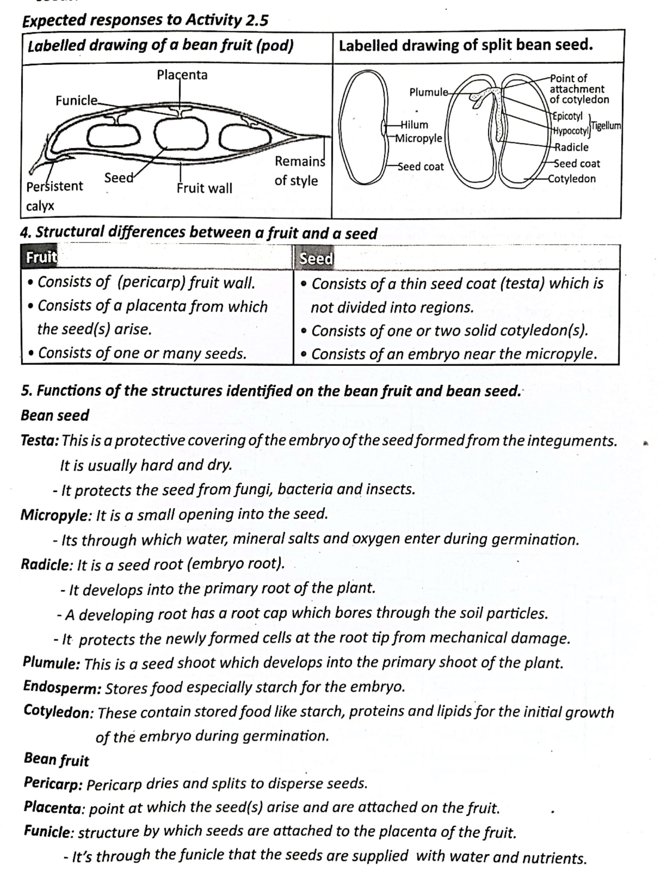***A fruit*** is a fertilized ovary.

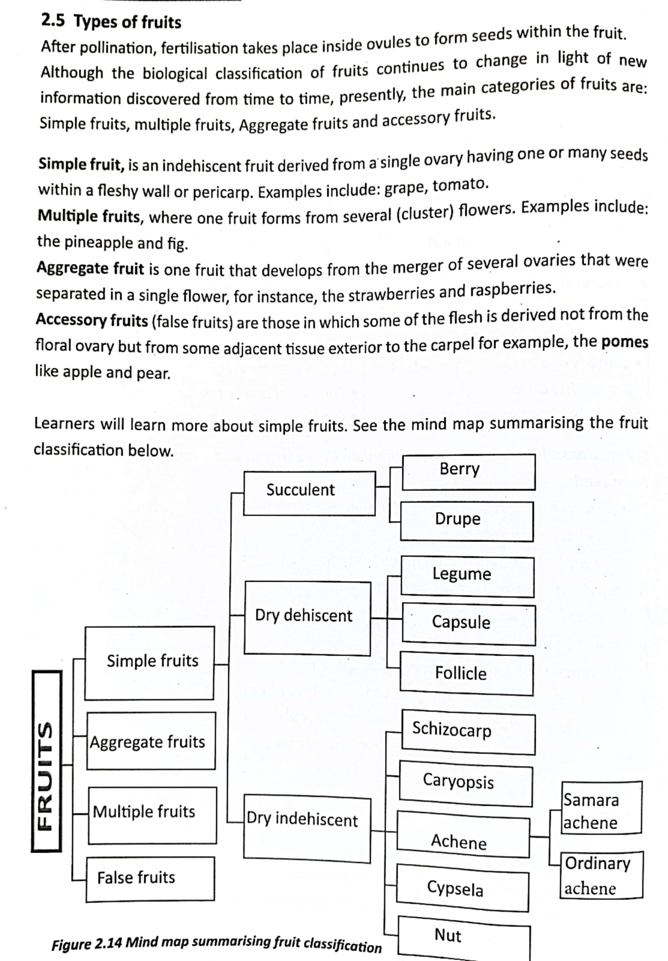

***2.7 Fruit and seed dispersal.***

[CamScanne](https://v3.camscanner.com/user/download)

[r](https://v3.camscanner.com/user/download)

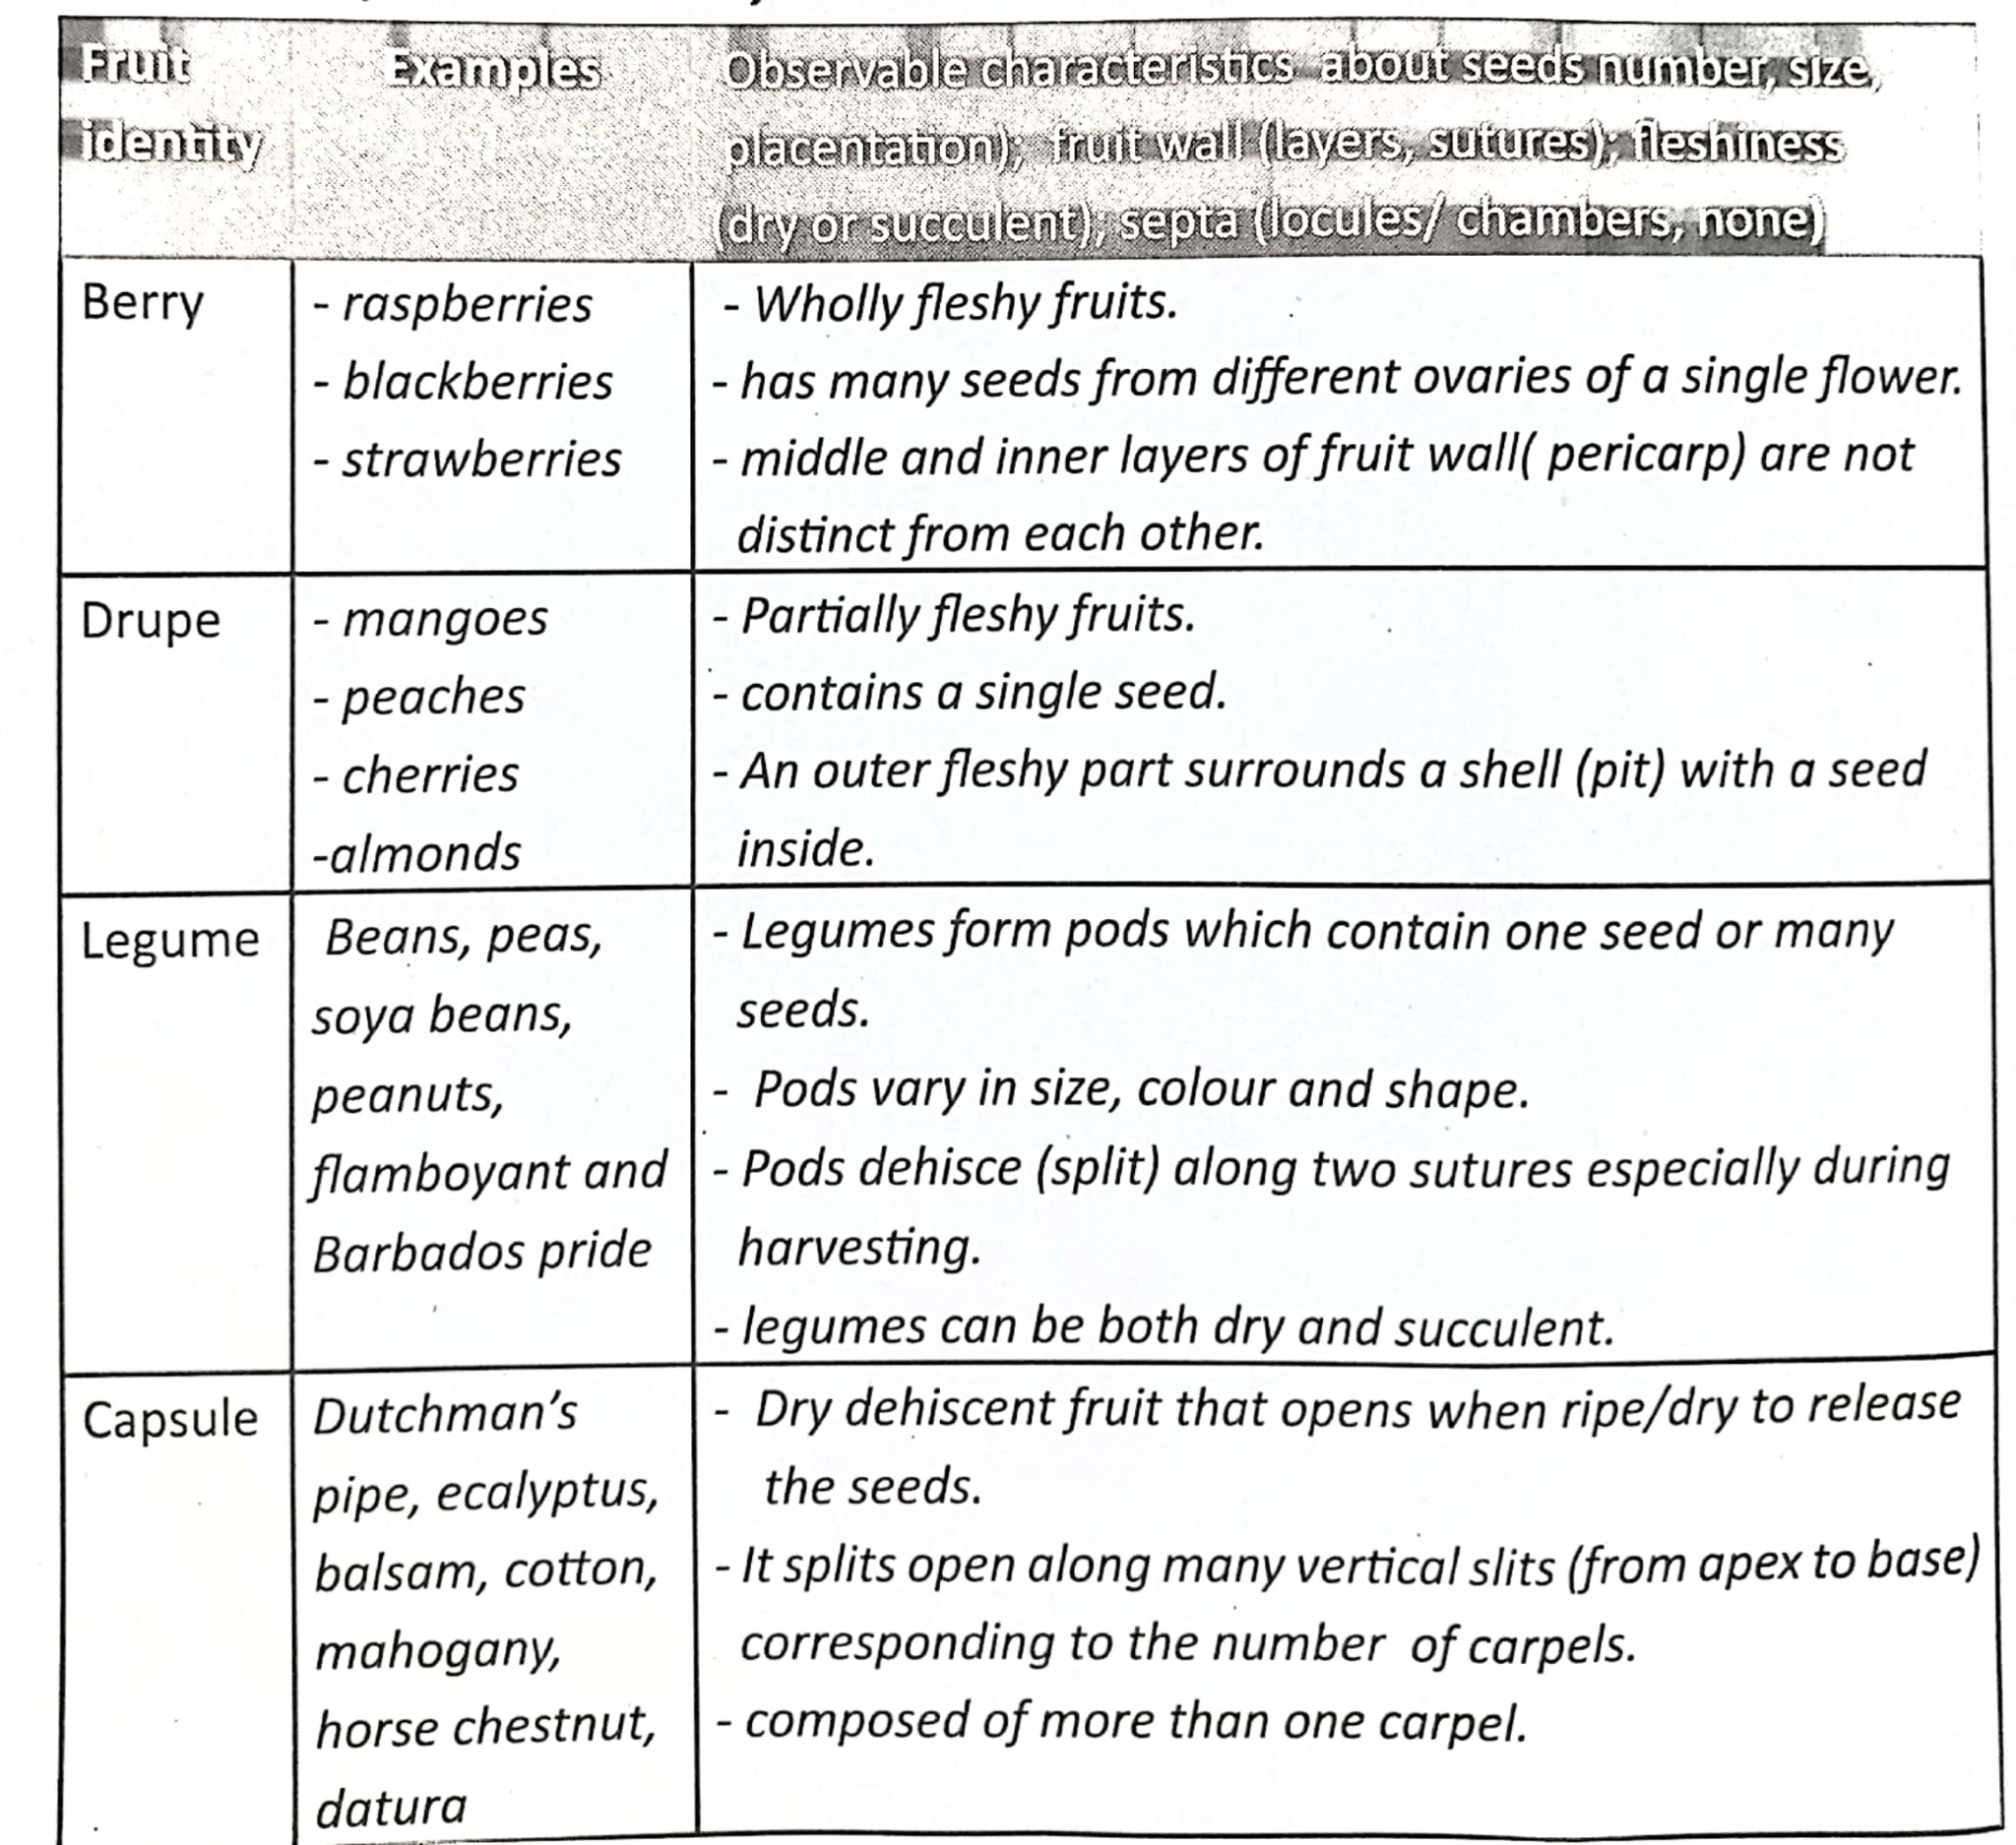

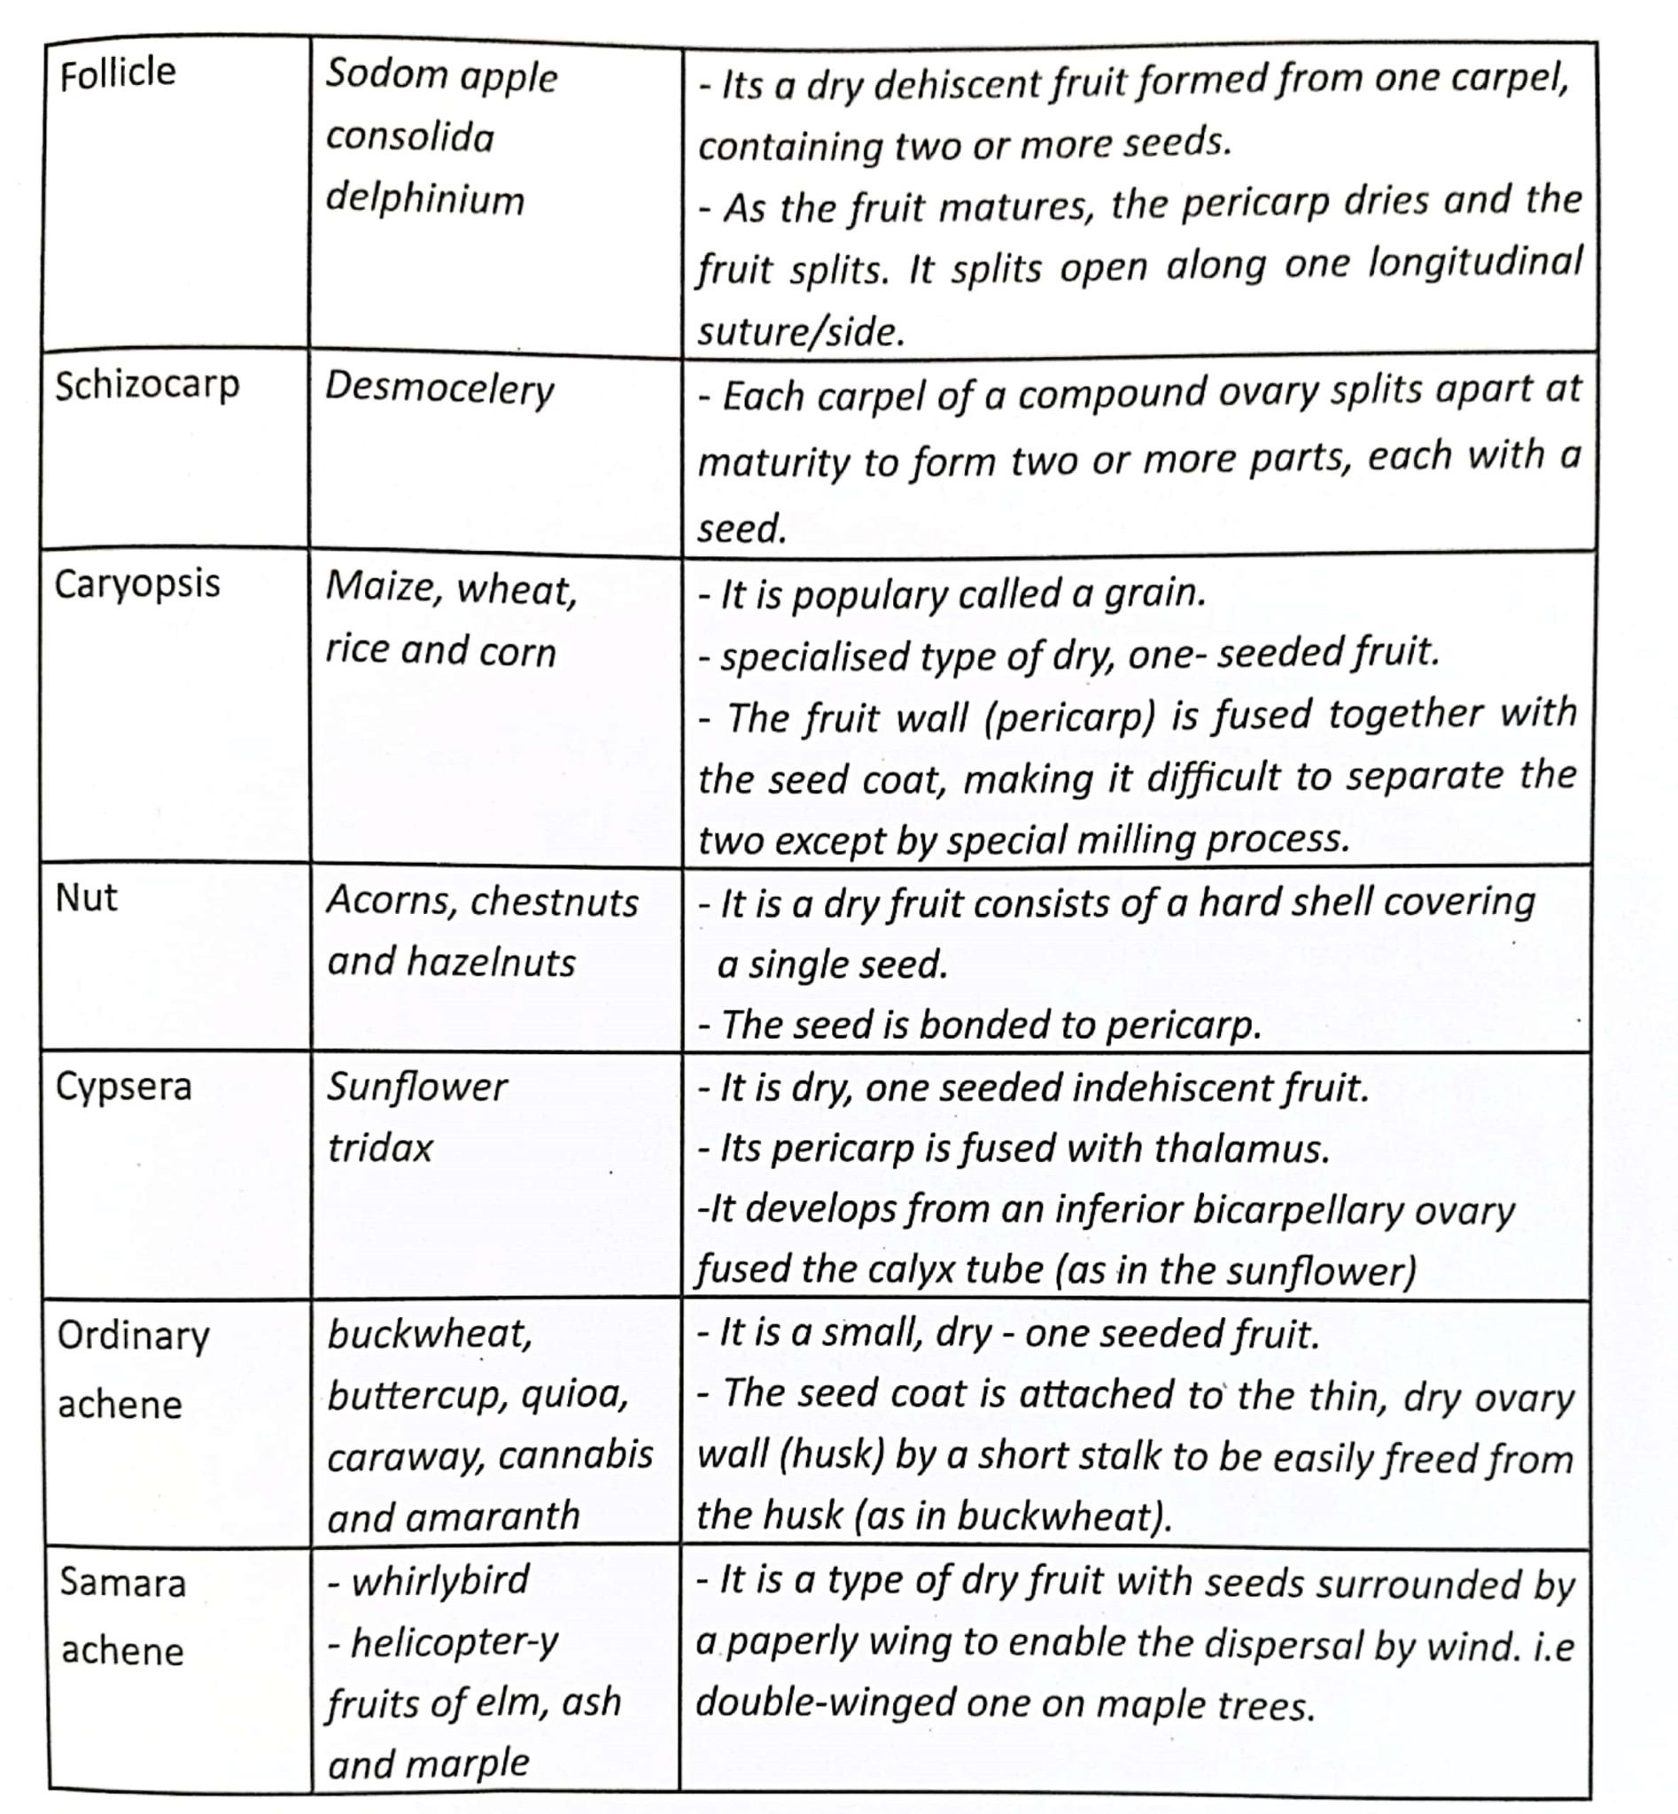

***Fruit and seed dispersal.***

***Dispersal*** refers to the scattering or spreading of fruits and seeds from their parent plants. In some plants only the seeds are dispersed while in others the fruits are dispersed with seeds.

***Importance of dispersal***.

* It reduces overcrowding among plants of the same species.
* It reduces competition between member plants of some species for light, water, mineral salts, space and air.
* It enables plants to colonise new areas which may even be better for the species survival.
* It minimises any rapid spread of epidemic diseases that can occur in case of outbreak especially in seedlings if they are overcrowded.
* It enhances the chances of survival and continuity of the plant species.

***How are seeds and fruits dispersed?***

Fruits and seeds are dispersed by means of ***agents.*** These agents include; **wind, *water and animals***. Some plants self-disperse their seeds by ***self-explosive mechanism or self-dispersal.***

Fruits and seeds possess specialised structures to aid their dispersal and suitably adapted for specific mode of dispersal.

|  |
| --- |
| ***How seeds and fruits are adapted to be dispersed by wind.***   * They are small, light and dry which enables them to be easily carried or blown by wind. * Some seeds have wing like structures which enable them to be easily blown by wind from their parent plant. * Some fruits like tridax have parachute like tuft of hairs called pappus which enable them to float and fly in wind.   ***How seeds and fruits are adapted to be dispersed by animals.***   * Some fruits like black jack and desmodium have hooks and sticky hairs respectively to enable the fruits to stick on the body of the animal as it moves around the parent plant. * Some fruits such as tomatoes, oranges and mangoes are usually large and brightly coloured when ripe to attract animals. * Some fruits usually possess the edible part. In most cases only part of the fruit is eaten and only rest containing the seed thrown away e.g. Mango. * Some fruits when ripe are scented e.g. jack fruit and this attracts animals. * In some fruits such as guava and tomatoes, the whole fruit is eaten and small seeds pass out in the faeces because of resistance to digestion.   ***How seeds and fruits are adapted to be dispersed by water.***   * They are usually light and contain air spaces inside which reduces their relative density and enable them float on water easily. * Some fruits have fibrous mesocarp e.g. coconut which enables them to float on water. * They normally possess impermeable outer coats which prevent water from entering before the embryo develops.   ***Fruits dispersed by explosive mechanism*** have two lines of weakness (sutures) in the pericarp that can open when the fruit dries. ***How seeds and fruits are adapted to be dispersed by wind.***   * They are small, light and dry which enables them to be easily carried or blown by wind. * Some seeds have wing like structures which enable them to be easily blown by wind from their parent plant. |

***End of chapter summary.***

In this chapter, you have learnt that;

* Plants in addition to asexual reproduction can reproduce sexually through production of fruits and seeds.
* The organs for sexual reproduction in plants are the flowers.
* Sexual reproduction in plants involves several processes which include; pollination, fertilisation, fruit and seed formation.
* Pollination requires agents like insects, wind and flowers are adapted differently for each type of pollination.
* Fertilisation can be self within the same plant or cross between separate plants of the same species.
* Dispersal is the scattering of fruits and seeds from parent plants. It is necessary to avoid overcrowding around the parent plant.
* Fruits and seeds are specifically modified for their mode of dispersal.

***Chapter 3. SEXUAL REPRODUCTION IN HUMANS.***

***Competency. The learner understands that sexual reproduction involves two parents with specialised reproductive systems.***

***Learning outcomes;***

***The learner should be able to;***

* ***Understand the structure and functions of male and female reproductive system in humans.***
* ***Understand the changes that take place during the menstrual cycle***
* ***Relate male and female gametes.***
* ***Appreciate the process of fertilization of an ovum and the development of zygote up to birth***
* ***Know the role of the placenta during pregnancy***
* ***Understand the importance of antenatal medical care.***
* ***Understand aspects of care for the baby after birth (breast feeding ,balanced diet, immunization and hygiene)***
* ***Recognise the health risks/complications associated with early/teenage pregnancy and abortion.***
* ***Identify the common birth control methods in Uganda and give the biological principle they employ and their effectiveness (Note; the only method recommended for young people is abstinence)***
* ***Identify and explain common issues associated with reproductive system***
* ***Know the causes, signs and symptoms and understand the mode of transmission of named STIs (Syphilis, Gonorrhea, Candida, Human Papilloma Virus (HPV), Hepatitis B and HIV/AIDS).***
* ***Appreciate the preventive measures for the named STIs (Note; The only preventive method recommended for young people is abstinence)***
* ***Identify the challenges faced by people living with HIV/AIDS and ho to overcome them.***

***Introduction.***

Sexual reproduction is a type of reproduction that involves ***gametes*** from a male and female organisms.

In this chapter, you will be able to understand that for sexual reproduction to occur, there must be two parents producing ***specialised reproductive cells***. In males specialised cells are ***sperm cells*** produced in the ***testis***, females the specialised cells are the ***ova*** found in the ***ovaries.***

***3.1: Structure of the reproductive systems in humans***

***Male reproductive system.***

|  |
| --- |
| ***Front view of the male reproductive system.*** |
| ***Functions of the different parts of the male reproductive system.***  ***Penis.***  This is the organ of copulation. It’s an erective tissue composed of two parts namely;   * ***Glans penis*** which is highly sensitive and causes sexual arousal it’s the enlarged tip of the penis. * ***Prepuce***. Which is the fore skin, the surgical removal of the fore skin is called ***circumcision.***   The function of the penis is to ***deliver sperms in semen into the vagina.***  ***Scrotum.***  This is the external pouch of skin and muscle which houses the testes, usually devoid of hair to allow ideal temperature for sperm development   * ***It promotes sperm to develop at a temperature lower than that of the body***   ***Urethra.***   * ***This is the common passage for both sperms and urine.***   ***Prostate gland.***   * ***This is a gland that secretes an alkaline, milky-white fluid that neutralizes the acidity of the vagina.***   ***Cowper’s gland.***   * ***This gland secretes a sticky fluid for semen in urethra.***   ***Sperm duct (vas deferens)***   * ***It carries the sperms from epididymis to the urethra.***   ***Seminal vesicles.***   * ***Produce a mucus secretion which aids the movement of sperms and also provides the sperms with nutrients and Vitamin C.***   **NOTE.**  *The secretions from* ***the seminal vesicles, Cowper’s gland, prostate gland and sperms*** *form* ***semen.***  ***Epididymis.***  This is a coiled tube attached to the back and upper side of testes that is connected to the sperm duct.   * ***Epididymis stores sperms produced by the testes.***   ***Testis.***.  Testes contain numerous tubules called ***seminiferous tubules*** that make sperms.   * ***Testes therefore produce sperms and testosterone.*** |

***Female reproductive system.***

|  |
| --- |
| ***Front view of the female reproductive system.***  ***Functions of parts of a female reproductive system.***  ***Uterus;***  This is a hollow, thick walled elastic muscular organ where the fetus undergoes growth and development. This organ is approximately 5cm in its usual state but capable of stretching to over 30cm to accommodate a growing baby.   * Provides suitable environment for growth and development of the fetus * It is also an area for implantation.   ***Vulva;***   * It’s the external genetalia made up of two skin folds that is the inner fold (labia minora) and the outer fleshy fold (labia majora) * ***Labia minora***; inner folds of skin containing mucus secreting glands which lubricate the vagina during copulation. * ***Labia majora***; made up of outer folds of fleshy fatty skin. Its function is to cushion the vagina and enables sexual arousal.   ***Vagina;***   * This is a muscular tube, which connects at the cervix and outside by the vulva. It has an average length of ***7.5cm***. It secretes acidic mucus, which controls growth of bacteria and fungi within the female reproductive tract. The mucus also lubricates the vagina during sexual intercourse.   ***Functions of the vagina.***   * It’s a passage for blood during menstration * It’s a birth canal that is passage for the baby during birth. * Receives erect penis during sexual intercourse.   ***Oviduct (Fallopian tube)***   * It allows movement of fertilized egg towards the uterus for implantation * It provides suitable environment for fertilisation.   ***Cervix;***   * It’s the gate way to the uterus for sperms during copulation and the baby during birth.   ***Clitoris;***   * Bean-shaped, most sensitive part of female reproductive system, which brings about sexual excitement in females when stroked by penis during copulation.   ***Ovary.***  Each ovary is made up of connective tissues, blood vessels and egg producing cells called graafian follicles. Very many follicles are present in the female by birth but not all develop into mature ova.  ***Functions of the ovary.***   * Secretes Oestrogen and Progesterone * It produces eggs and ova, and normally releases one each month.   ***3.2; HUMAN MENSTRAL CYCLE.***  This refers to a series of changes that occur within the uterus of female after onset of puberty. It takes or lasts about ***28 days*** in human being and the first menstrual cycle of a girl is called Manerche.  The menstrual cycle is controlled by four hormones of which two are secreted from the anterior lobe of pituitary gland ***(Follicle stimulating hormone and luteinizing hormone)*** and the other two from ovaries ***(Progesterone and Oestrogen).***  ***Follicle stimulating hormone.***   * This hormone causes the development of graafian follicles in ovaries. * It stimulates the ovaries to secrete Oestrogen.   ***Oestrogen.***  This hormone causes the following;   * Stimulates the repair and growth of the uterine lining following menstration. * It then inhibits the production of follicle stimulating hormone from pituitary gland to allow normally one follicle to mature at a time. * Its high level stimulates the release of Luteinising hormone.   ***Luteinising hormone.***  This hormone causes;   * Ovulation when in high level in blood at about the 14th day. * Stimulates the ovary to produce progesterone from Corpus luteum.   ***Progesterone.***  This is secreted by the corpus luteum. It brings about the following;   * Causes the uterine lining to be maintained in readiness for implantation. * Its high levels inhibit the production of follicle stimulating hormone and Luteinising hormone. * Since no fertilisation takes place the corpus luteum degenerates and the level of progesterone starts to fall. * A sharp decrease in the level of progesterone brings about ***menstration.*** |

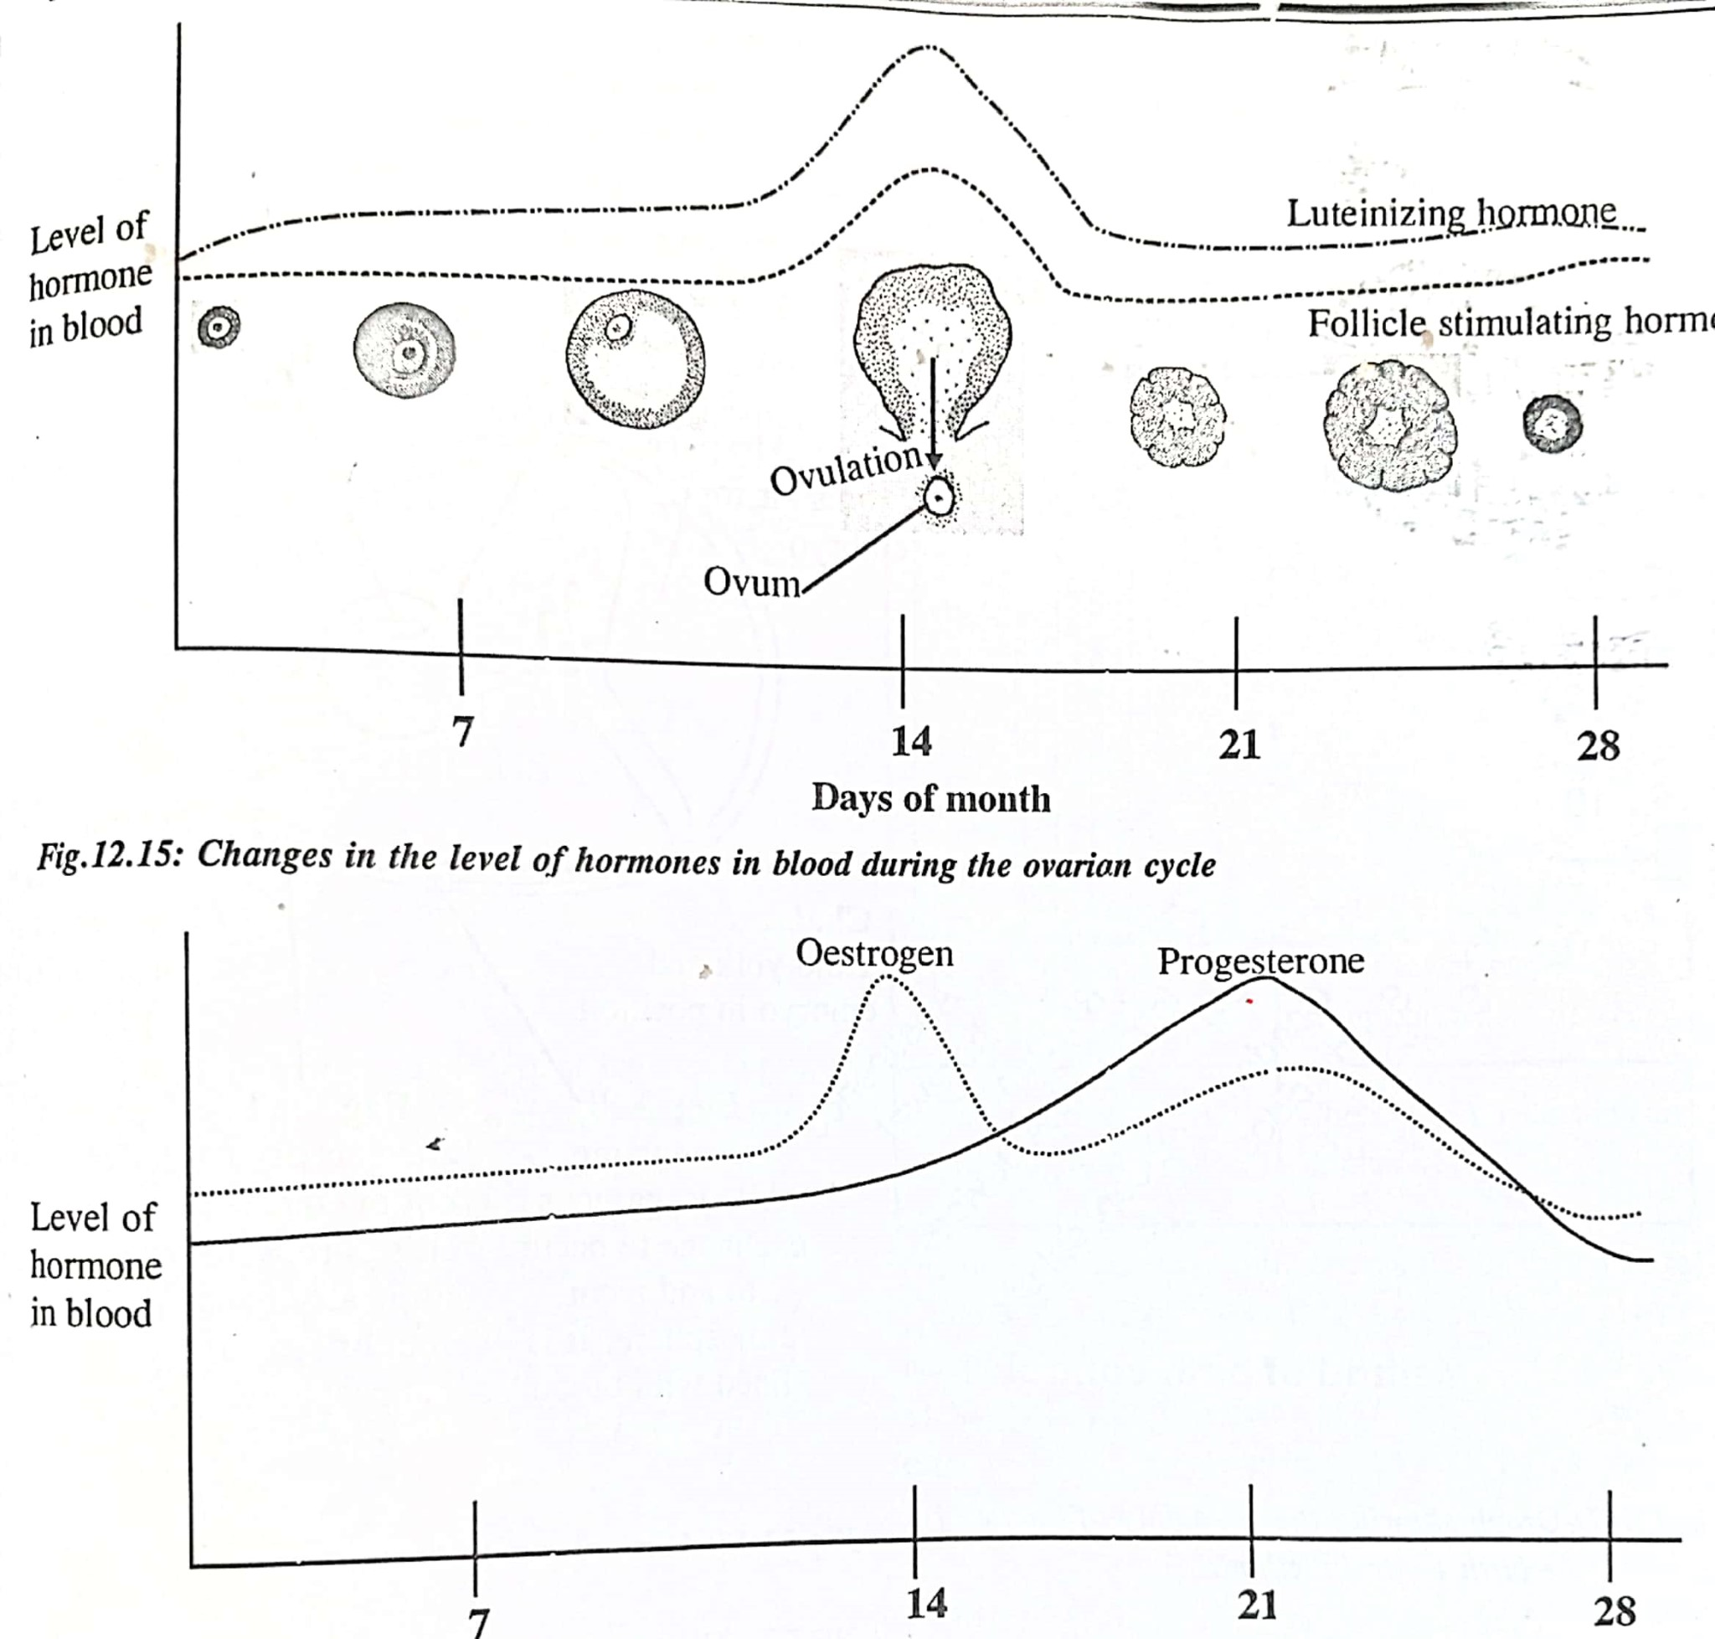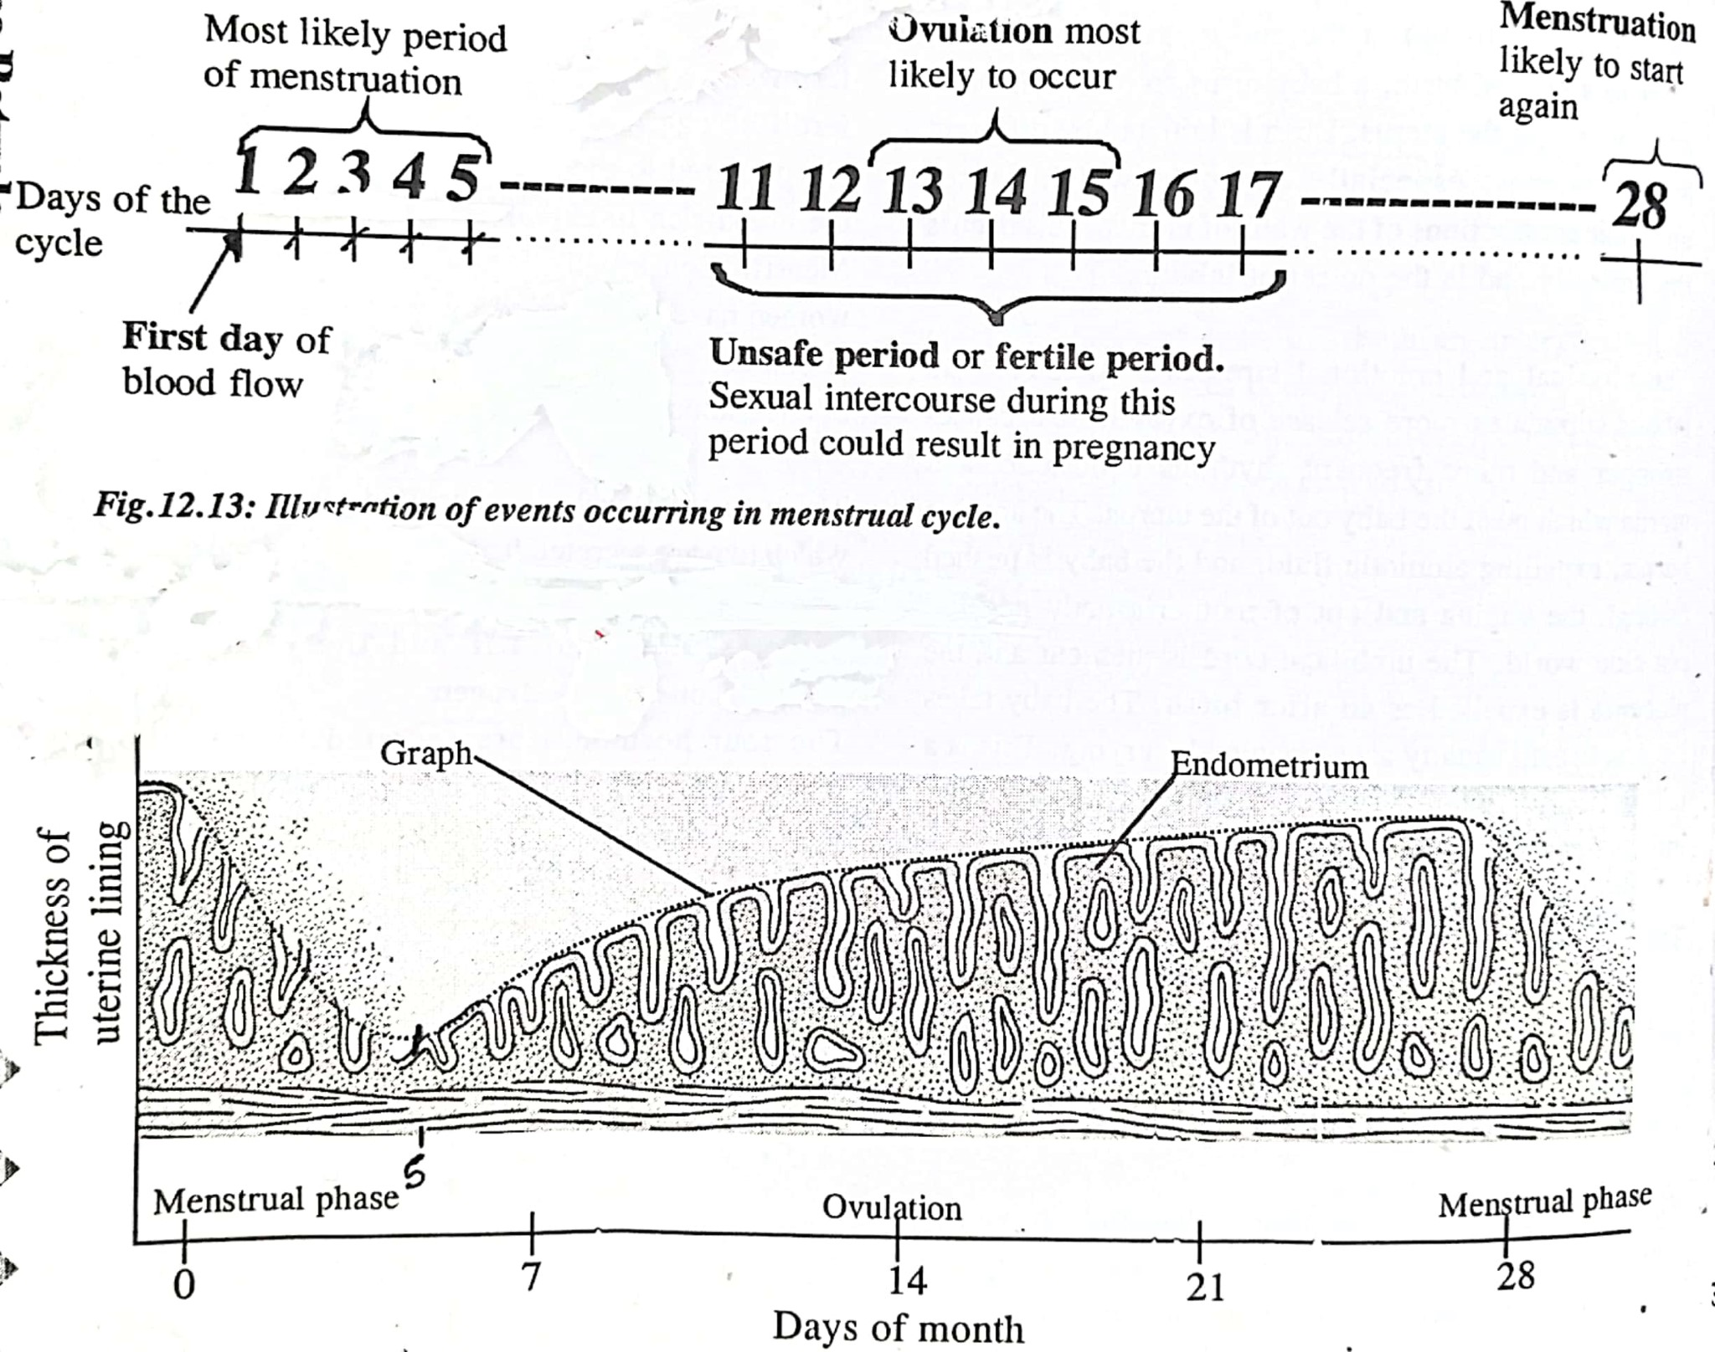

***3.3; Male and female gametes.***

In humans, there are two types of gametes namely, male and female gametes.

Male gametes are called ***Sperms*** while female gametes are called ***Ova or egg cells.***

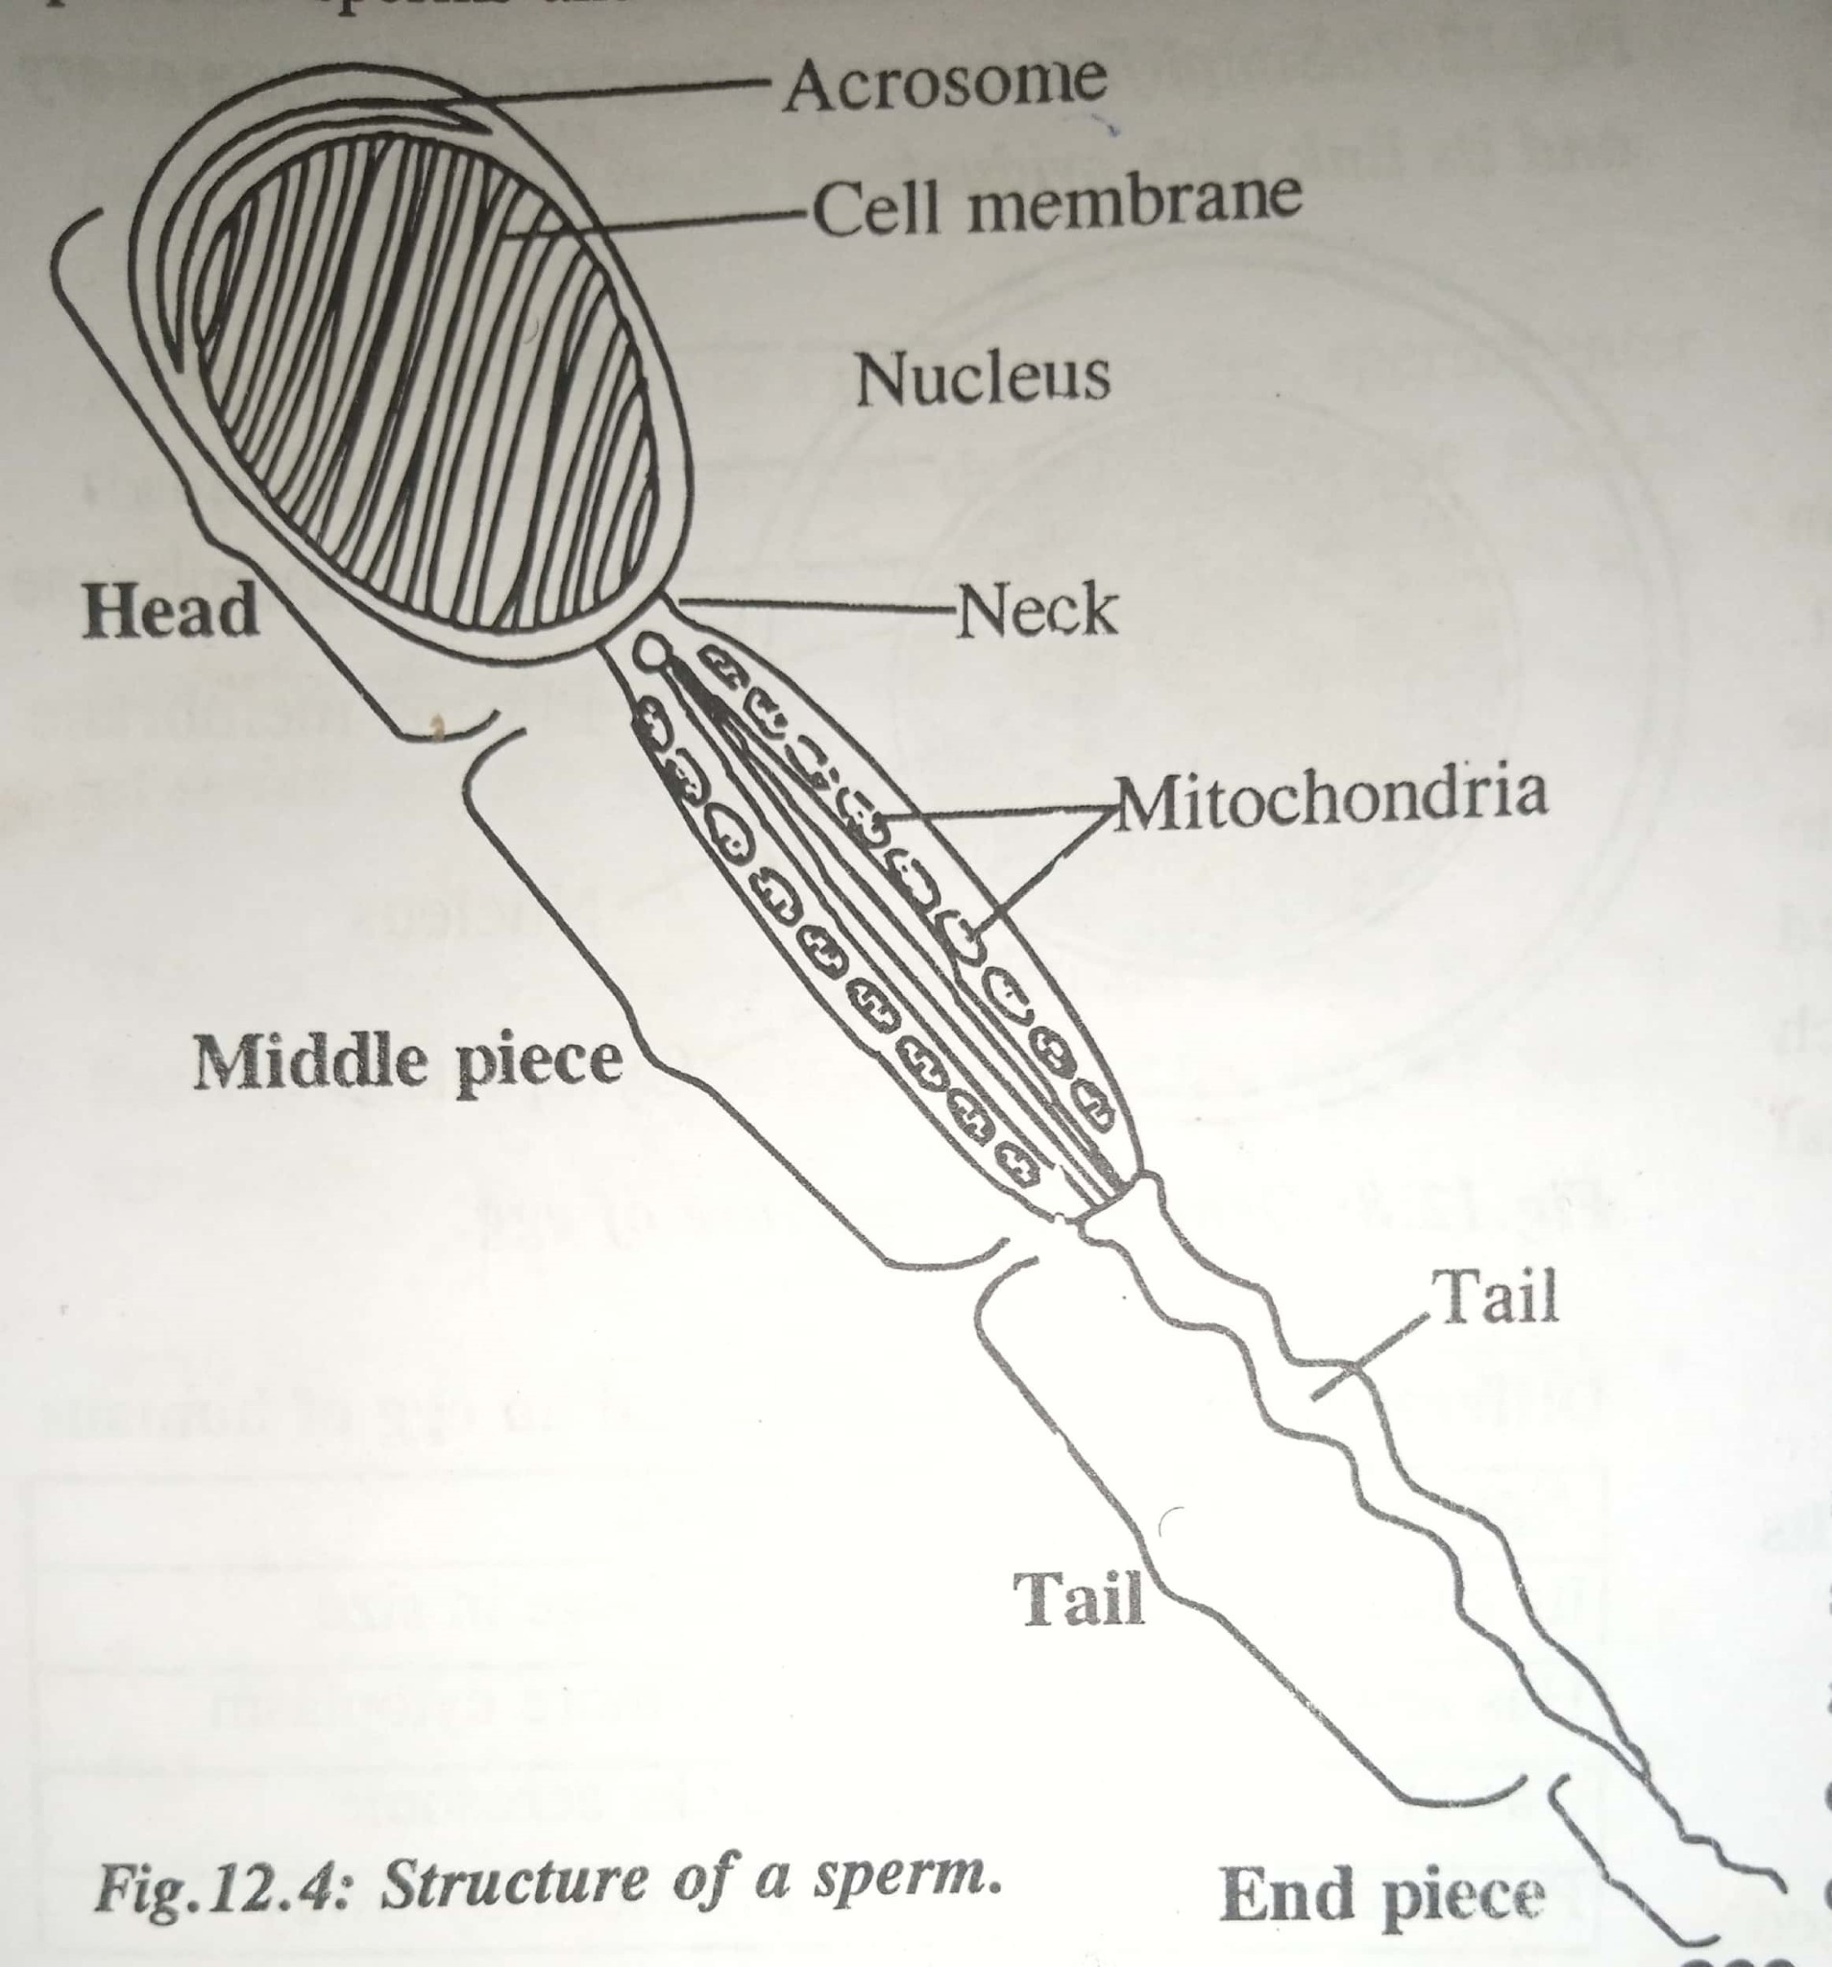***Structure of human male gamete.***

***Functions of parts of a sperm cell.***

***Acrosome;*** Contains juice together with enzymes which dissolve the egg membrane (vitelline) to bring about fertilisation.

***Nucleus;*** contains genetic material which is responsible for transmission of characters from the male parent to the offspring.

***Neck;*** Connects the head and tail of the sperm.

***Middle piece;*** Contains mitochondria which provides energy required for the movement of the sperm.

***Tail;*** propels the sperm forward as it swims towards the ovum.

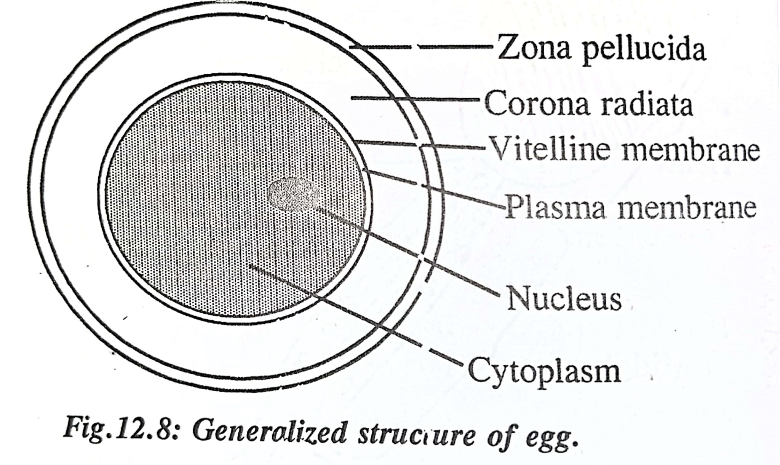***Structure of human female gamete.***

***Functions of parts of an ovum.***

***Cytoplasm***; It acts as a food store for the embryo.

***Vitelline membrane***; It provides protection to the inner part of the egg.

Allows exchange of materials around the egg and its surroundings.

***Zona pellucida;*** iss a jelly coat layer which acts as a barrier to sperm entry.

***Corona radiate***; is an external layer of follicle cells which provides support and nourishment to the egg cell.

***Nucleus:*** The nucleus of the ovum contains half genetic material to be passed on from the mother to the baby before fertilisation. It is usually invisible until after fertilisation, when its genetic material combines with that from the nucleus of sperm cell to form the genetic material of the offspring.

***Differences between a sperm and egg in humans.***

|  |  |
| --- | --- |
| ***sperm*** | ***Ovum*** |
| It is small in size. | It is large in size |
| Hass less cytoplasm. | Has more cytoplasm |
| Has an acrosome | Lacks acrosome |
| Produced by testis. | Produced by ovary |
| Lack a yolk | Has yolk |
| Possesses a tail hence motile. | Lacks tail and non-motile. |

***3.4 Process of fertilisation in man***

Fertilisation in humans is the fusion of mobile male gamete (sperm) and female gamete (ovum) to form a zygote. Naturally it takes place in the fallopian tube or oviduct.

The sperms are released into the vagina near the cervix by the erect penis upon ejaculation during sexual intercourse. The cervix relaxes and opens as millons of sperms swim through its opening to the uterus, then to the oviduct where they meet to the ovum.

When one sperm gets into contact with the egg membrane, it releases enzymes from chromosome. These break the egg membrane and enables the sperm cell to penetrate into the cytoplasm of the ovum. After this penetration, the egg membrane become thickened to form the fertilisation membrane, which serves as a barrier preventing entry of other sperm cells. This ensures only one sperm cell fertilizes the ovum.

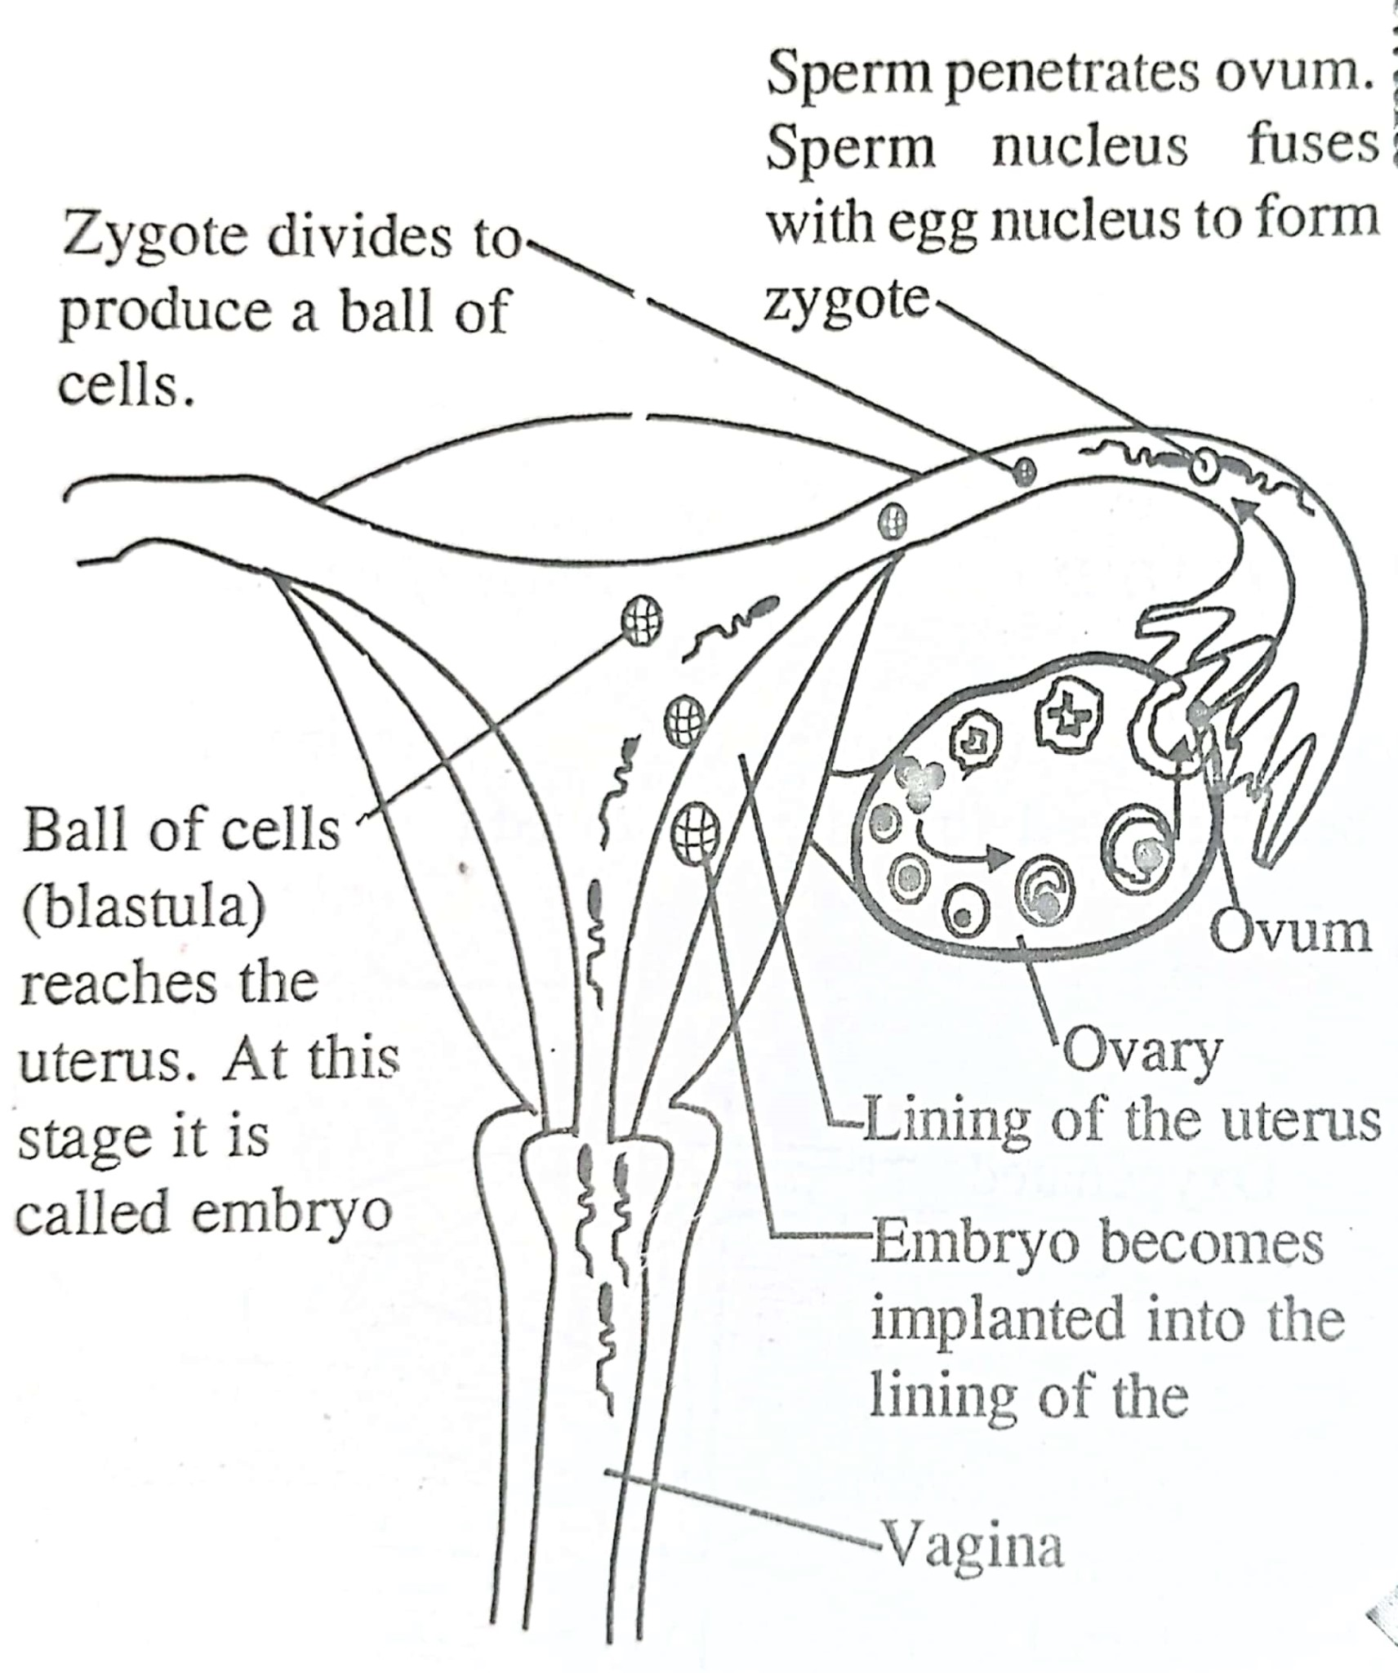The nuclear membrane of the two gametes breaks down, such that the male nucleus fuses with the female nucleus to form a fertilized egg.