
KAMPALA PREPARATORY SCHOOL
P.2 MID TERM ONE EXAMINATION 2025
MATHEMATICS
DURATION: 2HRS 30MINS

NAME: ____________________________________________STREAM:____________

SECTION A

1. Add : 5 + 2 =

2. Name this set symbol
$∅$
3. Today is Tuesday, what day of the week will it be Tomorrow.

4. Write 25 in words.

5. Show 1 2 3 on the abacus
H T O

1 2 3

6. Draw a set of six pencils

7. Circle the smaller number.
12 or 21

8. Which container carries less water?

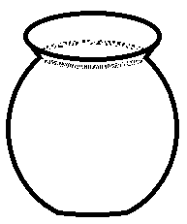
Pot Cup

9. Subtract : 3 3
- 2 1

10. How many days make a week?

11. Draw a circle

12. Fill in the missing numbers.

29 = ________tens _______ones.

13. Write a symbol of union set

14. Which number comes after 99

15. Name this shape.

______________________

16. Fill in the missing numbers.

+ 3 = 5

17. Write the shaded fraction.

18. Write the place value of 6 in the number 3 6 4

19. Count and write

=

20. Work out 3 x 5 =

SECTION B

21. Join set A with set B ( 2marks)
a c
c

1 2
3 4
a) + =

b) How many members are in set F (2marks)

______________

c) Write a symbol of an empty set

22. Study the diagram below and answer questions that follow.
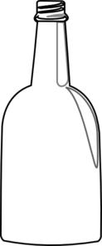

bottle
5 litres
bucket
9 litres

a) How many litres does a bottle hold? (2marks)

b) Which container holds much water? (1mark)

c) How many liters of water does a bucket and a bottle hold altogether? ( 2marks)

23. Add correctly. (2marks each)

a) 12 + 11 = (b) 4 4
+ 3 0

c) Tom has 13 sweets. Peter has 6 sweets. How many sweets do they have altogether?

24. Complete correctly
a) 7 8 = ______tens ______ones (1marks)

b) 1 2 3 = ______hundred _____tens_____ones (1marks)

c) Draw bundles and sticks (1marks)

23 =

d) Write “forty eight in figures. (2marks)

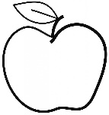
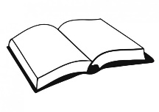
25. Study the shopping list below and answer question that follow

An Apple
Sh. 1000

A pencil
Sh. 600

A book
Sh. 500

a) What is the cost of a pencil? (1mark)

b) Which item costs much money? (1mark)

c) How much does a book and a pencil cost altogether? (2marks)

26. a) Shade (2marks)

= $\frac{2}{3}$

b) Write the unshaded fraction. (1mark)

c) Write $\frac{1}{2}$ in words. (2marks)

27. a) What is the first day of the week? (1mark)

b) On which day do muslems go for Juma prayers? (1marks)

c) Write any three months of the year you know. (1mark each)
_____________________________
_____________________________
_____________________________
28. Form small sets and name them. (4marks each)
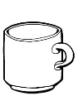



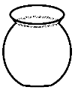

b) Name this set symbol
$∪$ ___________________________

29. Complete the puzzle. ( 4 marks )
____
2
____
____
5
3
8+

4
_____

30. Match correctly

100 first

3rd fifteen

15 forty five

45 third

1st one hundred

31. Name these shapes.

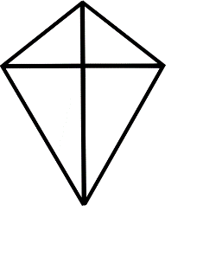
32. The graph below shows the number of trees each person planted, study it and answer questions that follow.

Musa | 
Ali
John
Peter

a) Who planted the smallest number of trees. ( 1mark)

b) How many trees did John planted? (1mark)

c) ______________and _______________planted the same number of trees. (2marks)

d) How many trees did they plant altogether? (2marks)

