

**KAMPALA PREPARATORY SCHOOL**

**P.2 MID TERM ONE EXAMINATION 2025**

**MATHEMATICS**

**DURATION: 2HRS 30MINS**

**NAME: ____________________________________________STREAM:____________**

**SECTION A**

**1. Add : 5 + 2 =**

**2. Name this set symbol**

**3. Today is Tuesday, what day of the week will it be Tomorrow.**

**4. Write 25 in words.**

**5. Show 1 2 3 on the abacus**

**H T O**

**1 2 3**

**6. Draw a set of six pencils**

**7. Circle the smaller number.**

**12 or 21**

**8. Which container carries less water?**

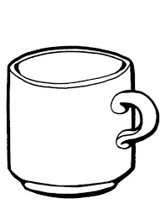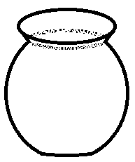 **Pot Cup**

**9. Subtract : 3 3**

**- 2 1**

**10. How many days make a week?**

**11. Draw a circle**

**12. Fill in the missing numbers.**

**29 = ________tens _______ones.**

**13. Write a symbol of union set**

**14. Which number comes after 99**

**15. Name this shape.**

______________________

**16. Fill in the missing numbers.**

**+ 3 = 5**

**17. Write the shaded fraction.**

**18. Write the place value of 6 in the number 3 6 4**

**19. Count and write**

**=**

**20. Work out 3 x 5 =**

**SECTION B**

**21. Join set A with set B ( 2marks)**

**a) + =**

**b) How many members are in set F (2marks)**

______________

**c) Write a symbol of an empty set**

**22. Study the diagram below and answer questions that follow.**

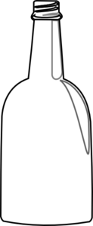

**bottle**

**5 litres**



**bucket**

**9 litres**

**a) How many litres does a bottle hold? (2marks)**

**b) Which container holds much water? (1mark)**

**c) How many liters of water does a bucket and a bottle hold altogether? ( 2marks)**

**23. Add correctly. (2marks each)**

**a) 12 + 11 =**   **(b) 4 4**

**+ 3 0**

**c) Tom has 13 sweets. Peter has 6 sweets. How many sweets do they have altogether?**

**24. Complete correctly**

**a) 7 8 = ______tens ______ones (1marks)**

**b) 1 2 3 = ______hundred _____tens_____ones (1marks)**

**c) Draw bundles and sticks (1marks)**

**23 =**

**d) Write “forty eight in figures. (2marks)**

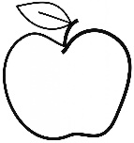**25. Study the shopping list below and answer question that follow**



**An Apple**

**Sh. 1000**

**A pencil**

**Sh. 600**

**A book**

**Sh. 500**

**a) What is the cost of a pencil? (1mark)**

**b) Which item costs much money? (1mark)**

**c) How much does a book and a pencil cost altogether? (2marks)**

**26. a) Shade (2marks)**

**=**

**b) Write the unshaded fraction. (1mark)**

**c) Write in words. (2marks)**

**27. a) What is the first day of the week? (1mark)**

**b) On which day do muslems go for Juma prayers? (1marks)**

**c) Write any three months of the year you know. (1mark each)**

**_____________________________**

**_____________________________**

**_____________________________**

**28. Form small sets and name them. (4marks each)**

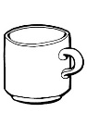

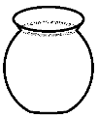



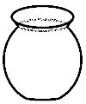





**b) Name this set symbol**

**___________________________**

**29. Complete the puzzle. ( 4 marks )**

**____**

**2**

**____**

**____**

**5**

**3**

**8+**

**4**

**_____**

**30. Match correctly**

**100 first**

**3rd fifteen**

**15 forty five**

**45 third**

**1st one hundred**

**31. Name these shapes.**

|  |  |  |
| --- | --- | --- |
|  |  |  |
|  |  |  |
|  | D:\2024\To Back\D - Storage\pics\CLIPART- OTHERS\kite half.png |  |
|  |  |  |

**32. The graph below shows the number of trees each person planted, study it and answer questions that follow.**

|  |  |
| --- | --- |
| **Musa** | **D:\2024\To Back\D - Storage\pics\Exam pics\tree4.PNGD:\2024\To Back\D - Storage\pics\Exam pics\tree4.PNGD:\2024\To Back\D - Storage\pics\Exam pics\tree4.PNG** |
| **Ali** | **D:\2024\To Back\D - Storage\pics\Exam pics\tree4.PNGD:\2024\To Back\D - Storage\pics\Exam pics\tree4.PNG** |
| **John** | **D:\2024\To Back\D - Storage\pics\Exam pics\tree4.PNGD:\2024\To Back\D - Storage\pics\Exam pics\tree4.PNGD:\2024\To Back\D - Storage\pics\Exam pics\tree4.PNGD:\2024\To Back\D - Storage\pics\Exam pics\tree4.PNGD:\2024\To Back\D - Storage\pics\Exam pics\tree4.PNG** |
| **Peter** | **D:\2024\To Back\D - Storage\pics\Exam pics\tree4.PNGD:\2024\To Back\D - Storage\pics\Exam pics\tree4.PNGD:\2024\To Back\D - Storage\pics\Exam pics\tree4.PNG** |

**a) Who planted the smallest number of trees. ( 1mark)**

**b) How many trees did John planted? (1mark)**

**c) ______________and _______________planted the same number of trees. (2marks)**

**d) How many trees did they plant altogether? (2marks)**