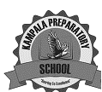
KAMPALA PREPARATORY SCHOOL
P.1 MID TERM ONE EXAMINATION 2025
LITERACY 1B
NAME:________________________________________STREAM:_____________

1. A____________is a place where people go to learn
(home, school)
2. Circle two people found at school.
Mother, farmer, nurse, cook, teacher,
3. Name these things found in a class.
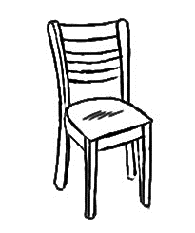 | 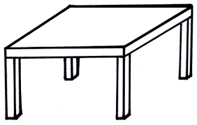 | 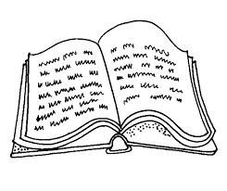
chair, book, desk
4. Fill in the missing letter.
s__ n tre___ co__k te__cher
5. Match correctly .
bursar classroom
nurse kitchen
cook sickbay
teacher office
6. Name these things we find at home.
 | 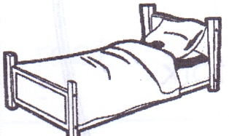 |  | 
(pot, cup, bed, key)
7. What is the name of our Head Teacher?
_______________________________________

SECTION B
8. Fill in correctly.
a) My name is ___________.
b) I am a ____________. (girl, boy)
c) I am ______________ years old.
9. Mention one use of water.
________________________________________
10. Draw this school symbol

School flag
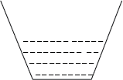
11. Match the tools used to clean our school.
broom

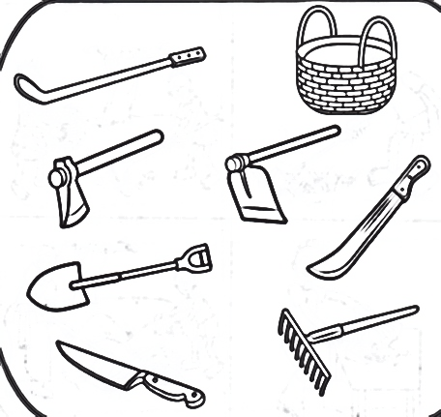
water

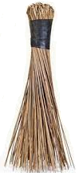
rake

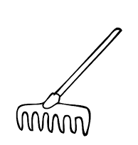
slasher

12. Name one important person at school.
________________________________________
13. Circle the people found at home.
Doctor, priest , mother , father,
Nurse, sister, brother, carpenter,
14. Draw these play materials.
ball | toy car | doll

15. Match animals to their names.
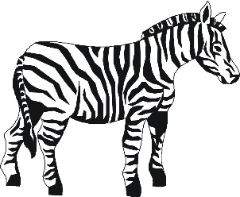
Snake

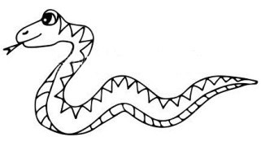
elephant
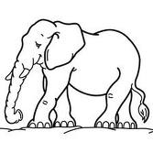

zebra

16. Write one thing we use to clean our classroom
______________________________________
17. Match correctly.
broom for mopping
mop for slashing
slash sweeping
18. Write one Christian name.
_______________________________________
19. Draw one thing God created.

20. _____________created me. (God, satan)
21. Name these God’s gift to us.
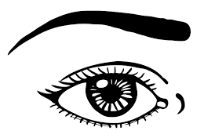 | 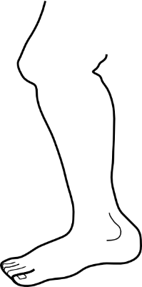 | 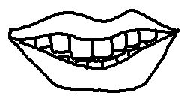  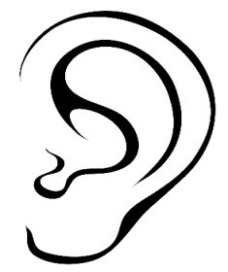
(mouth, eye, ear, leg)

