**KAMPALA PREPARATORY SCHOOL**

**P.1 MID TERM ONE EXAMINATION 2025**

**LITERACY 1B**

**NAME:\_\_\_\_\_\_\_\_\_\_\_\_\_\_\_\_\_\_\_\_\_\_\_\_\_\_\_\_\_\_\_\_\_\_\_\_\_\_\_\_STREAM:\_\_\_\_\_\_\_\_\_\_\_\_\_**

1. A\_\_\_\_\_\_\_\_\_\_\_\_is a place where people go to learn

(home, school)

2. **Circle two people found at school.**

Mother, farmer, nurse, cook, teacher,

3. **Name these things found in a class.**

|  |  |  |
| --- | --- | --- |
| D:\pics\CLIPART- OTHERS\chair (2).jpg | D:\pics\pics\Exam pics\table.png | C:\Users\hp\Desktop\PICS\PICTURES\PICS\New folder (2)\Pictures and Diagrams\Pictures\Exam pics\book 2.png |
|  |  |  |

chair, book, desk

4**. Fill in the missing letter.**

s\_\_ n tre\_\_\_ co\_\_k te\_\_cher

5**. Match correctly .**

bursar classroom

nurse kitchen

cook sickbay

teacher office

6. **Name these things we find at home.**

|  |  |  |  |
| --- | --- | --- | --- |
|  | C:\Documents and Settings\BRIGHT JUNIOR\My Documents\My Pictures\My Scans\2013-06 (Jun)\scan0002.jpg | D:\pics\pics\Exam pics\cup 5.png | C:\Users\Bright\Desktop\New folder (3)\Screenshot_20190427-112617.png |
|  |  |  |  |

(pot, cup, bed, key)

7. What is the name of our Head Teacher?

\_\_\_\_\_\_\_\_\_\_\_\_\_\_\_\_\_\_\_\_\_\_\_\_\_\_\_\_\_\_\_\_\_\_\_\_\_\_\_

**SECTION B**

8.  **Fill in correctly.**

a) My name is \_\_\_\_\_\_\_\_\_\_\_.

b) I am a \_\_\_\_\_\_\_\_\_\_\_\_. (girl, boy)

c) I am \_\_\_\_\_\_\_\_\_\_\_\_\_\_ years old.

9**. Mention one use of water.**

**\_\_\_\_\_\_\_\_\_\_\_\_\_\_\_\_\_\_\_\_\_\_\_\_\_\_\_\_\_\_\_\_\_\_\_\_\_\_\_\_**

10. **Draw this school symbol**

School flag

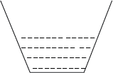11. **Match the tools used to clean our school.**

broom

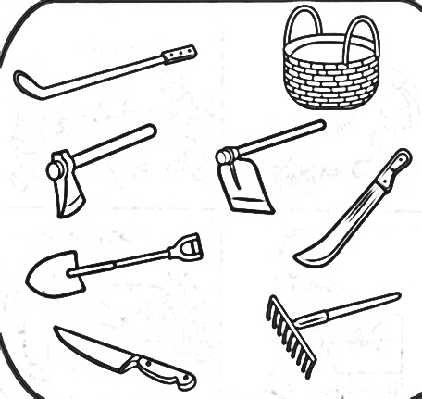 water

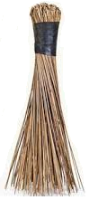

rake



slasher

12. **Name one important person at school.**

**\_\_\_\_\_\_\_\_\_\_\_\_\_\_\_\_\_\_\_\_\_\_\_\_\_\_\_\_\_\_\_\_\_\_\_\_\_\_\_\_**

13. **Circle the people found at home.**

Doctor, priest , mother , father,

Nurse, sister, brother, carpenter,

14. **Draw these play materials.**

|  |  |  |
| --- | --- | --- |
|  |  |  |
| ball | toy car | doll |

15. **Match animals to their names.**

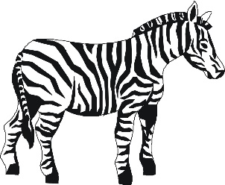

Snake

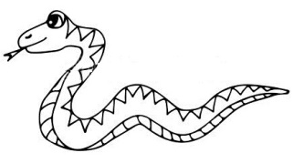

elephant

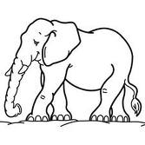

zebra

16. Write one thing we use to clean our classroom

\_\_\_\_\_\_\_\_\_\_\_\_\_\_\_\_\_\_\_\_\_\_\_\_\_\_\_\_\_\_\_\_\_\_\_\_\_\_

17. **Match correctly**.

broom for mopping

mop for slashing

slash sweeping

18. Write one Christian name.

\_\_\_\_\_\_\_\_\_\_\_\_\_\_\_\_\_\_\_\_\_\_\_\_\_\_\_\_\_\_\_\_\_\_\_\_\_\_\_

19. **Draw one thing God created**.

20. \_\_\_\_\_\_\_\_\_\_\_\_\_created me. (God, satan)

21. **Name these God’s gift to us.**

|  |  |  |  |
| --- | --- | --- | --- |
| C:\Users\hp\Desktop\PICS\PICTURES\PICS\New folder (2)\Pictures and Diagrams\Pictures\Exam pics\eye 3.png | D:\pics\pics\CLIPART- BODY PARTS\leg.png | **C:\Users\hp\Desktop\ \pictures infant\tuaha\teeth.gif**D:\pics\pics\CLIPART- OTHERS\ear.jpg |  |
|  |  |  |  |

(mouth, eye, ear, leg)