

**KAMPALA PREPARATORY SCHOOL**

**P.4 MID TERM ONE EXAMINATION 2025**

**INTEGRATED SCIENCE**

**DURATION : 2HRS 15MINS**

**NAME: ______________________________________________STREAM:……………..**

**DATE: …………………………………….**

D**ONOT OPEN THIS BOOKLET UNTIL YOU ARE TOLD TO DO SO**.

**READ THE FOLLOWING INSTRUCTIONS CAREFULLY**

1. **The paper has two sections: A and B.**
2. **Section A, has 40 questions (40 marks)**
3. **Section B has 15 questions. (60 marks)**
4. **Attempt ALL questions**
5. **All answers should be written using a blue or black – point pen or ink.**
6. **Diagrams should be drawn in pencil.**
7. **Unnecessary alterations of work may lead to loss of marks**
8. **Any hand writing that cannot easily be read may lead to loss of marks.**
9. **All calculations should be shown**

|  |  |  |  |
| --- | --- | --- | --- |
| **FOR OFFICIAL USE ONLY** | | | |
| **SECTION** | **A** | **B** | **TOTAL** |
| **MARKS** |  |  |  |
| **COMMENT** |  |  |  |

**SECTION A**

1. Name one domestic animal that provides us with milk.

____________________________________________________________

2. How useful is a broom in your classroom?

____________________________________________________________

3. Why is a maize plant grouped under flowering plants?

____________________________________________________________

4. Mention one garden tool used in cutting trees.

____________________________________________________________

5. Name one cause of road accidents.

____________________________________________________________

6. What is the difference between wind and air?

____________________________________________________________

7. Draw one item used in keeping the body clean

8. Identify one example of a useful insect.

____________________________________________________________

9. Write one place at home used for proper disposal of human wastes.

____________________________________________________________

10. State one common food eaten at school.

____________________________________________________________

11. Name any one characteristic of an insect.

____________________________________________________________

12. How is electricity useful at home?

__________________________________________________________

13. Why should we boil water for drinking?

____________________________________________________________

14. Mention one disease spread by a cockroach.

____________________________________________________________

15. What is a balanced diet?

____________________________________________________________

16. Why do we eat food?

____________________________________________________________

**The diagram below is of a tooth. Use it to answer question 17 and 18**

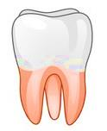

17. Identify the type of the tooth drawn above

____________________________________________________________

18. State the function of the above tooth

____________________________________________________________

19. Name one example of non – flowering plants.

____________________________________________________________

20. Mention one place where people cross busy roads from

____________________________________________________________

21. How are rock particles formed?

____________________________________________________________

22. Identify any one sign of dehydration.

____________________________________________________________

23. Name the best soil for growing crops.

____________________________________________________________

24. Give one reason why people keep cats at home.

____________________________________________________________

25. Name one factor that affect the rate of transpiration.

____________________________________________________________

26. Which type of clouds show a clear sign of rain?

____________________________________________________________

27. Why do we wash our hands with soap after visiting toilets?

____________________________________________________________

28. Name one cause of soil erosion.

____________________________________________________________

29. How useful are spiracles to an insect?

_____________________________________________________________

30. What is air?

_____________________________________________________________

31. Give one example of fuel

_____________________________________________________________

32. Write any one PIASCY message you know

_____________________________________________________________

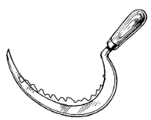 **Below is a garden tool. Use it to answer question 33 and 34**

33. Identify the garden tool below

_____________________________________________________________

34. How useful is the above tool to a crop farmer?

_____________________________________________________________

35. State one natural source of light

___________________________________________________________

36. Name one way weak stem plants climb others.

___________________________________________________________

37. Who is a casualty?

___________________________________________________________

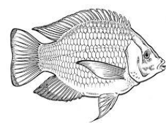**Below is a diagram of an aquatic animal. Use it to answer questions that follow**

38. Which environment is suitable for the life of the animal above.

__________________________________________________________

39. Name one other example of an aquatic animal.

__________________________________________________________

40. Mention one role of a child at home.

__________________________________________________________

**SECTION B.**

41 (a) What is an accident?

________________________________________________________

(b) State any two ways of controlling accidents

i)_____________________________________________________

ii) _____________________________________________________

(c) Why do we give first aid?

________________________________________________________

42.(a) Identify the type of weather that leads to drought.

________________________________________________________

(b) Give any two elements of weather.

i)______________________________________________________

ii) ______________________________________________________

(c) State one way of managing rainy weather

_______________________________________________________

43. **The diagram below show lifecycle of an insect. Use it to answer the questions that follow**

**Eggs**

**X**

**W**

**L**

(a) Name the type of lifecycle above

________________________________________________________

(b) Give any one insect that undergoes the above lifecycle

_________________________________________________________

(c) Write the stages marked

X _________________________________

L _________________________________

44. (a) Mention any two characteristics of living things

i)______________________________________________________

ii) ______________________________________________________

(b) Apart from animals, give any other group of living things

_________________________________________________________

(c) Why do animals move from one place to another?

_________________________________________________________

45. a) Name the main natural source of water

_________________________________________________________

b) How useful is water to people.(Give two)

i) _______________________________________________________

ii) _______________________________________________________

c) Give one way of caring for water sources.

_________________________________________________________

46. a) Draw the following types of leaf venation below.

|  |  |
| --- | --- |
|  |  |
| Parallel leaf venation | Network leaf venation |

b) State any two uses of leaves to people.

i) ____________________________________________

ii) ____________________________________________

47. a) Mention any one food stuff rich in carbohydrates

_______________________________________________________

b) State any two uses of food in our bodies

i) ______________________________________________________

ii) ______________________________________________________

c) Give one example of food values.

________________________________________________________

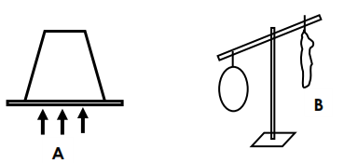48. **The diagram below shows properties of air. Use them to answer questions that follow.**

1. Identify the properties of air marked A and B

A _________________________

B_________________________

1. Mention any two components of air

**i)** _______________________________________________________

ii) _______________________________________________________

49. Arrange the following sentences in their correct order

a) The clouds become heavy and fall as rain.

b) The sun heats water in the water body.

c) The water vapour condenses to form nimbus clouds.

d) The water evaporates in the atmosphere.

________________________________________________________

________________________________________________________

________________________________________________________

________________________________________________________

________________________________________________________

50. a) Name any two childhood immunisable diseases.

i) __________________________________________________

ii) __________________________________________________

b) Identify any one place where children are taken for immunization

_______________________________________________________

1. Why are children always taken for immunization?

________________________________________________________

51. **The diagram below is of a plant. Use it to answer the questions that follow**

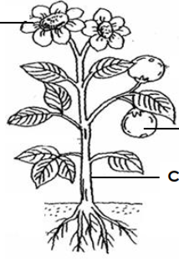

**M**

H

**N**

a) Name the part marked H

___________________________________________________

1. How useful is part H to the plant?

_________________________________________________________

1. State any two parts that make up a shoot system.

i) ___________________________________

ii) ___________________________________

52. a) What do we call the process by which plants make their own food?

_______________________________________________________

b) State any one condition needed for the above process to occurs

_______________________________________________________

c) Why can’t the above process occur at night?

_______________________________________________________

53. The diagram shows a tree and its shadow on a sunny day. Study and use it to and questions that follow.

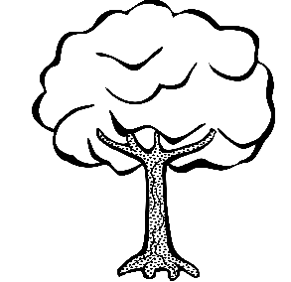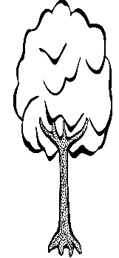

Tree

Shadow

1. Draw the sun in its right position

(b) State any two importance of shadow to people.

(i) __________________________________________________

(ii) _________________________________________________

(c) Name one danger of sun to a crop farmer.

________________________________________________________

54. a) What is sanitation ?

_________________________________________________________

b) Write down two items used in promoting good sanitation.

i) _____________________________________________________

ii) _____________________________________________________

1. State one danger of poor sanitation

_________________________________________________________

55. **Match and write the insects to the disease they spread**

**Insect Disease**

Tsetse flies Malaria

Culex mosquitoes Polio

Cockroach Elephantiasis

Anopheles mosquito Sleeping sickness

1. Tsetse flies _____________________________
2. Culex mosquitoes _____________________________
3. Cockroach _____________________________
4. Anopheles mosquito _____________________________