ME EDUCATIONAL CONSULT

**TEL: 0708856553 / 0702415886**

**P. 5 Beginning of Term 2 Examination 2025**

**English.**

# Name:

**Section A Sub-section I**

## For questions 1 – 5, complete the sentences with the most suitable word or group of words.

1. The mechanic used a to fix the nuts on the wheel of the car.
2. We are trying to find the thief used to break the door.
3. He is the man passport was confiscated by the court.
4. People who the law are arrested by the police.
5. Most of the members of parliament didn’t agree the proposed

bill.

## For questions 6 – 12, use the correct form of the word given in brackets to complete the sentence.

1. By the time the teacher arrived, the pupils had the map. (draw)
2. Uganda is experiencing the drought since 1982. (bad)
3. His prevented him from begging for food. (proud)
4. I chosen to play in the school football team. (to be)
5. The pupils were advised to conduct the experiment . (self)
6. The police have been instructed to guard all sites against terrorist attacks. (history)
7. The government should farmers to plant new crops when it rains. (courage.)

## For questions 13 – 15, rewrite the given short forms in full.

1. shan’t
2. Ref.
3. PSV

## In questions 16 – 17, arrange the given words in alphabetical order.

1. brother, bread, broken, broilers.
2. flower, florist, flour, float

## In questions 18 – 20, rewrite the sentences giving the opposite of the underlined words.

1. Mr. Maari is a cruel man.
2. There is security in this area.
3. Most of the pupils in my class passed the test.

## In questions 21 – 22, use the given words in sentences to show that you understand their meaning.

1. dairy
2. diary

## In questions 23 – 25, give one word for the underlined words in the sentence.

1. The children who had lost their parents cried loudly.
2. Meat is bought at a very high cost these days.
3. The doctor has given medicine to the sick man.

## For questions 26 – 28, rewrite the given sentences giving the plural form of the underlined words.

1. Which lady wrote the article we read in the newspaper?
2. He stored the half in the cupboard.
3. We saw a hippo grazing in the bush.

## In question 30, re – arrange the words to make a correct sentence.

1. eggs, do, where, lay, their, mosquitoes?
2. enough, bicycle, to, he, a, old, is, ride.

## Sub – section II

**For questions 31 – 50, rewrite the sentences as instructed in brackets.**

1. You bought a pen yesterday, didn’t you?

(Rewrite the above statement ending: did you?)

1. Musa and Ali failed the test.

(Rewrite the sentence using: Neither…………….nor… )

1. He has to pay school fees. He will not sit exams.

(Rewrite one sentence beginning: Unless )

1. We lose loved ones. We feel sad.

(Join into one sentence using: ………………….….when… )

1. A friend of mine has qualified to join Makerere University.

(Rewrite the sentence beginning: My… )

1. We have not eaten meat in the last two weeks.

(Rewrite the sentence ending: ago.)

1. The poor are killed by diseases. The rich are killed by diseases.

(Join into one sentence using: Both and… )

1. They are doing a Mathematics exam now.

(Rewrite the sentence using: ………………..….already )

1. Bakuli is a very strong man. Everybody fears him.

(Join into one sentence using: ………………such…………….that )

1. She is sick. She has done all the housework.

(Join the sentences beginning: Although… )

1. Mr. Kino is driving a big lorry.

(Rewrite the sentence beginning: A big lorry )

1. James is too poor to buy a car.

(Rewrite the sentence using: ………..enough… )

1. Nabbosa enjoys music. Nalule enjoys music.

(Join the two sentences using: …………………...and so… )

1. All the children in my class passed the exam.

(Rewrite the sentence beginning: None )

1. He went to school after sweeping the compound.

(Rewrite the sentence beginning: Having… )

1. “My sister is not feeling well,” said Diana.

(Rewrite the sentence beginning: Diana said that )

1. The sheep weighs 30 kilogrammes. The goat weighs 30 kilogrammes.

(Rewrite as one sentence using: ….as…..as……)

1. He is the candidate. He lost the elections for district chairperson.

(Rewrite the sentence using: who )

1. He will not go for the trip. He has to pay the fare first.

(Rewrite as one sentence beginning: If… )

1. The engineer wants to know the depth of the foundation.

(Rewrite the sentence using: ….………………………how )

# SECTION B

## Read the passage below and answer in full sentences all the questions about it.

**Mr. Opita’s Garage**

Mr. Opita is now eighty-five years of age. He has been repairing vehicles since he was 18 years old. He stared repairing bicycles in his home village of Kipuyo and after five years, he moved into Mbale Town where he opened MMO garage along Mboya Road. In Mbale Town, he moved from repairing bicycles to repairing cars, vans and lorries. He bought a breakdown and employed four other mechanics to help him in his work.

Mr. Opita is now an old man. His back is weak and all his strength is gone. He can no longer do the heavy work involved in vehicle repair. He now sits on a chair under the tree in his garage and directs other mechanics on how best to repair the vehicles brought to their garage.

Sometimes Mr. Opita is called on phone to go and offer his services. In such times, vehicles break down on their way. Mr. Opita usually sends Mr. Ogum, the driver of the breakdown service and another mechanic. If the problem is big, the car is

towed to the garage for repair. Where the problem involves loose nuts, punctured tyres or failing brake system, the vehicle is repaired at the site.

## Questions

* 1. At what age did Mr. Opita start repairing vehicles?
  2. For how long did Mr. Opiita repair bicycles?
  3. What is Mr. Opita’s birthplace?
  4. Why did Mr. Opita move to Mbale Town?
  5. When does Mr. Opita use the breakdown services?
  6. What type of repairs are carried out at the site?
  7. How is a breakdown important in Mr. Opita’s garage?
  8. In which part of Mbale Town is Mr. Opita’s garage?
  9. Why do you think Mr. Opita moved from repairing bicycles to repairing cars?
  10. What is the title of the passage?

## Below is a diagram of a family tree. Study it carefully and answer the questions that follow in full sentences.

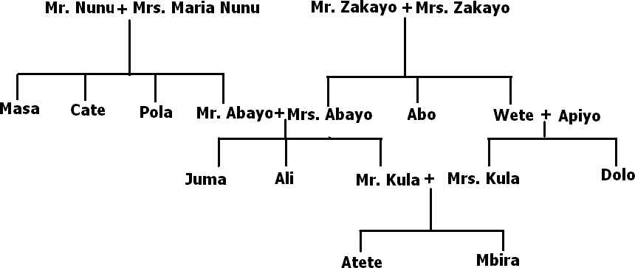

**Questions**

* 1. What type of information is given above?
  2. How many families are given in the above information?
  3. What is the relationship between Juma and Mr. Nunu?
  4. Who is Mr. Wete’s wife?
  5. Whose brother-in-law is Masa?
  6. How many grandparents are shown in the above information?
  7. In which way is Ali related to Mr. Kula?
  8. Which pair of cousins is there in the above information?
  9. How many married people are in the above family tree?
  10. Which person has no parents shown in the family tree?

## The following sentences are not in their correct order. Rearrange them correctly to make a composition about VEHICLE REPAIR AND MAINTENCE.

* 1. The man is spent on paying mechanics or buying another vehicle.
  2. It was Mr. Bugonza who taught us this topic.
  3. Without this knowledge, our vehicles may not last long.
  4. This term, we learnt about an important topic.
  5. Secondly, he / she should always service the vehicle in time.
  6. If a vehicle lasts for a short time, you spend a lot of money on it.
  7. The topic was VEHICLE REPAIR AND MAINTENANCE.
  8. First, he / she should have some basic tools such as the car jack, spanners and pliers.
  9. Mr. Bugonza said that everyone needs some knowledge about vehicle repair and maintenance.
  10. In order to avoid spending a lot of money, every vehicle owner should do certain things.

## The graph below shows the number of newspapers published daily in Uganda. Study it carefully and use it to answer the questions about it in full sentences.

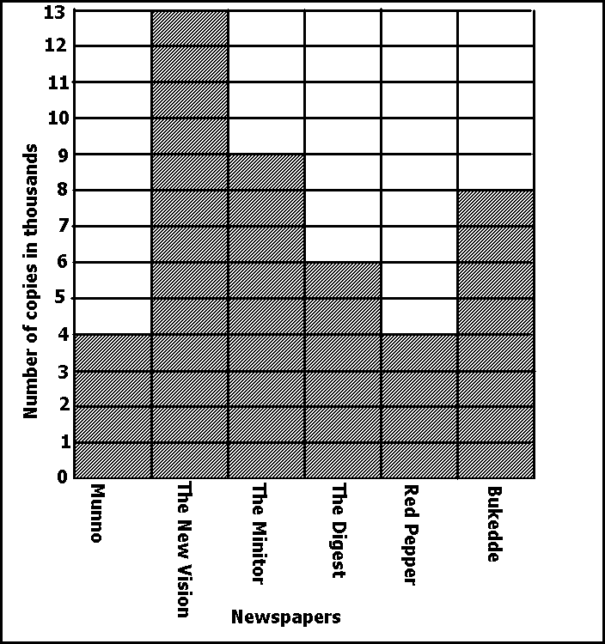

**Questions**

* 1. What is the graph about?
  2. Which newspaper company publishes the highest number of copies?
  3. Which newspaper companies publish the same number of copies?
  4. How many newspapers are published in Uganda daily?
  5. What number of copies do the Red Pepper and Munno companies publish in a day?
  6. Why do you think Munno publishes the least number of copies?
  7. Mention one newspaper published in the local language.
  8. Which newspaper company publishes nine thousand copies a day?
  9. Why do people buy newspapers?
  10. How many copies of the Monitor are published each day?

## Read the dialogue below and answer the following questions about it in full sentences.

**David:** Come on, John. Let’s go bicycle racing in the football field.

**John:** I am sorry; oh I can’t go with you today.

**David:** What is the matter?

**John:** I have to look after my sister. She got some injuries on her legs and knees.

**David:** What a pity! What happened?

**John:** I applied the brakes of my bicycle suddenly when a big snake was crossing the road. I was preventing both of us from getting bitten by the snake.

**David:** Wasn’t your bicycle damaged?

**John:** The front tyre got a puncture, the rim got bent and seven spokes got broken.

**David:** Have you taken your bicycle for repair?

**John:** Not yet. I will take it this afternoon when my parents return from church.

**David:** To whom will you take it?

**John:** I will take it to Mr. Juakali. He is a good mechanic and his charges are fair.

**David:** Where’s Mr. Juakali’s workshop?

**John:** It’s under the mango tree in front of Mr. Mambo Bado’s shop. He gets spare

parts from the shop and fixes them on the bicycles he repairs.

**David:** Does Mr. Jua kali repair motorcycles and cars as well?

**John:** No, he doesn’t

**David:** I am going to ask Mike to go with me.

**John:** Goodbye. Take care when riding next time.

# Questions

1. How many people are taking part in the dialogue?
2. Whose bicycle was involved in the accident?
3. Why couldn’t John go bicycle racing with David?
4. Who was injured in the accident?
5. Where did the accident happen?
6. What caused the accident?
7. How is Mambo Bado’s shop important to Juakali?
8. Where is Mr. Juakali’s garage?
9. Why do you think Juakali doesn’t repair cars?
10. Why will John take his bicycle to Mr. Juakali?