ME EDUCATIONAL CONSULT
0708856553/0702415886
“Hard work pays”
B.O.T TERM 2, 2025
SCIENCE
PRIMARY FIVE

DURATION: 2 HRS 15 MIN

Name: ……………………………………………………………………… Class: ……………………………………
DO NOT OPEN THIS BOOKLET UNTIL YOU ARE TOLD TO DO SO.
Read the following instructions carefully;
1. The paper has two sections: A and B.
2. Section A has 40 short questions (40 marks)
3. Section B has 15 questions (60 marks)
4. Attempt ALL questions. All answer to both Sections A and B must be written in the spaces provided.
5. All answers must be written using blue or black ball-point pen or ink. Only diagrams and graphs work may be done in pencil.
6. Unnecessary alteration of work will lead to loss of marks.
7. Any handwriting that cannot easily be read may lead to loss of marks.
8. Do not fill any thing in the boxes indicated for examiners’ use only.
FOR EXAMINER’S USE ONLY
SECTION A |  | TOTAL (%)
SECTION B |  | TOTAL (%)

SECTION A
1. What name is given to a place where seedlings are grown before transplanting?
……………………………………………………………………………………………………………………..
2. State one way in which a child gets natural immunity.
……………………………………………………………………………………………………………………..
3. Name the disease which is spread by a female anopheles mosquito.
………………………………………………………………………………………………………………………
4. Of what importance are gills to a fish?
……………………………………………………………………………………………………………………..
5. Name one viral disease among poultry.
……………………………………………………………………………………………………………………..
6. How is a broom useful in a classroom?
……………………………………………………………………………………………………………………..
7. Name the sense organ for hearing.
……………………………………………………………………………………………………………………..
8. State the importance of water during seed germination.
……………………………………………………………………………………………………………………..
9. Mention one item used for cleaning hands after visiting a latrine or toilet.
……………………………………………………………………………………………………………………..
10. How is a burn different from a scald?
……………………………………………………………………………………………………………………..
……………………………………………………………………………………………………………………..
11. Name the best soil for making pots.
……………………………………………………………………………………………………………………..
The diagram below shows a flower. Use it to answer questions that follow.
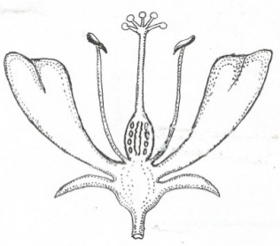

m

12. Name part marked m.
……………………………………………………………………………………………………………………..

13. Using a ruler and a pencil, indicate the filament with letter N on the above diagram.

14. Identify the type of family where there are parents and their biological children only.
……………………………………………………………………………………………………………………..
15. List down any one block in food path.
……………………………………………………………………………………………………………………..
16. Apart from trachoma, name one other disease of the eyes.
……………………………………………………………………………………………………………………..
17. Identify the immunisable disease which spreads through open wounds and cuts.
……………………………………………………………………………………………………………………..
18. Write one human activity which helps to reduce mosquitoes in a home.
……………………………………………………………………………………………………………………..
19. Which system of rearing poultry is commonly used in rural areas?
……………………………………………………………………………………………………………………..
20. Give one way poultry farmers control coccidiosis in the coop.
……………………………………………………………………………………………………………………..
21. What causes Kwashiorkor in children?
……………………………………………………………………………………………………………………..
22. Explain the meaning of the term “enzymes”.
……………………………………………………………………………………………………………………..
……………………………………………………………………………………………………………………..
23. Give one way through which worms enter our bodies.
……………………………………………………………………………………………………………………..
24. Where does absorption of alcohol take place in man?
……………………………………………………………………………………………………………………..
25. Apart from oiling, give one other way metals can be prevented from rusting.
……………………………………………………………………………………………………………………..
26. Which scientific word describes the structures that enable the absorption of food to take in small intestines?
……………………………………………………………………………………………………………………..
The diagram below shows a fracture. Use it to answer question 27.
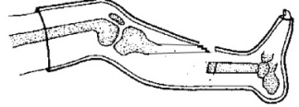

27. Name the type of fracture shown in the diagram above.
……………………………………………………………………………………………………………………..
28. At what age is measles vaccine administered to babies?
……………………………………………………………………………………………………………………..
29. Why is a patient of cholera advised to take ORS?
……………………………………………………………………………………………………………………..
30. Give a reason why culling is healthy practice in poultry keeping.
……………………………………………………………………………………………………………………..
31. State the units in which mass is measured.
……………………………………………………………………………………………………………………..
32. List down one example of a swimming bird.
……………………………………………………………………………………………………………………..
The diagram below shows a garden tool. Use it to answer the questions.
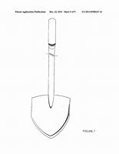
33. What is the importance of the above garden tool to a crop farmer?
……………………………………………………………………………………………………………………..
34. Which main duty does the Queen bee perform in the hive?
……………………………………………………………………………………………………………………..
The diagram below shows the life cycle of an insect. Use it to answer question 35.

Eggs

Adult
Nymph

35. Using a pencil and a ruler, draw arrows to complete the diagram.

36. Where does digestion end in man?
……………………………………………………………………………………………………………………..
37. State what happens to a piece of dry wood when dropped into a swimming pool.
……………………………………………………………………………………………………………………..
38. Why can’t mushrooms make their own food?
……………………………………………………………………………………………………………………..
39. Name one example of a perennial crop.
……………………………………………………………………………………………………………………..
40. Why should your teachers advise you to sleep under well treated mosquito nets?
……………………………………………………………………………………………………………………..
SECTION B
41.a) Which scientific term is used to describe special medicines used in prevention of certain diseases?
……………………………………………………………………………………………………………………..
b) How is the measles vaccine administered in the body of a baby?
……………………………………………………………………………………………………………………..
c) Apart from measles, give other two infant immunisable diseases.
i) ……………………………………………………………………………………………………………………
ii) …………………………………………………………………………………………………………………..
42.a) Name the two types of pollination in plants?
i) ……………………………………………………………………………………………………………………
ii) …………………………………………………………………………………………………………………
b) List down any two agents of pollination.
i) ……………………………………………………………………………………………………………………
ii) …………………………………………………………………………………………………………………
iii) …………………………………………………………………………………………………………………
43.a) State any two reasons why farmers practice weeding of their gardens.
i) ……………………………………………………………………………………………………………………
ii) …………………………………………………………………………………………………………………
b) Besides weeding, given any two other ways of caring for crops.
i) ……………………………………………………………………………………………………………………
ii)…………………………………………………………………………………………………………………

44.a) Which part of the human body is affected by each of the following diseases.
i) scabies
……………………………………………………………………………………………………………………..
ii) Trachoma
……………………………………………………………………………………………………………………..
b) State the vector responsible for the spread of each of the following diseases.
i) Bilharzia
……………………………………………………………………………………………………………………..
ii) Rabies
……………………………………………………………………………………………………………………..
45.a) Apart from a worker bee, mention other two types of bees found in a bee hive.
i) ……………………………………………………………………………………………………………………
ii) …………………………………………………………………………………………………………………
b) Write down two materials collected by a worker bee from the environment.
i) ……………………………………………………………………………………………………………………
ii) …………………………………………………………………………………………………………………
46.a) What is a first aid?
……………………………………………………………………………………………………………………..
……………………………………………………………………………………………………………………..
b) List down two things found in a first Aid box.
i) ……………………………………………………………………………………………………………………
ii) …………………………………………………………………………………………………………………
c) State a reason why your school should have a first Aid box.
……………………………………………………………………………………………………………………..
……………………………………………………………………………………………………………………..
47.a) Which type of vaccine is referred to as a triple vaccine?
……………………………………………………………………………………………………………………..
b) Apart from diphtheria, give two other immunisable diseases prevented by the above type of vaccine.
i) ……………………………………………………………………………………………………………………
ii)……………………………………………………………………………………………………………………

c) Briefly explain the term “Immunity”.
………………………………………………………………………………………………………………………
………………………………………………………………………………………………………………………
48.a) Write down two activities that help to promote good sanitation in a home.
i) ……………………………………………………………………………………………………………………
ii) ………………………………………………………………………………………………………………….
b) Mention two diseases which may attack a family due to poor sanitation.
i) ……………………………………………………………………………………………………………………
ii) …………………………………………………………………………………………………………………..
49. The table below shows weather instrument and what they measure. Match the items in list A with those in list B.
List A | List B
Wind vane  Barometer  Rain gauge  Anemometer | amount of rain  speed of wind  amount of air pressure  direction of wind

i) Wind vane …………………………………………………………………………………………..
ii) Barometer …………………………………………………………………………………………..
iii) Rain gauge …………………………………………………………………………………………..
iv) Anemometer …………………………………………………………………………………………..
50.a) Giveone example of an organ which belongs to the digestive system besides the mouth.
……………………………………………………………………………………………………………………..
b) List down two diseases, which affect the digestive system.
i) ……………………………………………………………………………………………………………………
ii) …………………………………………………………………………………………………………………..
c) Give one practice by humans which may lead to damaging of the digestive system.
……………………………………………………………………………………………………………………..
51.a) Name any two parts of a plant which provide human beings with food.
i) ……………………………………………………………………………………………………………………
ii) …………………………………………………………………………………………………………………..
b) Suggest two benefits of animals to plants in the environment.
i) ……………………………………………………………………………………………………………………
ii) …………………………………………………………………………………………………………………..

52. How does each of the following animals protect itself against enemies?
i) Tortoise
……………………………………………………………………………………………………………………..
ii) Wasp
……………………………………………………………………………………………………………………..
iii) Millipede
……………………………………………………………………………………………………………………..
b) Which slow moving animal changes its colour as a way of protection?
…………………………………………………………………………………………………………………….
53. The diagram below shows a box of chalk.
a) Find the volume of the box. (2mks)
3cm
2cm
5cm

b) Identify two examples of floating objects.
i) ……………………………………………………………………………………………………………………
ii) …………………………………………………………………………………………………………………..
54.a) Define “crop pests”.
……………………………………………………………………………………………………………………..
……………………………………………………………………………………………………………………..
b) Give one example of a crop pest.
……………………………………………………………………………………………………………………..
c) Apart from spraying, give other two ways of controlling crop pests.
i) ……………………………………………………………………………………………………………………
ii)…………………………………………………………………………………………………………………..

55. The diagram below shows part of the human digestive system. Use it to answer questions that follow.
Y
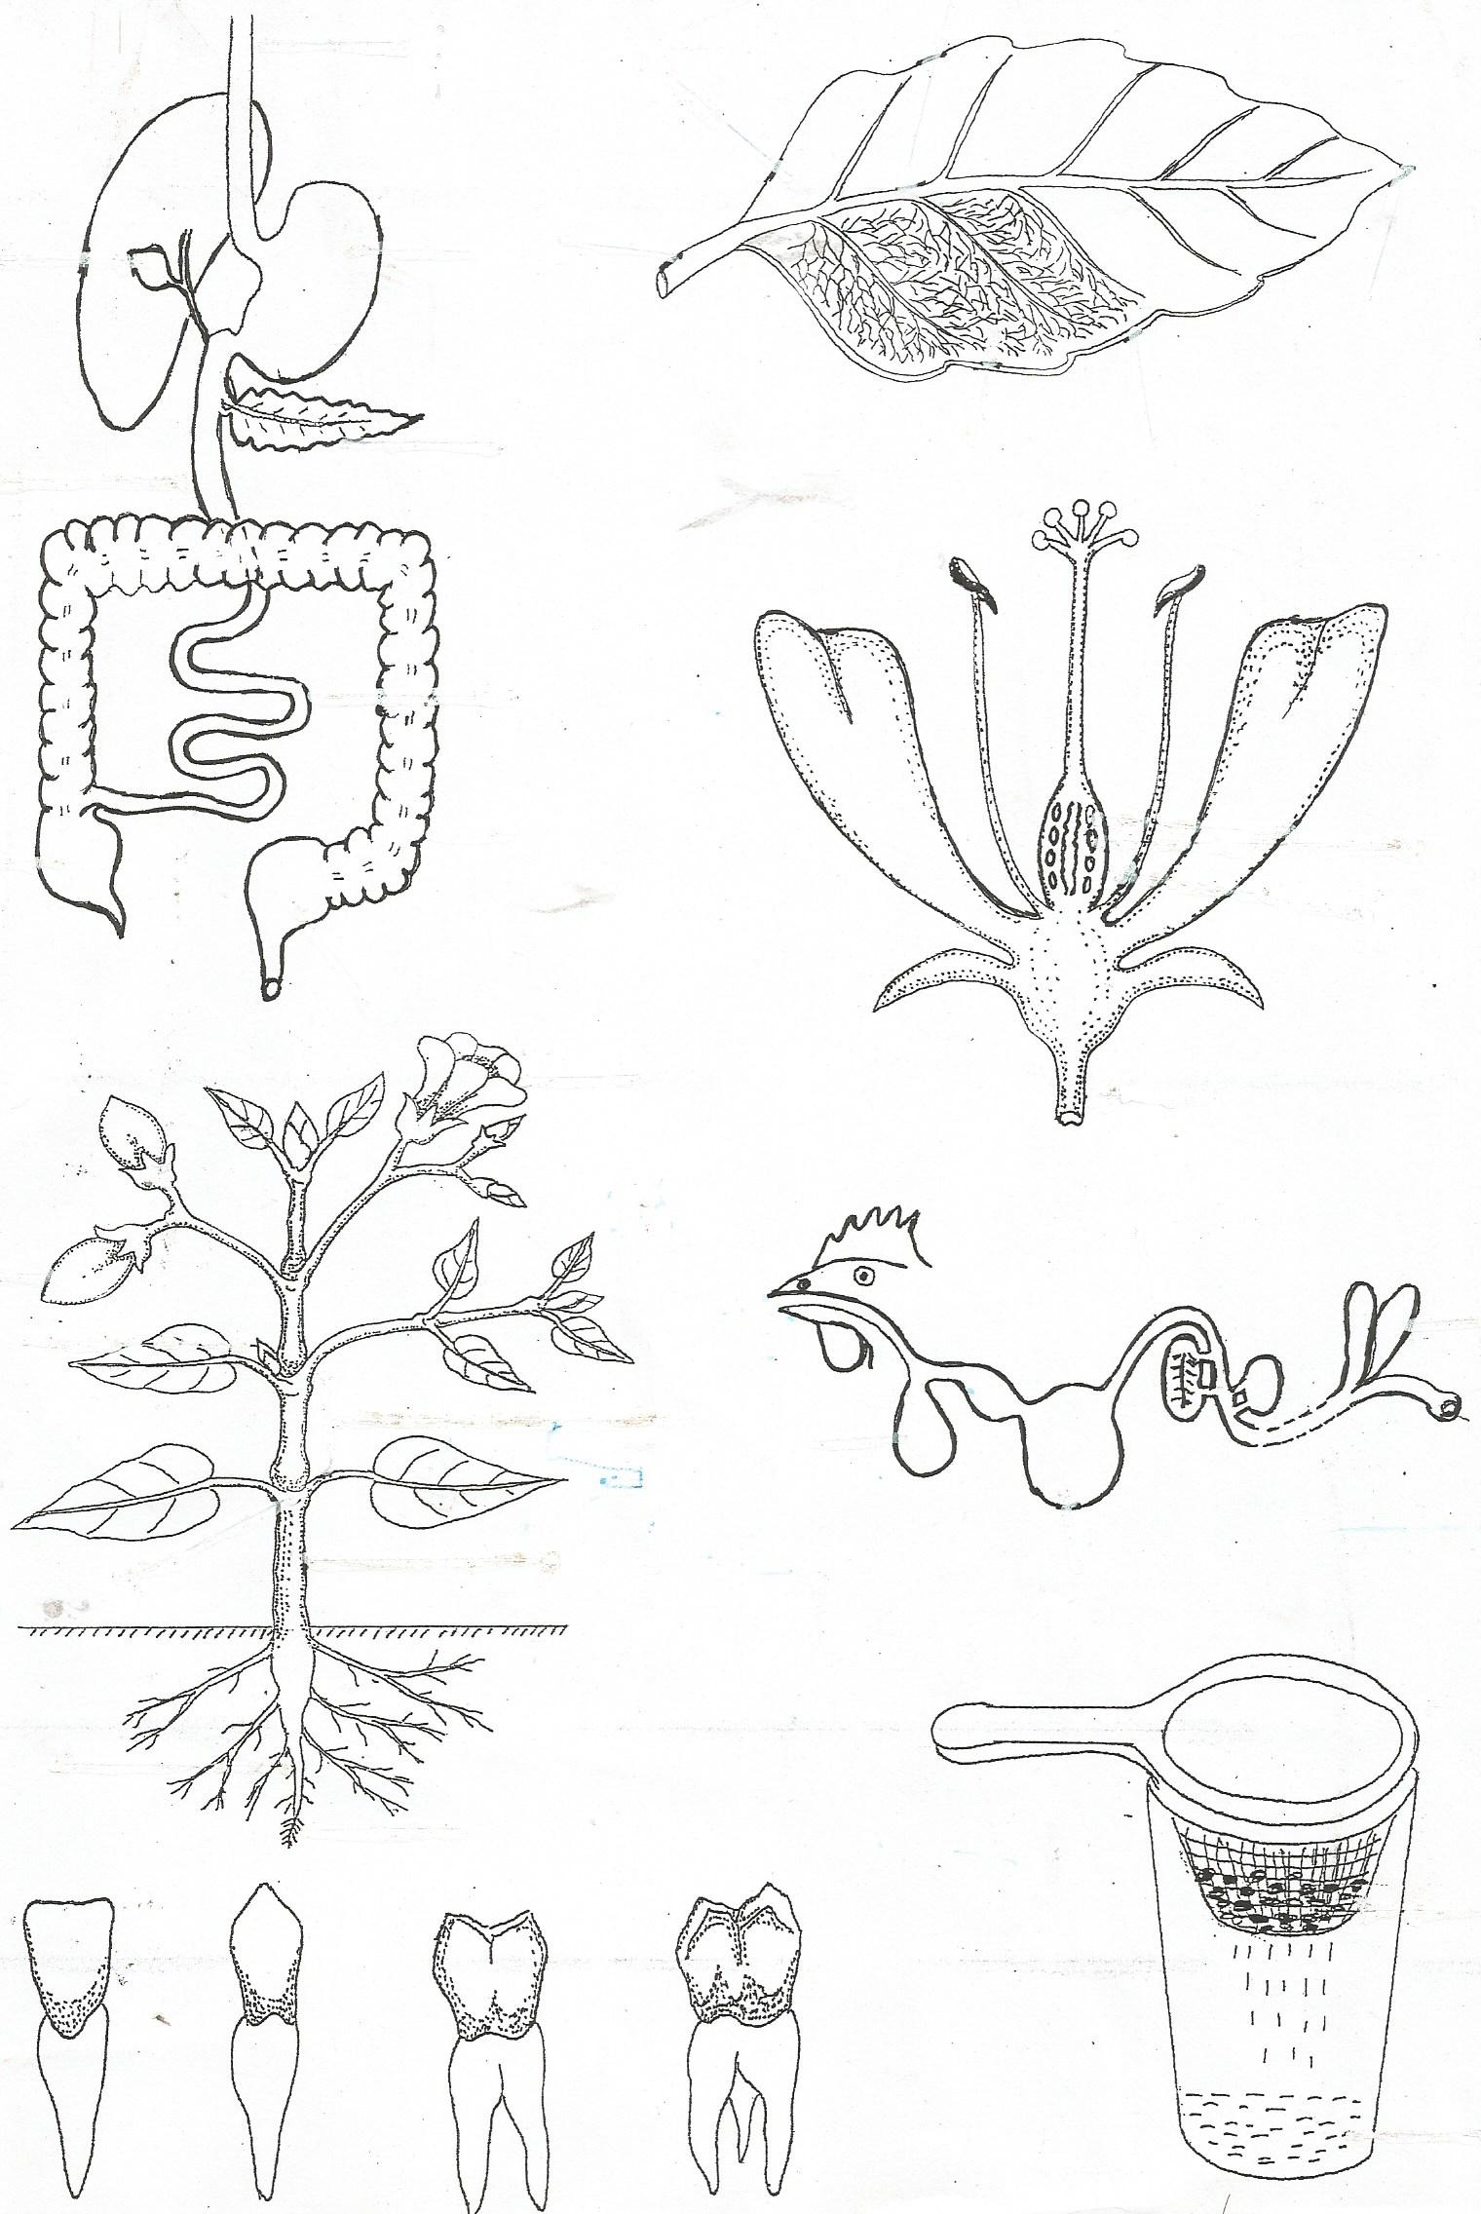
a) Name parts marked
i) Y …………………………………………………………………
ii) W ……………………………………………………………….
Z
X
W

b) State the function of part marked Z.
b ………………………………………………………………..
………………………………………………………………..
………………………………………………………………..
c) Name any one disease that affects the part marked X.
……………………………………………………………………………………………………………………..
END
“Yes we can”

