**ME EDUCATIONAL CONSULT**

**0708856553/0702415886**

**“Hard work pays”**

**B.O.T TERM 2, 2025**

**SCIENCE**

**PRIMARY FIVE**

DURATION: 2 HRS 15 MIN

**Name**: ……………………………………………………………………… **Class**: ……………………………………

**DO NOT OPEN THIS BOOKLET UNTIL YOU ARE TOLD TO DO SO**.

**Read the following instructions carefully;**

1. The paper has two sections: **A** and **B.**

2. Section **A** has 40 short questions (40 marks)

3. Section **B** has 15 questions (60 marks)

4. Attempt **ALL** questions. All answer to both Sections **A** and **B** must be written in the spaces provided.

5. All answers must be written using blue or black ball-point pen or ink. Only diagrams and graphs work may be done in pencil.

6. Unnecessary alteration of work will lead to loss of marks.

7. Any handwriting that cannot easily be read may lead to loss of marks.

8. Do **not** fill any thing in the boxes indicated for examiners’ use only.

**FOR EXAMINER’S USE ONLY**

|  |  |  |
| --- | --- | --- |
| **SECTION A** |  | **TOTAL (%)** |
| **SECTION B** |  |

**SECTION A**

1. What **name** is given to a place where seedlings are grown before transplanting?

……………………………………………………………………………………………………………………..

2. State **one** way in which a child gets natural immunity.

……………………………………………………………………………………………………………………..

3. Name the disease which is spread by a female anopheles mosquito.

………………………………………………………………………………………………………………………

4. Of what importance are gills to a fish?

……………………………………………………………………………………………………………………..

5. Name **one** viral disease among poultry.

……………………………………………………………………………………………………………………..

6. How is a broom useful in a classroom?

……………………………………………………………………………………………………………………..

7. Name the sense organ for hearing.

……………………………………………………………………………………………………………………..

8. State the importance of water during seed germination.

……………………………………………………………………………………………………………………..

9. Mention **one** item used for cleaning hands after visiting a latrine or toilet.

……………………………………………………………………………………………………………………..

10. How is **a burn** different from **a scald**?

……………………………………………………………………………………………………………………..

……………………………………………………………………………………………………………………..

11. Name the best soil for making pots.

……………………………………………………………………………………………………………………..

The diagram below shows a flower. Use it to answer questions that follow.

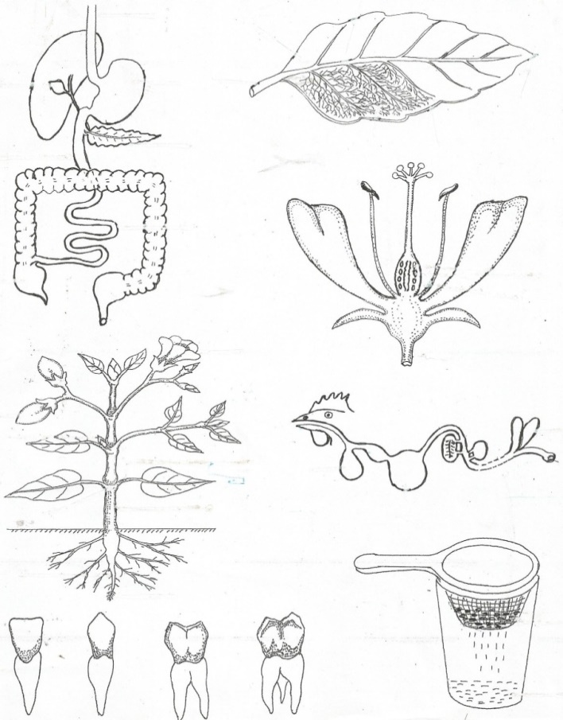

**m**

12. Name part marked **m**.

……………………………………………………………………………………………………………………..

13. Using a ruler and a pencil, indicate the filament with letter **N** on the above diagram.

14. Identify the type of family where there are parents and their biological children only.

……………………………………………………………………………………………………………………..

15. List down **any one** block in food path.

……………………………………………………………………………………………………………………..

16. Apart from trachoma, name one other disease of the eyes.

……………………………………………………………………………………………………………………..

17. Identify the **immunisable disease** which spreads through open wounds and cuts.

……………………………………………………………………………………………………………………..

18. Write **one** human activity which helps to reduce mosquitoes in a home.

……………………………………………………………………………………………………………………..

19. Which **system** of rearing poultry is commonly used in rural areas?

……………………………………………………………………………………………………………………..

20. Give **one** way poultry farmers control coccidiosis in the coop.

……………………………………………………………………………………………………………………..

21. What **causes** Kwashiorkor in children?

……………………………………………………………………………………………………………………..

22. Explain the meaning of the term “**enzymes”**.

……………………………………………………………………………………………………………………..

……………………………………………………………………………………………………………………..

23. Give **one** way through which worms enter our bodies.

……………………………………………………………………………………………………………………..

24. Where does **absorption** of alcohol take place in man?

……………………………………………………………………………………………………………………..

25. Apart from oiling, give **one** other way metals can be prevented from rusting.

……………………………………………………………………………………………………………………..

26. Which **scientific word** describes the structures that enable the absorption of food to take in small intestines?

……………………………………………………………………………………………………………………..

The diagram below shows a fracture. Use it to answer question **27**.

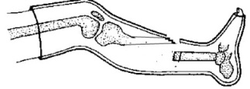

27. Name the type of fracture shown in the diagram above.

……………………………………………………………………………………………………………………..

28. At **what age** is measles vaccine administered to babies?

……………………………………………………………………………………………………………………..

29. Why is a patient of cholera advised to take ORS?

……………………………………………………………………………………………………………………..

30. Give a reason why culling is healthy practice in poultry keeping.

……………………………………………………………………………………………………………………..

31. State the **units** in which **mass** is measured.

……………………………………………………………………………………………………………………..

32. List down **one** example of a swimming bird.

……………………………………………………………………………………………………………………..

The diagram below shows a garden tool. Use it to answer the questions.

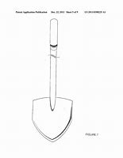

33. What is the importance of the above garden tool to a crop farmer?

……………………………………………………………………………………………………………………..

34. Which **main duty** does the Queen bee perform in the hive?

……………………………………………………………………………………………………………………..

The diagram below shows the life cycle of an insect. Use it to answer question 35.

Eggs

Adult

Nymph

35. Using a pencil and a ruler, draw arrows to complete the diagram.

36. Where does digestion **end** in man?

……………………………………………………………………………………………………………………..

37. State what happens to **a piece of dry wood** when dropped into a swimming pool.

……………………………………………………………………………………………………………………..

38. Why can’t mushrooms make their own food?

……………………………………………………………………………………………………………………..

39. Name **one** example of a perennial crop.

……………………………………………………………………………………………………………………..

40. Why should your teachers advise you to sleep under well treated mosquito nets?

……………………………………………………………………………………………………………………..

**SECTION B**

41.a) Which scientific term is used to describe **special medicines** used in prevention of certain diseases?

……………………………………………………………………………………………………………………..

b) How is the measles vaccine administered in the body of a baby?

……………………………………………………………………………………………………………………..

c) Apart from measles, give other two infant immunisable diseases.

i) ……………………………………………………………………………………………………………………

ii) …………………………………………………………………………………………………………………..

42.a) Name the **two** types of pollination in plants?

i) ……………………………………………………………………………………………………………………

ii) …………………………………………………………………………………………………………………

b) List down **any two** agents of pollination.

i) ……………………………………………………………………………………………………………………

ii) …………………………………………………………………………………………………………………

iii) …………………………………………………………………………………………………………………

43.a) State **any two** reasons why farmers practice weeding of their gardens.

i) ……………………………………………………………………………………………………………………

ii) …………………………………………………………………………………………………………………

b) Besides weeding, given **any two** other ways of caring for crops.

i) ……………………………………………………………………………………………………………………

ii)…………………………………………………………………………………………………………………

44.a) Which part of the human body is affected by each of the following diseases.

i) scabies

……………………………………………………………………………………………………………………..

ii) Trachoma

……………………………………………………………………………………………………………………..

b) State the vector responsible for the spread of each of the following diseases.

i) Bilharzia

……………………………………………………………………………………………………………………..

ii) Rabies

……………………………………………………………………………………………………………………..

45.a) Apart from a worker bee, mention other **two** types of bees found in a bee hive.

i) ……………………………………………………………………………………………………………………

ii) …………………………………………………………………………………………………………………

b) Write down **two** materials collected by a worker bee from the environment.

i) ……………………………………………………………………………………………………………………

ii) …………………………………………………………………………………………………………………

46.a) What is a **first aid**?

……………………………………………………………………………………………………………………..

……………………………………………………………………………………………………………………..

b) List down **two** things found in a first Aid box.

i) ……………………………………………………………………………………………………………………

ii) …………………………………………………………………………………………………………………

c) State a reason why your school should have a first Aid box.

……………………………………………………………………………………………………………………..

……………………………………………………………………………………………………………………..

47.a) Which type of **vaccine** is referred to as **a triple vaccine**?

……………………………………………………………………………………………………………………..

b) Apart from diphtheria, give **two** other immunisable diseases prevented by the above type of vaccine.

i) ……………………………………………………………………………………………………………………

ii)……………………………………………………………………………………………………………………

c) Briefly explain the term **“Immunity”**.

………………………………………………………………………………………………………………………

………………………………………………………………………………………………………………………

48.a) Write down **two** activities that help to promote good sanitation in a home.

i) ……………………………………………………………………………………………………………………

ii) ………………………………………………………………………………………………………………….

b) Mention **two** diseases which may attack a family due to poor sanitation.

i) ……………………………………………………………………………………………………………………

ii) …………………………………………………………………………………………………………………..

49. The table below shows weather instrument and what they measure. Match the items in list **A** with those in list **B**.

|  |  |
| --- | --- |
| **List A** | **List B** |
| Wind vane  Barometer  Rain gauge  Anemometer | amount of rain  speed of wind  amount of air pressure  direction of wind |

i) Wind vane …………………………………………………………………………………………..

ii) Barometer …………………………………………………………………………………………..

iii) Rain gauge …………………………………………………………………………………………..

iv) Anemometer …………………………………………………………………………………………..

50.a) Give**one** example of an organ which belongs to the digestive system besides the mouth.

……………………………………………………………………………………………………………………..

b) List down **two** diseases, which affect the digestive system.

i) ……………………………………………………………………………………………………………………

ii) …………………………………………………………………………………………………………………..

c) Give **one** practice by humans which may lead to damaging of the digestive system.

……………………………………………………………………………………………………………………..

51.a) Name **any two** parts of a plant which provide human beings with food.

i) ……………………………………………………………………………………………………………………

ii) …………………………………………………………………………………………………………………..

b) Suggest **two** benefits of animals to plants in the environment.

i) ……………………………………………………………………………………………………………………

ii) …………………………………………………………………………………………………………………..

52. How does each of the following animals protect itself against enemies?

i) Tortoise

……………………………………………………………………………………………………………………..

ii) Wasp

……………………………………………………………………………………………………………………..

iii) Millipede

……………………………………………………………………………………………………………………..

b) Which **slow moving** animal changes its colour as a way of protection?

…………………………………………………………………………………………………………………….

53. The diagram below shows a box of chalk.

a) Find the volume of the box. (2mks)

3cm

2cm

5cm

b) Identify **two** examples of floating objects.

i) ……………………………………………………………………………………………………………………

ii) …………………………………………………………………………………………………………………..

54.a) Define **“crop pests”**.

……………………………………………………………………………………………………………………..

……………………………………………………………………………………………………………………..

b) Give **one** example of a crop pest.

……………………………………………………………………………………………………………………..

c) Apart from spraying, give other **two** ways of controlling crop pests.

i) ……………………………………………………………………………………………………………………

ii)…………………………………………………………………………………………………………………..

55. The diagram below shows part of the human digestive system. Use it to answer questions that follow.

**Y**

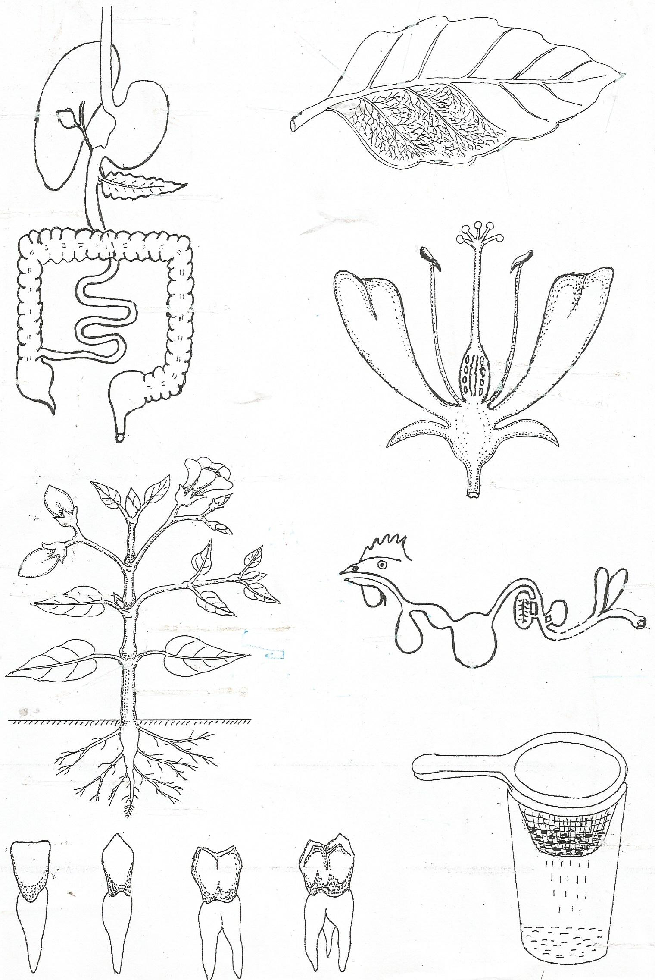 a) Name parts marked

i) **Y** …………………………………………………………………

ii) **W** ……………………………………………………………….

**Z**

**X**

**W**

b) State the function of part marked **Z**.

b ………………………………………………………………..

………………………………………………………………..

………………………………………………………………..

c) Name **any one** disease that affects the part marked **X**.

……………………………………………………………………………………………………………………..

***END***

***“Yes we can”***