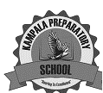
KAMPALA PREPARATORY SCHOOL
P.5 MID TERM I EXAMINATION 2025
SOCIAL STUDIES AND RELIGIOUS EDUCATION

DURATION: 2HRS 15MINS

NAME: ________________________________________ STREAM: ___________ CLASS: ………………………………
DISTRICT: …………………………. DATE: …………………………………….
DONOT OPEN THIS BOOKLET UNTIL YOU ARE TOLD TO DO SO.
READ THE FOLLOWING INSTRUCTIONS CAREFULLY.
- The paper has two sections: A and B.
- Section A, has 40 questions (40 marks)
- Section B has 15 questions. (60 marks)
- Attempt ALL questions
- All answers should be written using a blue or black – point pen or ink.
- Diagrams should be drawn in pencil.
- Unnecessary alterations of work may lead to loss of marks
- Any hand writing that cannot easily be read may lead to loss of marks.
- All calculations should be shown

FOR OFFICIAL USE ONLY
SECTION | A | B | TOTAL
MARKS
COMMENT

SECTION A (40 MARKS)
- How do we call a drawing of an object as seen from above?
______________________________________________________
- Give one use of a dog in a home?
______________________________________________________
- Who is the political head of a district?
______________________________________________________
- Why should a school have a bursar?
______________________________________________________
- How many members make up the L.C I executive committee?
______________________________________________________
- What is a plateau?
______________________________________________________
- Draw a map symbol of a pot in the space below.

- Name any one aquatic /marine animal that you know.
______________________________________________________
- Why are traffic officers encouraged to wear uniform?
_____________________________________________________
- What is the importance of prime meridian?
_____________________________________________________
- Name the major line of latitude.
_____________________________________________________
- In which geographical region is Uganda located?
_____________________________________________________
- Which animal is used as a means of transport in the highland districts
of Uganda?
_____________________________________________________

- Give one reason for cutting down trees in an area.
_____________________________________________________
- Give one problem faced by the government of Uganda when providing
_____________________________________________________
- Why do people in highland areas terrace their land?
_____________________________________________________
- Name the raw material used to make the craft shown below.
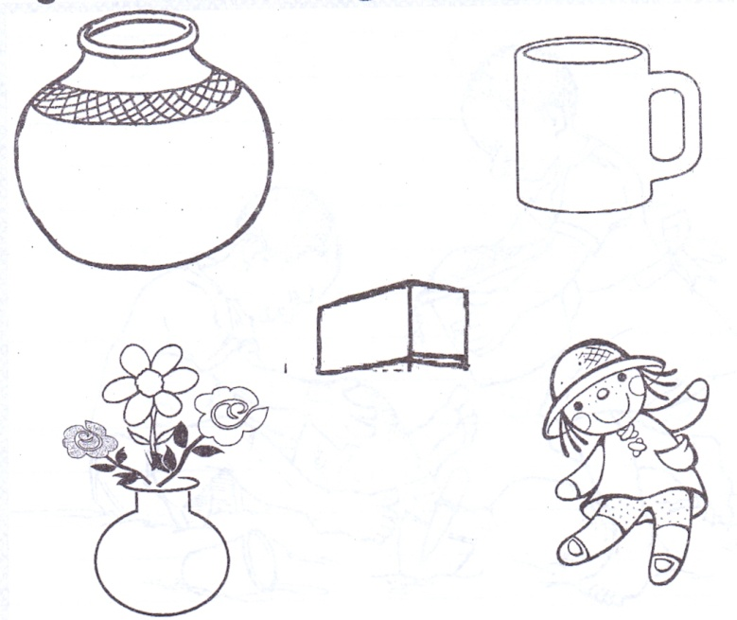

18. Give any one importance of a market in our community.
___________________________________________________
19. To which ministry do all schools in Uganda belong?
____________________________________________________
20. State any one problem faced by people living in towns.
____________________________________________________
21. Mention any one role of a child at home.
____________________________________________________
22. Why do island districts in Uganda receive conventional rainfall?
____________________________________________________
23. Draw a road sign for accident /danger ahead in the space below.

24. State any one way the police enforce law and order.
____________________________________________________
25. Apart from Kalangala district, name one other island district in
Uganda.
____________________________________________________
26. Why do some people fail to get basic needs?
____________________________________________________
27. Where should pedestrians cross a busy road from?
____________________________________________________
28. Give the general name for line of longitude.
____________________________________________________
29. State any one reason why Entebbe is a very important town in Uganda.
____________________________________________________
30. Name the highest mountain in Uganda.
____________________________________________________
31. Mention any one problem faced by people living in highland areas.
____________________________________________________
32. Mary is facing the North and she turns through an angle of 90⁰
clockwise. What is her new direction?
____________________________________________________
33. State the importance of a title to a map reader.
____________________________________________________
34. Name any one district found in the central region of Uganda.
____________________________________________________
35. Why do people carry out farming?
____________________________________________________
For questions 36 – 40, either Christianity or Islam questions but
not both.
36. Either: What is sin?
_____________________________________________
Or : What is sin?
_____________________________________________
37. Either : How was Amina related to John the Baptist?
_____________________________________________
Or : How was Amina related to Prophet Muhammad?
_____________________________________________
38. Either : Who was the first martyr in Christianity?
_____________________________________________
Or : Who was the first martyr in Islam?
_____________________________________________
39. Either : Mention any one way God talks to Christians.
_____________________________________________
Or : Mention any one way Allah talks to muslims.
_____________________________________________
40. Either : Which group of people introduced Christianity in Uganda?
_____________________________________________
Or : Which group of people introduced Islamic religion in
Uganda?
_____________________________________________
SECTION B (60 MARKS)
41. a) Name the points of a compass direction labeled D and N.
N
B______________________
A
D_________________
W
C
D
B

b) Mention any one group of people who use a compass in their work.
__________________________________________________
c) What problem will Hamza face if he reads a map without a compass
direction?
__________________________________________________
__________________________________________________
42. a) What is a legend?
__________________________________________________
__________________________________________________
b) Which legend is told by the following tribes?
i) Baganda
________________________________________________
ii) Bagisu
________________________________________________
c) Which lesson do we learn from the legend of Gipiir and Labong?
__________________________________________________
__________________________________________________
43. Use the diagram below to answer the questions that follow.

x
O⁰ A O⁰

- Name the shaded part on the globe.
___________________________________________________
- Why is latitude marked with letter A numbered zero degrees?
__________________________________________________
- Identify line marked x on the globe.
__________________________________________________
- Give nay one importance of line marked zero degrees on the globe.
__________________________________________________
44. a) What is vegetation?
_________________________________________________
b) Mention any two uses of trees to people.
i) ________________________________________________
ii) ________________________________________________
iii) _______________________________________________
c) Which type of wood is got from natural forests?
_________________________________________________
45. Match correctly.
Raw materials Product
- Oil palm cigarettes
- Tobacco cooking oil
- Coffee cloth
- Cotton beverage

- Oil palm ___________________________________________
- Tobacco ___________________________________________
- Coffee ____________________________________________
- Cotton ____________________________________________
46. a) Give any two examples of social services centres.
i) ________________________________________________
ii) ________________________________________________
b) Why do people need health services?
_________________________________________________
c) Mention any one social services provider.
_________________________________________________
47. Name the following map symbols.
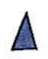
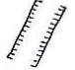
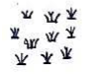
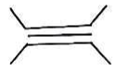

48. a) What is child abuse?
__________________________________________________
b) Give any one way child abuse can be reduced in communities.
__________________________________________________
c) Write any two basic needs a child can get from school.
i) _____________________ ii) _____________________
49. a) Give one neighbour of Uganda which is also land locked.
__________________________________________________
b) Why is Uganda referred to as a land locked country?
__________________________________________________
c) State any two problems faced by landlocked countries like Uganda.
i) _________________________________________________
ii) ________________________________________________
50. a) Mention any two landforms in Uganda.
i)_________________________________________________
ii)_________________________________________________
b) State any two values of lakes and rivers in Uganda.
i)_________________________________________________
ii) ________________________________________________
For questions 51-55, answer Either Christianity or Islam But not both in a number.

51. Either : a) How many commandments did God give to Moses?
_________________________________________
b) On which mountain did Moses receive the above
commandments?
_________________________________________
Or : Write down any four pillars of Islam.
- __________________ iii) ________________
- __________________ iv) ________________
52. Either : a) In how many days did God create the Universe?
__________________________________________
b) Who were the first two people to be created by God?
i)__________________ ii) _________________
c) What did God use to create Adam?
__________________________________________
Or : a) In how many days did Allah create the Universe?
__________________________________________
b) Who were the first two people to be created by Allah?
__________________________________________
c) What did Allah use to create Adam?
__________________________________________
53. Either : a) What is a Bible?
__________________________________________ b) Name any two sinful acts in Christianity
i)_________________________________________
ii) ________________________________________
c) What should a Christian do after sinning?
__________________________________________
Or : a) What is a Quran?
_________________________________________
b) Name any two sinful acts in Islam.
i)________________________________________
ii) _______________________________________
c) What should a muslim do after sinning?
_________________________________________
54. Either : a) What name is given to the fasting period for Christians?
_________________________________________
b) How many days do Christians fast?
_________________________________________
c) Give any two reasons Christians fast.
i) ________________________________________
ii) ________________________________________
Or : a) What name is given to the fasting period for Muslims?
_________________________________________
b) How many days do Muslims fast?
_________________________________________
c) Give any two reasons Muslims fast.
i) ________________________________________
ii) ________________________________________
55. For both:
a) Who is a leader?
__________________________________________________
b) State any two qualities of a good leader.
i) ________________________________________________
ii) ________________________________________________
c) How do people become leaders?
__________________________________________________
__________________________________________________

**All the Best.**

