**KAMPALA PREPARATORY SCHOOL**

**P.5 MID TERM I EXAMINATION 2025**

**SOCIAL STUDIES AND RELIGIOUS EDUCATION**

**DURATION: 2HRS 15MINS**

**NAME: ________________________________________ STREAM: ___________ CLASS: ………………………………**

**DISTRICT: …………………………. DATE: …………………………………….**

D**ONOT OPEN THIS BOOKLET UNTIL YOU ARE TOLD TO DO SO**.

**READ THE FOLLOWING INSTRUCTIONS CAREFULLY.**

1. **The paper has two sections: A and B.**
2. **Section A, has 40 questions (40 marks)**
3. **Section B has 15 questions. (60 marks)**
4. **Attempt ALL questions**
5. **All answers should be written using a blue or black – point pen or ink.**
6. **Diagrams should be drawn in pencil.**
7. **Unnecessary alterations of work may lead to loss of marks**
8. **Any hand writing that cannot easily be read may lead to loss of marks.**
9. **All calculations should be shown**

|  |  |  |  |
| --- | --- | --- | --- |
| **FOR OFFICIAL USE ONLY** | | | |
| **SECTION** | **A** | **B** | **TOTAL** |
| **MARKS** |  |  |  |
| **COMMENT** |  |  |  |

**SECTION A (40 MARKS)**

1. How do we call a drawing of an object as seen from above?

______________________________________________________

1. Give one use of a dog in a home?

______________________________________________________

1. Who is the political head of a district?

______________________________________________________

1. Why should a school have a bursar?

______________________________________________________

1. How many members make up the L.C I executive committee?

______________________________________________________

1. What is a plateau?

______________________________________________________

1. **Draw a map symbol of a pot in the space below**.
2. Name any one aquatic /marine animal that you know.

______________________________________________________

1. Why are traffic officers encouraged to wear uniform?

_____________________________________________________

1. What is the importance of prime meridian?

_____________________________________________________

1. Name the major line of latitude.

_____________________________________________________

1. In which geographical region is Uganda located?

_____________________________________________________

1. Which animal is used as a means of transport in the highland districts

of Uganda?

_____________________________________________________

1. Give one reason for cutting down trees in an area.

_____________________________________________________

1. Give one problem faced by the government of Uganda when providing

_____________________________________________________

1. Why do people in highland areas terrace their land?

_____________________________________________________

1. Name the raw material used to make the craft shown below.

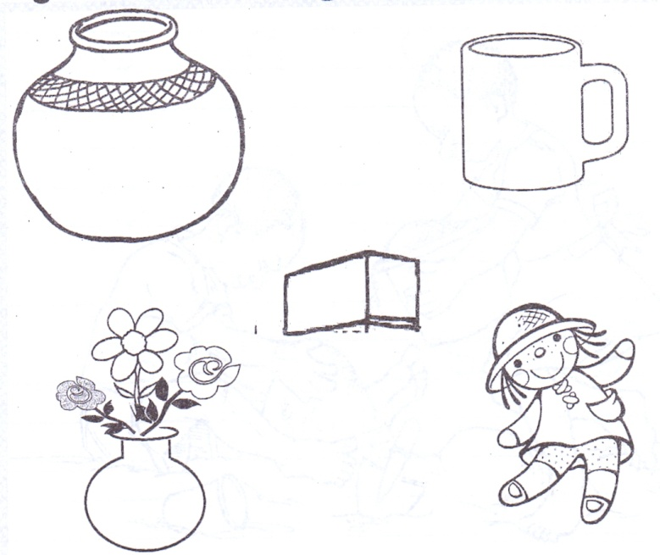

18. Give any one importance of a market in our community.

___________________________________________________

19. To which ministry do all schools in Uganda belong?

____________________________________________________

20. State any one problem faced by people living in towns.

____________________________________________________

21. Mention any one role of a child at home.

____________________________________________________

22. Why do island districts in Uganda receive conventional rainfall?

____________________________________________________

23. Draw a road sign for accident /danger ahead in the space below.

24. State any one way the police enforce law and order.

____________________________________________________

25. Apart from Kalangala district, name one other island district in

Uganda.

____________________________________________________

26. Why do some people fail to get basic needs?

____________________________________________________

27. Where should pedestrians cross a busy road from?

____________________________________________________

28. Give the general name for line of longitude.

____________________________________________________

29. State any one reason why Entebbe is a very important town in Uganda.

____________________________________________________

30. Name the highest mountain in Uganda.

____________________________________________________

31. Mention any one problem faced by people living in highland areas.

____________________________________________________

32. Mary is facing the North and she turns through an angle of 900

clockwise. What is her new direction?

____________________________________________________

33. State the importance of a title to a map reader.

____________________________________________________

34. Name any one district found in the central region of Uganda.

____________________________________________________

35. Why do people carry out farming?

____________________________________________________

**For questions 36 – 40, either Christianity or Islam questions but**

**not both.**

36. ***Either***: What is sin?

_____________________________________________

***Or*** : What is sin?

_____________________________________________

37. ***Either*** : How was Amina related to John the Baptist?

*_____________________________________________*

***Or*** *: How was Amina related to Prophet Muhammad?*

*_____________________________________________*

*38.* ***Either*** *: Who was the first martyr in Christianity?*

*_____________________________________________*

***Or*** *: Who was the first martyr in Islam?*

*_____________________________________________*

*39.* ***Either*** *: Mention any one way God talks to Christians.*

*_____________________________________________*

***Or*** *: Mention any one way Allah talks to muslims.*

*_____________________________________________*

40. ***Either*** : Which group of people introduced Christianity in Uganda?

_____________________________________________

***Or*** : Which group of people introduced Islamic religion in

Uganda?

_____________________________________________

**SECTION B (60 MARKS)**

41. a) Name the points of a compass direction labeled D and N.

N

B______________________

A

D_________________

W

C

D

B

b) Mention any one group of people who use a compass in their work.

__________________________________________________

c) What problem will Hamza face if he reads a map without a compass

direction?

__________________________________________________

__________________________________________________

42. a) What is a legend?

__________________________________________________

__________________________________________________

b) Which legend is told by the following tribes?

i) Baganda

________________________________________________

ii) Bagisu

________________________________________________

c) Which lesson do we learn from the legend of Gipiir and Labong?

__________________________________________________

__________________________________________________

43. **Use the diagram below to answer the questions that follow**.

x

O0 A O0

1. Name the shaded part on the globe.

___________________________________________________

1. Why is latitude marked with letter A numbered zero degrees?

__________________________________________________

1. Identify line marked x on the globe.

__________________________________________________

1. Give nay one importance of line marked zero degrees on the globe.

__________________________________________________

44. a) What is vegetation?

_________________________________________________

b) Mention any two uses of trees to people.

i) ________________________________________________

ii) ________________________________________________

iii) _______________________________________________

c) Which type of wood is got from natural forests?

_________________________________________________

45. **Match correctly**.

**Raw materials Product**

1. Oil palm cigarettes
2. Tobacco cooking oil
3. Coffee cloth
4. Cotton beverage
5. Oil palm ___________________________________________
6. Tobacco ___________________________________________
7. Coffee ____________________________________________
8. Cotton ____________________________________________

46. a) Give any two examples of social services centres.

i) ________________________________________________

ii) ________________________________________________

b) Why do people need health services?

_________________________________________________

c) Mention any one social services provider.

_________________________________________________

47. **Name the following map symbols**.

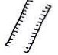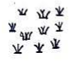

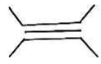

48. a) What is child abuse?

__________________________________________________

b) Give any one way child abuse can be reduced in communities.

__________________________________________________

c) Write any two basic needs a child can get from school.

i) _____________________ ii) _____________________

49. a) Give one neighbour of Uganda which is also land locked.

__________________________________________________

b) Why is Uganda referred to as a land locked country?

__________________________________________________

c) State any two problems faced by landlocked countries like Uganda.

i) _________________________________________________

ii) ________________________________________________

50. a) Mention any two landforms in Uganda.

i)_________________________________________________

ii)_________________________________________________

b) State any two values of lakes and rivers in Uganda.

i)_________________________________________________

ii) ________________________________________________

**For questions 51-55, answer Either Christianity or Islam But not both in a number.**

51. ***Either***  : a) How many commandments did God give to Moses?

_________________________________________

b) On which mountain did Moses receive the above

commandments?

_________________________________________

***Or***  : Write down any four pillars of Islam.

1. __________________ iii) ________________
2. __________________ iv) ________________

52. ***Either*** : a) In how many days did God create the Universe?

__________________________________________

b) Who were the first two people to be created by God?

i)__________________ ii) _________________

c) What did God use to create Adam?

__________________________________________

***Or*** *:* a) In how many days did Allah create the Universe?

__________________________________________

b) Who were the first two people to be created by Allah?

__________________________________________

c) What did Allah use to create Adam?

__________________________________________

53. ***Either*** : a) What is a Bible?

__________________________________________ b) Name any two sinful acts in Christianity

i)_________________________________________

ii) ________________________________________

c) What should a Christian do after sinning?

__________________________________________

***Or***  : a) What is a Quran?

_________________________________________

b) Name any two sinful acts in Islam.

i)________________________________________

ii) _______________________________________

c) What should a muslim do after sinning?

_________________________________________

54. ***Either*** : a) What name is given to the fasting period for Christians?

_________________________________________

b) How many days do Christians fast?

_________________________________________

c) Give any two reasons Christians fast.

i) ________________________________________

ii) ________________________________________

***Or*** : a) What name is given to the fasting period for Muslims?

_________________________________________

b) How many days do Muslims fast?

_________________________________________

c) Give any two reasons Muslims fast.

i) ________________________________________

ii) ________________________________________

55. ***For both***:

a) Who is a leader?

__________________________________________________

b) State any two qualities of a good leader.

i) ________________________________________________

ii) ________________________________________________

c) How do people become leaders?

__________________________________________________

__________________________________________________

**\*\*All the Best.\*\***