SECTION A
1. | Add: 63 + 45 | 6. | Take away 2x – 7 from 3x – 4
2. | Write in words; 49,014 | 7. | Draw tallies for 18 girls.
3. | 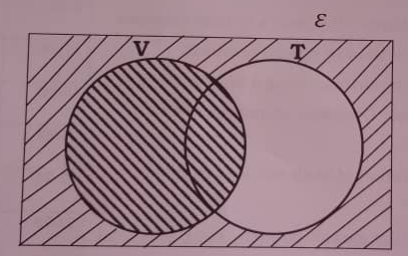  On the Venn diagram below, describe the shaded set region. | 8. | Express eleven minutes to six o’clock in the evening in 24 hours clock system.
4. | Circle the number from the list below that is exactly divisible by 3.  441, 1024, 413, 1104 | 9. | Using the dial. Workout  4 – 8 = _____ (Finite 7)
5. | Simplify: 4$\frac{1}{3}$ ÷ 2$\frac{1}{6}$ | 10. | Round off 4,954 to the nearest hundreds.
11. | Amponye was given a discount of 12% on purchasing 40kg of sugar whose marked price was sh. 4000 each kg. How much money did he pay for the 40kg of sugar?
12. | Kyalimpa’s distance from school to his parent’s home is 167metres. Express it in kilometres.
13. | Using a pair of compasses, a ruler of a sharp pencil only, construct an angle of 60⁰.
14. | Find the sum of the missing numbers.  14, 15, 18, 23, _____, ______ | 15. | Find the bigger angle between North – East and West
16. | Jardy ate $\frac{1}{3}$ of the cake and gave of the remainder to her family. Find fraction of the same cake that her family received.
17. | List all subsets in a set below.  M = {composite numbers between 3 and 9}
18. | Calculate the circumference of a clock face whose formation was based on a diameter of 28cm.
19. | Find the value of k in degrees in the figure below. If ∠WAE doubles angle ∠AEW.  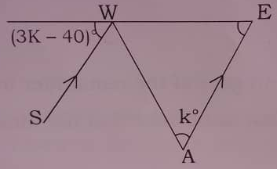
20. | Twelve boys can slash the compound in 5 days. How many more days will 10 boys take to slash the same compound.
SECTION B
21. | a) Write (7 x10²) + (4 x 10⁰) + (3 x 10^{–2}) (2marks)  b) Find the product of the value of 5 and the place value of 7 in the 4 digits numeral below 3571. (2marks)  c) Express 41_{five} as a decimal base. (2marks)
22. | Mudiima went to Nakasongola main market with two notes worth sh. 20,000 each, he shopped the following items.  1$\frac{1}{2}$ dozen of books at sh 1,000 each book.  5 pens at sh 1000 @ pen  10 pencils at sh 1,000 every 2 pencils.  A geometry set at sh. 3,500  A school bag at sh. 12,000  - Calculate his total expenditure. (3marks)  - If he received 10% discount on a bag and 15% on books, how much did he pay altogether? (3marks)
23. | a) Seeta Junior School has 29 classrooms, each class room has 68 pupils and each pupil uses a stool. How many stools are there in the school? (2marks)  b) If there are 116 teachers, what is the ratio of teachers to pupils? (2marks)
24. | a) Study the Venn diagram below and complete it carefully. (2maks)  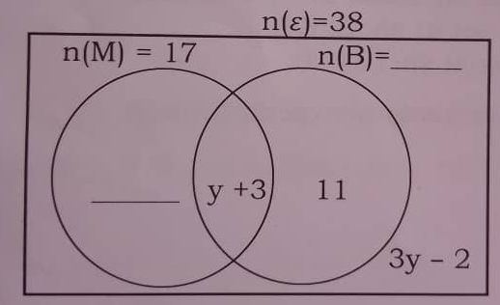  b) Find the value y. (2marks)
25. | Increase sh.704,000 by 17$\frac{1}{2}$% and then decrease it by 12$\frac{1}{2}$% (4marks)
26. | Find the area of the unshaded part. (6marks)  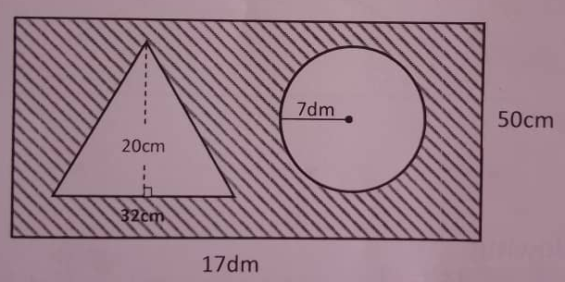
27. | Amuge left Kumi town at 9:00am and travelled to Mbale town where she reached at 11:00a.m. moving a steady speed of 40km/h.  - Find the distance between Mbale and Kumi. (3marks)  - She returned in only 1hour and 12 minutes. Calculate her average speed for to and from journey. (2marks)  - Express her departure time in a 24 hour clock system. (1mark)
28. | Solve the following.  - $\frac{2x+3}{2}$ = $\frac{3x−3}{4}$ (3marks)  - 11 – 2y ≤ 1 (2marks)
29. | - Find the supplementary angle of (t – 10)⁰ (3marks)  - Find the value of x. (3marks)  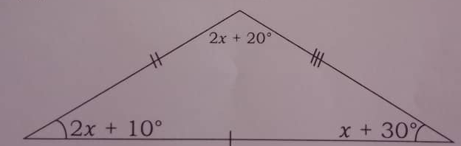
30. | If 1 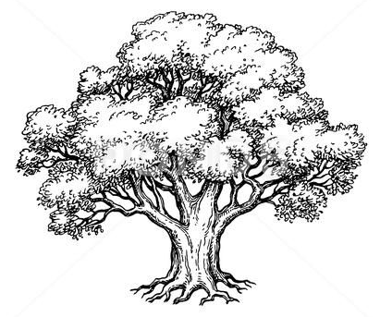represents 48 trees, draw a pictograph for the data below. (3marks)  Sarah planted 144 trees  Camel planted 240 trees  Joan planted 96 trees  b) If 1 tree costs sh. 5000, how much did camel spend altogether?
31. | a) Using a pair of compasses, a ruler and a sharp pencil only, construct a triangle PAK where AK = PA = 7cm.  PAK = 150⁰ (4marks)  b) Measure the length of PK  PK = __________________ (1mark)
32. | Jubilee spends $\frac{1}{2}$ of his monthly income on food, 75% of the remainder on school fees and saves sh. 120,000.  - What fraction does he spend on school fees? (2marks)  - How much is his monthly income? (3marks)
*END*

