SECTION B
- Which group of people were the founders of Bunyoro Kitara?
___________________________________________________
- How were rift valley lakes formed?
___________________________________________________
- What is mixed farming?
___________________________________________________
- What must be taken into account when choosing a place where to put a rain gauge at a weather station?
___________________________________________________
- Give one reason why mountain slopes of east Africa are densely populated.
___________________________________________________
- In which arm of government are members of parliament?
___________________________________________________
- State one reason why the government of Uganda started UPE and USE programmes.
___________________________________________________
- How does cutting trees on a large scale affect the climate of an area?
___________________________________________________
- In which way was Semei – Kakungulu helpful to the British?
___________________________________________________
- Suggest one major reason why Kenneth Borup is still remembered in Uganda.
___________________________________________________
- State one way Omukama Kasagama benefited from the coming of Captain F. Lugard.
___________________________________________________
- Suggest one importance of good transport network in an area.
___________________________________________________
- Give the main reason for the coming of explorer to Uganda.
___________________________________________________
- Why is the government discouraging poaching around and in game parks?
___________________________________________________
- Give any one cause of the collapse of the East African Community in 1977.
___________________________________________________
- Which political party in Uganda made an alliance with UPC in order to win DP?
___________________________________________________
- In which way did the Uganda railway line help to stop slave trade?
___________________________________________________
- Suggest any one cause of early migrations.
___________________________________________________
- Give a reason why the British extended the railway line from Kampala to Kasese during colonial days.
___________________________________________________
- Give one economic importance of Fort Jesus to the economy of Kenya.
___________________________________________________
- Who heads the executive arm of government?
___________________________________________________
- Give one reason why German rule was hated in Tanganyika.
___________________________________________________
- Name the means of transport on mountainous areas.
___________________________________________________
- Mention any one challenge facing Uganda due to her location.
___________________________________________________
- Why was Sir Samuel Baker liked by the people of Northern Uganda?
___________________________________________________
- Suggest one way the coming of the white settlers affected the people of Kenya.
___________________________________________________
- State one characteristic of a down warped lake.
___________________________________________________
- Identify any one product got from a ranch.
___________________________________________________
- Why was indirect rule practiced in Uganda by the British?
___________________________________________________
- Mention the type of vegetation that favours wildlife.
___________________________________________________
- Suggest one cause of land fragmentation in some areas of East Africa.
___________________________________________________
- What causes day and night?
___________________________________________________
- Give a reason why Uganda trades with other countries.
___________________________________________________
- Why was the cement industry built in Tororo?
___________________________________________________
- Name the main export of Uganda today.
___________________________________________________
FOR QUESTIONS 36 – 40, ANSWER EITHER CHRISTIANITY OR ISLAM BUT NOT BOTH.
- Either: Write UJCC in full.
___________________________________________________
Or: Write UMSC in full.
___________________________________________________
- Either: Why did John the Baptist preach about repentance?
___________________________________________________
Or: What is Zakat – al – Fitr?
___________________________________________________
- Either: When does a Christian ask for forgiveness from God?
___________________________________________________
Or: When does a Moslem ask for forgiveness from Allah?
___________________________________________________
- Either: Why did Jesus love sinners?
___________________________________________________
Or: Why should there be a day of judgment?
___________________________________________________
- Either: Why do Christians pray when they are about to start eating food?
___________________________________________________
Or: Where did early Muslims face when praying?
___________________________________________________

SECTION B
- a) Suggest any two benefits of the East African community to member states.
- _________________________________________________
- _________________________________________________
b) Which organ of the East African Community does the following?
- Work as the parliament of Uganda.
___________________________________________________
- Judges whether one is guilty of not.
___________________________________________________
- a) What do the following symbols stand for on the Uganda coat of arms?
- Green color
___________________________________________________
- Blue color
___________________________________________________
b) Give two reasons why the Crested Crane was chosen as the emblem of Uganda.
- _________________________________________________
- _________________________________________________
- a) Suggest two causes of poverty among people in Uganda today.
- _________________________________________________
- _________________________________________________
b) Mention two ways the government of Uganda can help people to fight poverty.
- _________________________________________________
- _________________________________________________
- a) Mention two advantages of railway transport.
- _________________________________________________
- _________________________________________________
b) State any one problem faced by the builders of the Uganda railway.
___________________________________________________
c) How was the problem of labour shortage solved during the building of the Kenya - Uganda railway?
___________________________________________________
- Use the map of East Africa to answer question 45.
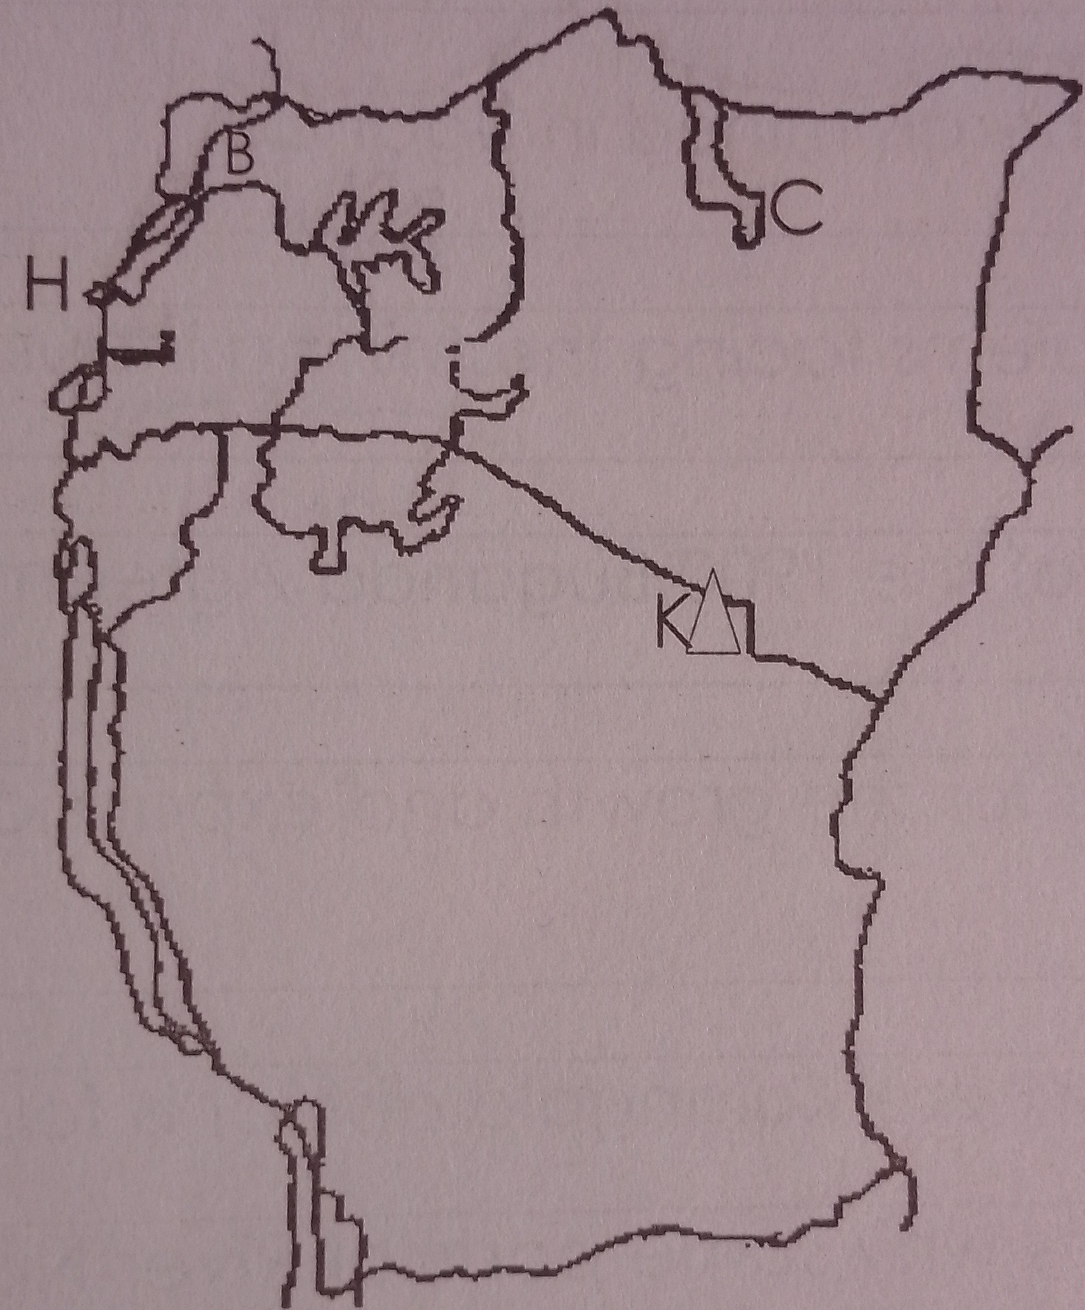
N

- Name the lake marked C.
___________________________________________________
- Which country border Uganda at H?
___________________________________________________
- Name Mountain marked K.
___________________________________________________
- Why does river B flow towards the Indian Ocean?
___________________________________________________
- a) Give two uses of land to people.
- _________________________________________________
- _________________________________________________
b) Mention two ways people mis-use land as a resource.
- _________________________________________________
- _________________________________________________
- a) Give two terms of the 1900 Buganda agreement.
- _________________________________________________
- _________________________________________________
b) Identify two factors for the growth and expansion of Buganda kingdom.
- _________________________________________________
- _________________________________________________
- a) Name the lake where Kalangala district is found.
___________________________________________________
b) Suggest two reasons why some parts of River Nile are not used for transport.
- _________________________________________________
- _________________________________________________
c) Mention the feature in River Nile used for generating hydro – electric power.
___________________________________________________
- a) Mention two minerals mined in Uganda.
- _________________________________________________
- _________________________________________________
b) State any two problems facing mining industry in Uganda.
- _________________________________________________
- _________________________________________________
- a) What are natural forests?
___________________________________________________
___________________________________________________
b) Name the largest natural forest in Central Uganda.
___________________________________________________
c) State two characteristics of natural forests.
- _________________________________________________
- _________________________________________________
FOR QUESTIONS 51 – 55, ANSWER EITHER CHRISTIANITY OR ISLAM BUT NOT BOTH.
- Either: Write down four gospel books.
- _________________________________________________
- _________________________________________________
- ________________________________________________
- ________________________________________________
Or: Write down four holy books in Islamic faith.
- _________________________________________________
- _________________________________________________
- ________________________________________________
- ________________________________________________
- Either: What event took place at the following places?
- Bethlehem:
___________________________________________________
- Cana
___________________________________________________
- R. Jordan
___________________________________________________
- Mt Sinai
___________________________________________________
Or: Give the meaning of the following Islamic word.
- Hejira
___________________________________________________
- Ramadhan:
___________________________________________________
- Zakat:
___________________________________________________
- Indi:
___________________________________________________
- a) Name the period of fasting for Christians.
___________________________________________________
b) Mention two things a Christian should observe during fasting period.
- _________________________________________________
- _________________________________________________
c) Why is fasting important in Christianity?
___________________________________________________
Or: State four things a Muslim is supposed to do during the period of fasting period.
- _________________________________________________
- _________________________________________________
- ________________________________________________
- ________________________________________________
- Either: a) Which work was Moses doing before he was called by God?
___________________________________________________
b) Name the sea Moses crossed with the Israelites.
___________________________________________________
c) Mention two punishments God gave to the Egyptians.
- _________________________________________________
- _________________________________________________
Or: a) Which work was Musa doing before he became a prophet?
___________________________________________________
b) Name the sea Musa crossed with the Israelites.
___________________________________________________
c) Mention two punishments Allah gave to the Israelites.
- _________________________________________________
- _________________________________________________
- Either: a) After the fall of man, state the punishment God gave to the following:
- Adam _____________________________________________
- Serpent ___________________________________________
- Eve ______________________________________________
b) State any one effect of sinning.
___________________________________________________
Or: a) After the fall of man, state the punishment Allah gave to the following:
- Adam: ________________________________________
- Hawa: ________________________________________
- Serpent ______________________________________
- Give one effect of sinning.
___________________________________________________
*END*

