***Uganda Advanced Certificate of Education***

**MID TERM II ASSESSMENT 2025**

**S.5 GENERAL PAPER S101/1**

**2 hours**

# INSTRUCTIONS:

* *This paper has* ***one*** *section with* ***two*** *items. Answer* ***one*** *item in all.*
* *The total time of 2 hours includes ten minutes for you to study the items before you begin answering.*

**SECTION A**

# Either:

* 1. The 2025/2026 National Budget of Uganda has recently been read to take effect on 1st July, 2025. The key statistics of this budget are given in the figure below. Study the details provided and use them to answer the tasks that follow.

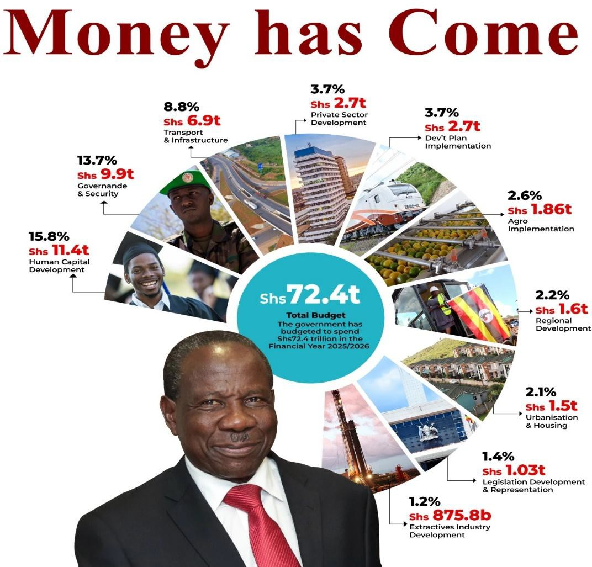

# Tasks:

Page2

1. Generate a debate motion related to the 2025/2026 National Budget as represented in the figure, ensuring that it is specific, arguable, and relevant to contemporary society.
2. You are a main participant in a debate based on the motion you generated in

(a) above. Using evidence and logical reasoning to support your arguments, write what you will present at this debate, engaging with opposing arguments and respond thoughtfully.

# Or:

* 1. *Read the following passage and respond to the tasks that follow.*

# A startling book present: ‘and sex shall have no dominion’

The title of the book is *Sexual Perceptions, Culture and the Law*. An autographed copy was given to me last Monday by the author/editor, my friend Nassur Tab’an El-Tablaz. Yes, we have a new Tab’an on the literary scene. His book was one of the lovely presents I was given at the “Mother House”, the seat of FEMRITE, my literary sisters in Kampala, where we were celebrating my arrival at the “eighth floor” of my life.

Tab’an’s book startled me on quite a few fronts. At a personal level, for example, I could not help wondering what “sexual perceptions” an 80-year old guy is supposed to have. Then, curiously, the book title reminded me of the final chapter of my novel, *The People’s Bachelor*, with the title, “And Sex Shall Have No Dominion”. My friends and I have often joked about that, but I cannot say for certain why I gave the chapter that title. It is, of course, a parody of the line “And Death Shall Have No Dominion”, from the poem by Dylan Thomas. Most importantly, however, the book’s title and content, as I absorb it, coincidentally connected with a debate I wanted to share with you in our chat today.

You see, a member of one of the WhatsApp groups to which I belong shared, with obvious approval and enthusiasm, the claim in a book by a German woman author, Esther Viller, that the main purpose of women is to capture and enslave men, using their sexual attraction. This stung me, a self-confessed emancipation feminist, to the quick. I wanted to unleash an angry rebuttal to the claims, or at least show that there are perfectly logical reasons why some women behave as they do in the face of toxic male chauvinism. But on second thoughts, I realised that what I had read were just the responses of my social media friend to the book and I

should not rush into judgements without a reasonable acquaintance with the books myself.

Page3

Anyway, I will tell you in a moment what I think about that oft-made claim that women use their charms to entrap and enslave men. First, let me tell you about my book gift and how I read it. Tab’an’s title, *Sexual Perceptions, Culture and the Law*, struck me as rather eclectic, and the reader cannot help wondering how, and if, all these topics would be covered within the 140-or-so pages of a typical pocket book. On thumbing through the text, I found that the book is not the single- tracked discourse that I had expected. Rather, it is an anthology, comprising verse pieces, poems, by the author/editor himself and a few other contributors, and a third of the book comprises a number of satirical epistolary (letter-type) pieces addressed to easily recognisable local dignitaries on burning issues in the country.

It is in the poems that one finds a great deal of frank and unusually explicit reflections on sex and its challenges, although these, too, often stray into the legal and political tangles of the present. Incidentally, the anthology is multilingual, a growing tendency among Ugandan contemporary writers and publishers.

Closing in on our sexual exploitation theme, and Esther Viller’s book, *Manipulated Man*, let me start by expressing my personal opinion. I think that sex is obsessively exaggerated in the latter twentieth and twenty-first centuries. I do not know if we do it more or better than our predecessors, but we certainly talk, image, sing and legislate it more than ever before. Have you heard of the Kinsey Sexual Revolution?

Dr Alfred Kinsey started the Institute of Sex Research at Indiana University in the US in 1947. The purpose of the Institute was to study, demystify and debunk human sex and sexuality. This was a useful venture because American society, and many other societies around the world, were extremely prudish and secretive about sex, shrouding it in layers of taboo, prohibitions and mystifications. This, Kinsey and his disciples felt, was bad for humanity, burdening us with crude and crazy inhibitions and guilty consciences about the perfectly natural, normal and necessary endowment of sex. These led to people either fearing sex, being furtive about it and failing to talk about it, even when it involved disease or serious malfunctioning.

The publication of the two Kinsey Reports, *Sexual Behaviour in the Human Male* and *Sexual Behaviour in the Human Female*, was a landmark in human history. It liberated millions of people around the world, enabling them to understand, accept and enjoy their sex as a healthy, normal activity. But, as often

happens with many good things, this move towards empowered and emancipated sexual activity was soon perverted by social delinquents and turned into limitless promiscuity, licentiousness and even commodified profiteering, the position where we are today. This brings us to the claim that women use their sexual endowments to enslave men. I will not challenge this because, as I pointed out, I have not read and studied the texts that make the allegations. But even if we were to accept the charge that some women do use sexual favours to attract and retain male partners, it is quite easy to prove that one of the main causes of this is the unfair and lopsided structure of society.

Page4

No woman, however decent and well-meaning, can automatically expect fair treatment in a society that, from the word go, labels and classifies people according to their sex. In many of our patriarchal societies, where girls may be denied even the most elementary right of sitting in a classroom, what weapons does the woman have for fighting her survival battles? In the “macho” (toxic masculinity) ranks, where even some leaders of the most advanced nations think the best way to deal with women is “grabbing them by the crotch” (ashakum!), are you surprised that you will be fought with the same weapon?

Ramadhan will be over when we meet again. So, here is an early “Eid Mubarak!”

*(By Austin Bukenya, a leading East African scholar of English and literature.)*

# Tasks:

* + 1. The above passage is about topic that belongs to social issues, culture, education, human rights, and historical perspectives. Explain the writer’s argument in the passage. Do you agree with him? Give reasons.
    2. Based on the passage, prepare a speech, or an article that effectively communicates the influence of language and literature in social transformation. Choose a specific audience such as policymakers, general public, or the youth.

***Reading can seriously Damage your Ignorance!***